List of the assembly code files:

timesthree.asm

To implement this project I had to modify the existing source file, timesthree.asm, from blackboard. I accomplished this by adding system calls to prompt the user for three integers, system calls to move the user’s inputs from $v0 to some temporary registers, system calls to add said temporary registers together, system calls to add the result of the inputs to itself effectively multiplying by 3, and finally a system call to show the result of this calculation.

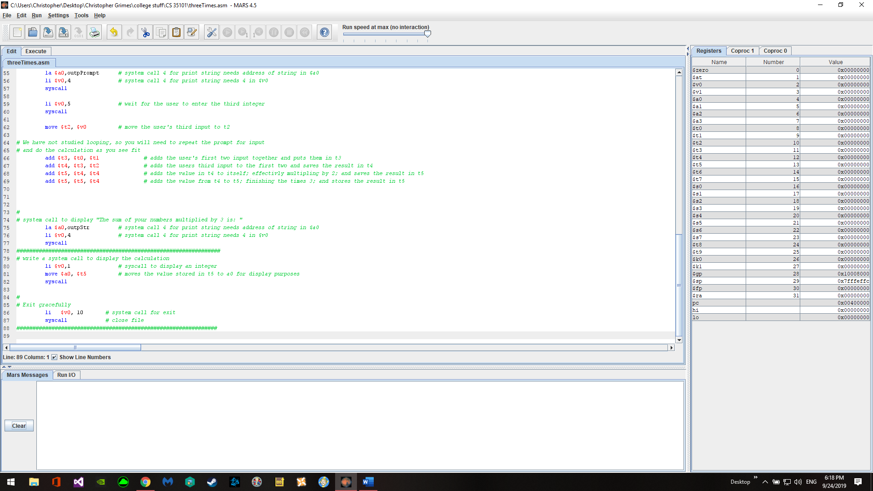

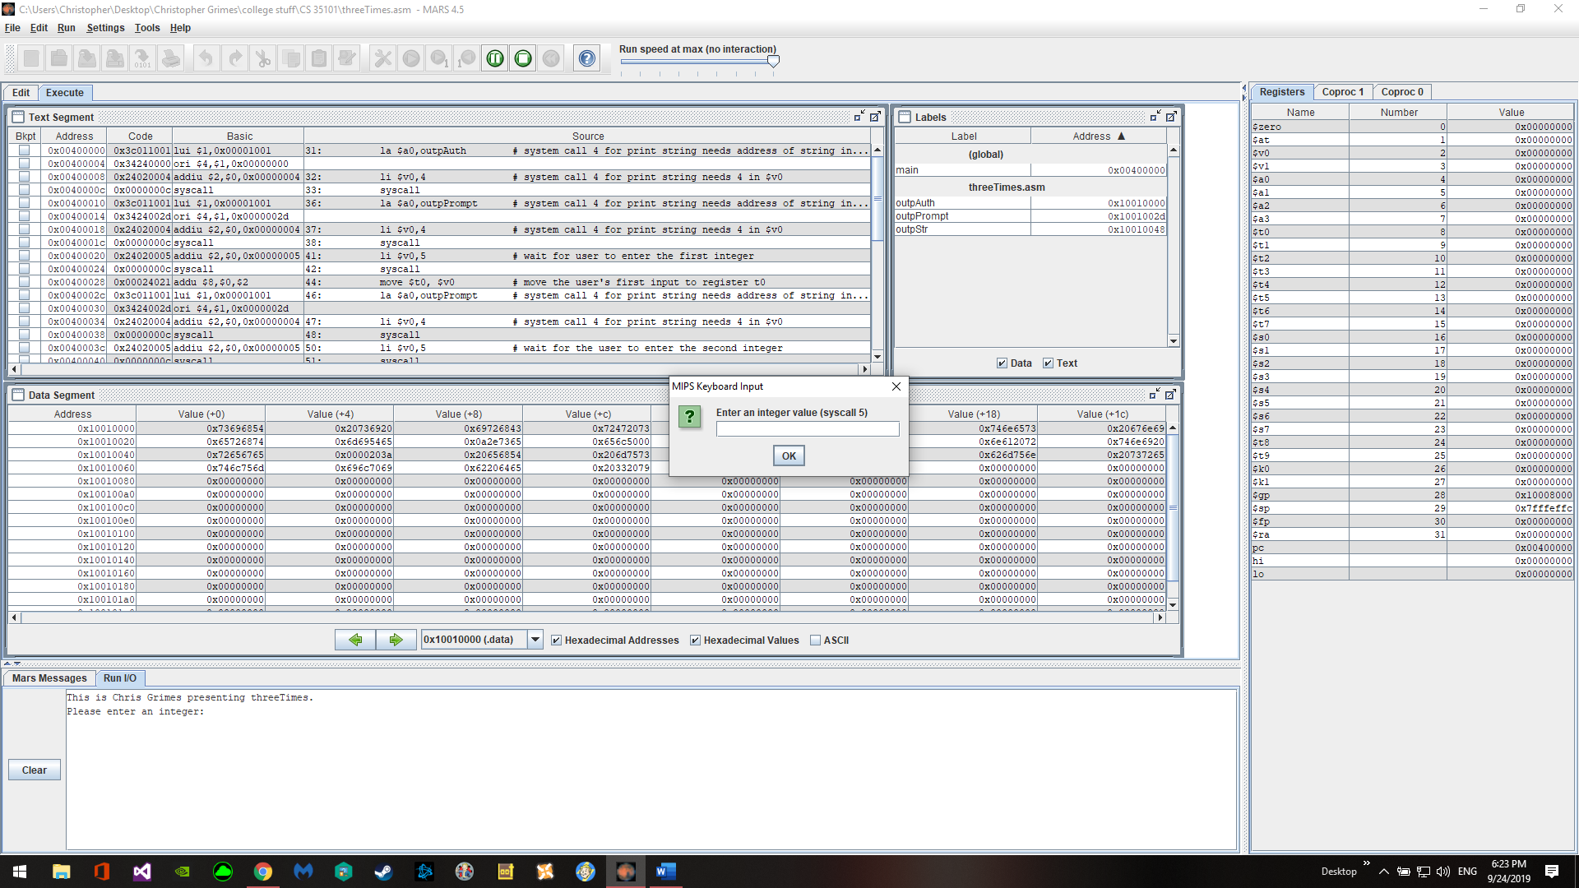

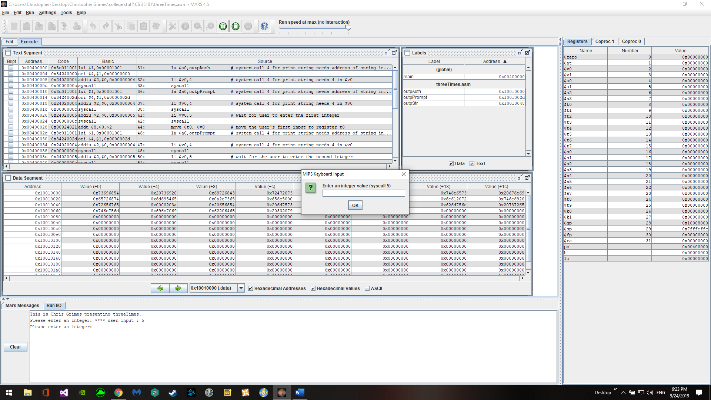

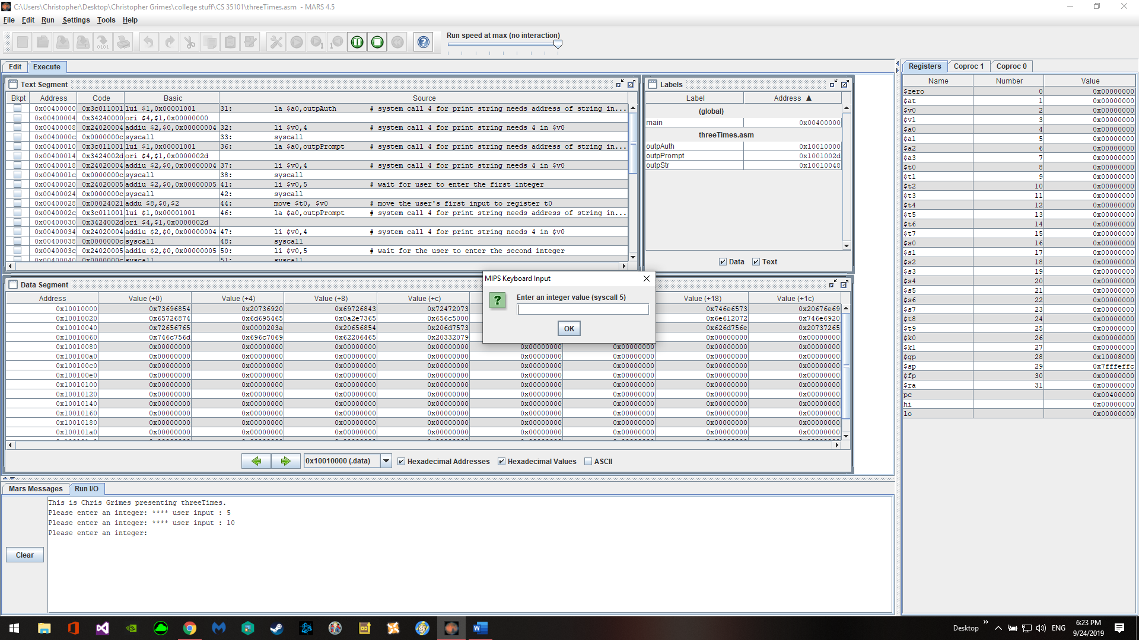

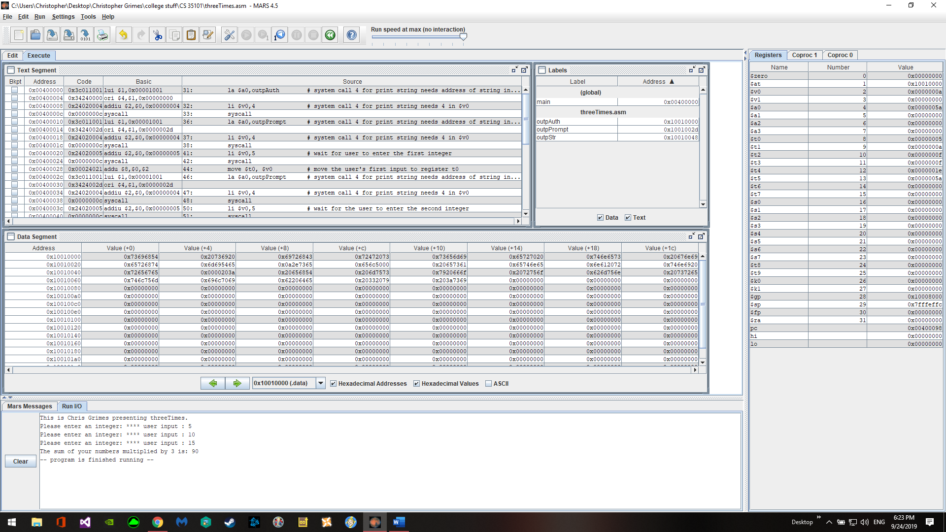

The only real problem that was faced was trying to find an example of taking users inputs which was remedied by a quick Google search.