My class project is similar to the Playstation 2 game Katamari. In this game you will control the player, a ball with the Quake symbol on it, and attempt to increase your size and mass by running into other smaller gameobjects. Depending on the game mode you choose on the title page you may play against computers or alone.

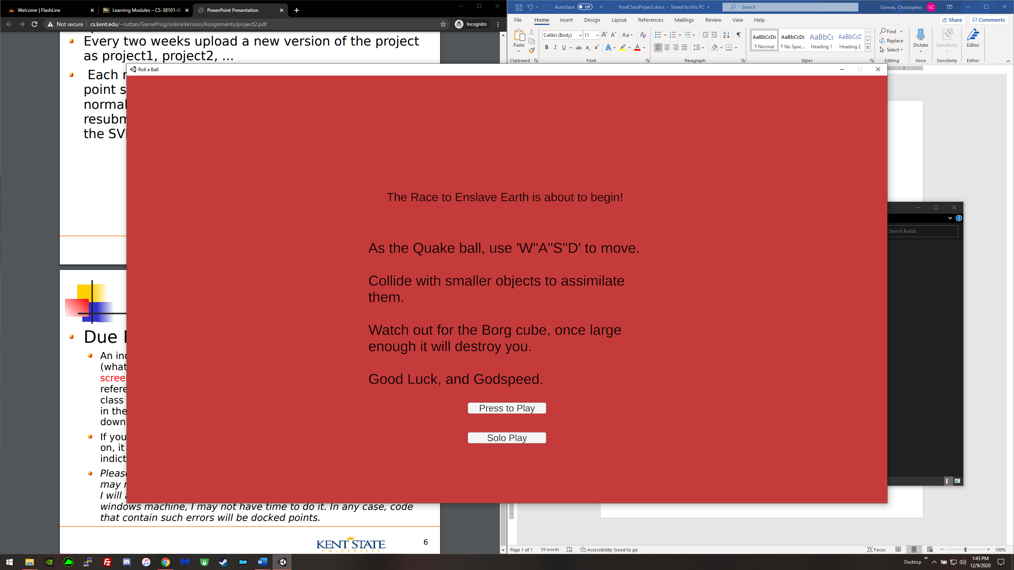

The player is controlled by using the ‘w’’a’’s’’d’ keys like in most first person shooters.

After playing alone, whether you win or lose, the game will take you back to the title screen.

If you choose to play against the computer the game will continuously load new levels until either you close the application or you complete level 6. If you are defeated while playing with the computer the next level will be 1- the current level and the computer will be easier to defeat. If, however, you beat the computer the next level will be 1+ the current level making the computer more efficient. Every even numbered positive level above 0 adds another enemy.

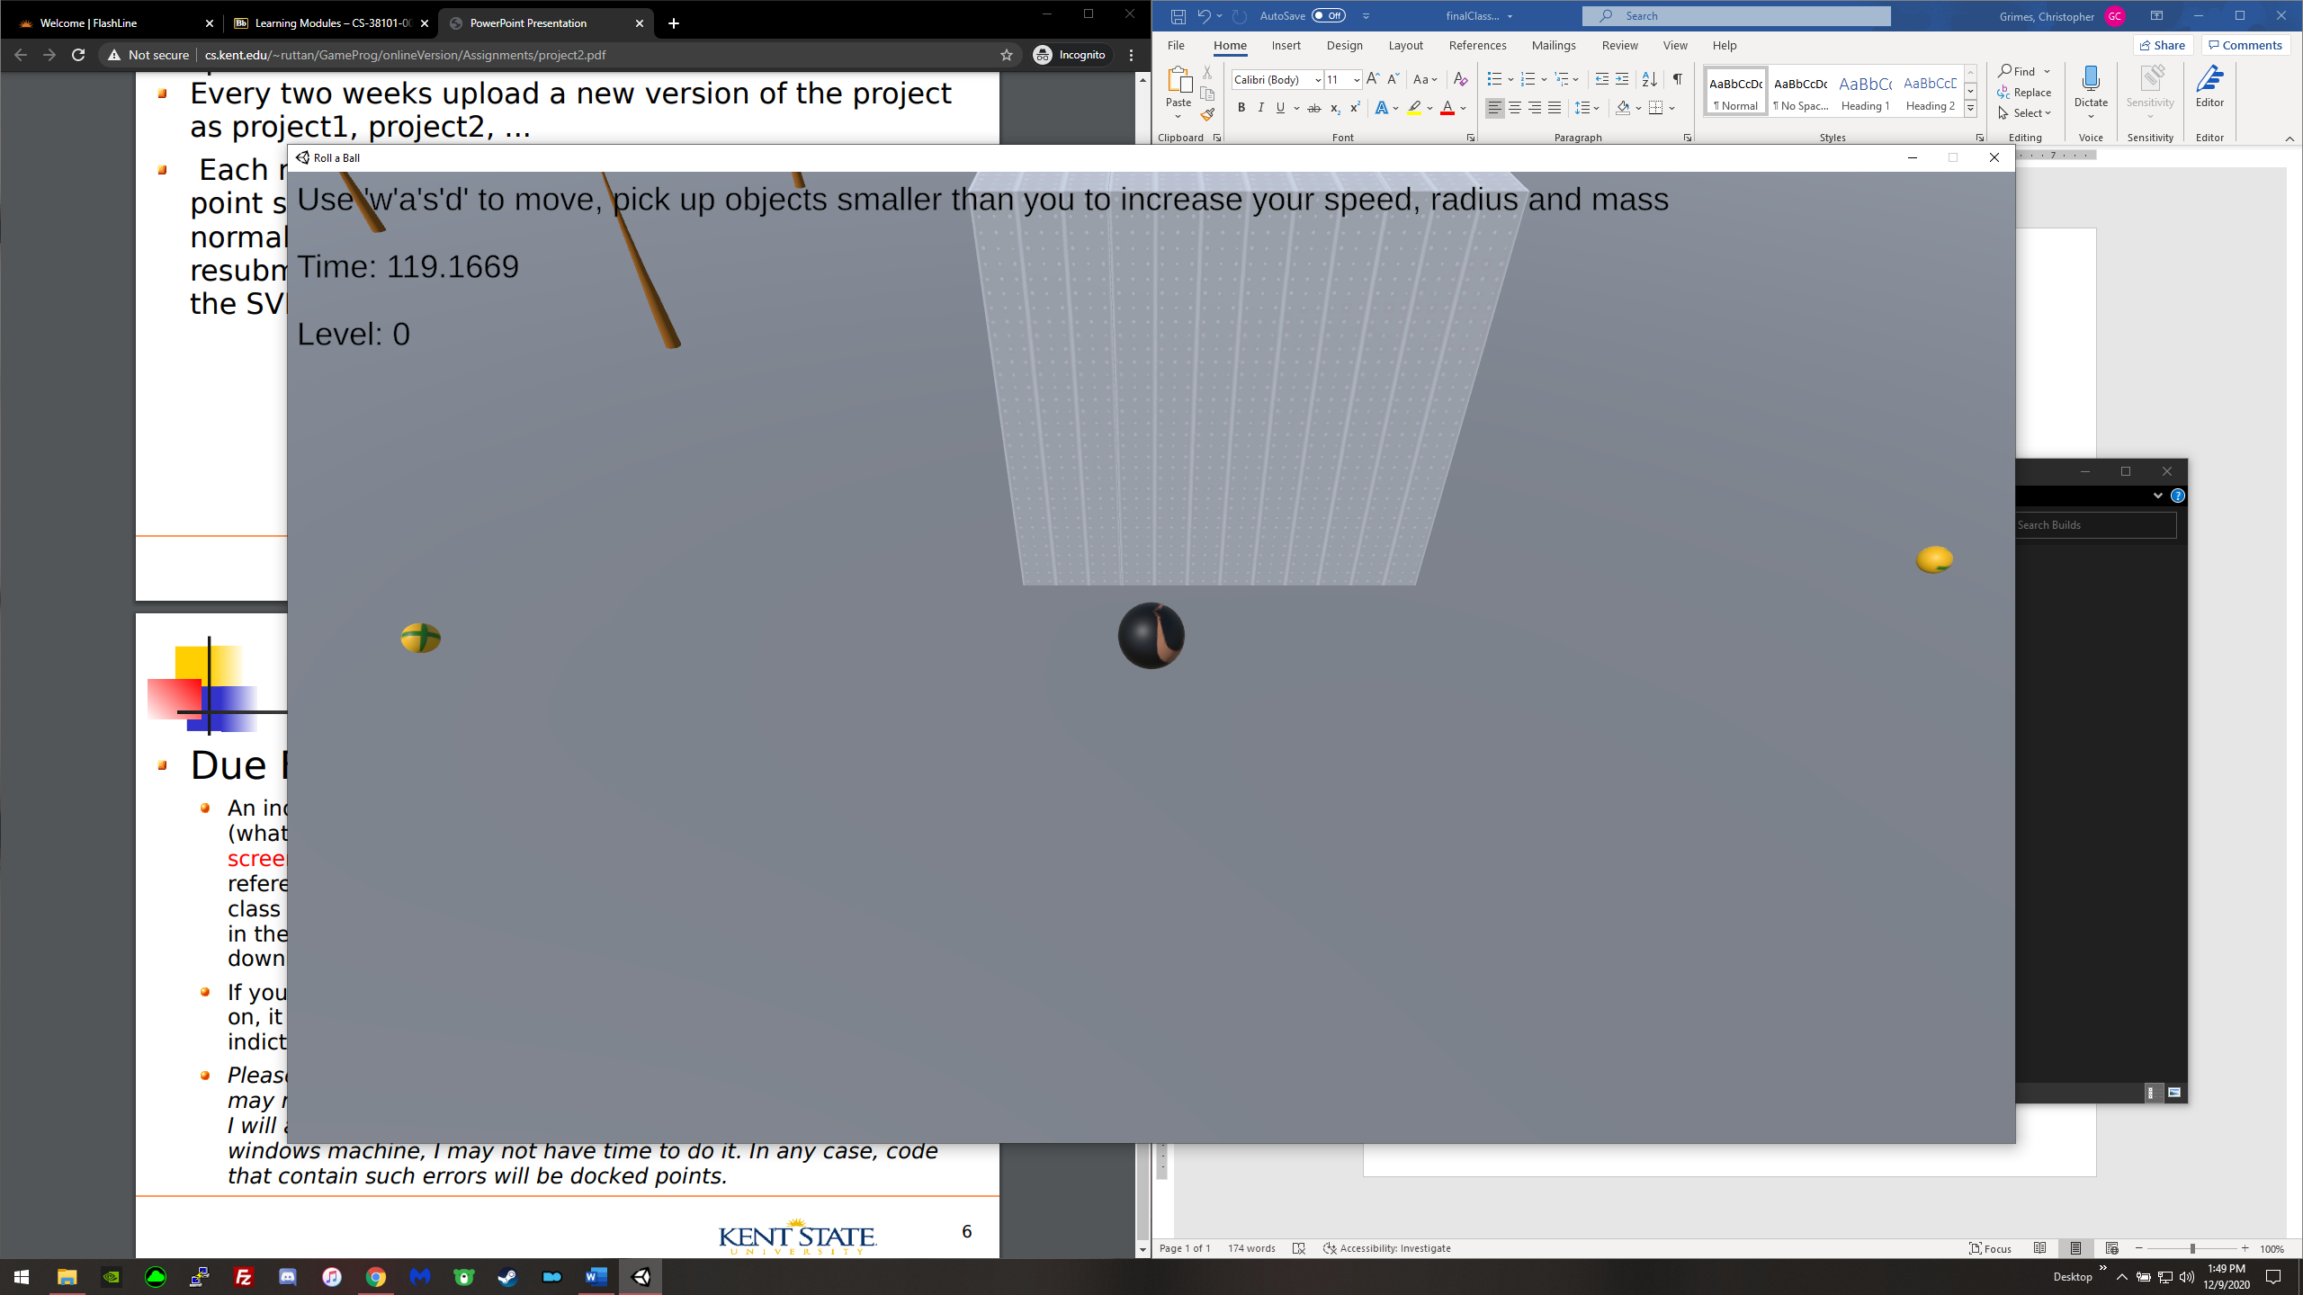

While playing, the players current mass is displayed in the upper left-hand corner. Below it is the time left in said match, and below that is the current level.

Running the “Roll a Ball.exe” in the “Builds” folder of the “FinalClassProject” should load and run the game.

Considerable time was spent creating the level, optimizing the cars, sidewalks and buildings as to not have a terrible framerate.

Algorithms that took considerable time include:

-the algorithm that makes smaller gameobjects a child of the player after contact, found in PlayerController

-the movement and logic for the enemies, found in EnemyMovement

-properly loading levels took some time to iron out, but the code is very simple found in any Loadx script