Tini Grosso

cgrosso@bu.edu

Abstract

This document contains a link to a Trello board, a link to a Wix website, and a Sprint Retrospective for Sprint 1 of the website design of beatboxer, Josh Moore.

Sprint 1 Execution

CS634 Agile S/W Development

Table of Contents

Introduction 2

Link to Trello board for Josh Moore Beatboxing website 3

Link to Wix.com website for Josh Moore Beatboxing 4

Sprint 1 Retrospective 5

Link to Vision Statement 7

Personas 8

Press Release 9

User Flows 10

Style Sheet 13

Works Cited 14

# Introduction

This document is the final deliverable for MET CS 634, Agile Software Development. This student enjoyed learning about Agile Software Development, but found website design to be quite challenging, and not exactly as she had imagined (thus, the retrospective!).

For reference, this document also contains the previously submitted vision statement, personas, press release, user flows and a style sheet.

# Link to Trello board for Josh Moore Beatboxing website

<https://trello.com/b/nUTz6p0Y/cs634group4grossochristine>

# Link to Wix.com website for Josh Moore Beatboxing

<https://cgrosso8.wixsite.com/mysite>

# Sprint 1 Retrospective

Although this student can shop online like a pro, she had never actually had anything *ever* to do with *constructing* a website. This situation, coupled with the fact that each student in the class was his/her own Agile “team” in charge of website design, presented significant challenges for this student.

First, I was glad for the opportunity to learn something about designing a website. I very much enjoyed creating a unique logo for Josh and making the “Merch” mockup on my site. In my opinion, the Merch pictures themselves came out just fine—I would like to buy a mug and T-shirt myself!!

Second, here are some of the things I struggled with:

1. Scope creep! The Trello board and Release 1 we created for Assignment 4 did not seem adequate for the list of 15 PBIs required for Sprint 1 in Assignment 5. Of course, and in spite of warnings in the back of my brain, I added plenty of other things to the Release and the Sprint, at least two of which are not doable for this first Sprint, namely:
2. The Sprint items that have to do with the “Name that Sound” game. This game will require significantly more thought and planning to adequately decompose it for a Sprint, and it simply cannot happen for this one.
3. Buttons. I very much dislike the ones I used. They are too small, albeit the right color for my Style Sheet, and they look ridiculous on the Wall of Fame. I spent too long trying to figure out an alternative solution, but if one arises now, it’s too late to change them, considering how many links I’ve got connected to them, and how long that took me to do. I believe that “someone else on my Agile team” would have known how to properly create the right size/color buttons, but as they look now, they are inadequate for the proper UXD.
4. Searching on the Tutorials page for “clean content” video. As I wrote that for the Sprint 1 (last week), I had decided that it would be nice to be able to search both ways (by description of sound category, as well as by instructor). Frankly, searching by *instructor* is trivially easy: either the tutorial is one from Josh, or it is one from humanbeatbox.com’s website. Searching by *description* is not easy at all, *from our website*. For one thing, Josh has no tutorials of his own yet, so there is nothing to describe there. Humanbeatbox.com, however, has over 100 tutorials, but as soon as you click the humanbeatbox.com link, you end up on their site and can choose what you want to see THERE, by category and by subcategory of sound. I also promised that searching (or perhaps I meant “browsing”?) will be enabled by drop-down menus. Again, it seemed like a good idea last week. This week, it seems highly unnecessary.

Also, a note about social media icons: Wix.com kindly supplied them with my website; however, I realized that I hadn’t mentioned these links either in my Release 1, nor in my Sprint 1. Therefore, so as not to additionally “scope-creep,” I decided to leave the links on the pages but not connect them to anything (yet).

# Link to Vision Statement

Spark page: <https://spark.adobe.com/page/WlxSFnWq35GDt/>

# Personas

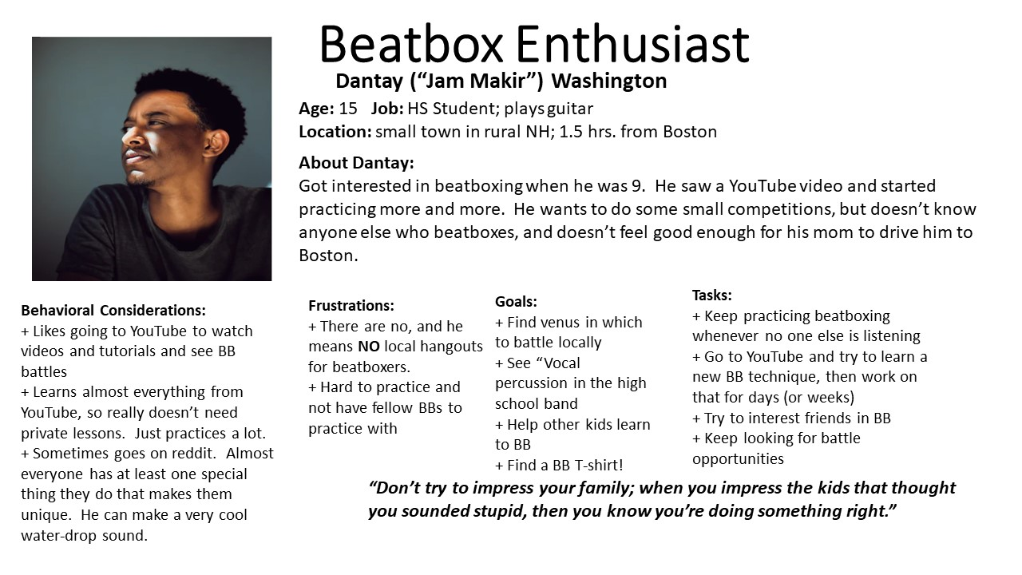

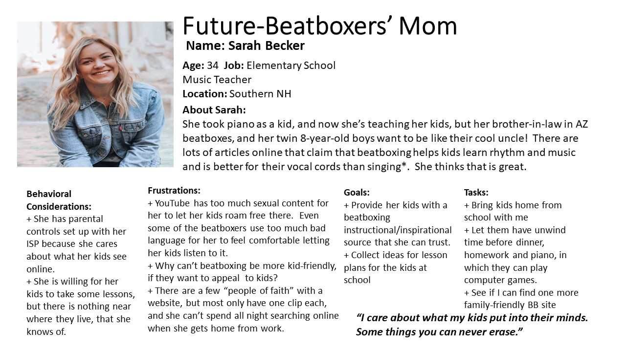

# Press Release

Josh Moore, Christian Beatbox Artist, Launches New Website

Fans of Josh now have a hub from which to access all things Josh!



Logo created and paid for on my.logomakr.co by Tini Grosso

Nov. 11, 2019—Christian beatboxing artist Josh Moore announces the launching today of his new website, JoshMooreBeatbox.com. The website finally brings together Josh’s full repertoire of beatbox video clips and tutorials, as well as his long-awaited Wall of Fame, which is Josh’s personal collection of favorite artists, sayings, cool information, photo gallery, and his story. You’ll be able to find Josh’s schedule of events here, his fan blog, and even merch with his new logo.

Human beatboxing as an artform is still relatively unnoticed, and YouTube is the main way to experience it. But the internet has desensitized the world to some pretty raw language and overt sexuality (Huerta, 2018) (Nudity and Sexual Content Policies, 2019), and even some YouTube videos contain vulgarity (Binder, 2019). Here at last is a site and hub to which beatboxers and fans can turn for top-notch beatboxing information and entertainment without objectionable content.

“I loved working with Josh on his new website—he’s so talented,” said Tini Grosso, head of design strategy at SaymeWorld Web. “Josh wants to elevate beatboxing and also impact people’s lives for good right where they are. Josh told me, ‘Some people already have so much junk they are dealing with. Beatboxing has been a means of getting many of them out from under the junk. I want to help them. I don’t want to pile on more junk.’”

Josh’s webpage contains links to his Facebook, Twitter and Instagram accounts, and also a link to The Patriot Initiative, which is an organization founded by Josh.

“Josh is fantastic and his website is fun and amazing,” said fan Shauna Wilson. “I’m just learning to beatbox, so I come here all the time to get lost in it!”

Visit Josh at [www.JoshMooreBeatbox.com](http://www.JoshMooreBeatbox.com)

# User Flows

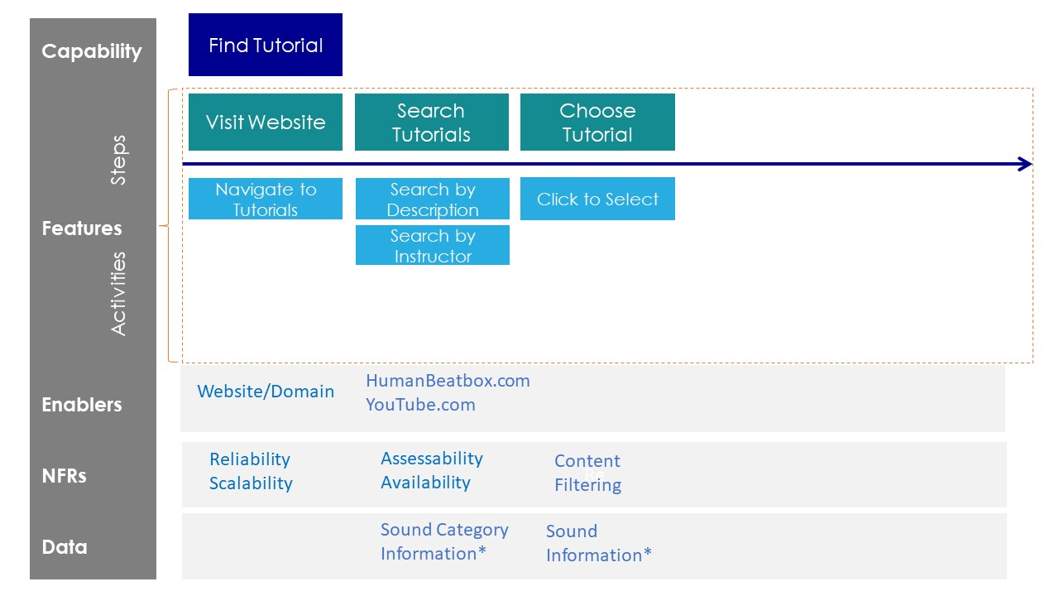

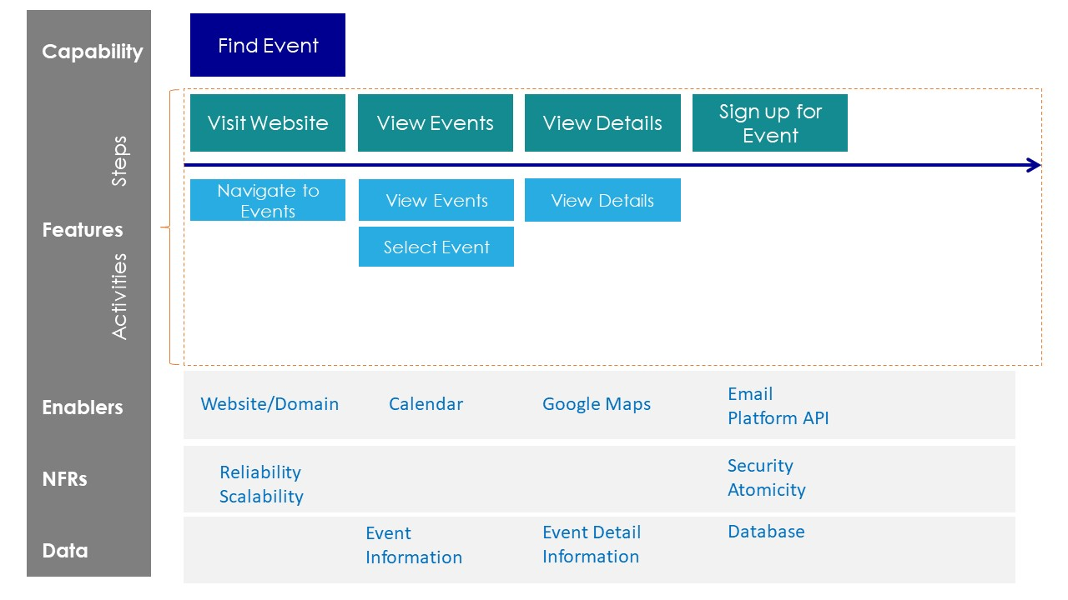

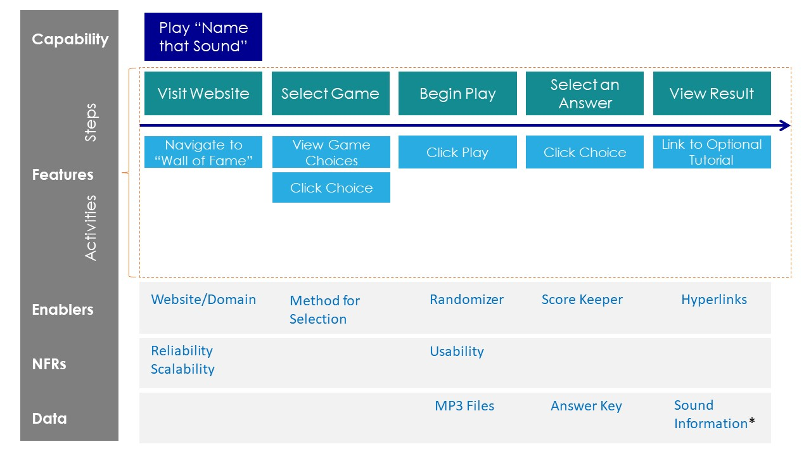

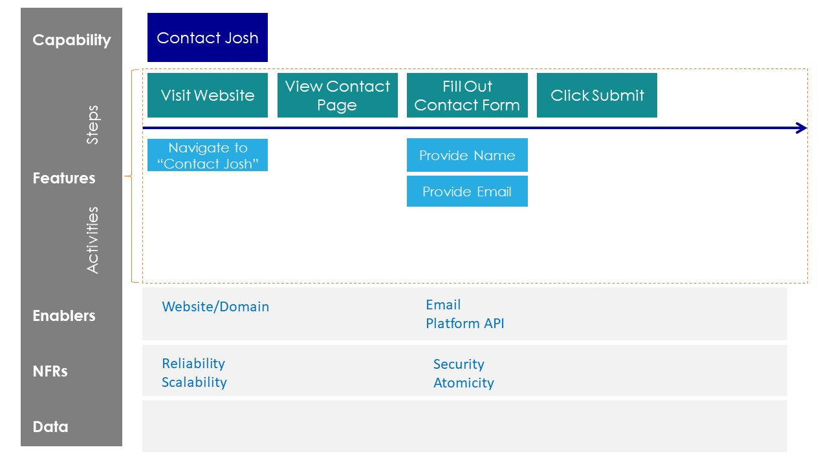

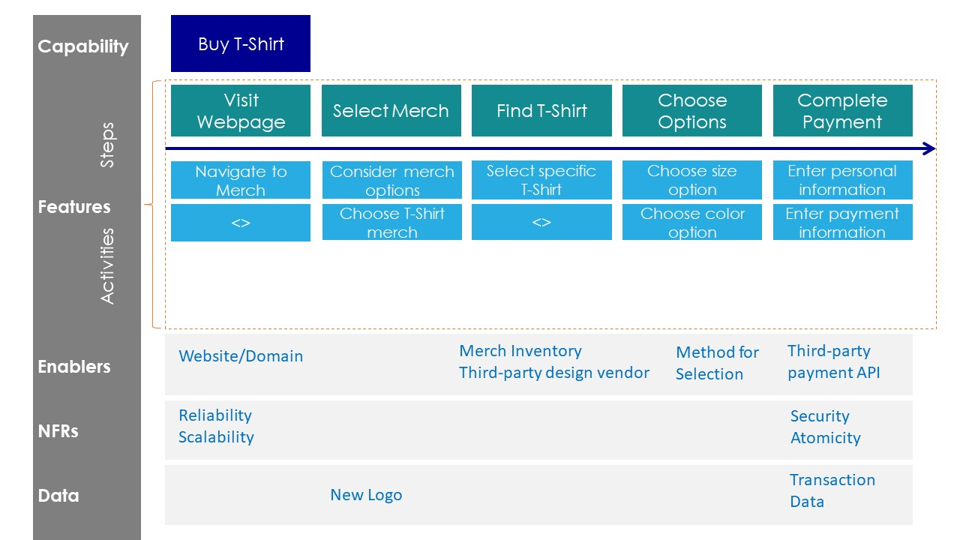

# Style Sheet

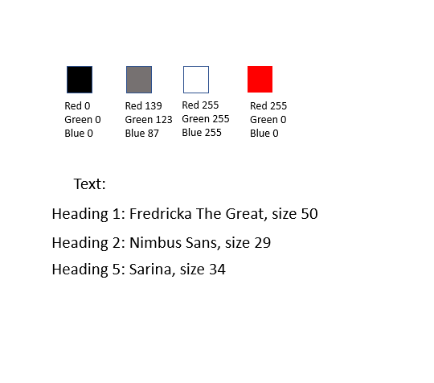

# Works Cited

Binder, M. (2019, January 14). *Damn and hell are fine on YouTube. Here's what you can't f**king say.* Retrieved from Mashable: https://mashable.com/article/youtube-profanity-monetization-guidelines/

Huerta, D. (2018, August 14). *Use of Pornography Among Tweens and Teens*. Retrieved from Focus on the Family: https://www.focusonthefamily.com/parenting/use-of-pornography-among-tweens-and-teens/

*Nudity and Sexual Content Policies*. (2019). Retrieved from YouTube Help: https://support.google.com/youtube/answer/2802002?hl=en