|  |  |
| --- | --- |
| LILLEBAKK cmyk |  |

Datasheet

Project NAME: LE_NB_IOT_CONTROLLER

Customer: <AAA_BBB_CCC_NX>

Features

* …
* …
* …
* …
* …
* …

Table 2: Key parameters

|  |  |  |  |  |  |
| --- | --- | --- | --- | --- | --- |
| **Supply voltage** | **Placement** | **ΔX (largest)** | **ΔY (largest)** | **ΔZ (largest)** | **Sertifications** |
| <xxx V> | <Core/ IO> | <xxx µm> | <xxx µm> | <xxx mm2> | <Yes / No> |

Contents

1. Module Interface 2

2. Electrical Characteristics 3

2.1. Parameter definitions 3

2.2. Verification Plan 3

2.3. Simulation result plots 3

2.3.1. DC Simulations 3

2.3.2. Transient Simulations 3

2.3.3. AC Simulations 3

3. Deliverables 3

4. Module Background 3

4.1. Dependencies 3

4.2. Derivate 3

4.3. Relevant Literature 3

4.4. Footprint 3

5. Control Modes 3

6. Circuit Description 3

6.1. Operation 3

6.2. Alternative Topologies 3

6.2.1. Alternatives 3

6.2.2. Justification for Selection 3

6.3. Design Process 3

6.3.1. High Level Model 3

6.3.2. Transistor Level Design 3

6.4. Schematics 3

7. Test Plan 3

7.1. Test Modes for this Module 3

7.2. Prototype Verification and Characterization 3

7.3. Production Test 3

7.4. Probe Points 3

8. Verilog and WREAL Model Error! Bookmark not defined.

8.1. Model Specification **Error! Bookmark not defined.**

8.2. Model Verification **Error! Bookmark not defined.**

9. History Error! Bookmark not defined.

10. Change requests Error! Bookmark not defined.

# Module Interface

Table 3: Pin description

|  |  |  |  |  |
| --- | --- | --- | --- | --- |
| **Pin name** | **Type** | **Domain (V)** | **Description** | **Comments** |
| mix33vdd! | Power | - | Power supply |  |
| mix33vss! | Power | - | Ground |  |
| vdd! | Power | - | Power supply |  |
| vss! | Power | - | Ground |  |
| i12input | Digital input | vdd! |  |  |
| o12output | Digital output | vdd! |  |  |
| aio33input | Analog input | mix33vdd! |  |  |
| aio33output | Analog output | mix33vdd! |  |  |
| ci33input | Current input | mix33vdd! |  |  |
|  |  |  |  |  |

# Electrical Characteristics

Verification levels:

1. Specification
2. Schematic simulation- PVT with 100 MC runs
3. Post layout simulation - PVT only
4. Characterization – will be part of the device characterization – see link in Table1. Optional to be added!

Table 4: Electrical characteristics

|  |  |  |  |  |  |  |  |  |
| --- | --- | --- | --- | --- | --- | --- | --- | --- |
| **Parameter** | **Test name** | **Parameter name** | **Condition** | **Ver. level** | **Min** | **Typical** | **Max** | **Unit** |
| **Operating Conditions** | | | | | | | | |
| Ambient temperature |  |  | Within specification | I | Tbd | 25 | Tbd | °C |
| Functional | I | Tbd |  | Tbd |
| Battery voltage |  | Vbat |  | I | tbd | 3,6 | tbd | V |
| Ground |  | Gnd |  | I |  | 0 |  | V |
| Supply voltage sensor |  | Vsense |  | I |  | tbd |  | V |
| Supply voltage MCU[1] |  | Vmcu |  | I | 3,1 | 3,8 | 4,2 | V |
| Supply voltage RF |  | Vrf |  | I |  |  |  |  |
|  |  |  |  |  |  |  |  |  |
| **DC Characteristics** | | | | | | | | |
| BOD level |  |  |  | I | Tbd |  |  | V |
| II |  |  |  |
| III |  |  |  |
|  |  |  |  | I |  |  |  |  |
| II |  |  |  |
| III |  |  |  |
| **Transient Characteristics** | | | | | | | | |
| Power on reset time |  | Tpor |  | I | 535 |  |  | us |
| II |  |  |  |
| III |  |  |  |
|  |  |  |  | I |  |  |  |  |
| II |  |  |  |
| III |  |  |  |
| **AC Characteristics** | | | | | | | | |
|  |  |  |  | I |  |  |  |  |
| II |  |  |  |
| III |  |  |  |
|  |  |  |  | I |  |  |  |  |
| II |  |  |  |
| III |  |  |  |
| **Notes** | | | | | | | | |
| Note 1: <Notes on electrical characteristics> | | | | | | | | |

## Parameter definitions

<This is more detailed explanations on parameters>

## Verification Plan

<Delete this text and add a verification plan here – what is verified how (distinguish between schematic and PLS)>

## Simulation result plots

### DC Simulations

<Delete this text and paste DC simulation plots here (max recommended width on pictures is 25cm)>

### Transient Simulations

<Delete this text and paste TRAN simulation plots here (max recommended width on pictures is 25cm)>

### AC Simulations

<Delete this text and paste AC simulation plots here (max recommended width on pictures is 25cm)>

# Deliverables

Table 5: Design schematics

|  |  |  |
| --- | --- | --- |
| **Library** | **View** | **Comments** |
| [<library name>](http://syncserver-lib-nor1.norway.atmel.com:26611/scripts/isynch.dll) | <view name> |  |

Table 6: Design testbenches

|  |  |  |  |
| --- | --- | --- | --- |
| **Library** | **ADE XL view** | **Test name** | **Comments** |
| [<library name>](http://syncserver-lib-nor1.norway.atmel.com:26611/scripts/isynch.dll) | <view name> | dc_test_name_1 |  |
| “ | “ | tran_test_name_2 |  |
| “ | “ | ac_test_name_3 |  |

# Module Background

This module is based upon the LPWAN SRD: [..\LE_LPWAN_SYSTEM\doc\lpwan_system_requirement.docx](../LE_LPWAN_SYSTEM/doc/lpwan_system_requirement.docx)

## Dependencies

<This module is dependent on such-and-such libraries/modules>

## Derivate

<This module has been derived from so-and-so module designed in such-and-such technology>

## Relevant Literature

<This is the literature based on which this module was designed>

## Footprint

<Delete this text and paste the layout snapshot picture here (max recommended width on pictures is 25cm) >

Figure 1 : Layout snapshot of the module.

# Control Modes

Table 7: States

|  |  |  |  |  |  |  |
| --- | --- | --- | --- | --- | --- | --- |
| **Inputs** | | | **Outputs** | | |  |
| **i12intputA** | **i12intputA** | **i12intputC** | **o12output** | **ao33outputA** | **ao33outputB** | **Comments** |
| 0 | X | 0/1 | 0 | 0 | 0 |  |
| 1 | 0 | 0/1 | 0 | Not valid | 0 |  |
| 1 | 0 | 0/1 | 1 | 1.1V | 0 |  |
| 1 | 1 | 0/1 | 0 | Not valid | Not valid |  |
| 1 | 1 | 0/1 | 1 | 1.1V | 750mV |  |

Table 8: Calibration

|  |  |  |  |
| --- | --- | --- | --- |
| **Signals** | **Descriptions** | **Settings** | **Results** |
| i12inputD<3:0> |  | 0000 |  |
| “ |  | 0001 |  |
| “ |  | 0010 |  |
| “ |  | 0100 |  |
| “ |  | 1000 |  |

# Operation system description

AT commands are listed in: quectel_docs\Quectel_BC95_AT_Commands_Manual_V1.0.pdf

## Operation system overview

The operation system runs as shown in the below flow chart.

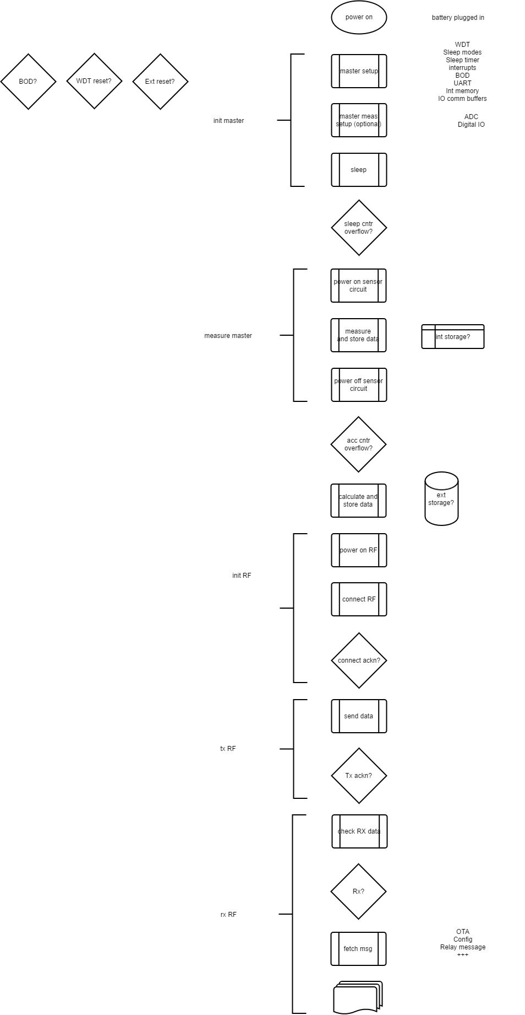

## Error messages

Tbd.

## Init master

MCU setup

## Measure master

MCU measure

## Init RF



### Power on and HW reset

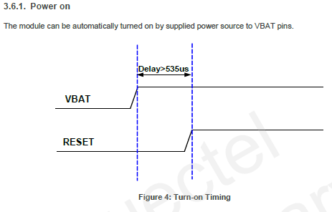

### Init ID

## Tx RF

## Rx RF

## Schematics

<Delete this text and paste snapshots of the schematics here (max recommended width on pictures is 25cm)>

# Test Plan

Table 10: Test conditions

|  |  |  |  |  |
| --- | --- | --- | --- | --- |
| **Temperature** | **-40°C** | **Room** | **85°C** | **Range [min:step:max]** |
| X | X | X |  |
| **Analog power supply** | **2.5V** | **3.3V** | **3.6V** | **Range [min:step:max]** |
| X | X | X |  |
| **Load** | **20pF** | **260pF** | **500pF** | **Range [min:step:max]** |
| X | X | X |  |

## Test Modes for this Module

<Explain clearly what kind of test modes are implemented in the module>

## Prototype Verification and Characterization

<Explain clearly how the prototype should be verified and characterized. List and sequence the signals that should be applied for each parameter>

## Production Test

<List and explain the tests that should be carried out in production to be able to catch the defective devices.>

## Probe Points

<Delete this text and paste the layout snapshot picture with marked probe points>

Figure 2 : Probe points on the module.

Table 11: List of probe points

|  |  |  |
| --- | --- | --- |
| **Probe point #** | **Node** | **Test usage** |
|  |  |  |
|  |  |  |
|  |  |  |
|  |  |  |
|  |  |  |

1. Extracted from the preliminary datasheet of BC95.