|  |  |
| --- | --- |
| LILLEBAKK cmyk |  |

Datasheet

Project NAME:

Customer: KJELLER VINDTEKNIKK

Features

* …
* …
* …
* …
* …
* …

Contents

Datasheet 1

Project NAME: LE_NB_IOT_CONTROLLER 1

Customer: KJELLER VINDTEKNIKK 1

1. Module Interface 2

2. Electrical Characteristics 3

3. Data format and storage capacity 4

4. Cost 5

5. Deliverables 6

6. Module Background 7

6.1. Initial coverage 7

7. Control Modes 11

8. Operation system description 12

8.1. Operation system overview 12

8.2. Error messages 12

8.3. Init master 13

8.4. Measure master 13

8.5. Init RF 13

8.5.1. Power on and HW reset 13

8.5.2. Init ID 13

8.6. Tx RF 14

8.7. Rx RF 14

8.8. Schematics 14

9. Test Plan 15

9.1. Test Modes for this Module 15

9.2. Prototype Verification and Characterization 15

9.3. Production Test 15

9.4. Probe Points 15

# Module Interface

Table 2: Pin description

|  |  |  |  |  |
| --- | --- | --- | --- | --- |
| **Pin name** | **Type** | **Domain (V)** | **Description** | **Comments** |
|  |  |  |  |  |
|  |  |  |  |  |
|  |  |  |  |  |
|  |  |  |  |  |
|  |  |  |  |  |
|  |  |  |  |  |
|  |  |  |  |  |
|  |  |  |  |  |
|  |  |  |  |  |
|  |  |  |  |  |

# Electrical Characteristics

Verification levels:

1. Specification concept 2 (final product)
   1. Specification concept 1 (pilot)
2. Measurements concept 0 (bench setup)
3. Measurements concept 1 (pilot in field)
4. Measurements concept 2 (final product in field)

Table 3: Electrical characteristics

|  |  |  |  |  |  |  |  |  |
| --- | --- | --- | --- | --- | --- | --- | --- | --- |
| **Parameter** | **Test #** | **Parameter name** | **Condition** | **Ver. level** | **Min** | **Typical** | **Max** | **Unit** |
| **Operating Conditions** | | | | | | | | |
| Ambient temperature |  | temp |  | I | -20 | 25 | 50 | °C |
| Battery voltage |  | Vbat |  | I | 2,0 | 3,6 | 3,7 | V |
| Battery capacity |  |  | 10 years life time | I | 9 |  | 17 | Ah |
| Ground |  | Gnd |  | I |  | 0 |  | V |
| Supply voltage Load cell[1] |  | Vlc |  | I |  | 3,4 |  | V |
| Supply voltage IA[2] |  | Via |  | I | 4 |  | 16 | V |
| Supply voltage OPAMP |  | Vopa |  | I | 2,3 |  | 5,5 | V |
| Supply voltage RF |  | Vrf |  | I | 3,1 | 3,8 | 4,2 | V |
| Supply voltage MCU |  | Vmcu |  | I | 1,6 |  | 3,6 | V |
| Supply voltage ext MEM |  | Vmem |  | I | 1,8 |  | 5,5 | V |
| Supply voltage REG |  | Vreg |  | I | 1,8 |  | 5,5 | V |
| Sampled data size |  | Ms |  | I |  | 16 |  | B |
| Internal data storage |  | Mint | Program memory | I |  | 16 |  | kB |
| External storage |  | Mext | Non-volatile EEPROM | I |  | 256 |  | kB |
| Sampling rate | 1 | Ts |  | I | 1[3] | 5[4] | 3600 | s |
| Data transmission rate | 2 | ttx |  | I | 60 | 600 | 3600 | s |
| **DC Characteristics** | | | | | | | | |
| Regulator output voltage |  |  |  | I | 3,3 | 3,7 | 4,0 | V |
| Battery lifetime | 3 | Tbat | NB-IoT | I | 2 | 10 |  | years |
| Ia |  | 1[5] |  |
| GPRS | I | 0,2 | 2 |  |
| Ia |  | 1[6] |  |
| Internal storage span |  |  | 16B/second | I |  | 900 |  | s |
| External storage span | 4 |  | 16B/60 seconds | I |  | 10 |  | days |
|  |  |  |  |  |  |  |  |  |
| **Transient Characteristics** | | | | | | | | |
| Supply IR drop |  |  | Including Tx burst. | I |  |  | 200 | mV |
| Transmission time |  |  |  | I |  | 10 |  | ms |
| Wake-up time from sleep |  |  |  | I |  | 100 |  | ms |
| Start-up time from power down |  |  |  | I |  | 5 |  | s |
| Transmission burst time |  |  |  | I |  | 1 |  | ms |
|  |  |  |  |  |  |  |  |  |
| **AC Characteristics** | | | | | | | | |
| Transfer error rate | 5 | TER |  | I |  |  | 5 | % |
| Ia |  |  | 20 |
| PSRR |  |  | During sampling | I | 40[7] |  |  | dB |
| **Sensor Characteristics** | | | | | | | | |
| Tension range | 6 | Ffsr |  | I | 0 |  | 150 | kN |
| Total tension error | 7 | Ferr |  | I | -500 |  | +500 | N |
|  | Ia | -900 |  | +900 |
| Tension step size | 8 | Flsb |  | I |  | 73 |  | N |
|  | Ia |  | 300 |  |
| Output voltage |  | Vfout |  | I | 1,000 |  | 2,000 | V |
|  |  |  |  |  |  |  |  |  |

### Measurement resolution in current system

The information given by the current system states:

* Supply = 3,4V into the load cell
* Measurement range = [1,000, 2,000]V.
* Measurement resolution = 0,5mV.
* Total error of +-500N (100kN version).
* Assuming the total non-linearity is 0,5mV. It’s not stated whether this is the total peak to peak, or any direction. In the best case scenario it is total peak to peak giving +-0,25mV/1V. The resolution of the system would be ~12 bits, hence ~11bits if it is +-0,5mV.
* In the web page it’s stated a resolution of 1/2222 => ~11 bits (100kN version).
* The microcontroller’s ADC is 10 bits only (or even 8), single ended. And the range is from 1-2V, hence it must have 11 bits resolution in that limited area.

### Measurement resolution in the new system

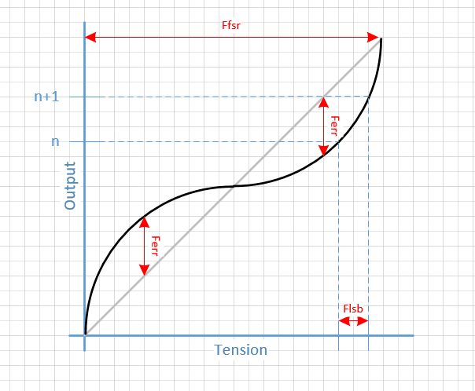

# Data format and storage capacity

# Cost

See: le_nb_iot_controller_current_consumption.xlsx.

# Deliverables

# Module Background

This module is based upon the LPWAN SRD: ..\LE_LPWAN_SYSTEM\doc\lpwan_system_requirement.docx

## Initial coverage

Wish from :

Lastcelle i høyspentmast :

|  |  |
| --- | --- |
| **NORD** | 60.1889461  60° 11.3367684'  60° 11' 20.2061'' |
| **ØST** | 6.2401207  6° 14.4072426'  6° 14' 24.43455'' |

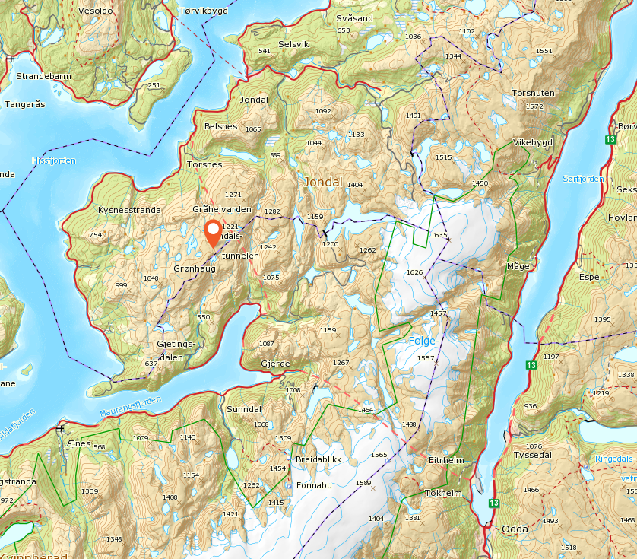

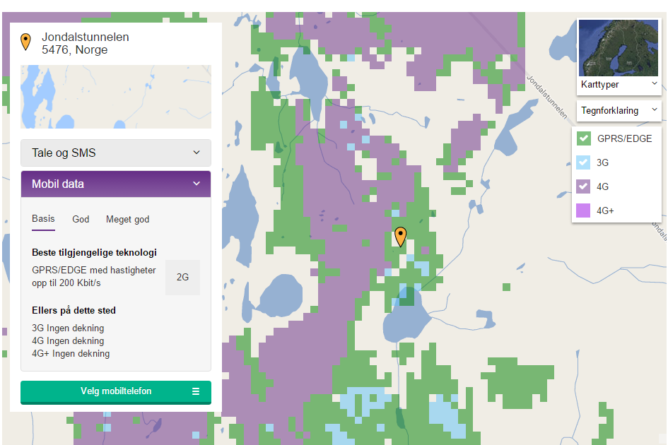

Mulig prøvespenn:

|  |  |
| --- | --- |
| **NORD** | 60.1616694  60° 9.7001652'  60° 9' 42.00991'' |
| **ØST** | 6.1779481  6° 10.6768846'  6° 10' 40.61308'' |

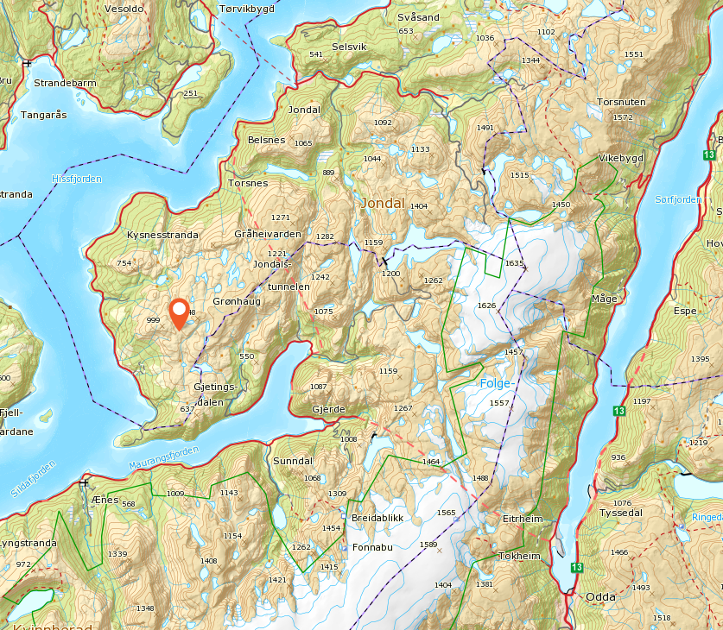

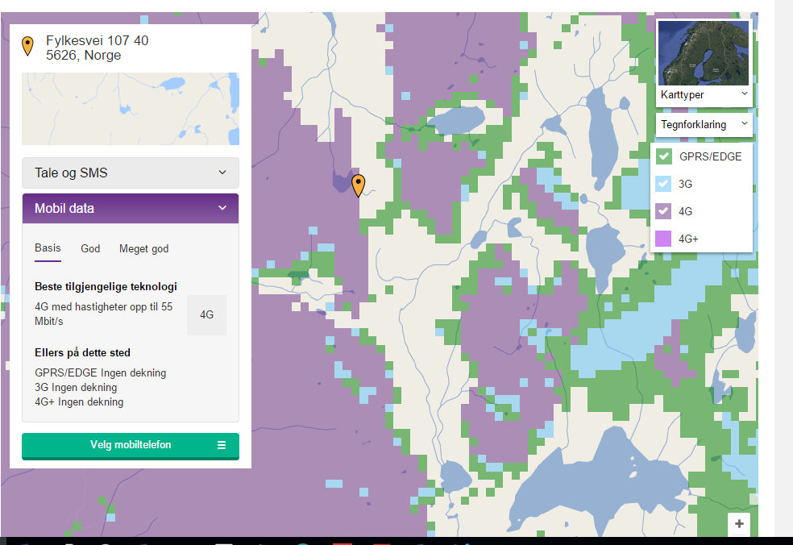

# Control Modes

Table 6: States

|  |  |  |  |  |  |  |
| --- | --- | --- | --- | --- | --- | --- |
| **Inputs** | | | **Outputs** | | |  |
|  |  |  |  |  |  | **Comments** |
|  |  |  |  |  |  |  |
|  |  |  |  |  |  |  |
|  |  |  |  |  |  |  |
|  |  |  |  |  |  |  |
|  |  |  |  |  |  |  |

Table 7: Calibration

|  |  |  |  |
| --- | --- | --- | --- |
| **Signals** | **Descriptions** | **Settings** | **Results** |
|  |  |  |  |
|  |  |  |  |
|  |  |  |  |
|  |  |  |  |
|  |  |  |  |

# Operation system description

AT commands are listed in: quectel_docs\Quectel_BC95_AT_Commands_Manual_V1.0.pdf

## Block diagram



## Operation system overview

tbd

## Error messages

Tbd.

## Init master

MCU setup

## Measure master

MCU measure

## Init RF

### Power on and HW reset

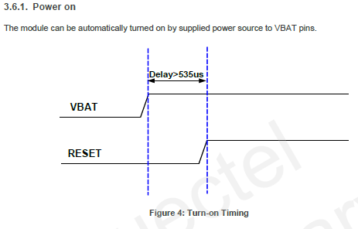

### Init ID

## Tx RF

## Rx RF

## Schematics

<Delete this text and paste snapshots of the schematics here (max recommended width on pictures is 25cm)>

# Test Plan

Table 8: Test conditions

|  |  |  |  |  |
| --- | --- | --- | --- | --- |
| **Temperature** |  |  |  |  |
|  |  |  |  |
| **Supply** |  |  |  |  |
|  |  |  |  |
| **Load** |  |  |  |  |
|  |  |  |  |

## Test Modes for this Module

<Explain clearly what kind of test modes are implemented in the module>

## Prototype Verification and Characterization

<Explain clearly how the prototype should be verified and characterized. List and sequence the signals that should be applied for each parameter>

## Production Test

<List and explain the tests that should be carried out in production to be able to catch the defective devices.>

## Probe Points

<Delete this text and paste the layout snapshot picture with marked probe points>

Figure 1 : Probe points on the module.

Table 9: List of probe points

|  |  |  |
| --- | --- | --- |
| **Probe point #** | **Node** | **Test usage** |
|  |  |  |
|  |  |  |
|  |  |  |
|  |  |  |
|  |  |  |

1. Information labelled on the load cell.
2. 5V is explicitly written, but there is a figure of common mode range where the supply is +-2V.
3. 1 second for wave/resonance detection. Is this the same measurements that the accelerometer should measure?
4. Current iokeys minimum setting, with 18 hours at max.
5. Adding more battery capacity for safety.
6. Adding more battery capacity for safety.
7. <1mV for a 100mV noise @ vref=1V and 10 bits ADC.