Colin Grundey

Principles of Computer Security

Programming 2

**Task 1: Encryption using different ciphers and modes**

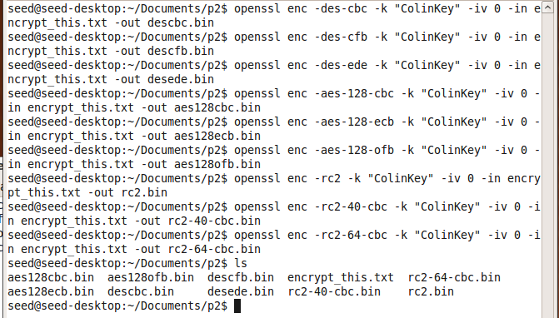

**Task 2: Encryption Mode – ECB vs. CBC\**

Commands used:

1. openssl enc -aes-128-ecb -e -in pic_original.bmp -out task2ecb.bmp -K 00112233445566778889aabbccddeeff -iv 0102030405060708

2. openssl enc -aes-128-cbc -e -in pic_original.bmp -out task2cbc.bmp -K 00112233445566778889aabbccddeeff -iv 0102030405060708

Original ECB CBC

When using AES-128-ECB encryption mode, the bitmap image is somewhat distinguishable when restoring the original header to the encrypted file. However, AES-128-CBC mode does not leave any trace of the original image after restoring the original header. This shows how ECB is not as strong an encryption mode as CBC is due to the chain method used in CBC.

**Task 3: Encryption Mode – Corrupted Cipher Text**

1. ECB: 14 incorrect characters

CBC: 16 incorrect characters

CFB: 17 incorrect characters

OFB: 2 incorrect characters

1. ECB and OFB have the fewest incorrect character count because they are the least secure modes. ECB doesn’t have any feedback for a chain encryption technique. OFB has a simple output feedback for subsequent block ciphers. CBC and CFB are a little more involved, causing the algorithm to fail more when a single byte is modified. Their feedback mechanisms allow the algorithm to generate a more secure encryption, thus the decryption isn’t as successful with ciphertext that has errors.
2. The less errors there are means that two files that differ in one byte can be decrypted to a very similar output. This shows the weakness in the modes because the output should differ more given even a small change or error in the ciphertext.

**Task 4: Guessing the Key**