Colin Grundey

Digital Design I

Homework #4

**Problem 1:**

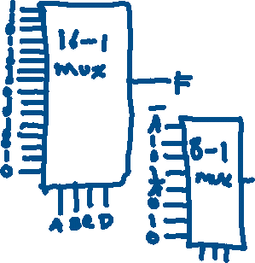

**Problem 2:**



The code below shows my implementation for a 4-to-16 decoder and the function given in problem 1. I also created a test bench to produce the waveforms shown below.

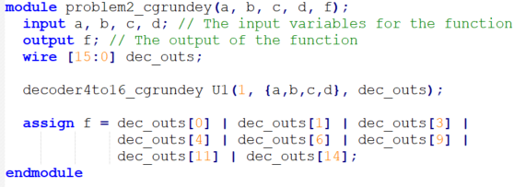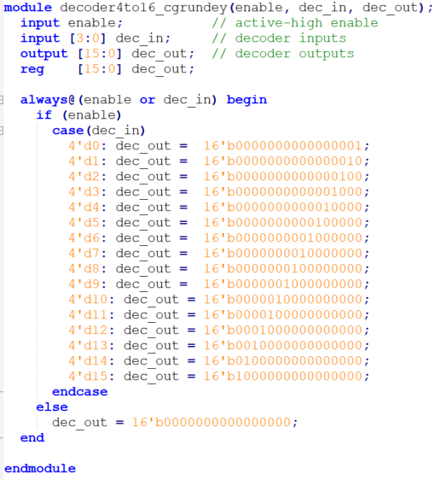

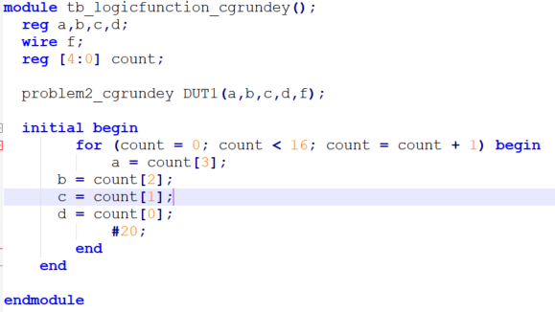

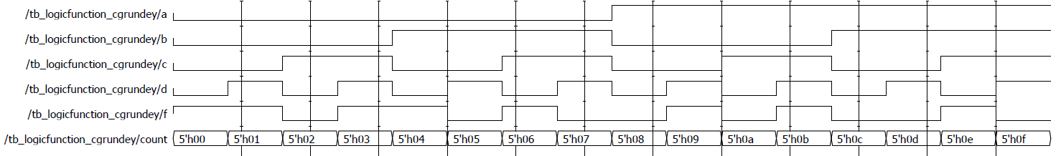

**Problem 3:**

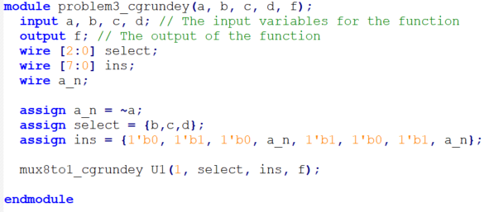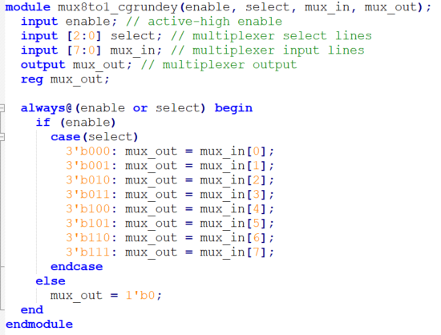The code for my implementation of a 8-to-1 multiplexer and the function described in problem 1 is shown below along with the test bench and waveform output.

