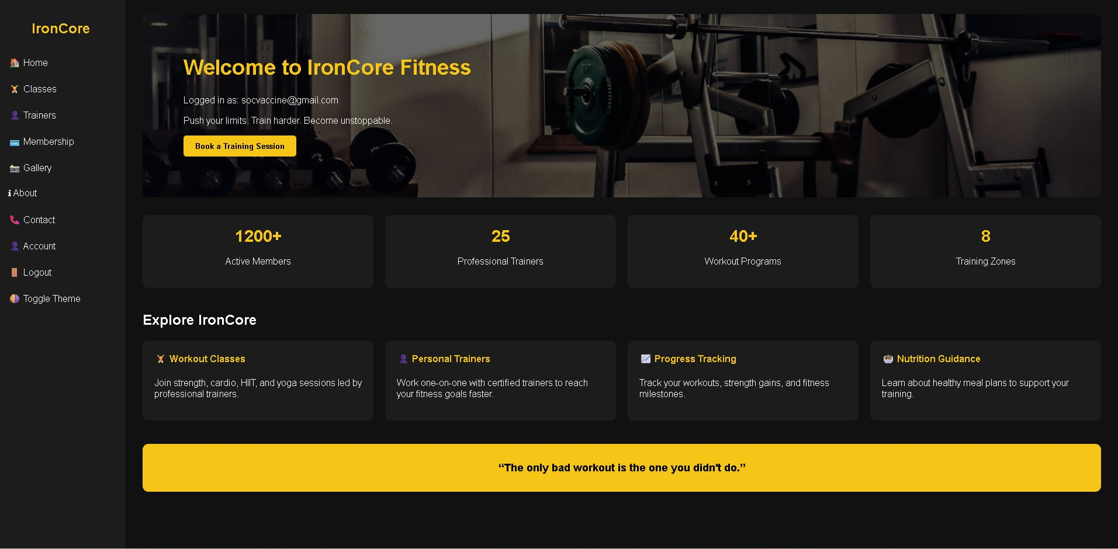
Personal Trainers
- Work one-on-one with certified trainers to reach your fitness goals faster.
Gallery
- Browse photos of our gym facilities, equipment, training sessions, and fitness community. See the environment where members train, improve, and stay motivated.

Membership
- Join our gym with flexible membership plans that give you access to equipment, fitness classes, and professional training support.
Workout Classes
- Join strength, cardio, HIIT, and yoga sessions led by professional trainers.
IronCore Fitness
Home Contact Gallery About

