**How to Write a Python Script to Add Users Via Pagerduty’s REST API**

This tutorial is used to manually create a python script to add multiple users to an existing Pagerduty Account.

1. Store your Pagerduty account’s API key located in **Configuration 🡪 API Access**
2. On the command terminal, create a folder to store a .csv file containing user data and a python script.
3. Create a *users.csv* file to store user data with the following syntax:

name,role,email

Example:

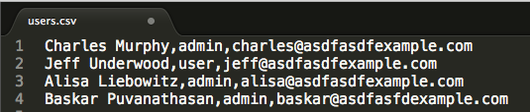

*\* Make sure that there are no spaces between commas*

1. Create a *create_users.py* file and open in a text editor.
   1. Import the following libraries to be used in this script:
      1. Requests – used for making API calls
      2. Json
      3. CSV – to parse .csv file data
      4. Sys – to extract user input from command line

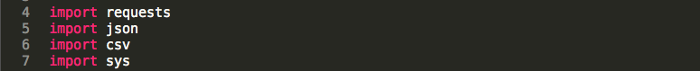

* 1. Store the Pagerduty REST API endpoint.

  :Users:charlotte:Desktop:Screen Shot 2017-12-11 at 2.11.53 PM.png

* 1. Write the snippet of code below that allows input from the command terminal to be stored as usable data when the python script is run.

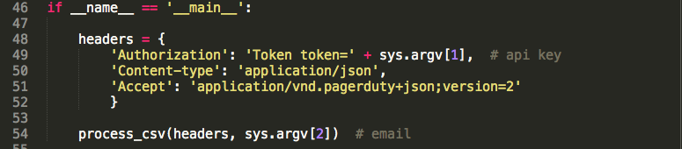*As you can see, the HTTP Request Headers are included to be passed into the process_csv function (that you will write in the next step).*

* 1. Write a function that parses the .csv file.

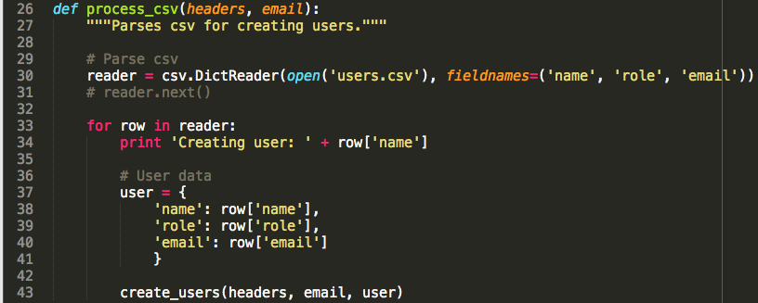

* 1. Write a function that makes an API call to Pagerduty’s REST API endpoint.

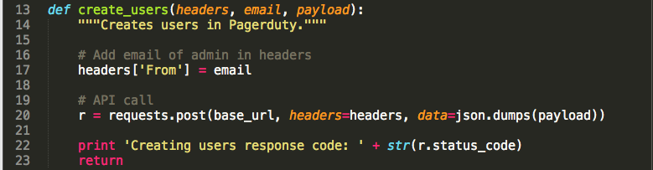

1. Save your python script, and type the following command into the command terminal to execute the script:

*python create_users.py [api key from Step 1] [your email]*

Example:

*python create_users.py R9r6tRWcz3cx7vHgyqAY sarfati.charlotte@gmail.com*