python train.py
python train_streamlit.py

mlflow ui
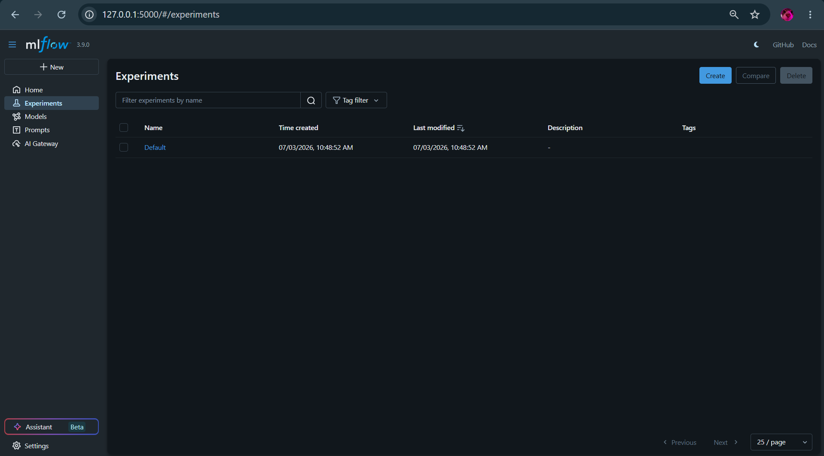
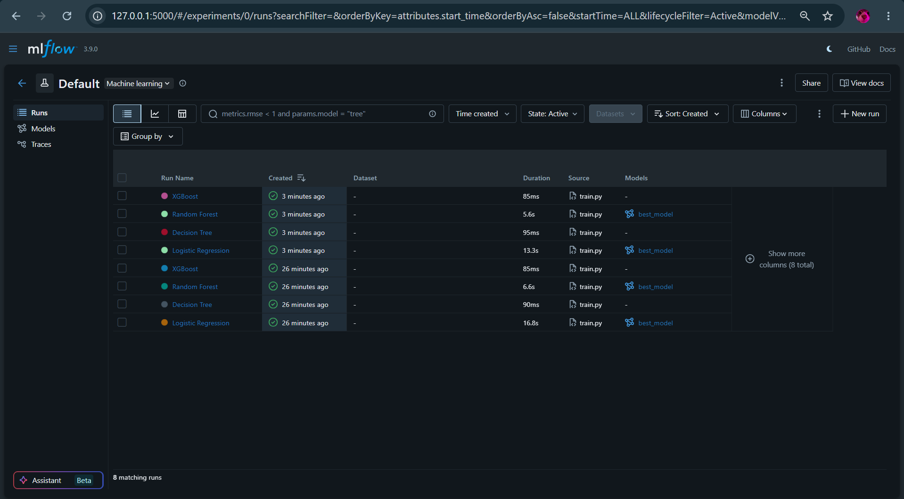
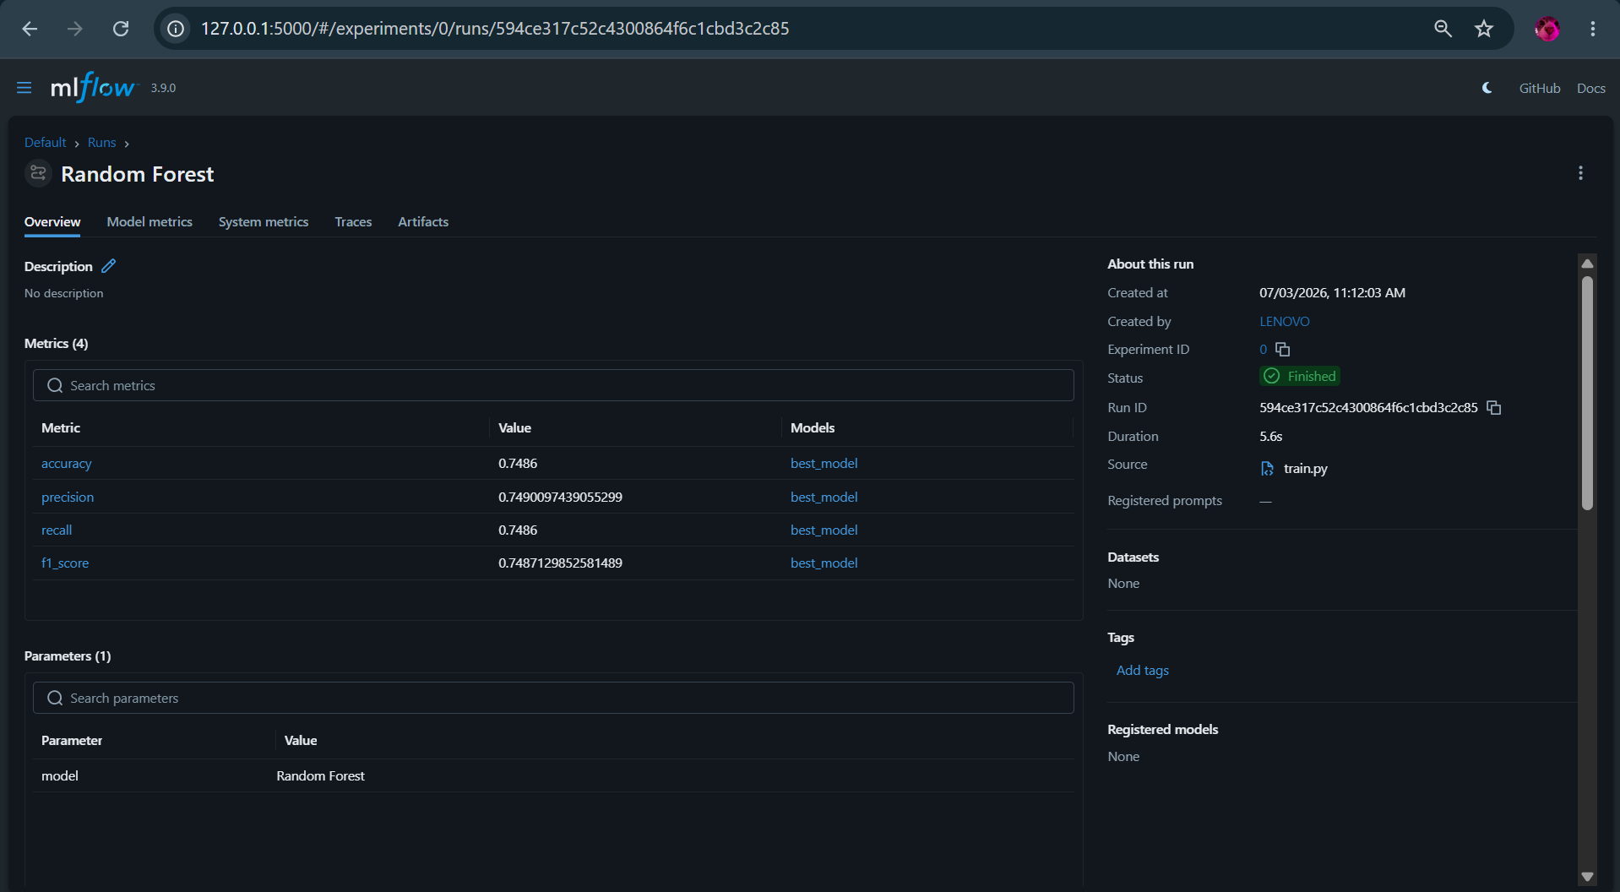
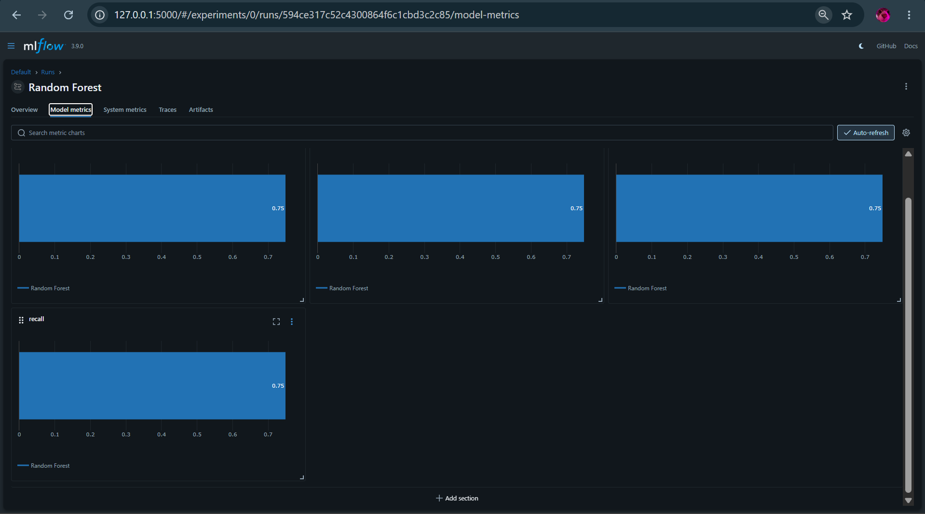
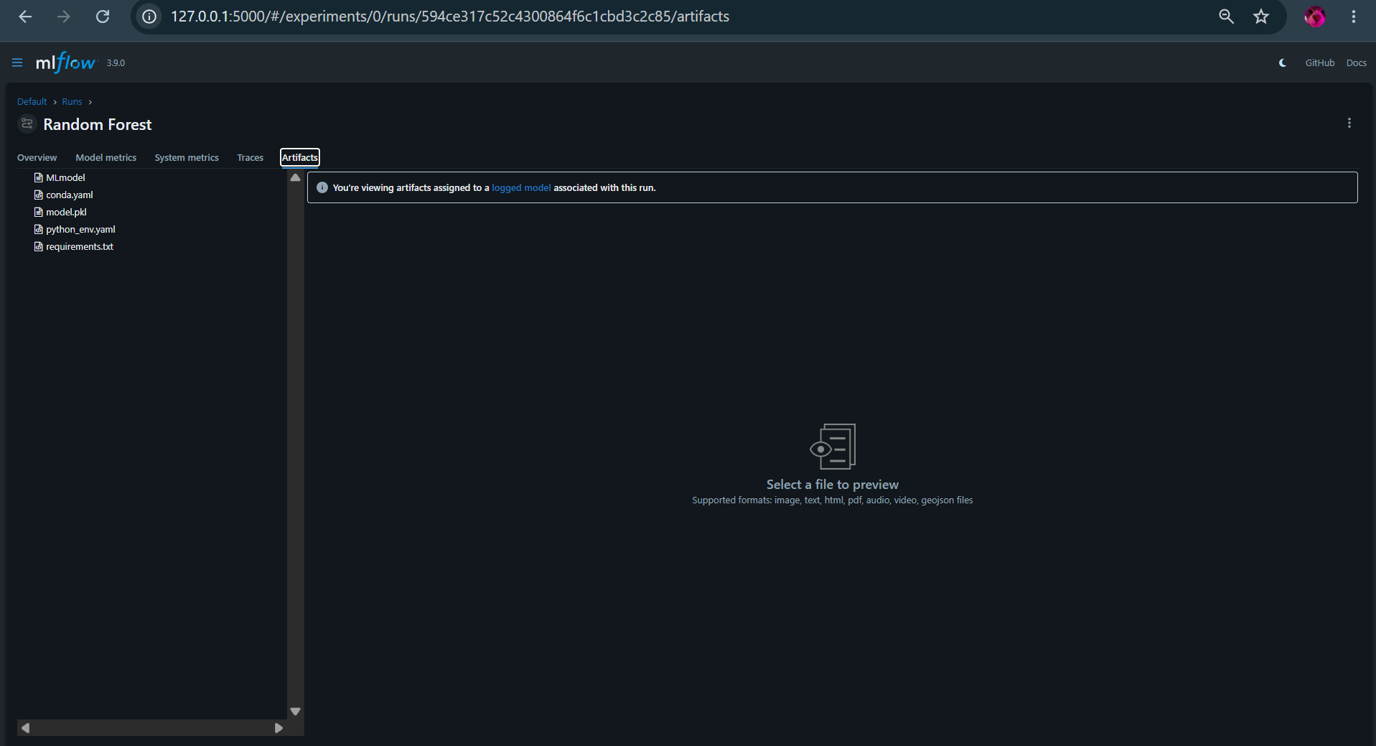

run app/streamlit_app.py
STREAMLIT TEST CASES

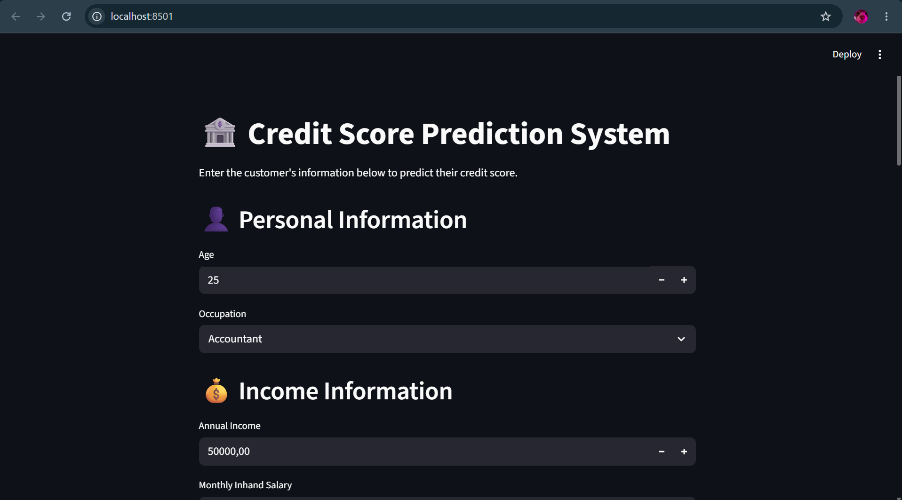
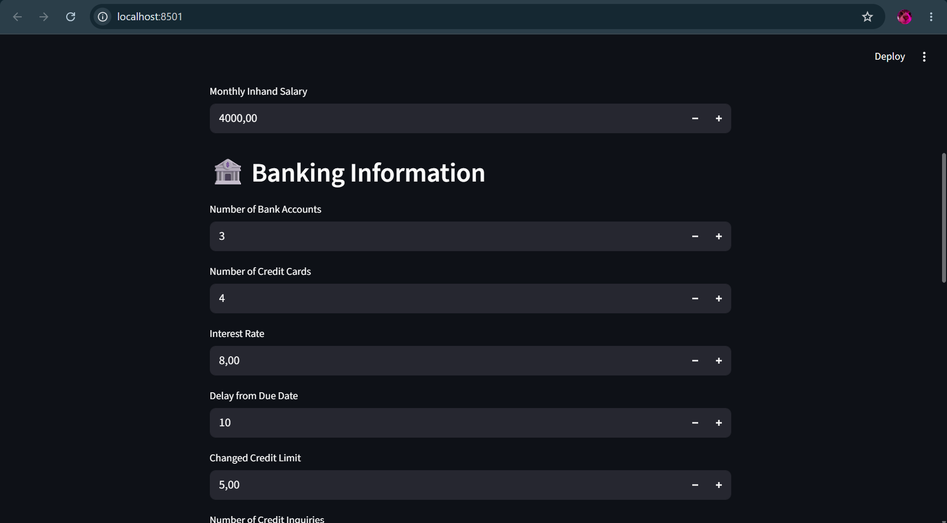
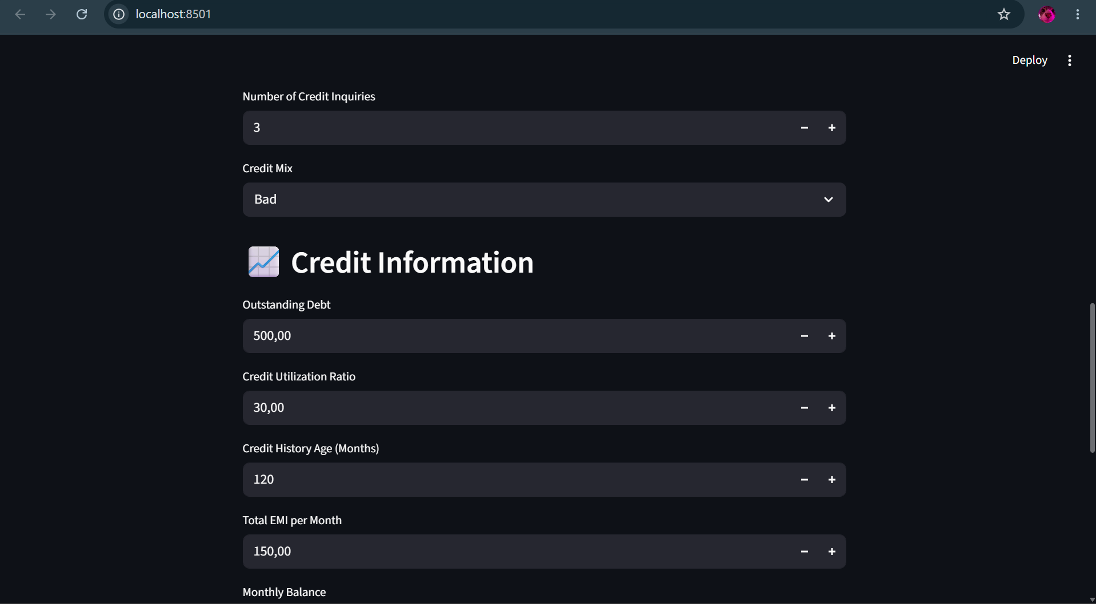
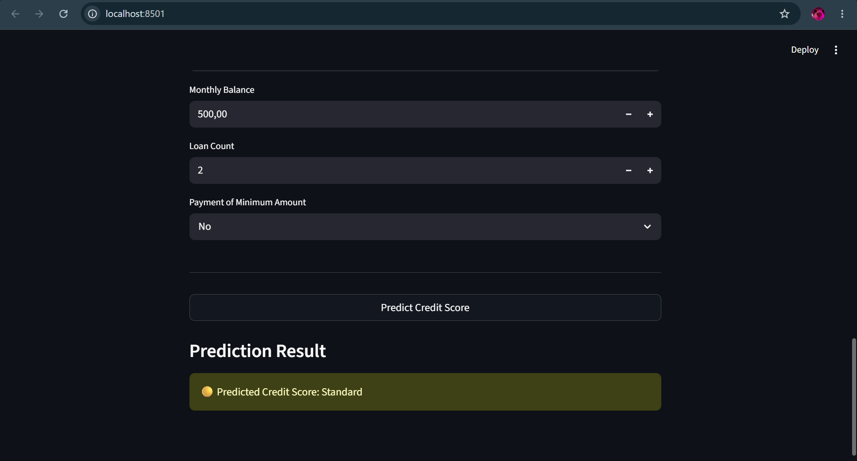

Test Case 2:
Age: 22
Occupation: Mechanic
Annual Income: 15000
Monthly Inhand Salary: 1000

Num Bank Accounts: 1
Num Credit Cards: 0
Interest Rate: 35
Delay from Due Date: 60
Changed Credit Limit: -5
Num Credit Inquiries: 10

Credit Mix: Bad
Outstanding Debt: 5000
Credit Utilization Ratio: 95
Credit History Age: 12
Total EMI per Month: 900
Monthly Balance: 50
Loan Count: 6
Payment of Min Amount: Yes
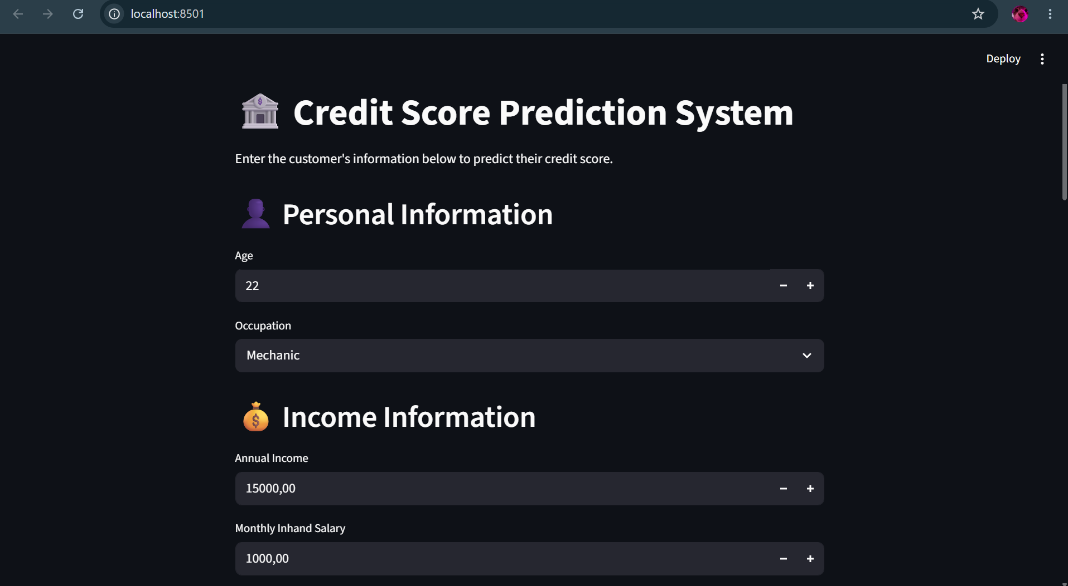
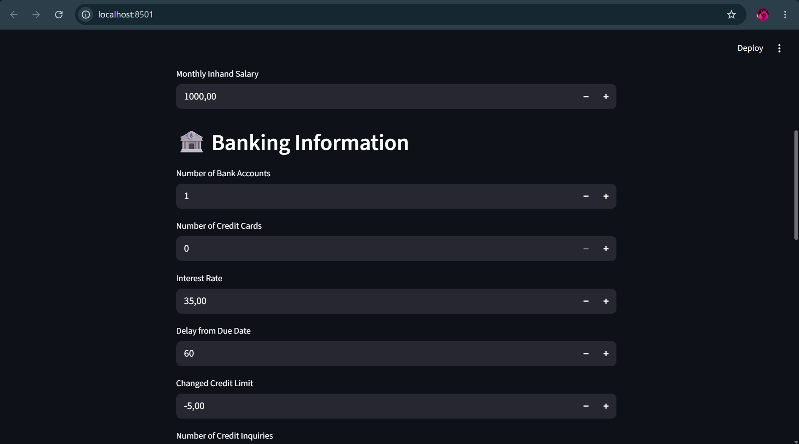
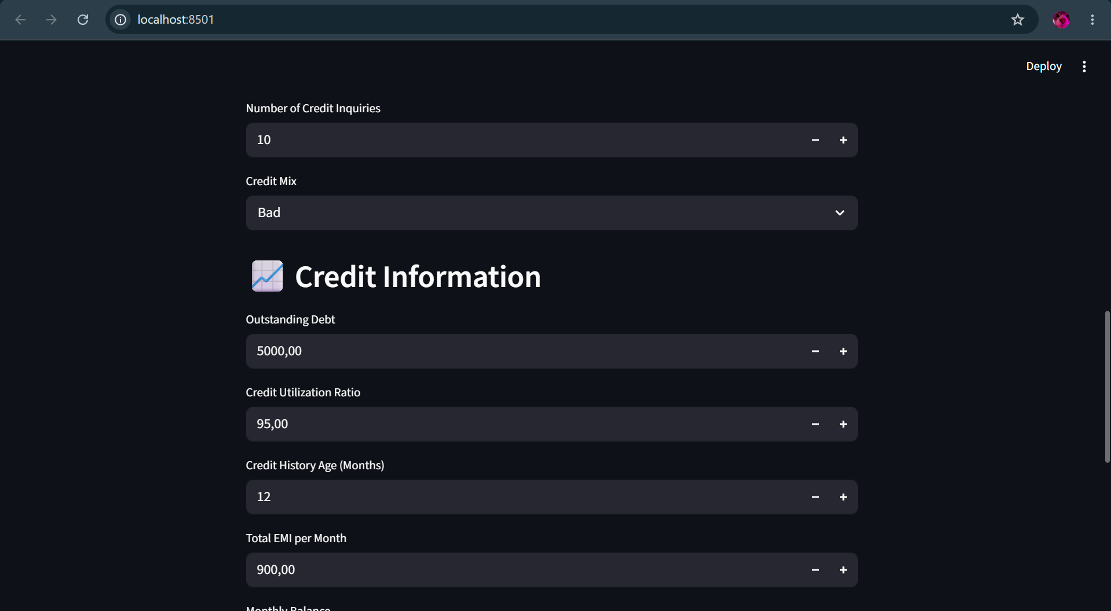
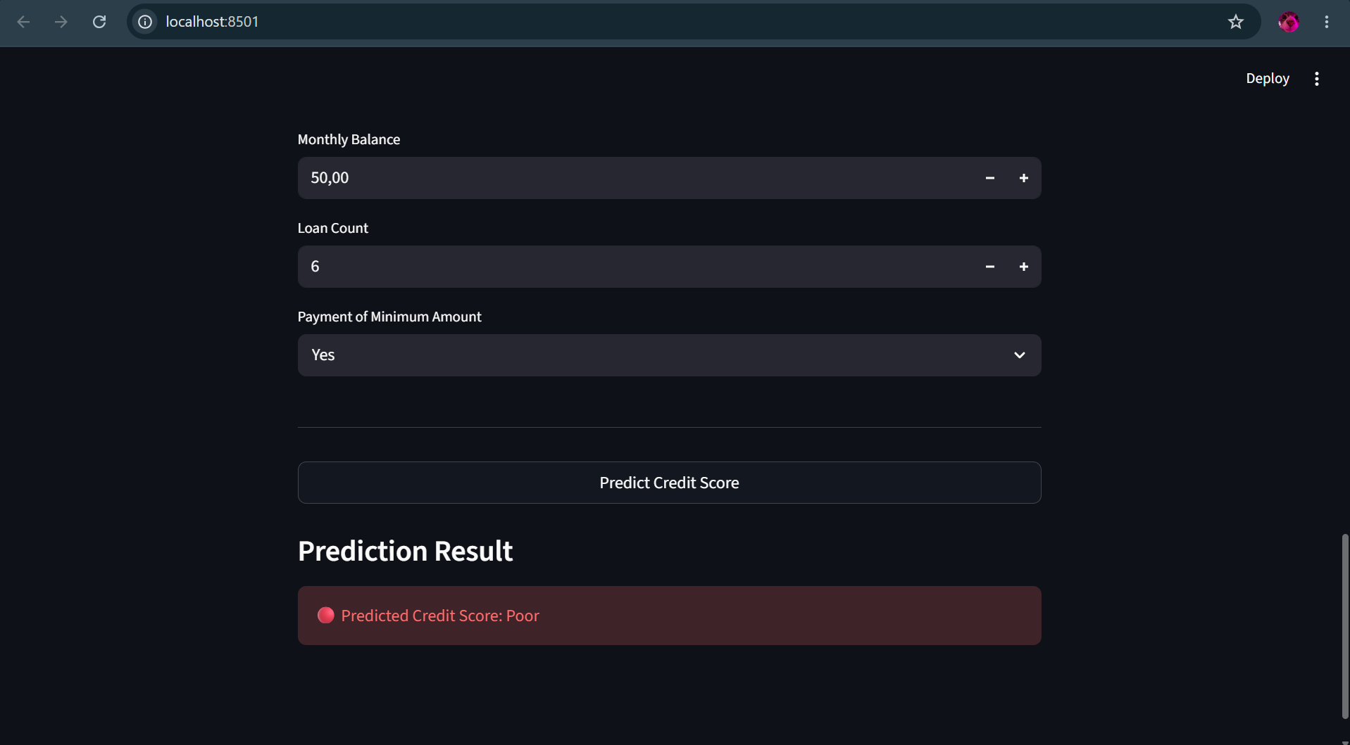

Test Case 3
Age: 35
Occupation: Engineer
Annual Income: 120000
Monthly Inhand Salary: 9000

Num Bank Accounts: 5
Num Credit Cards: 4
Interest Rate: 6
Delay from Due Date: 0
Changed Credit Limit: 10
Num Credit Inquiries: 1

Credit Mix: Good
Outstanding Debt: 500
Credit Utilization Ratio: 20
Credit History Age: 180
Total EMI per Month: 200
Monthly Balance: 3000
Loan Count: 1
Payment of Min Amount: No

