# Avnet Reporter Documentation

Team SIGSEGV, Christopher Thornton

## Getting Started

Once you launch the application for the first time, you will be prompted to import report data for the first time. Make sure you have uploaded report data to the **/mnt/sdcard/Download** folder.

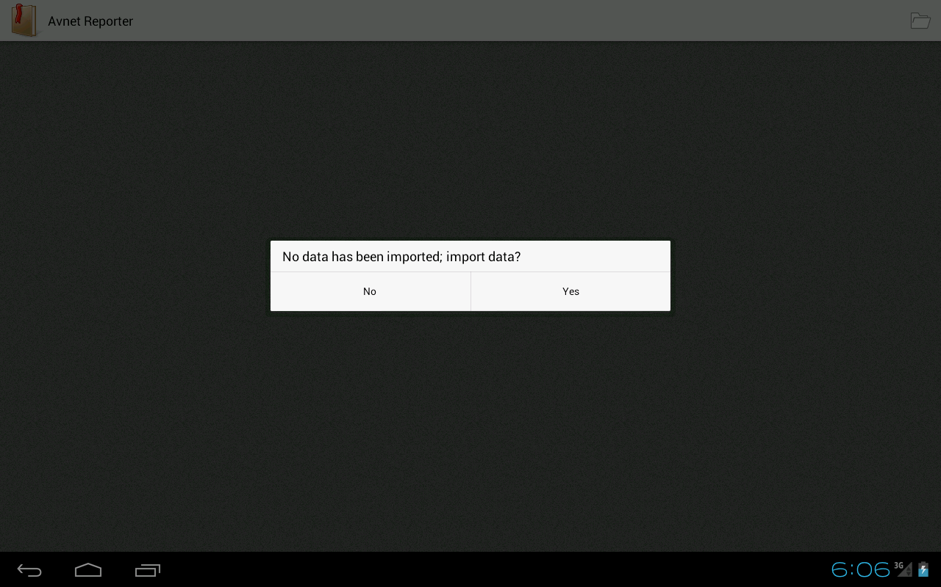

## Importing Data

Make sure you have uploaded the report data to the **/mnt/sdcard/Download** folder. Select the file you wish to import and then select the *“Import Data”* button. You may browse to another app during import.

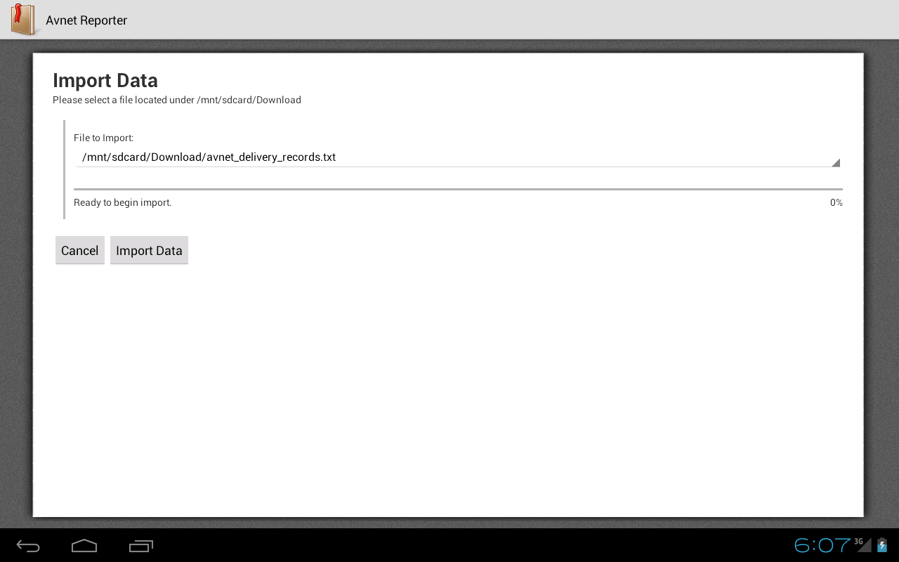

Import may take several minutes to complete. You may cancel the import at any time, which will result in partial report data. A notification will be sent upon completed import.

## Using the Application

After importing data, you are now ready to use the application. The application is configured to be view only in landscape mode. You may re-import data any time by clicking the folder icon on the top-right of the application.

Select a menu item to the left to display a particular report.

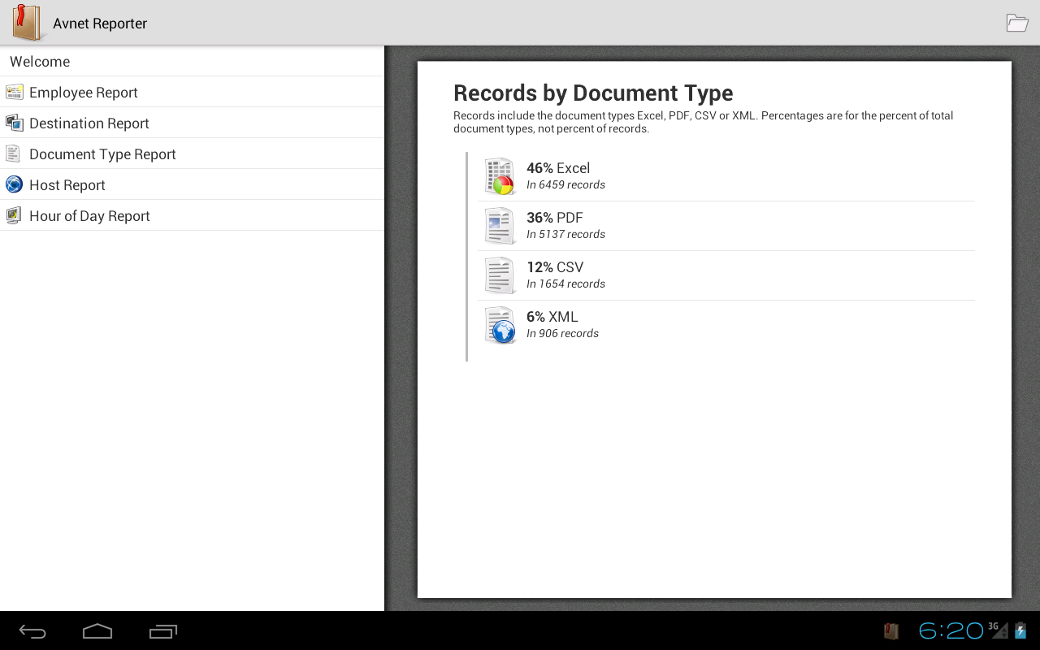

If you have any questions, please email Christopher Thornton at [cgthornt@asu.edu](mailto:cgthornt@asu.edu)