The Great Devonian Controversy – Similarity, Groups & Polarization

Motivation
- During the Great Devonian Controversy (GDC), participants inferred different hypotheses about the age of all the older strata in Devonshire from evidential beliefs.
- During the GDC, many of the participants' evidential beliefs have changed.
- In the end, there was a consensus between the main participants, not only regarding the dating of all the older strata but also most of the evidential statements.

Main Question of Interest: How did the main participants change their evidential beliefs so that they finally reached a consensus?

Consensus Dynamics

The GDC is a exceptionally-well documented scientific debate among 19th century geologists about the dating of all the older strata in Devonshire. [2] recreates this debate as a narrative and delineates consensus and consensus dynamics as follows:

- First, there is a dissensus dividing participants into two parties facing each other rather irreconcilable.
- As the GDC evolves, with new evidence popping up, some kind of middle ground seems to emerge.
- Finally, there is a consensus between most of the main participants which is no mere compromise but nevertheless incorporating beliefs from both parties.

In [2], consensus dynamics are plotted in a schematic chart (Fig 15.5). However, this plot seems in need of some make-over. While the x-axis shows unambiguously time, it is rather unclear what the y-axis actually shows. It is denoted as “an unquantifiable impression of theoretical distance” (S.412/3 in [2]).

I try to improve this plot this by reconstructing the debate at several time steps using the theory of dialectical structures, identifying positions and calculating degrees of similarity between them with a suitable similarity measure. As a last step, groups of positions are identified using a similarity threshold and polarization is assessed using 4 different concepts of polarization taken from [1].

Note: A position is a participant’s a dating hypothesis together with its body of evidence. Bodies of evidence, unlike dating hypotheses, are relying heavily on the reconstruction.
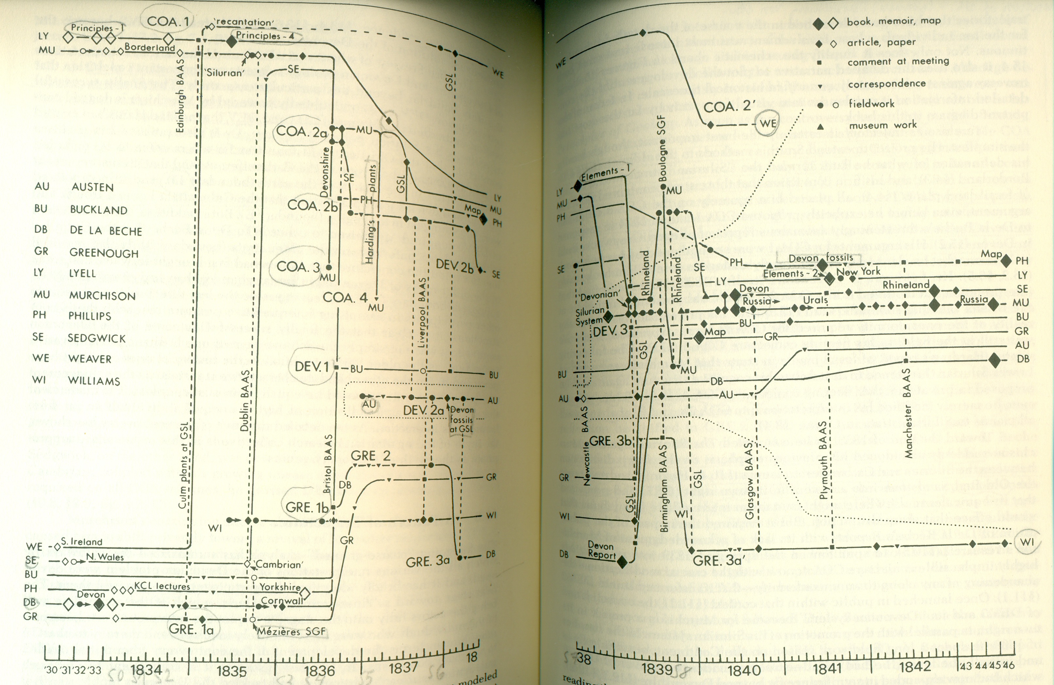Illustration 1: Consensus Dynamics as Shown in [2] (FIG 15.5, 412/3)

Reminder – Definition Similarity
Similarity between two bodies of evidence respectively dating hypotheses
For two sets of statements, let |C| ,|S| and |A| denote the number of contradictions, judgment suspensions and agreements, respectively. ranges from 0 to 1.
Two dating hypotheses are more similar if they share more atomic dating hypotheses. Two dating hypotheses are maximally similar, if there is nothing but agreement. Two dating hypotheses are minimally similar, if there is nothing but contradiction.
Example: Similarity Between Dating Hypotheses
,
,

Here, it holds that and .

Two bodies of evidence are more similar if they share more evidential beliefs, that is, there are less contradictions or less judgment suspension. These two cases are weighted differently. Two bodies of evidence are maximally similar, if there is nothing but agreement. Two bodies of evidence are minimally similar, if there is no agreement. (Cases of no agreement include (i) cases with nothing but contradictions, (ii) cases with nothing but judgment suspension and (ii) cases with contradictions as well as judgment suspensions)
Example: Similarity Between Bodies of Evidence
,
,

,

Here, it holds that and .

and are similarity measure. The corresponding distance measures are just given by and , that is

is a normalized Hamming distance. Despite similarities, is not a normalized edit distance with weights and .
Note: In order to facilitate comparison between and , presume no weights and no normalization, that is

- For two positions and with :

Note: For two positions and , can be obtained from and vice versa in steps of adding, removing or switching a judgment at a time. If , then, for two positions and with :

Example 1: There are two positions and z with :

There are contradictions and judgment suspensions, that is . Further, can obtained from and vice versa in steps.

2 addings
5 switches
4 removals

2 removals
5 switches
4 addings

However, the fastest way getting from to and vice versa would be in steps, that is . Therefore, .

Similarity Results
For two persons and , the similarity between their dating hypotheses respectively bodies of evidence is assessed, that is respectively is calculated. For each time step, there is a heat map showing (lower triangle) and (upper triangle) for all persons participating at that time.

Illustration 1: For two persons, similarity between dating hypotheses (upper triangle) respectively bodies of evidence (lower triangle)

Three Group Definitions in Terms of Similarity Thresholds

If persons form a group , then there are 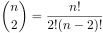 two-elements subgroups. For each of these subgroups, the corresponding condition applies.

Examples for :

- Persons 1 and 4 form a -group, iff
- Persons 1, 4 and 5 form a -group, iff
    - ,
- Persons 1, 4, 5 and 6 form a -group, iff
  - ,
  - ,
  - ,
  - ,
- Persons 1, 3, 4, 5 and 6 form a -group, iff
    - ,
    - ,
    - ,
    - ,
- Persons 1, 2, 3, 4, 5 and 6 form a -group, iff
    - ,
    - ,
    - ,
    - ,

Groups have been identified for each time step after individual belief changes, that is .

Caveat
Using a threshold is somewhat arbitrary. Therefore, results are compared for three different thresholds.

Results

Groups
Table 1:
Time | Persons
1b | 1,2,3 | {3,2} | - | -
2b | +4 | {3,2}, {4,1} | {4,1} | {4,1}
3b | +5 | {2,3,5}, {4,1} | {1,5,4} | {4,1}
4b | - | {3,2},{5,4} | {4,1}, {5,4} | {5,4}
5b | - | {3,2}, {5,4} | {4,1} | -
6b | +6 | {2,3,4,6} | {6,1},{6,4} | {6,4}
7b | - | {3,2},{6,4} | {3,2},{6,4},{6,1},{6,5} | {3,2},{6,4}
8b | - | {1,2,3,4,5,6} | {1,4,5,6},{2,3} | {1,4,5,6},{2,3}

Table 2:
Time | Persons
1b | 1,2,3 | {3,2} | - | -
2b | +4 | {3,2}, {4,1} | {4,1} | {4,1}
3b | +5 | {2,3,5}, {4,1} | {1,5,4} | {4,1}
4b | - | {2,3,4,5} | {1,4,5} | {4,5}
5b | - | {3,4,5}, {3,2} | {1,4,5} | {4,5}
6b | +6 | {2,3,4,6}, {2,3,4,5} | {1,4,5,6} | {6,4}
7b | - | {2,3,6}, {6,4},{6,5} | {3,2},{4,5,6},{6,1} | {3,2}, {6,4}, {5,4}
8b | - | {1,2,3,4,5,6} | {1,2,3,4,5,6} | {1,2,3,4,5,6}

Table 3:
Time | Persons
1b | 1,2,3 | {3,2} | - | -
2b | +4 | {3,2}, {4,1} | {4,1}, {4,2}, {3,2} | {4,1}, {3,2}
3b | +5 | {2,3,5}, {4,1} | {1,3,4,5}, {2,3,4} | {4,1}, {2,3}, {3,5}
4b | - | {2,3,4,5} | {1,4,5}, {2,5}, {2,3}, {1,3} | {4,5}, {2,3}, {2,5}
5b | - | {2,3,4,5} | {1,4,5}, {3,2}, {2,5} | {3,2}, {2,5}, {4,5}
6b | +6 | {2,3,4,5,6} | {1,4,5,6}, {2,3,5} | {2,3,5}, {4,5,6}
7b | - | {2,3,4,6},{4,5,6} | {2,3,6}, {1,4,5,6} | {2,3,6}, {4,5,6}
8b | - | {1,2,3,4,5,6} | {1,2,3,4,5,6} | {1,2,3,4,5,6}

Polarization
Based on such a table, the following questions can be answered for each time step:
- How many groups can be defined? How many subgroups can be maximally defined? (Community fragmentation)
- How are participants distributed over groups? Are all groups more or less comparably sized? Or is there one dominant group? (Size parity)
Based on such a table and the specific similarity measure SIM, the following questions can be answered for each time step (Definition of SIM, see below):
- To what extent do positions of members of the same group differ? (Group Consensus)
The difference can be assessed by respectively .
(This means that two persons differ (i) in respect to , if there are contradictory atomic dating beliefs, (ii) and in respect to , if there are contradictory evidential beliefs or abstentions.)
- Are there shared beliefs between members of different groups? (Distinctness)
Two persons share no belief at all iff . It shows that this is never the case, even between members of different groups.
According to [1], community fragmentation, size parity, groups consensus and distinctness are four definitions of polarization (in terms of groups).

Bibliography
[1] Aaron Bramson, Patrick Grim, Daniel J. Singer, William J. Berger, Graham Sack, Steven Fisher, Carissa Flocken, and Bennett Holman. Understanding polarization: Meanings, measures, and model evaluation. Philosophy of Science, 84(1):115–159, 1 2017.
[2] M. J. S Rudwick. The great Devonian controversy the shaping of scientific knowledge among gentlemanly specialists. University of Chicago Press, Chicago, 1988. ISBN 978-0-226-73100-1.

