Coffee Matcher

An idea to demonstrate and improve my JavaScript knowledge

The user gets asked questions/some form of input text or prompt/selection of options – radio buttons, once user has picked from options available show them a list of results based on their preferences.

Show a photo with the description of the coffee show a map with the location of nearby coffee shops with their contact details/information of opening hours etc – geolocation API – privacy control to turn off if user wants to.

Need to think about UI/UX and how it is all going to work – a selection of text input questions?

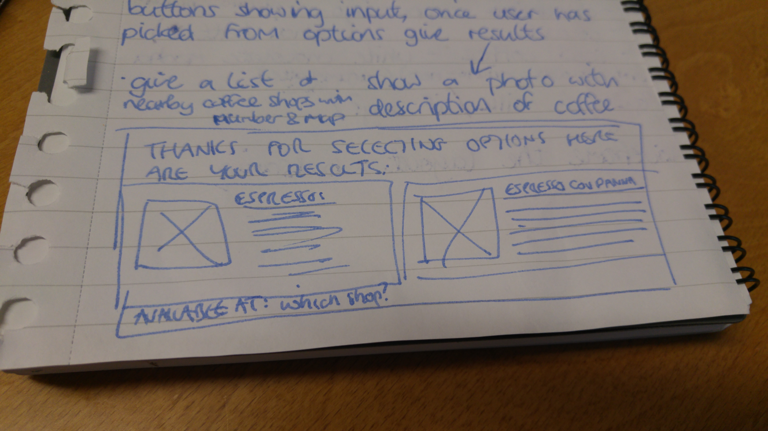

Questions/options

Hot or cold drink
Strong coffee or decaffeinated
Do you take milk? If so what type? Skimmed/whole/soya

List of coffees and history behind them:

Espresso/espresso con panna/macchiato/ristresso
Americano – black or white
Latte – what type of milk? How many shots of coffee? Any flavoured syrup?
Cappuccino – chocolate or cinnamon on top
Flat white – type of milk? Cortissimo coffee shot
Mocha/mocha latte/white chocolate mocha
Cortado/mocha cortado – type of milk?
Iced coffee

Research the origins. Include did you know fact about each coffee?
Type of beans used/where are they sourced?

