https://storymaps.arcgis.com/stories/2567a23a2da8449b952a7dd297daaf00

Proposed workflow for Tapari’s story

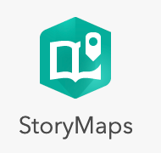
Go to ArcGIS.com and login using the university information.

Open the gallery in the upper right hand corner (left of your account information). Find the StoryMaps icon and open Story Maps. This brings you to a Content page. Click on the button + Create, and select the first option Story

TITLE

Give the story a unique title

[Your Name’s] Story - On the Road to Healing
The Via Tecta of the Asklepieion near Pergamon

Choose Add a cover image – add an image, e.g. starting with a 1 from the image folder.

Go to the option Design at the top – choose a layout, turn the option Navigation on (this adds shortcuts) under Optional story sections, and select a Theme.

Block 1 - Abstract

Starting the Story Map with a short blurb helps draw the reader in – add the first paragraph, and italicize it to emphasize it.

Block 2 – First block of text

The Asklepieion of Pergamon

Now add the next block of text, starting with the title. Set this as Heading 1. If you turned the Navigation option on, you will see now see this as a menu button towards the top of the page.

Now add an image – e.g. ‘2_Asklepieion_overview.jp’ from the image folder.

Then add the paragraph, telling about the Asklepieion.

Block 3 – Next block with map features

You can do similar actions with subsequent blocks. But for now we will focus on the mapping element.

SIDECAR
To narrate the story of Tapari and her journey to the Asklepieion we decided to use a sidecar.
The main media is the background behind the panel. It is meant to create a backdrop related to the story narrated through the text. The main media is image or video, map, embed, swipe and color (which creates a monochrome background). You can alter the appearance of the panel, certain color in the background and letters, positions of the panel and the size. In the panels you can add text as well as media such as map, map action, image, video, audio, embed and timeline. Map action is only active if the main media is a map.
For the first paragraph of Tapari’s journey, we create a sidecar slide with the main media a map.

3.1 SLIDE 1

Tapari and her journey to the Asklepieion

In the box ‘Continue your story’, copy the text. Format the title as Heading 1, this adds it to the menu bar at the top.

Click ‘Add’ at the top of the screen – select the 3rd option ‘Map’. This brings you to a new page

Create a new express map.

Go to ‘Options’ (gear wheel) and select a better basemap. Instead of Newspaper, choose the satellite image called Imagery as a basemap.

- Search by location: Asklepieion, Pergamon, Izmir.
This brings you to the area. You can save this mark on the map ‘Add to map’

3.1.1. Add a point on the hill of the city of Pergamon.
Use the tool “add a point” and put a point on the top of the Pergamon hill.
To edit the points, go to layers, name the new layer “Pergamon”, add an image (I selected the iDAI map with the features of the city), wait till the program has added the image (if you don’t it might crash down) and save.

2. For the Asklepieion we will create an outline of the site.
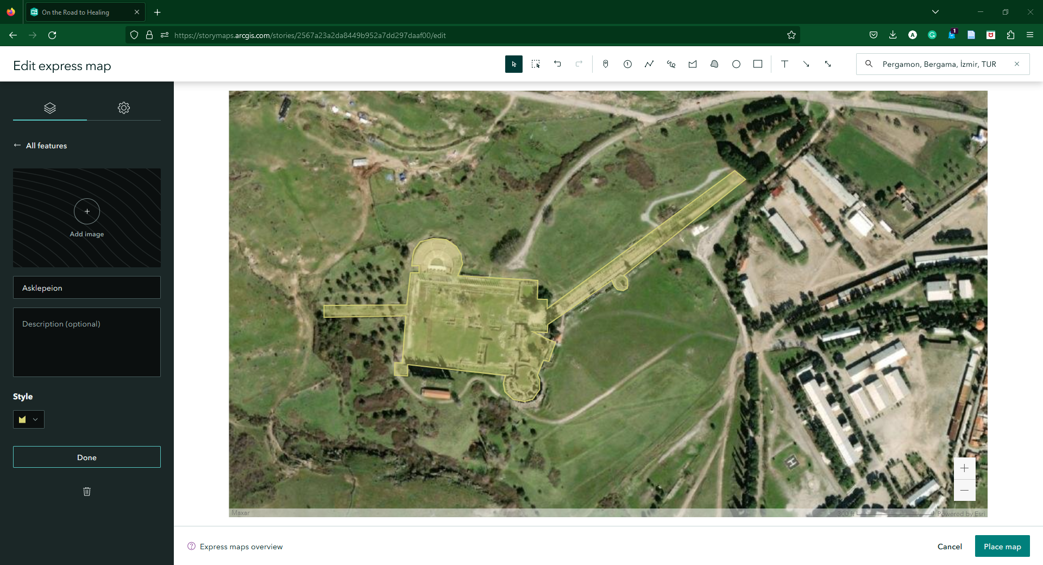
Select the tool “draw an area”, follow the outline of the Asklepieion by clicking points, to finish the shape double-click the last point. You can add more points once the shape is completed. Do not work on this in very zoomed in version. Name the layer Asklepieion and alter the color however you see fit.

3. Add point for the South Parodos of the Theater
The theater is the green area on the E of the Asklepieion. Use the tool “add a point”, add a picture and in the description add this link: https://www.dainst.blog/transpergmikro/the-largest-theater-in-ancient-asia-minor-rediscovered/ .This link will will appear as a read more link and then it will redirect to the page of the project.
Zoom out so that both features are visible.

4. Place the map.
Go to options and open options and select: Legend, Overview map.
What you see in the screen is the image that will be exported and added as the main media on the sidecar, so make sure all the points are visible and once you are happy with the result, Click Save – this will place the map
We have also connected zoomed in versions of the map with specific areas, this is done with “map actions”. This create word activated versions of the map (only specific zoom in versions). In the text find the word “Pergamon” double click and select “map action” and zoom in towards the point of the Pergamon city. Once you are happy with the result, click save action. Do the same with the word “shrine” and “theater”.

Add New slide.
1. Add in the panel the next paragraph. Make the “coming Close” into a subheading and the rest of the text as a paragraph.
2. As a main media select a map and create new express map.
3. Change the basemap to imagery (see previous slide) and search location “Pergamon”. Zoom in the city and find the Asklepieion at the NW of the city.

Add numbered points on the Slide:
1. before the Via Tecta (into the cluster of the trees) and name “Beginning of Via Tecta”,
2. and the beginning of the columns and name it “Roman Stoa”,
3. at the rectangular building on the N of the columns and name it “Bath House”. You can add images to the points from the photos that we shared with you.
4. Activate legend and overview map and click on Place Map. If you are not pleased with the panel overlapping the points or the image click on the edit button and move the map, click place map and repeat.
5. You want, you can add “Map Actions” based on the words “Via Tecta”, “Stoa” and “bath house” and zoom in to the respective points. (tip: the resolution of the basemap is poor, so do not zoom in too much).

Add New Slide - Hallenstrasse
For the Hallenstrasse paragraph and create a narrative however you want.

Add New Slide - Sculpture
For the Sculptural messages in the Hallenstrasse. For the new slide, we decided on combining all the photos from the sculptures bust and used that as the main media as an image.

Add New Slide - Conclusion
Lastly, the conclusion was added as another slide in the sidecar to allow for a more pleasing transition.

