On the Road to Healing
The Via Tecta of the Asklepieion near Pergamon
Catalog of file names, captions and thumbnails image impressions (low resolution)

GENERAL IMAGES – BANNER OR OPENING
1_Asklepieion_Hallenstrasse_clouds_P1090036.JPG  The Sacred Road (Hallenstrasse) leading into the sanctuary of Asklepios (photo: CGW 2009). |  | 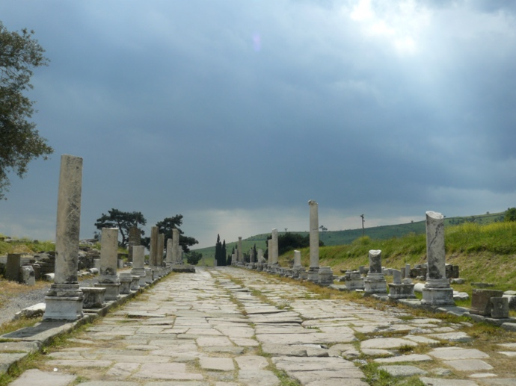
THE ASKLEPIEION OF PERGAMON
2_Asklepieion_OverviewFromTheater_DSC_3508.JPG  The Asklepieion of Pergamon, looking southeast across the sanctuary, from the theatre terrace. The oldest part of the shrine with the healing centre and incubation area is to the right of the young trees in the foreground (photo: CGW 2021). |  | 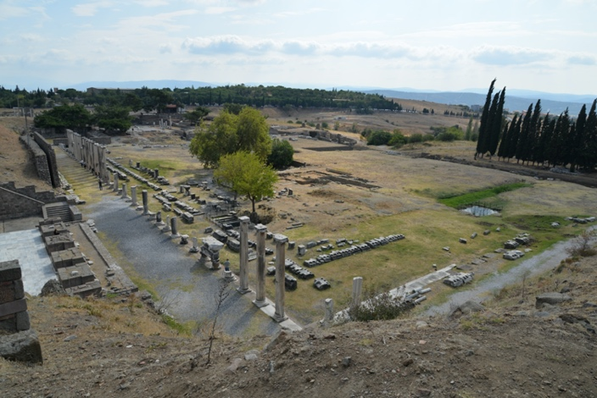
2_ViaTecta_FromAfar_DSC_3085.JPG  The Via Tecta and Hallestrasse, seen from the necropolis area to the north, with the Kaikos valley in the distance (photo: CGW 2021). |  | 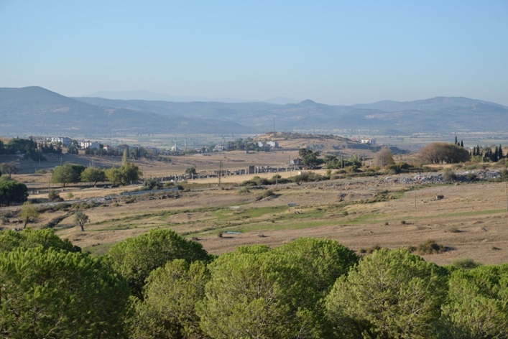
THE VIA TECTA
3_Map_Pergamon_ViaTecta.jpg  Map showing the location of the Asklepieion and Pergamon, with the Via Tecta shown in red. (map: CGW using shapefiles from iDAI Pergamon Digital Map v.1). |  | 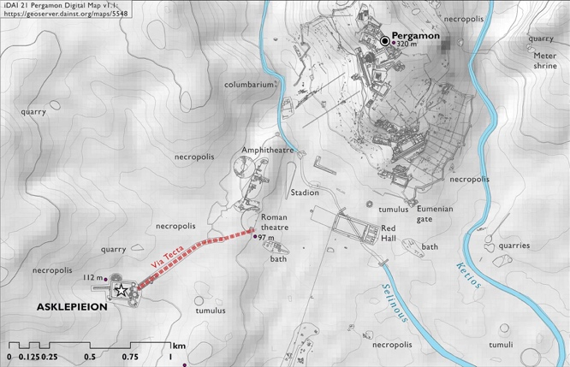
3_Plan_AvPXI.4_Taf71_ViaTecta.jpg  Plan of the Via Tecta (AvP XI.4, Taf. 71). |  | 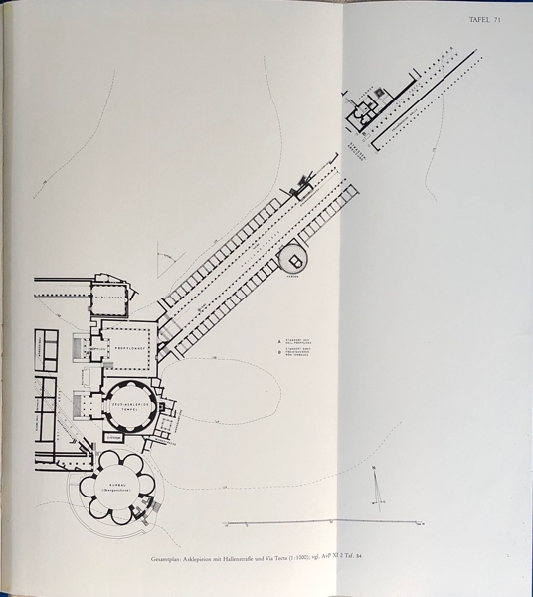
5_RomanTheater_ViranKapi_IMG_6807.jpg  The south parodos of the Roman theatre, with the opening for the Via Tecta, knon in Bergama as the Viran Kapı (photo: CGW 2021). |  | 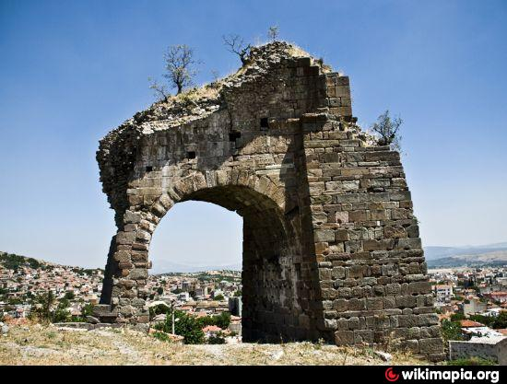
THE VIA TECTA AS LIVED SPACE
TAPARI AND HER JOURNEY TO THE ASKLEPIEION
5_ViaTecta_DSC_3610.JPG  View of the Via Tecta looking southwest (photo: CGW 2021). |  | 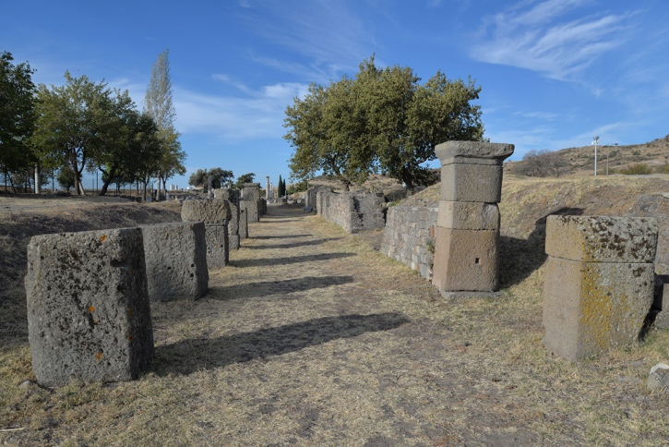
5_ViaTecta_DSC_3784.JPG  View of the Via Tecta looking southwest (photo: CGW 2021). |  | 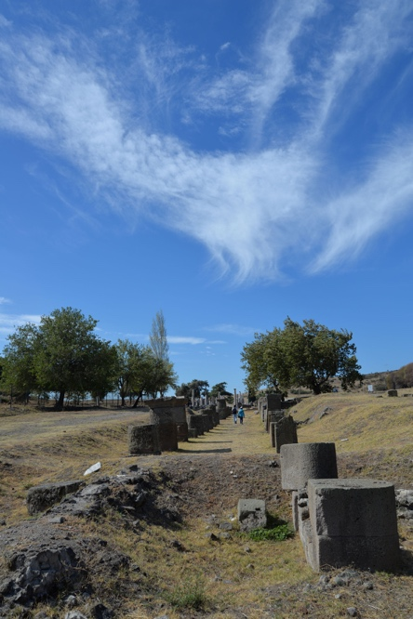
5_ViaTecta_graffiti_DSC_3611.JPG  View of the Via Tecta looking southwest, with grafitti carved in the vaulted pillar (photo: CGW 2021). |  | 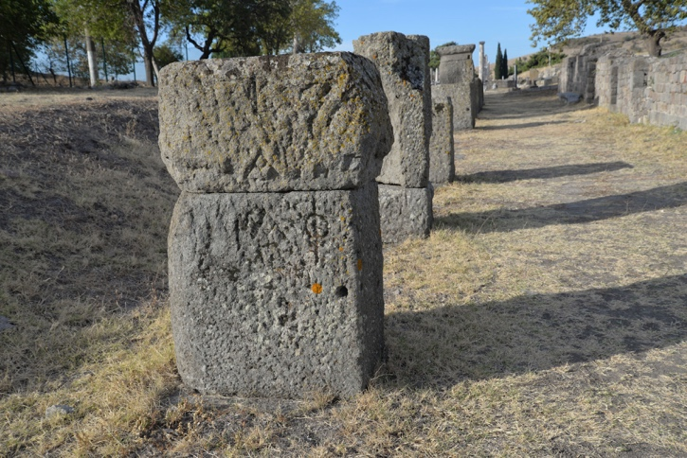
5_ViaTecta_IMG_6614.jpg  View of the Via Tecta looking southwest (photo: CGW 2019). |  | 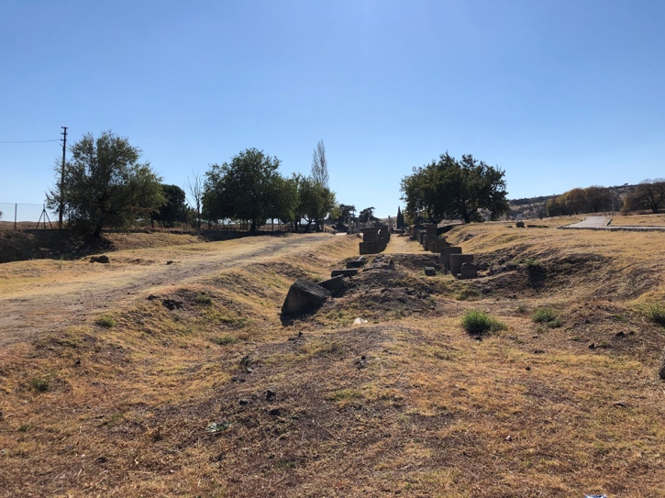
5_ViaTecta_StatueBase_Thermen_DSC_3615.JPG  View of the thermal complex along the Via Tecta in the background, with a statue base in the foreground (photo: CGW 2021). |  | 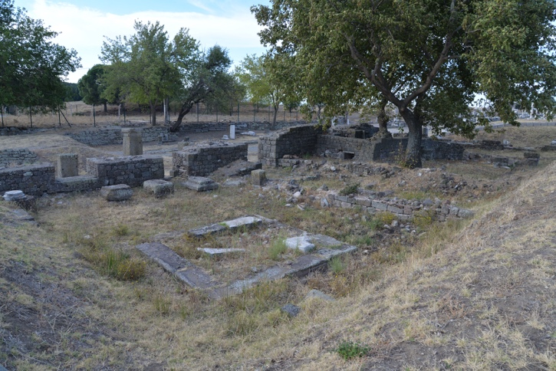
THE HALLENSTRASSE
6a_Hallenstrasse_ArchwayViaTecta_DSC_1221.JPG  View of the transition from the Via Tecta to the colonnaded street (Hallenstrasse), with the foundations for the archway in the foreground. A side street enters from the right (photo: CGW 2021). |  | 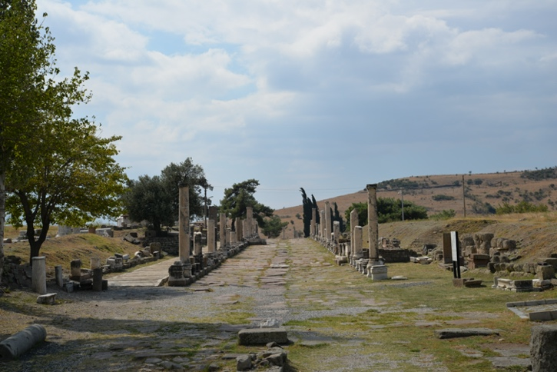
6b_Hallenstrasse_Fountain_DSC_3628.JPG  View of the fountain at the beginning of the colonnaded street (Hallenstrasse) (photo: CGW 2021). |  | 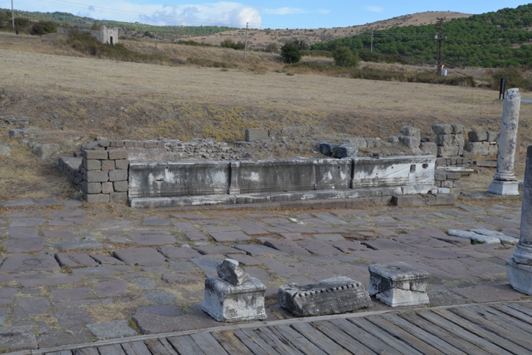
6c_Hallenstrasse_Heroon_DSC_3224.JPG  Shops along the colonnaded street, with the Heroon further to the back. Pergamon is visible in the background (photo: CGW 2021) |  | 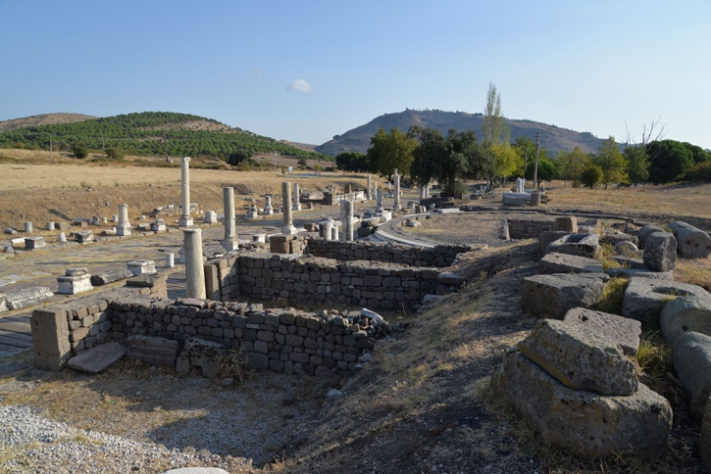
ENTERING THE SANCTUARY
8a_PropylaiaDescent_StairsDown_DSC_3228.JPG  Descending down from the Hallenstrasse to the propylaia, the gateway complex to the Asklepieion (CGW: 2021) |  | 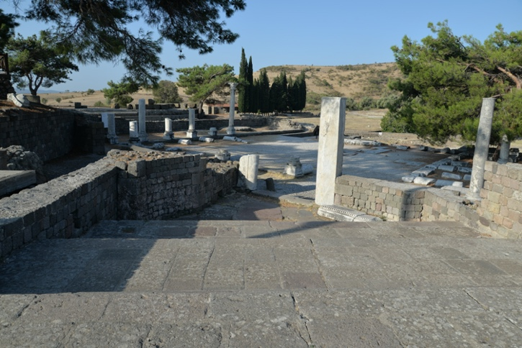
CONCLUSION
9_TheRealTapari_IvPIII_111b_Tapari_votiveEyes_2.jpg  The dedication by the real Tapari, IvP III 111b (photo: Habicht 1969, No. 111b). |  | 