P5 Data App

Where I got the extension idea?

There is no tool on the internet to be able to import a csv file and visualize it as a height-map or create an height-map and save it as a .csv file.

You can create a height-map from any image-manipulation app but there is no way of saving it as a csv file and its not a dedicated tool to create a height-map.

I got technical insparation from the Python3 library Numpy as this library can save image file formats as csv for the use of AI applications.

Height-map of the map of the game Arma3:

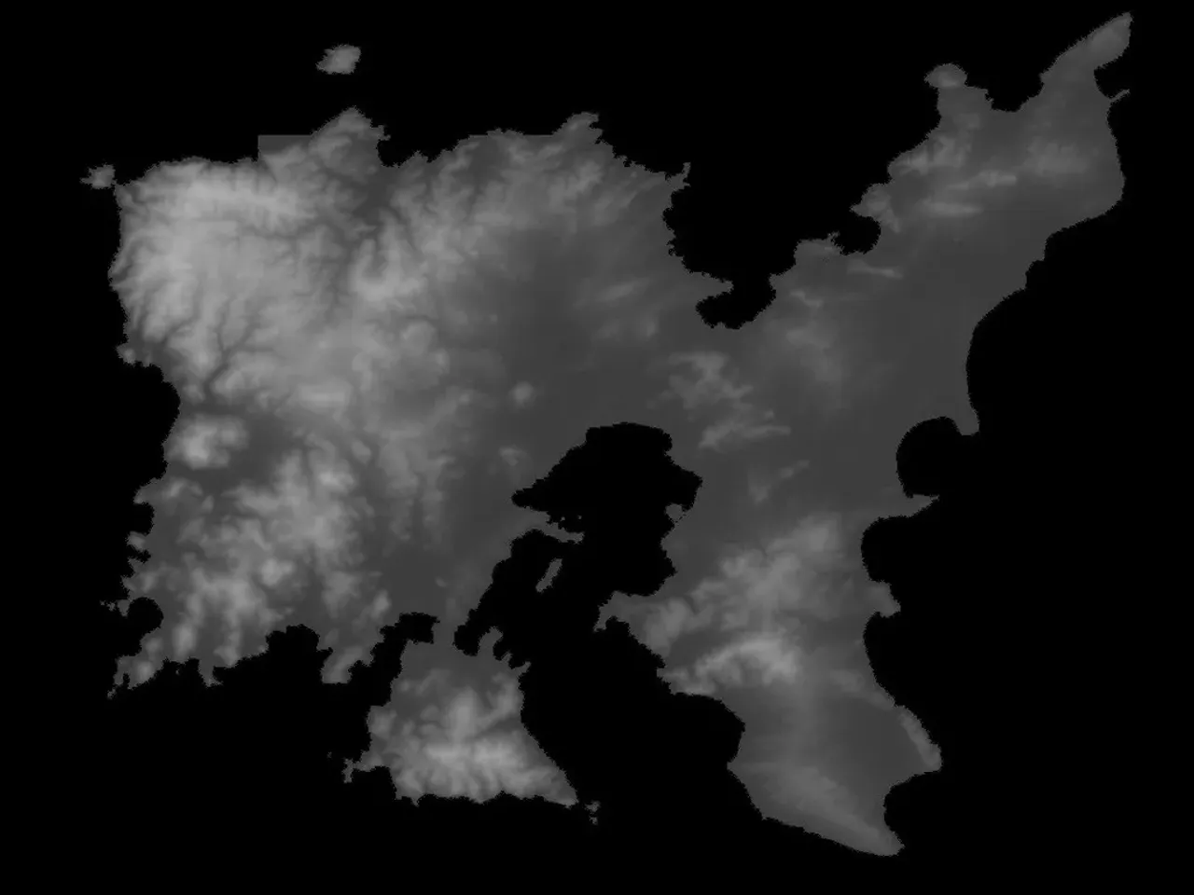

Extension:  
I want to extend the functionality of the data visualization app so that the user can create a heat map on the canvas and save it as a .csv file.

We also want the user to be able to load a .csv file to the app and visualize it or even maybe modify it.