ME 499

Computer Programming for Mechanical

Systems

Lab 3

3 May 2018

Samuel J. Stumbo

List of Assignment Figures:

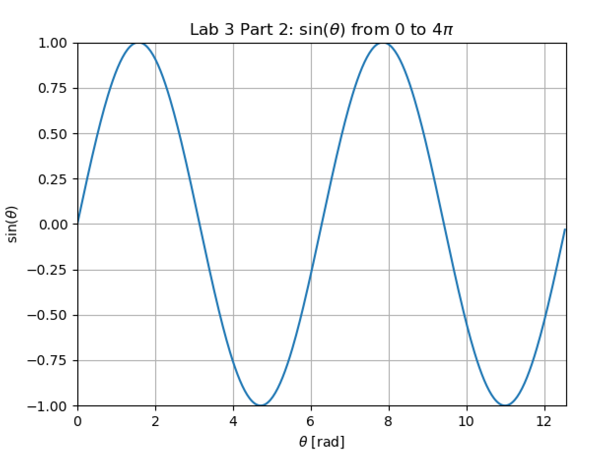

Figure 1: Plot for question #2.

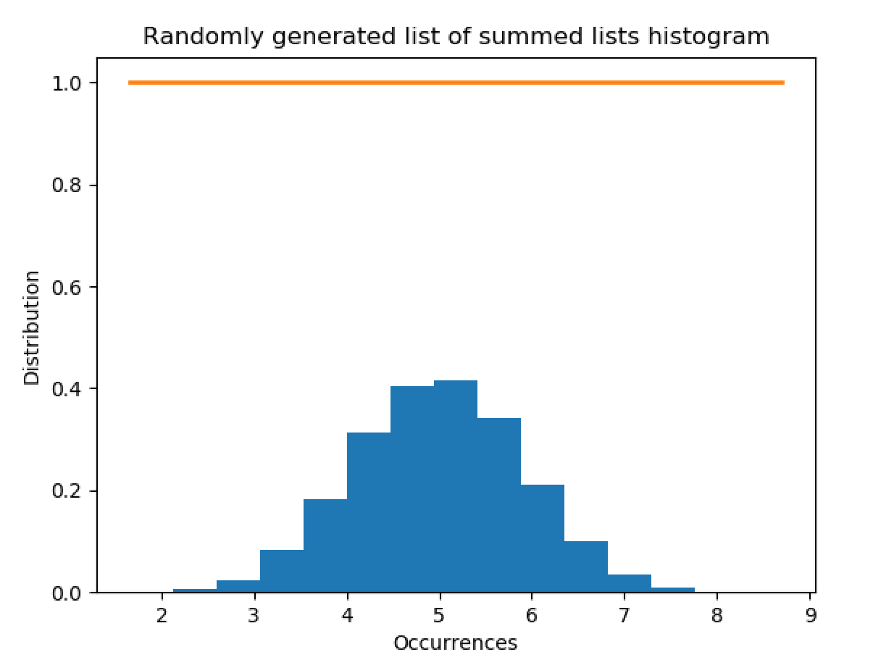

Figure 2: Plot for question #3.

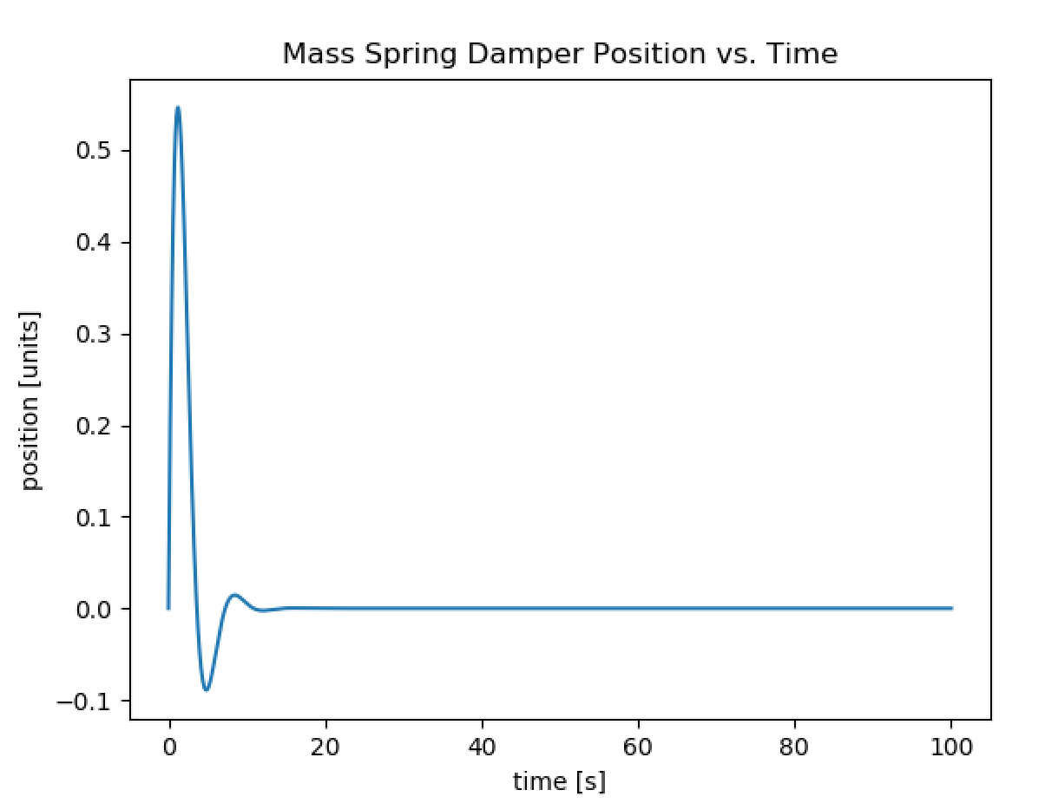

Figure 3: Plot for #4.

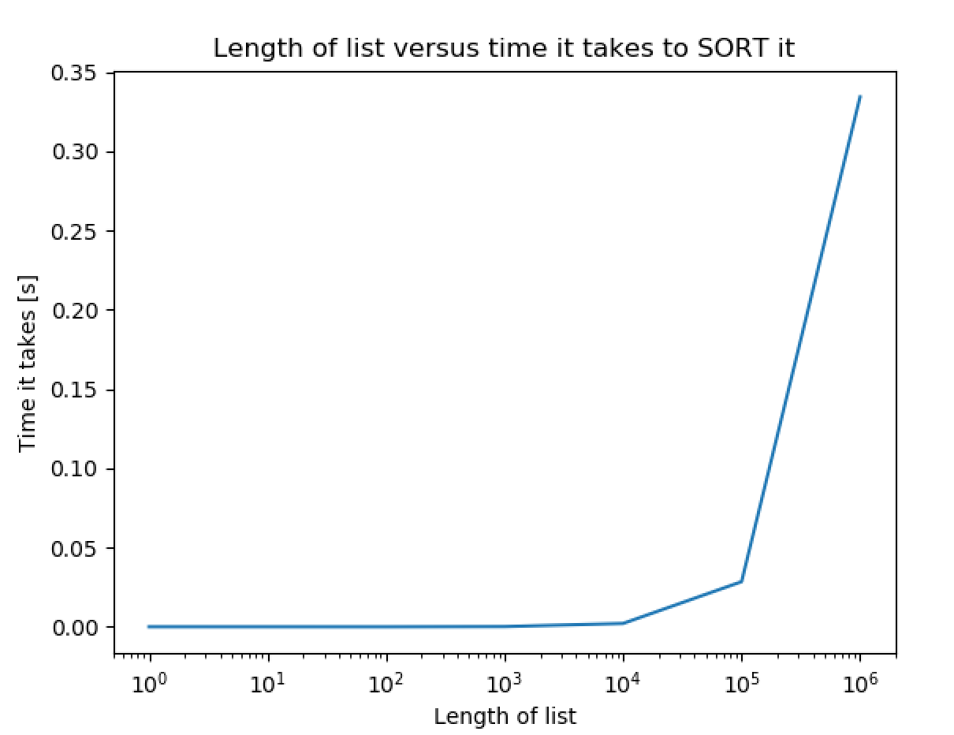

Figure 4: Plot 1 for #4 – Plot of sorting time.

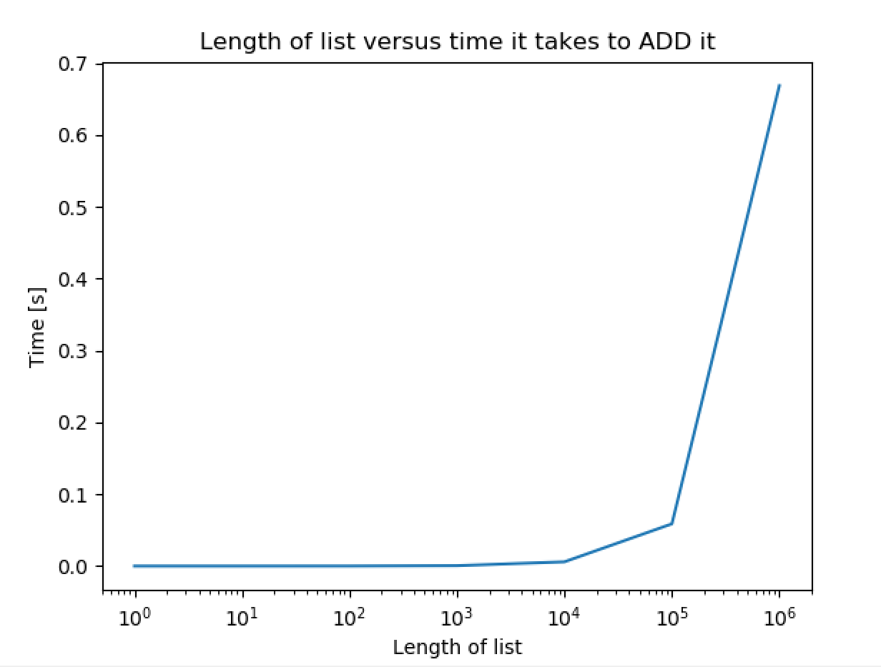

Figure 5: Plot 2 for #4 – Plot of adding time.