Don't Make Me Think! ... Unless? : Priors of Visual Communication and Mental Models of UX Design

Introduction Outline

Concerns: right now I have a lot of concepts and I’m having a hard time narrowing down which ones are relevant to my introduction, and which ones are extra (or belong more in ‘discussion’).

1. Currently, what is considered “good design” in the design world is **usability**
   1. **Usability:**
      1. from the “Interaction Design Foundation”: a design is not usable or unusable itself but rather the product of the **features of the design** plus the **context of the user** (goals + environment) determines its usability. More from interaction design foundation: ease/speed of user adoption (easy for user to become familiar with and competent in during first contact); ease of achieving objective; ease of recall (should be just as easy to use in subsequent visits)
      2. How is usability measured? Often through **user research/testing** which has its own flaws … **to the point where articles have been published urging designers not to listen to user feedback about efficiency but instead observe user behavior.** I found this sentiment interesting.
   2. Is usability conflated with intuitiveness, is intuitiveness conflated with conformity to convention? How much of our design for virtualized environments is based on preserving prior mental models from real world environments, or existing UI conventions? What does this mean for low-literacy users, what does this mean for accessibility, what does this mean for novel designs?
   3. When does it go wrong? Don’t want to focus on poor incompetence, but rather when there are **mental model mismatches** between designer and user
      1. Provide example? I want to introduce Lucy Suchman’s ‘printer that teaches you how to print’ example and sort of analyze another selected example of ‘poor design’ using that frame
   4. Why does this matter? When is it appropriate to disrupt interfaces and information architectures? Is it OK to have a more novel user interface as long as the **user onboarding/adoption** is good enough?
      1. Example: Case study of Slack vs Email+Skype
      2. Side note: The nature of the medium/platform informs what information is elevated, which molds the behavior of the user
2. Visual information
   1. Propose an analysis of how users navigate an interface and the information presented
      1. Propose a really basic system where there is the **interface** and there is the **user**
      2. **Environment:** provides **context of use** and **affordances**
      3. **User:** provides **their own context of use**, **objective/goal,** **problem-solving behavior (decision-making),** **prior knowledge**
      4. Collaboration between the environment and the user. User mental models evolve dynamically as the user continues to use/discover the interface. Context of use will change the meaning of affordances, etc. The effectiveness of affordances depends on user’s prior knowledge. For example, as investigated in Dubey et al., if the user is a RL model, they solve the game **without prior knowledge at all**
         1. Further consider, the ‘designer’ as a third role in the system. The user may assume that design decisions are made with intentionality on the ‘other end’ (for example, perhaps “if the objects look to be placed like they are on a shelf, then the designers intended to communicate to me that these objects will behave as if they are on a real world shelf-like structure”)
   2. Systemically masking visual information. Shoutout to Investigating Human Priors for Playing Video Games (Dubey et al.)!
3. Two goals:
   1. Try to identify the elements of prior knowledge that humans use to navigate/use an interface.

Users will act on assumptions that..

* spatial representation of environment will reflect physics/gravity of system
  + flat vs tilted perspective, “top-down” vs “platformer” physics, weight/height of drop
* layout/structure cues will reflect behavior of grid
  + grid vs circular arrangement, separate some sections off with a line
  + visual property of ‘slots’ will reflect how objects change positions (i.e. box/container vs unbounded, continuous shifting vs ‘switching places’) — also, will the nature of the sorting task itself (i.e. if you’re sorting them based on a continuous dimension, will there be shifting?)
* visual properties of object (color, texture) will reflect behavior of object or system
  + semantic/symbolic = red vs green, black vs grey
  + temporal: ANIMATIONS (colors changing or blinking) will reflect state of object
* object/grid similarity will reflect consistency/stability of behavior
  + if they look similar, they will act similar. if they look different, will they act different? this is what the RL model worsened on when masked
    1. Perhaps a case study where I analyze several different interfaces?
    2. Test if these elements are even there, or effective enough to influence performance. Like Dubey et al. said, “quantify the importance” of the priors.
  1. What can we learn about human problem-solving behavior when confronted with design that purposely disrupts prior knowledge? For each category of prior:
     1. First, investigating performance. This is the most straightforward, with simple analysis of moves and time. Is the disruption of this prior significant enough to cause decrease in performance?
     2. Second, investigating problem-solving behavior. Explore data of mouse movements, can inferences about strategy be made?
     3. Third, comparing actual performance to self-reported perception of performance (rating/self-scoring after the task). How much does disrupting that prior affect the subject’s perception of how well they did/how usable the interface was?
  2. And lastly…. if I can … applying a simple RL model to try and compare its performance with the user performance in each category of priors – see which ones that it performs better on. And trying to build inductive biases into the model.

Mockups:

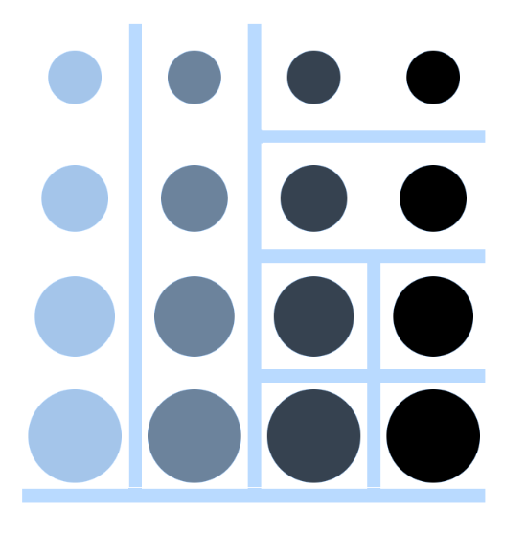 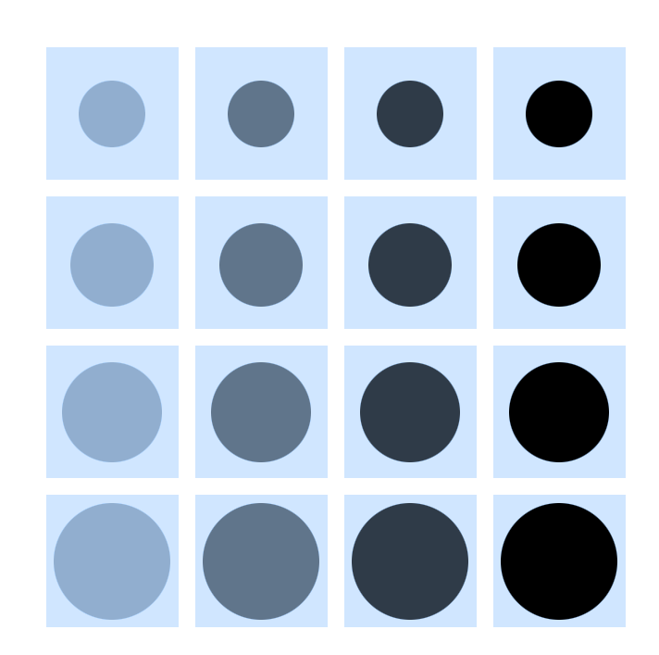

And others that will be found here: <https://github.com/ch-en/uxexperiments> currently in the main folder but I will move them to a designated folder when I make more!

1. Bonus: Can we investigate ‘recoverability’ and how it affects performance by adding an undo button?
   1. Using ‘undo’ button to simulate ‘cost’ of actions.
      1. Increasing cost of performing an operation will increase planning and reduce level of action in the world (O’Hara, *Planning and the user interface: the effects of lockout time and error recovery cost,* 1999) = the more destructive or costly an action, the less actions will be taken by the user.
      2. The presence of an undo/back button provides a revisitation method (Greenberg and Cockburn, 1999) — and it makes operations non destructive. This will likely encourage exploration. But will this increase the speed at which people understand the ‘world’?
      3. Effect on self-reported perception of performance **: Does it matter** if efficiency is actually increased or not, if the self-perceived performance (and therefore, the ‘experience’) of the user is improved? (In the real world, people likely don’t want to solve a puzzle perfectly – allowance to make mistakes and be able to recover from them)
      4. Back button: go back 1 move? Go back 5? Go back to a checkpoint? What happens if the user sets their own checkpoint? (This may be too much, move to discussion?)

Methodology Challenges:

* + 1. Threats to external validity: Reactive/interaction effects of testing and experimental setting. I’m worried about the generalizability of these results..
       1. Often bad design is interpreted as incompetence or failure to implement a feature. This is different than design that is intentionally misleading or disruptive, which it rarely is. Therefore, does this have value in the real world..?