Pitufino—Quick User Guide
Document version 1.9
Last modified for firmware version V1.5.2

Installation

Mounting your Pitufino
For mounting your Pitufino, choose a safe environment that is
- close to your existing navigation devices you wish to connect to Pitufino and/or close to your NMEA2000 backbone T connectors,
- at least 90cm (3ft) away from a compass,
- at least 20cm (8”) away from solid metal objects such as a metal hull or metal bulkhead,
- dry and not exposed to any splashing water or rain,
- not beneath or near any container or plumbing filled with water or other liquids,
- far away from any flammable or hazardous atmosphere such as in an engine/generator room or close to fuel tanks or gas bottles.
Mount Pitufino vertically, with its connectors facing downwards, to a flat surface on a wall or bulkhead using 2 small screws.

Connections
Pitufino has 6 connectors that can be unplugged from their sockets to facilitate the installation. Each connector has 2 screw terminals for bare wire ends.
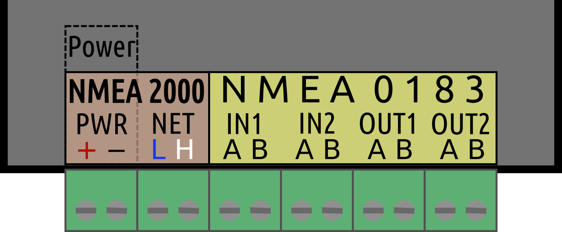

Connecting to an NMEA2000/FurunoCAN/SimNet/SeaTalkNG network
For an NMEA2000 or FurunoCAN network, you need a Micro-C T-connector and a Micro-C cable. For SimNet and SeaTalkNG, you need either a T-piece or a free port on a multi joiner and a cable. Pitufino comes with screw terminals so it needs bare wires at one end of the cable. If your drop/spur cables have connectors on both ends, you can cut off the (female) connector, strip about 2-3" (max. 8 cm) of the sheath and shield, and strip less than 0.5" (max. 1 cm) of the wire ends. It is recommended to tin the wire ends. We also recommend to wrap the shield back over the pair of data wires and fix it with heat-shrink tube to avoid unshielded sections. SeaTalkNG cables have an additional wire (yellow) that is not used. This extra wire end can be cut short and isolated.
Connect the network data wires to the NET-L and NET-H screw terminals (note, the following wire colors are valid only for original cables, compliant with the NMEA2000 standard):
blue ... NET-L (or CAN Low) => NET L
white (in SimNet cables yellow) ... NET-H (or CAN High) => NET H
It is recommended to supply Pitufino with power via the network. Check whether your network can handle an additional load: Pitufino adds a network load of 3 LEN. If yes, connect the network power supply wires to the correct screw terminals:
black ... NET-C (Common, GND, Ground) => PWR –
red ... NET-S (Supply, usually 12 VDC) => PWR +
If your network cannot power an additional device, it is possible to supply Pitufino from another power source (12 VDC or 24 VDC) as long as it has the same ground as the NMEA2000 network.

Connecting a power supply
If you do not have an NMEA2000 network or your network powers already too many other devices, connect the PWR – (battery minus) and PWR + (battery plus) screw terminals to your power source. It is recommended to use a breaker and a fuse (3-5 A) in the positive supply wire.

Connecting NMEA0183 devices
Pitufino can be connected to two NMEA0183 talkers and to two (or more) NMEA0183 listeners. Connect a talker to an NMEA0183 input (#1 or #2). Only one talker is allowed per input. Connect A (or H or +) to A and B (or L or -) to B.
Connect a listener to an NMEA0183 output (#1 or #2). It is possible to connect two or three listeners in parallel to one output if they operate at the same baud rate. Connect A (or H or +) to A and B (or L or -) to B.

Configuration
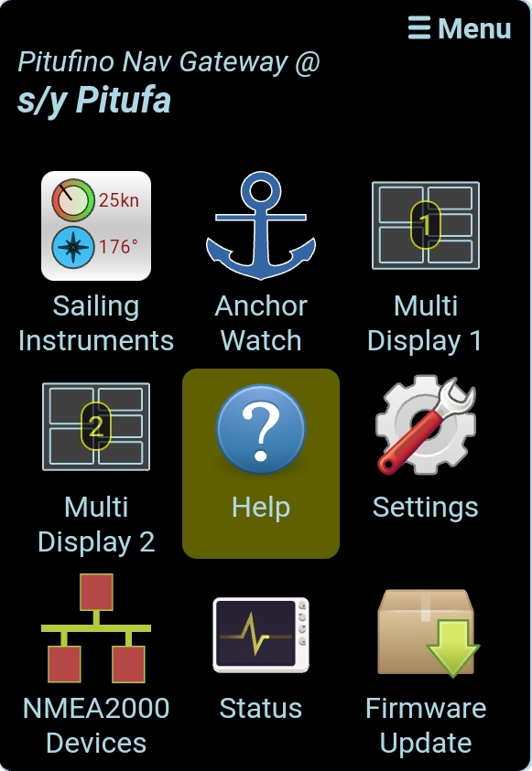
Pitufino can be configured using your web browser. As soon as Pitufino gets supplied with power, it provides a Wi-Fi access point named PITUFINO1 (this is the factory default name and should be changed). To connect to this access point, a password is needed: the factory-default password is 12345678. If your computer or mobile device supports mDNS (e.g., Apple’s Bonjour service discovery), Pitufino’s web pages can be found under the address pitufino.local (i.e., http://pitufino.local/ ). If your device does not support mDNS (e.g., older Android or older Windows), you have to enter Pitufino’s IP address 192.168.4.1 (http://192.168.4.1/) in your browser’s address bar.

Welcome to Pitufino! On the browser page with Pitufino’s main menu, click “Settings”.

Essential Settings
- On Pitufino’s “Settings” page (Menu) change the Wi-Fi password under “Wi-Fi Settings”. We strongly recommend to also change the name (SSID) of Pitufino’s access point.
- If your Pitufino is connected to NMEA0183 devices, you must set the proper baud rates for the two NMEA0183 ports (see documentation of your NMEA0183 devices) under “NMEA0183 In/Out #1/#2 Settings”. The standard value is 4800, for AIS devices tzpicallz 38400 is used.

Recommended Settings
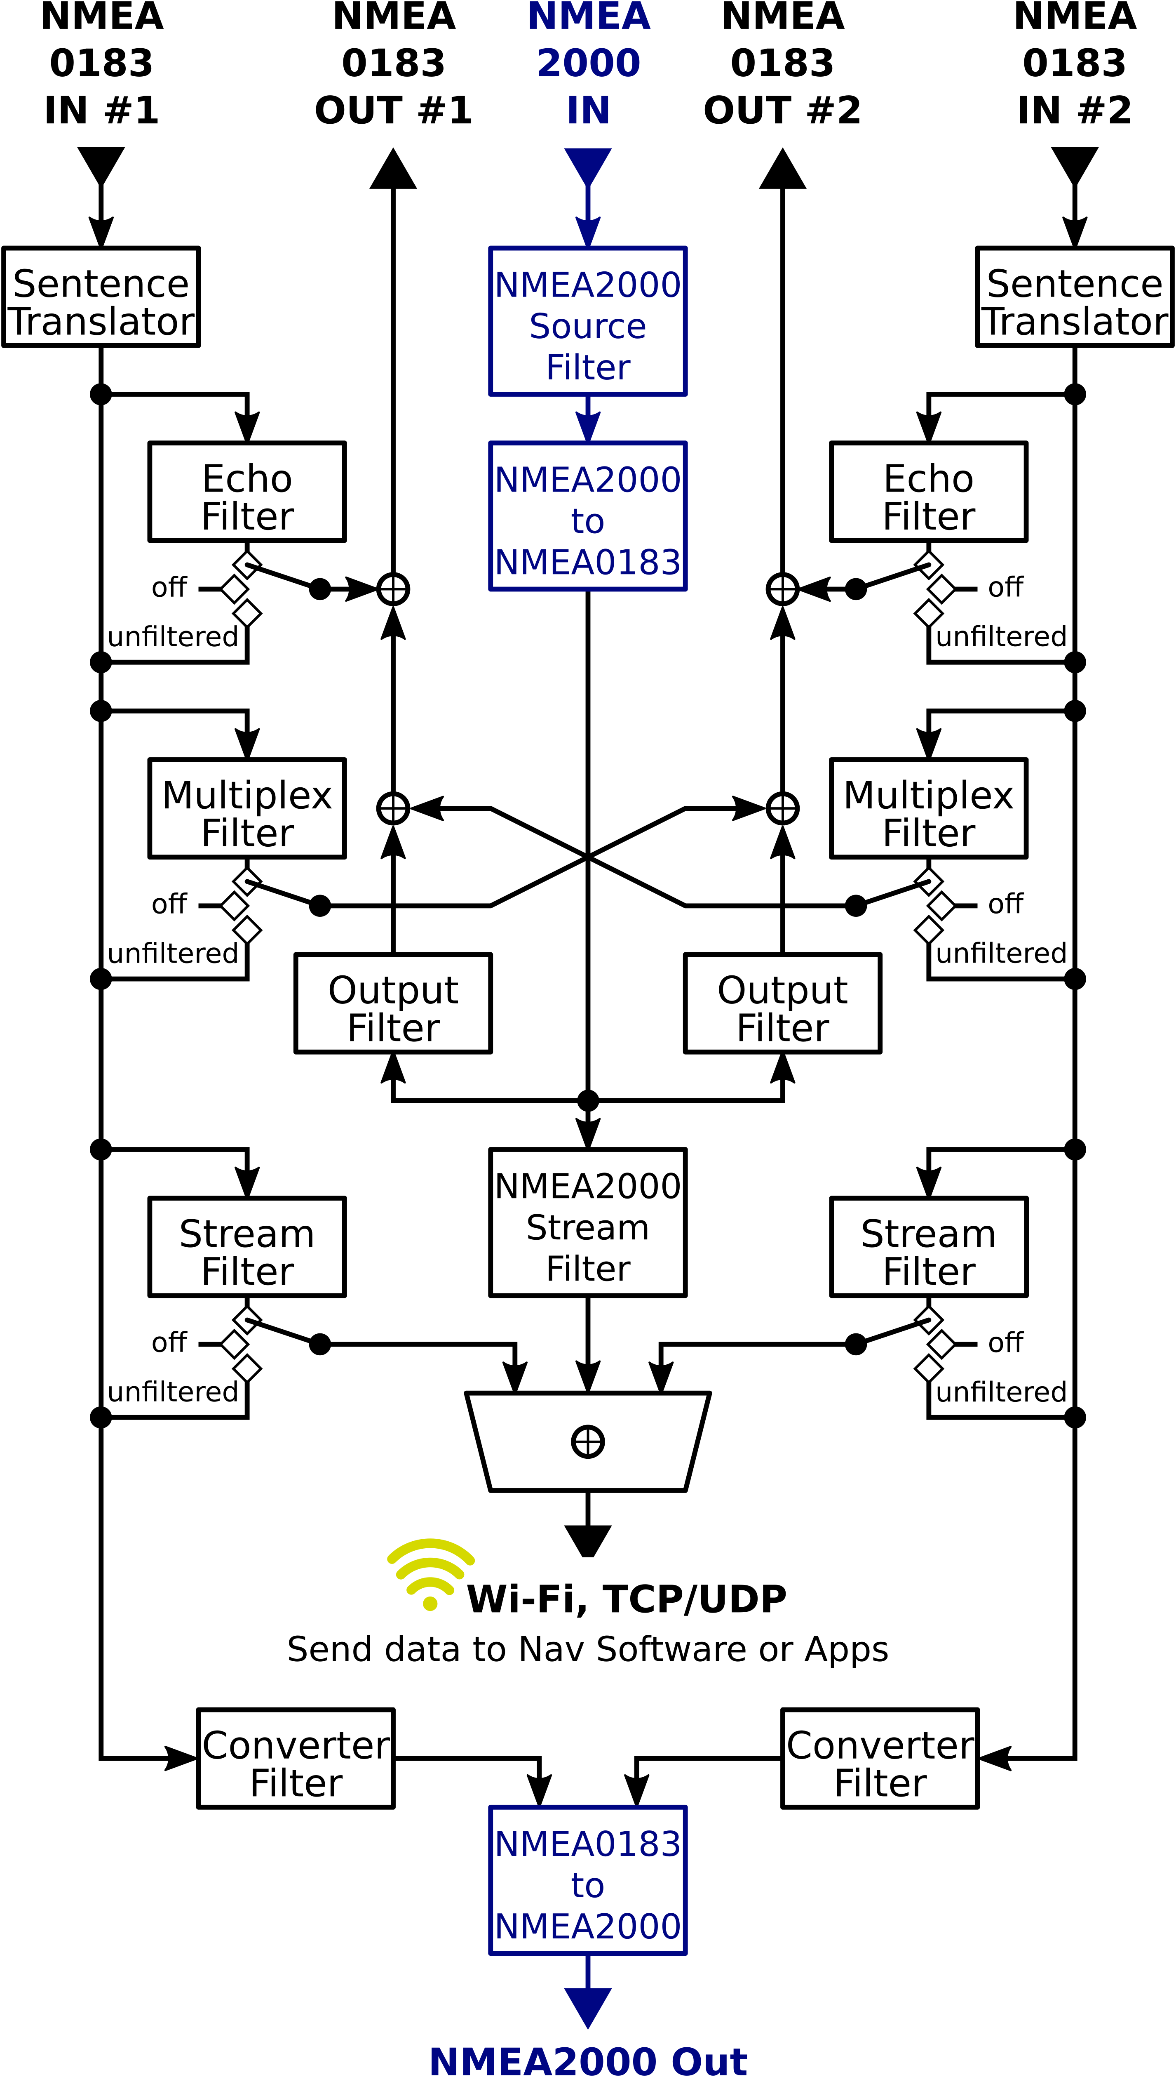
- We recommend to enable HTTP Authentication under “General Settings”. Choose a username and a password. This login is then necessary in your web browser for all security-critical requests (e.g., to see/change settings, reboot, restore factory defaults, remote-control your auto pilot, update firmware, …). Note, the login credentials are requested only once per browser session and are transferred in an encrypted form. For convenience, your browser can remember your login data.
- Enter your vessel’s name.

Filter Settings and Routing
A filter can allow or reject data from a connected navigation device. For example, often several devices transmit position data (GPS, chart plotter, AIS, dedicated NMEA2000 GPS antenna, ...) and it is a bad idea to merge data of different devices of the same kind into a single stream (as the current position would quickly jump between the different mounting places of the GPS antennas). Now, filter settings should allow GPS data only from one device, the most reliable or your preferred one.
For NMEA0183 inputs, different filters can be used for different routing destinations: a “stream filter” controls what is sent to other apps/software over TCP/UDP, a “multiplex filter” controls what is sent to the other NMEA0183 output and an “echo filter” selects which sentences are echoed back to the own output.
To facilitate configuration, Pitufino’s “Help” page (Menu) shows the routing diagram and each filter box is a hyperlink that brings you to the corresponding section on the “Settings” page.
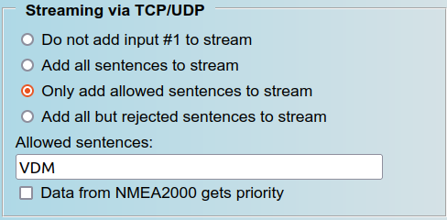
For an optimal configuration it is necessary to know about all connected devices, so it’s wise to have their user manuals close by. Pitufino’s device monitoring feature (see below) can also help you to learn what kind of data different devices transmit. This knowledge is needed to choose proper filter settings.
Example NMEA0183 filter
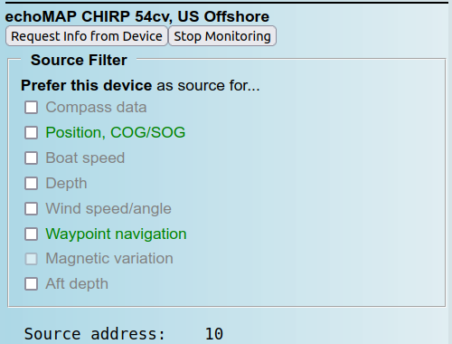
As an example, an AIS device is connected to one of Pitufino’s NMEA0183 inputs and we do not want its GPS data, but are only interested in its AIS messages. In this case an “allow only” filter for “VDM” sentences should be used. Alternatively, a “reject” filter could be used, however, the device sends GPS data using several sentences, so a longer list would be needed, e.g., “RMC, GSA, GSV, GLL, VTG, ZDA”.
If we want to use the GPS data of this AIS device as a fallback when no NMEA2000 GPS is available, we should select “Add all sentences to stream” and activate the option “Data from NMEA2000 gets priority”.
Example NMEA2000 source filter
For NMEA2000 devices, Pitufino’s device list (Menu) provides GUI options to select preferred devices for a certain type of data. The example device in the image can output all kind of data (under certain circumstances), but currently, only GPS and waypoint data is sent (items in green).

Server Settings and Client-Software Configuration
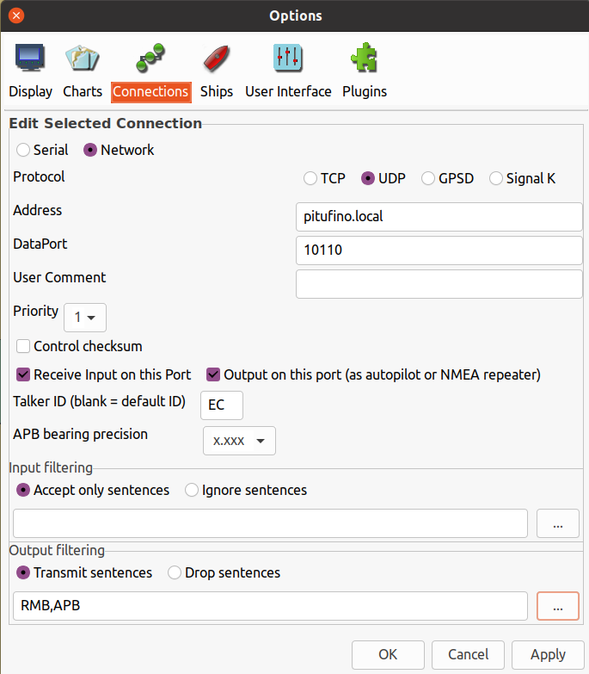
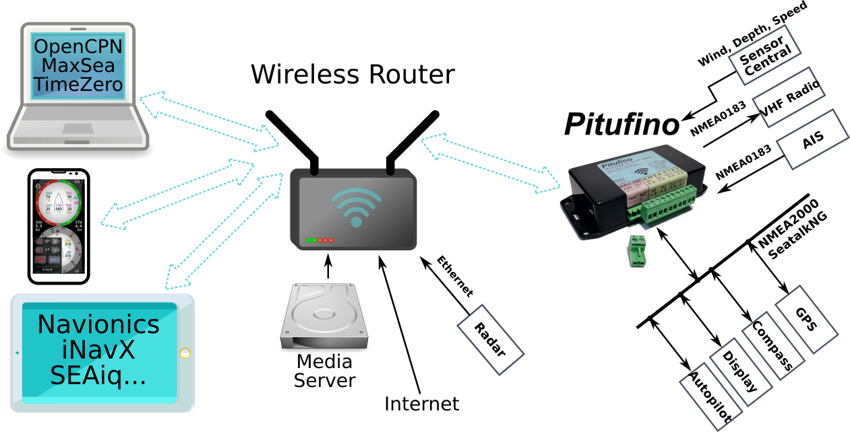
Most navigation apps and programs can read NMEA0183 streams from TCP or UDP network connections. Check Pitufino’s settings for TCP and UDP port numbers (factory defaults: TCP 2947 and broadcast UDP 10110). Those numbers are required when configuring apps and chart-plotter software. Some apps (e.g. Navionics Boating) are pre-configured for UDP 10110 and don’t need any further server settings. Note, some firewalls block UDP broadcast messages and/or do not allow listening on most ports. If so, an exception rule needs to be added to your firewall to allow listening on that particular UDP port (see Appendix 1).
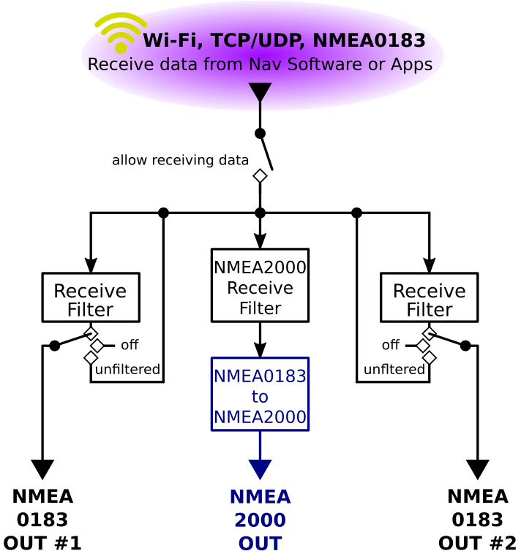
The example in the image shows the configuration of the chart-plotter software OpenCPN on a Linux or macOS device. On devices without mDNS support (older Windows or older Android versions), the IP number 192.168.4.1 must be entered in the address field. The enable a chart-plotter program to send data of the active waypoint (current waypoint of active route) back to Pitufino, make sure it outputs the RMB sentence.
Pitufino can send data from a chart-plotter program on to NMEA devices (such routing for the active waypoint data is enabled by default). In order to use the software’s waypoint data on an NMEA2000 device, it may need to be configured: select Pitufino as the source for ‘navigation’.
For more information on Pitufino’s NMEA0183 servers, see Appendix 1. If your navigation program cannot read nav data from a network connection (e.g., SAS.Planet), a virtual serial port can be created from a network connection (see Appendix 2).

Wi-Fi Settings—Connection to an Existing Wi-Fi Network
If you have already a Wi-Fi network onboard (i.e., a wireless router), you can configure Pitufino to connect to that network instead of creating its own. This has several advantages: First, mobile devices do not need to switch between different networks to access different services (e.g., either Pitufino’s web apps and NMEA0183 streams or your media server and internet connection) – instead, all devices are connected to your wireless router and can access all services at the same time. Second, dedicated router devices have external antennas and so a stronger Wi-Fi signal, bringing a more robust Wi-Fi connection and a wider range. And third, the router takes over some work, reducing the workload of Pitufino.
If you choose to connect Pitufino to an existing Wi-Fi network, it will get a different IP address from that external router (DHCP). In case your mobile devices do not support mDNS (i.e., they do not find Pitufino at pitufino.local), your apps and web browsers need this new IP address to find Pitufino. Clever routers provide a name server with the host names of all connected devices. In that case, Pitufino can be found also at the address pitufino (without .local), in a browser that is http://pitufino/. If this does not work, you may refer to your router’s administration page and documentation. We recommend to configure your wireless router to give Pitufino always the same IP address.

NMEA0183 Sentence Translator
To solve incompatibility problems between some devices, Pitufino offers several sentence translations.
- VDO to RMC: some AIS transponders (e.g. Furuno FA-50) do not output GPS sentences, but only VDM (other vessels’ position reports) and VDO (own vessel’s position report). Enable this translation to convert VDO into the GPS sentence RMC, which allows you to use this AIS device as a GPS source for other devices or your chart-plotter apps.
- DBK to DPT: some older devices (e.g. Simrad/Robertson Dataline) only output DBK (depth below keel, i.e., the depth to be displayed), but newer devices only accept DPT (transducer depth and separate display offset). Enabling this translation also requires entering your vessel’s transducer-to-keel offset in centimeters.
- VWR to MWV and MWV to VWR: older wind instruments output VWR sentences, whereas newer ones use MWV. Enable the VWR-to-MWV translation to use older wind transducers on newer displays or the MWV-to-VWR translation to use new transducers on old displays.
- GPS date correction: many older GPS units and AIS transponders suffer from the 1024-week rollover. Enabling this feature gives you the correct date again.

Magnetic Variation, True Wind, Data Damping, Active Waypoint Data
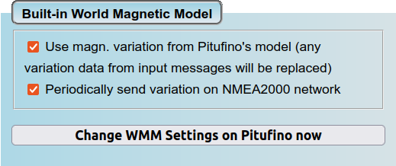
Pitufino not only relays navigation data from its inputs to its outputs, but also computes its own data. The built-in world magnetic model (requires GPS input) provides magnetic variation which is needed whenever a heading or direction needs to be converted between magnetic and true. Pitufino’s firmware available for download will always contain the latest, up-to-date model and it is very easy to update Pitufino (see section 5 Firmware Updates).
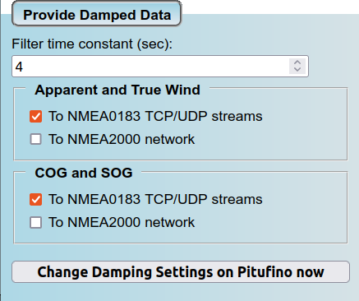
Pitufino properly computes ground-referenced true wind using COG/SOG (requires GPS input, wind sensor and compass). Additionally, wind data (true and apparent) and COG/SOG are provided to your apps or your displays on the NMEA2000 network with optional damping. This is useful if your apps or displays do not offer adequate damping options. Using Pitufino’s damping for wind and COG/SOG together has the advantage that the different data remain synchronous, i.e., have the same delay (damping for wind and COG/SOG of your apps/displays should then be disabled). If your apps/displays do offer adequate damping but you wish to use the true wind computed by Pitufino, ‘Apparent and True Wind’ need to be enabled in Pitufino’s settings, but the filter time constant should be set to 0 seconds. Note, Pitufino’s browser-run displays (see section 4) have their individual damping options.
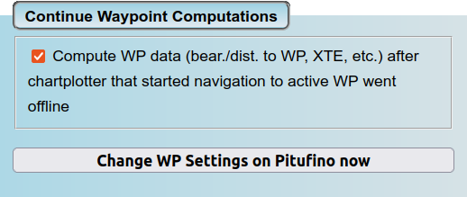
Another feature of Pitufino is that it can take over the computations of waypoint data after the chartplotter (device or software) that started a navigation to the active waypoint (‘Go to’ or ‘active route’) has been switched off. This is particularly useful on longer legs without any charted navigational obstacles where you do not really require a plotter—you can switch off your navigation laptop or your (power-hungry) plotter and still get waypoint (WP) data like bearing and distance to the active WP or cross-track error (XTE) which is needed by the autopilot when it is in NAV/TRACK mode. Pitufino stops its WP computations as soon as a connected device (or software) starts sending valid WP data again (for instance, advancing to the next WP of the active route).
To use data computed by Pitufino on an NMEA2000 device, the device must be properly configured. Depending on your needs, select Pitufino as the source for variation, true/apparent wind, GPS, and/or Navigation.

Alarms
Pitufino implements several own alarms: anchor drag (see 4.5 Anchor-Watch App), close AIS target, waypoint arrival, pilot waypoint confirmation and off course (see 4.4 Sailing Instruments App). Aside from these own alarms, Pitufino can be used as a repeater (or external alarm) for alarms transmitted over NMEA2000 from Raymarine devices and Navico/Simrad/B&G devices.
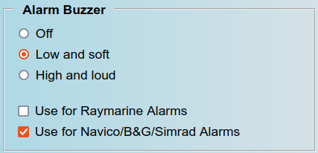
Pitufinos of the first generation (hardware version 1.0) do not have a buzzer but sound an alarm on your mobile devices. This requires to have a Pitufino app running continually. Starting with hardware version 1.1, Pitufino features a buzzer to sound alarms and no longer requires a continually running app. For those newer models the Settings page (Menu) has a section for the buzzer under “General Settings”.
Note that on Navico/Simrad/B&G devices not all alarms are communicated over NMEA2000. For instance, a B&G Triton² display does not transmit when it triggers an ‘Anchor’ or an ‘XTE’ alarm.

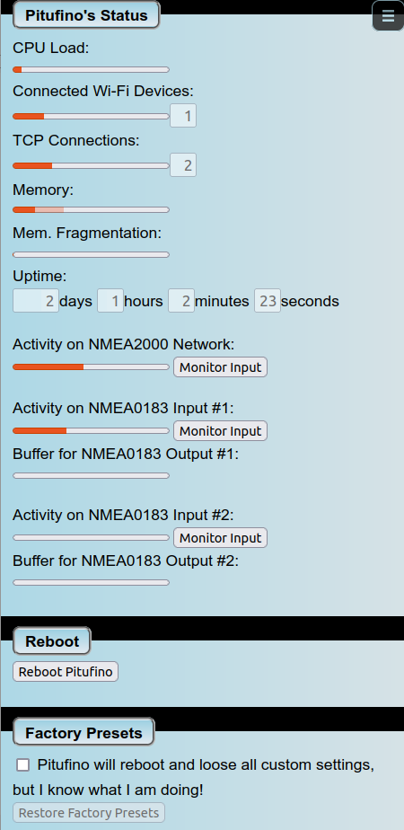
Expert Features

Status/Monitoring/Debugging Stream
Pitufino sends occasional status information to a debugging stream on UDP port 1122. Under macOS and Linux it is easy to view such a stream using the netcat (nc) command in a terminal window: “nc -u pitufino.local 1122”. Press ‘Enter’ another time to start the connection. Note, only a single client connection is possible on this port.

Status Page
Pitufino‘s Status page (Menu) shows system values for diagnostics.
- Number of connected Wi-Fi devices: Only shows a number when Pitufino’s own Wi-Fi access point is used. Number is limited to 5. The more concurrent Wi-Fi connections, the more work and memory is required, so try to keep this number low.
- Number of TCP connections: TCP connections require a considerable amount of processing power and memory, so try to use UDP connections in your navigation apps and chartplotter programs whenever possible. Note, that also Pitufino’s web apps require TCP connections. Number is limited to 8.
- Memory: This indicator shows Pitufino’s memory consumption. The paler shade indicates the maximally used memory since Pitufino was powered up.
- Memory fragmentation: This indicator should show either nothing or about 50%. If more than 50% is shown, you should reduce Pitufino’s load (e.g. reduce the number of connections).
- Activity on NMEA2000/NMEA0183 inputs: This may be the first place to check after installing Pitufino. All connected inputs should show activity. For NMEA0183 inputs, the baud-rate settings must be correct to see activity here.
- Buffer usage for NMEA0183 outputs: Ideally, these buffers should remain relatively empty. When a buffer fills up, you try to send too much data to this output. Particularly low-speed (4800-baud) connections fill up quickly. Either select less data to be sent to this output or, if the connected device can be configured to use a higher data rate, use a higher baud rate.

Device Monitoring

For NMEA0183 devices, monitoring of an input can be activated on the “Status” page (Menu). NMEA messages of this input only are then sent to Pitufino’s monitoring stream on UDP port 1122.
For NMEA2000 devices, monitoring of an individual device can be activated on the “NMEA2000 Devices” page (Menu). NMEA2000 raw data is then sent on UDP port 1122.

Hardware Factory Reset
In case you cannot remember the password of Pitufino’s Wi-Fi access point or you forgot the browser login to change Pitufino’s settings, a hardware factory reset can be performed. This restores factory defaults for Wi-Fi settings and disables HTTP authentication.
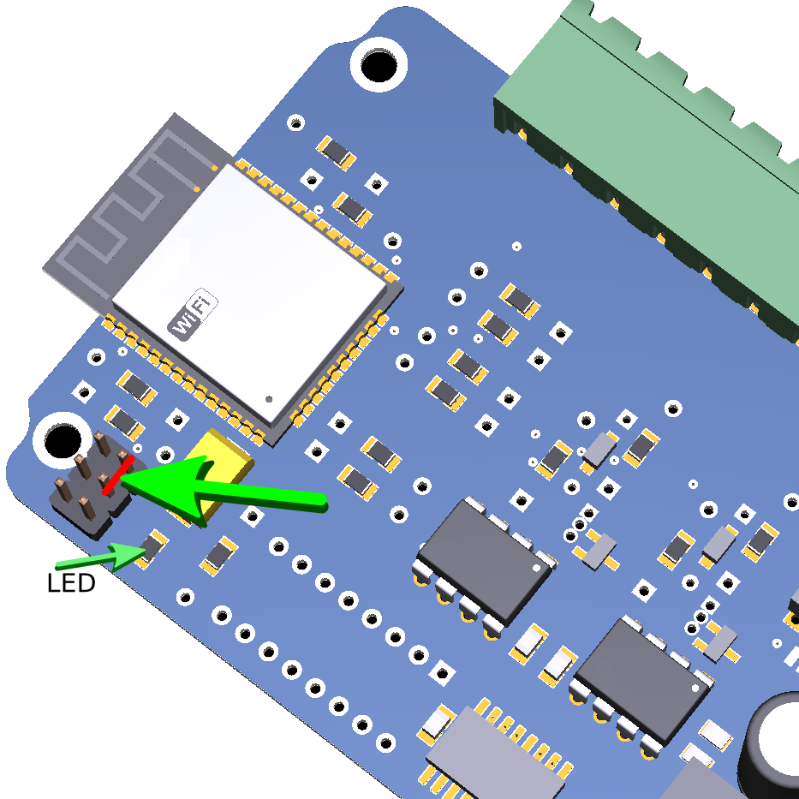
For this reset, unplug Pitufino’s connectors and remove it from its mounting place. It is necessary to open Pitufino’s housing by unscrewing the 4 screws on the backside. Locate the 6-pin header in one corner of Pitufino’s circuit board (see illustration). You have to connect the two pins indicated by a red line in the illustration, preferably using a jumper. Once this connection is made, provide Pitufino with power. The LED will blink 3 times to indicate a successful reset. After that, unplug power and remove the connection between the 2 pins. You can reassemble the housing and mount Pitufino to its place again.

Using fixed IP addresses with Pitufino’s own Wi-Fi
Mobile devices connecting to Pitufino’s own access point can use fixed (i.e., manually set) IP addresses in the range from 192.168.4.100 to 192.168.4.199. This actually speeds up connection time. However, it is of paramount importance to uniquely assign an address to a single device. In addition to an IP address from this range, the network settings of your mobile device require input of a subnet mask of 255.255.255.0 (or a prefix length of 24) and a gateway address of 192.168.4.1.

Pitufino’s Browser-Run Instruments
Pitufino’s local web server provides pages to view navigation data in real time in your web browser. These feature-rich web apps do not need to be installed on your mobile devices—a web browser is enough!

Browser Compatibility
Pitufino’s web apps use many of the latest HTML5 features, so a browser with a current version is required. The apps run well on recent versions of Google Chrome, Mozilla Firefox, Samsung Internet or Opera. Note, Apple’s Safari is severely lagging behind in the implementation of support for the latest Web and HTML5 standards. On iOS devices, support may generally be incomplete as also other browsers have to use Safari’s implementation.
Note that some browser settings may interfere with web-app usability. For instance, a fresh install of Samsung Internet comes with 2 enabled options that should be turned off under Settings > Webpage view and scrolling: 1.) Request desktop sites and 2.) Pinch to zoom in/out of webpages.

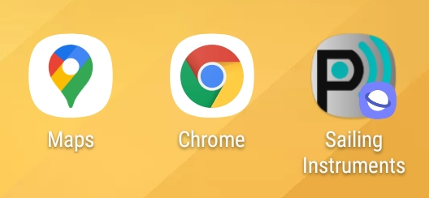
App Launchers on your Mobile‘s Home Screen
We recommend to create launchers (icons) on your home screen so you can quickly open your preferred Pitufino web apps. On modern browsers such launchers will start Pitufino’s pages in a separate window without a visible browser bar/menu.
To create a launcher, open the web app in your preferred web browser. In the browser menu search for an entry like “Add to Home Screen” or “Add page to …” (and then further select “home screen”). On Android devices this works nicely with Chrome and Samsung Internet. Unfortunately, on iOS only Safari allows web-app integration.

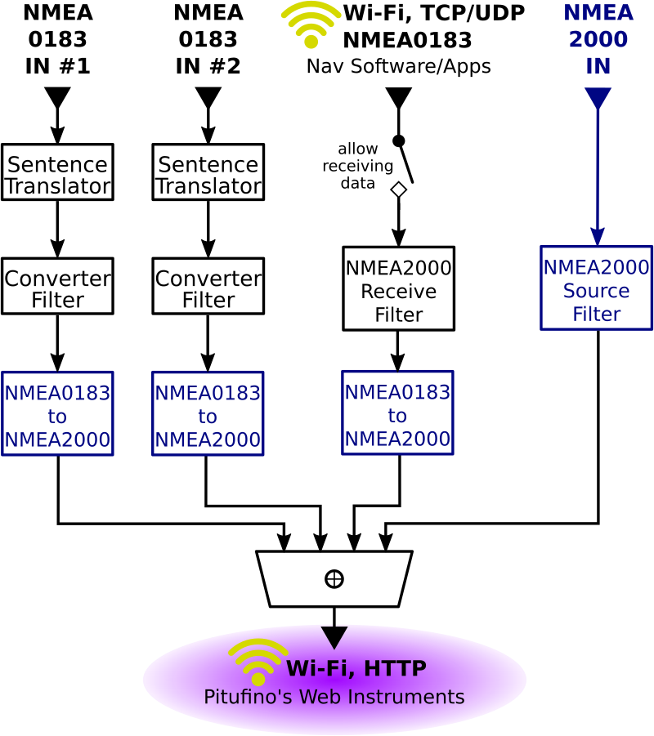
Which data-routing/filtering rules apply for these browser-run instruments?
Consider the web instruments as instruments on the NMEA2000 network. So, all settings for the NMEA2000 source filter and the NMEA0183-to-NMEA2000 converter filters affect data availability. If certain data that is already present on the NMEA2000 network is also being converted from NMEA0183, the NMEA2000 version is given higher priority.

Sailing Instruments
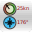
Pitufino’s sailing instruments combine a wind instrument and a compass gauge and display most relevant sailing data, including AIS targets and a logbook. On top of that, an autopilot controller keypad allows you to remote-control your pilot.

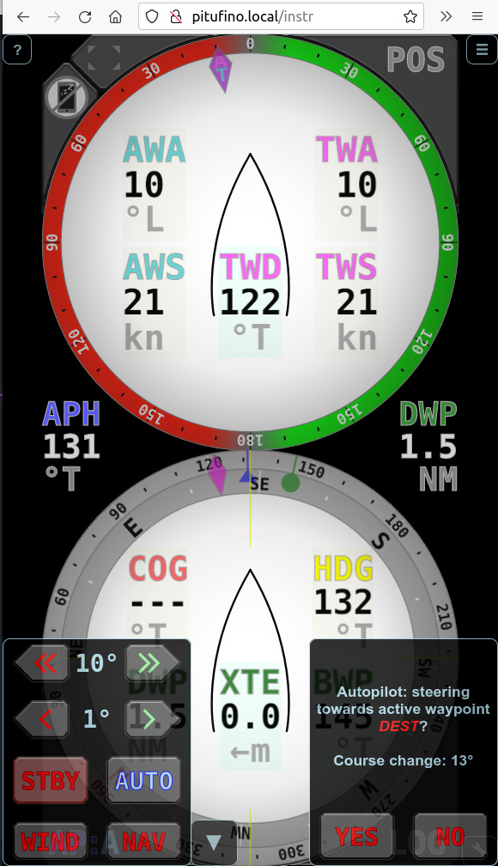
Which data can be displayed?
Fixed data fields inside the wind gauge:
- AWA ... Apparent Wind Angle
- AWS ... Apparent Wind Speed
- TWA ... True Wind Angle
- TWS ... True Wind Speed
The turquoise pointer in the wind gauge shows AWA, the pink one shows TWA. When a supported autopilot is in wind mode, the set wind angle of the auto pilot (APW) is displayed by a blue pointer.
Fixed fields in the compass gauge:
- HDG ... HeaDinG
- COG ... Course Over Ground
Available data for the six custom fields (fields with green-flashing background):
- SOG ... Speed Over Ground
- STW ... Speed Through Water
- DPT ... DePTh
- AFT ... AFT depth (or second depth sounder)
- DWP ... Distance to WayPoint
- BWP ... Bearing to WayPoint
- XTE ... Cross-Track Error
- VMC ... Velocity Made on Course (i.e., closing velocity/speed to WP. Sometimes called VMG.)
- TWP … Time to WayPoint
- TWD ... True Wind Direction
- APH .... AutoPilot Heading
- APW .... AutoPilot Wind angle
- VAR ... magnetic VARiation
- SEA ... SEA temperature
- plus plugin entries (see Appendix 3)
A click/tap on a custom field opens the data-selection menu.
Differently colored pointers on the compass rose indicate HDG (yellow line straight ahead), COG (red triangle), BWP (green circle), TWD (pink rhombus), and APH (blue triangle).
The two buttons 1’ and 10’ activate/deactivate average display. In this mode instead of the instantaneous values, 1-min or 10-min averages are shown for TWS, TWD, SOG, COG, and VMC and the averages are indicated by overlined labels (e.g., SOG). Also the pointers in the compass rose for COG (red) and TWD (pink) show averages in this mode, plus a new pointer (red, dashed) indicates the estimated tack/jibe direction, i.e. the COG after a symmetrical tack/jibe (layline). Note, for SOG, COG and VMC, instead of averaging the instantaneous values over time, the long-term values are obtained by measuring back to your 1-min/10-min old position along a straight line. The so-obtained values for speed are generally smaller than values obtained by averaging as the real track is typically not a perfectly straight line and therefore longer.
Clicking the LOG button shows time and date (UTC), averages over the last 1min/10min/1h for SOG, COG, TWS and TWD and the distance log (distance through water), total and 2x trip. The latter two can here be reset to 0. Note, for SOG and COG, instead of averaging the instantaneous values over time, the long-term values are obtained by measuring back to your 1-min/10-min/60-min old position along a straight line.
Clicking the POS button shows time and date (UTC) and the current GPS position.
Clicking the 24h button opens the logbook of the last 24 hours. The list shows data entries like position, log, and averages of course, speed and wind taken at the last 24 full hours (UTC). Maxima and minima like fastest 1-min speed were recorded since the respective previous full hour. The top-most entry shows the current values.
The button with a red triangle ⊲ shows the number of AIS targets, clicking this button opens a list of up to 25 AIS targets closest to your vessel. The list is sorted according to the target distance, the closest one is at the top. The red triangle starts flashing when an AIS target enters an adjustable safety radius (see alarm settings below).
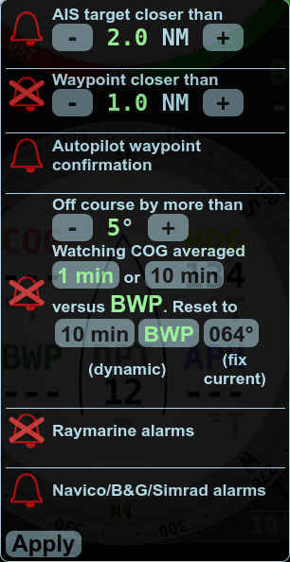
The bell button indicates whether any alarms are enabled (when none are enabled, the bell is crossed out). The bell starts flashing and a siren starts sounding after an enabled alarm was triggered. Pressing the bell button opens the menu for alarm settings and silences the siren if it is on (and also acknowledges the last ringing NMEA2000 alarm if any). Currently implemented alarms are for close AIS targets, waypoint arrival, autopilot waypoint confirmation, off course and NMEA2000 alarms from Raymarine and Navico/B&G/Simrad devices. Each alarm can be enabled or disabled by clicking its bell symbol. The alarm settings include the safety distance to AIS targets, waypoint-arrival radius and maximum course deviation. The off-course alarm can be based on 1-minute or 10-minute COG averages and the reference course can be fixed to the current value of the 1 or 10-minute average or can be dynamic by using the waypoint bearing (BWP) or, if the 1-minute average is watched, by using the momentary 10-minute average. Changes to the settings take effect only after pressing the “Apply” button.
For Pitufinos of the first generation (hardware version 1.0), make sure your browser is allowed to play media and the volume is set properly. For a reliable alarm, also make sure your browser and/or your mobile device must not enter any kind of sleep mode (don't lock your screen as this might send this browser-run app to sleep). It is also recommended to plug your mobile device to a charger to ensure it does not run out of power. Enabling an alarm automatically tries to put your device into a no-sleep mode if supported.
Pitufino hardware version 1.1 features a buzzer to sound an alarm and no longer requires the browser app to be running, the app can go to sleep or can be closed.
Clicking the AP button opens the autopilot remote control. This button also indicates the autopilot status:
- ? ... autopilot is switched off or not supported
- S ... autopilot is on Standby
- A ... autopilot is in AUTO mode (set heading)
- W … autopilot is in WIND mode (set wind angle)
- N … autopilot is in NAV or TRACK mode (towards active waypoint)

Which autopilots can be controlled?
Currently, Raymarine’s SeaTalkNG pilots like EV-1/EV-2/SPx30 as well as NMEA2000 pilots from Navico/Simrad/B&G like NAC-3/NAC-2 or AC-42 are supported. Firmware V1.5.0 adds support for Garmin Reactor pilots. To enable the remote control, your pilot must be selected in the NMEA2000 source-filter settings for “Autopilot data”.

The  Preferences Menu
In this menu in the bottom-right corner you can choose your preferred
- units, for instance true or magnetic, meter or feet,
- damping for COG, SOG and wind data between 0 sec (i.e. no damping in flat-calm conditions) and 9 sec (very strong damping for a rough sea state. Note, stronger damping inherently causes longer delays. Also note, web apps have their own data damping and are not affected by Pitufino’s system settings.),
- color theme for day or night.
The color theme might also be switched by a long tap (some touch devices) or a right click (laptops/PCs) on the button or anywhere on the open Preferences menu. Note, web app preferences are stored by your web browser, so different mobiles (or browsers) can have different (i.e., personal) choices.

Toggles fullscreen mode.

Toggles no-sleep mode (to prevent mobile devices from blanking their screens). This feature works on most Android devices and on older iOS devices.

Exporting your Logbook
Firmware V1.5.0 comes with a rudimentary Logbook Assistant that can be opened in a browser from the address pitufino.local/logbook (or 192.168.4.1/logbook). Note, this program is still work in progress and will come with more features in future firmware releases. Pitufino stores logbook entries of the last 24 hours internally. Additionally, the Sailing Instruments web app as well as the Logbook Assistant store these entries in the browser. Entries will be kept in the browser for 14 days. To obtain a continuous, gapless recording in a browser, the Sailing Instruments web app (or the Logbook Assistant) should be used regularly, at least twice a day.
The Logbook Assistant can export logbook entries stored in the browser to be used, e.g., in spreadsheet progams like MS Excel. Select the days you want to export and then drag-and-drop the .csv icon onto either a text editor or a folder (file manager) and save the file with a .csv extension.

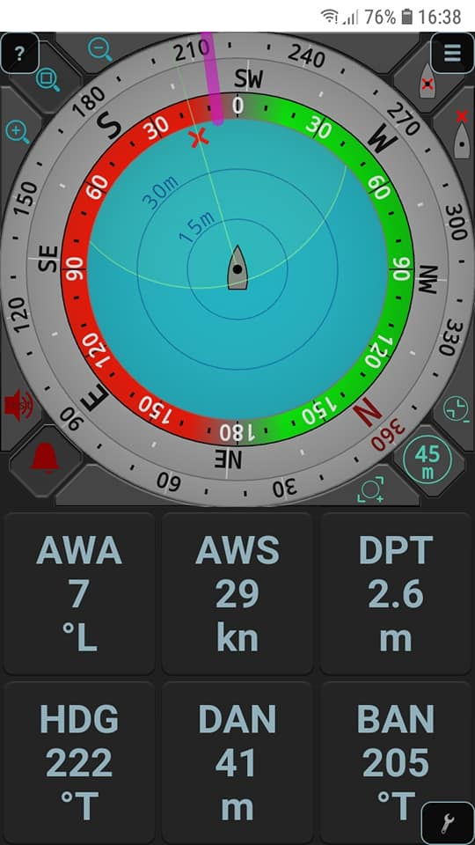
Anchor-Watch Instrument View
This web app implements a dedicated instrument view for times at anchor.

Combination gauge and anchor watch
This gauge graphically displays your vessel’s heading and apparent wind angle/direction and, after an anchor position has been set, also anchor bearing and anchor distance. Use the buttons in the top-right corner of the gauge to set an anchor position:

Sets your current ship’s position as the anchor position.

Lets you enter a distance to set a position straight ahead of your GPS position, e.g., your bow when you set the anchor position while dropping the anchor, or your chain radius when you set the anchor position after you have anchored.

These buttons in the lower-right corner of the gauge show and change the safety radius for an anchor alarm.

To enable an audible alarm, this bell button in the lower-left corner needs to be activated.
Make sure your browser is allowed to play media and the volume is set properly. You can use the Test-Audio button to ensure your settings are correct. Also note that for a reliable alarm, your browser and/or your (mobile) device must not enter any kind of sleep mode. So, don’t lock your screen as this might send this browser-run app to sleep (just dim the screen if appropriate). It is also recommended to plug your mobile device to a charger to ensure it does not run out of power. Enabling the audible alarm automatically puts your device into a no-sleep mode (if supported).
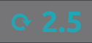
Pitufino keeps track of how many turns (i.e., rotations or 360s) your vessel does while at anchor. For instance, ⟳ 2.5 means it turned clockwise two and a half times. In some anchorages (i.e., changing currents, wind against current, or catabatic winds from different directions) this info can be useful for untwisting your chain again. Pressing this button resets the counter.

Data Fields
A click/tap on one of the six data fields opens the data-selection menu and you can choose to display any of the following:
- AWA ... Apparent Wind Angle (equals true wind angle at anchor)
- AWS ... Apparent Wind Speed (equals true wind speed at anchor)
- DPT ... DePTh
- AFT ... AFT depth (or second depth sounder)
- STW ... Speed Through Water
- DAN ... Distance to ANchor
- BAN ... Bearing to ANchor
- HDG ... HeaDinG
- SEA ... SEA temperature
- TWS_{1’} ... 1min-average Wind Speed
- TWS_{10’} ... 10min-average Wind Speed
- TWS_{60’} ... 60min-average Wind Speed
- TWD_{1’} ... 1min-average Wind Direction
- TWD_{10’} ... 10min-average Wind Direction
- TWD_{60’} ... 60min-average Wind Direction

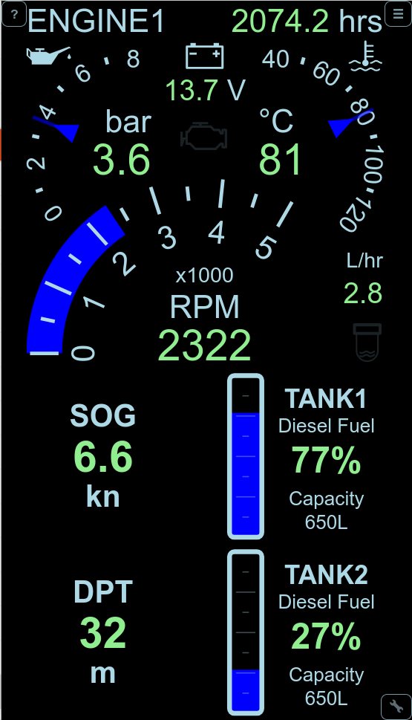
Multi-Instrument Display
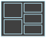
This app implements a fully customizable instrument display.

Choosing a layout
In the Preferences menu, click/tap the “Layout” button, then choose your preferred number of columns and rows. Note, the screen is always divided into two partitions and for each you can choose the columns and rows. For instance, “3 x 2 + 2 x 1” means 3 columns by 2 rows in the first screen partition and 2 columns by 1 row in the second. Also note, if you rotate your display from portrait to landscape (or the other way round), rows and columns will be swapped to maintain good space filling.
To improve screen utilization, the division into the two primary partitions can be adjusted, e.g., 50% + 50% for two equal halves, or 56% + 44% to obtain a square first partition on a 16:9 widescreen for a maximum-size first display.
Once a layout is chosen, all displays in a screen partition have the same size. This can be changed at any time by zooming in on one display using a pinch gesture on touch devices or a scroll input (mouse wheel, 2-finger or edge scroll on trackpad, etc.) on laptops/PCs.

Choosing display types
A swiping/dragging gesture over a display field opens the display-type selector. Alternatively, a long tap (some touch devices) or a right click (laptops/PCs) on a display field might work as well.
Currently ten types are available:
- digital display
- wind instrument
- compass
- pilot controller
- averages (for SOG, COG, TWS and TWD)
- tank display
- engine dashboard
- UTC date/time
- position
- distance/trip log
Note, the multi display is under active development and more display types will be available in upcoming firmware versions. Check Pitufino's web site or facebook page whether a new firmware can be downloaded.

Choosing display data
For some display types, the data (or tank or engine) to be shown needs to be selected. A short click/tap on a display field opens the data/tank/engine selector.

AIS targets
Firmware V1.5.2 added a button in the bottom-left corner to the Multi-Instrument Display that shows the number of AIS targets. Clicking this button opens a list of up to 25 AIS targets closest to your vessel. The list is sorted according to the target distance, the closest one is at the top.

Firmware Updates

Where to find updates?
Our development team regularly releases updates with new features and improvements. The latest firmware version can be downloaded from https://pitufa.at/pitufino/. Announcements of new features and firmware version are also made on Pitufino’s public facebook page https://facebook.com/pitufino.gateway. If you have a facebook account you may follow this page to receive notifications about updates.

How to update?
While connected to the internet, download the latest firmware as a .zip file from the web page http://www.pitufa.at/pitufino/. After downloading, extract the contents of the zip file onto your computer. This will create a new folder called “Pitufino.Firmware.Vx.y.z” (where x.y.z will be replaced by the actual version number, e.g. “Pitufino.Firmware.V1.4.3”).

Switch on your Pitufino and connect your computer’s Wi-Fi to Pitufino. In a web browser, open one of Pitufino’s pages, e.g. http://pitufino.local or 192.168.4.1 (or the IP address your external router has assigned to Pitufino). Choose “Firmware Update” from the page menu.
On the Firmware Update page, click “Browse…” to select the folder you created by extracting the downloaded zip file, e.g. “Pitufino.Firmware.V1.4.3”. Then click “Update”. Do not switch off your Pitufino or your computer and do not disconnect the Wi-Fi connection while the update is in progress. Pitufino automatically reboots after a successful update, which may disconnect the Wi-Wi connection. If your computer’s Wi-Fi does not automatically reconnect to Pitufino, you have to reconnect manually.
It is recommended to verify Pitufino’s settings after an update as new features often bring new configuration options. Note that a new World Magnetic Model is released usually only every 5 years.

Technical Support
The (private) Pitufino Owners facebook group https://www.facebook.com/groups/pitufino.owners is a platform to discuss all Pitufino-related topics with other Pitufino owners as well as with the developers, to ask for support, suggest feature requests or report problems. A facebook account is required to read posts and to contribute in this group.

If you do not have a facebook account, you can contact our technical team by sending an email to the address support@currently-marine.com.

Appendix 1: Pitufino’s NMEA0183 data servers

TCP Server (default port 2947)
As soon as an application (e.g., a chart-plotter program) establishes a TCP connection to the server, Pitufino sends the data stream to the application and listens for NMEA sentences received from the application. As each app has its own TCP connection, the server has to send the same data stream several times. Several applications can be served simultaneously, even several programs running on the same computer/mobile. Note, TCP connections require considerable CPU time and memory, so the total number of simultaneous TCP connections (including connections to the web server) is limited to 8. Also note, the handshaking of TCP to ensure reliable delivery (e.g., retransmitting packets) is rather hindering than useful for real-time data such as GPS messages as this can lead to network congestion and delays. For instance, when a Wi-Fi connection is weak and not all packets arrive, retransmission of an old position may delay or even jeopardize the transmission of the new position.

UDP Broadcast Server (default port 10110)
A broadcast server sends the data stream to the network without a particular destination address and without any prior requests from applications. Each computer/mobile in the network can receive this data. An application does not need to establish a connection but asks the operating system to listen on a port. Note that firewalls typically block such traffic by default and exception rules need to be specified (e.g., ALLOW INCOMING UDP 10110). Also note that commonly only one application per computer (or rather per operating system) is allowed to listen on a particular port. Many nav apps on mobile devices automatically listen on UDP port 10110, so no configuration is necessary.

UDP Unicast Server (default port 10111)
Similar to TCP connections, an application needs to initiate the data transfer and each app receives its own data stream. As UDP works without any handshaking, the application initiates (or resumes) the transfer by sending the first data packet (this can be empty or contain an NMEA0183 or any other message) to the server. Usually no firewall exception rules are necessary and several programs running on either the same computer/mobile or on different ones can be served. There is no strict limit on the number of simultaneous UDP streams as these require only little resources.
Weighing the pros and cons of the 3 different network connections, the UDP unicast server is the preferable choice for real-time NMEA data: no firewall problems, no limitation on the number of simultaneous streams (not in total nor per device), little CPU and memory utilization and barely any susceptibility to congestion. However, hardly any navigation apps can establish a unicast UDP connection (or not yet). To still benefit from Pitufino’s UDP unicast server, virtual serial ports can be created from a UDP stream.

Appendix 2: Virtual Serial Ports from Network Connections
If your navigation program cannot read nav data from a network connection at all (e.g., SAS.Planet) or if you prefer to use Pitufino’s UDP unicast server, you can create a virtual serial port—most navigation programs on Windows, Linux and macOS can read NMEA0183 data from serial (i.e. COM) ports. Under Linux and macOS, the socat program can be used (see script below), for Windows a driver software is needed.

Bash script for Linux or macOS using socat
- Creates the bidirectional, virtual serial port /tmp/vcom0 which links to Pitufino’s unicast UDP server.
- Periodically sends ‘HELLO’ to Pitufino—only after the first ‘HELLO’ the connection is actually established and the data stream starts; the repeated transmissions are ignored unless the connection got interrupted, in which case the ‘HELLO’ resumes the stream transfer.

#!/bin/bash
coproc socat pty,link=/tmp/vcom0,rawer UDP:pitufino.local:10111,end-close
while test $COPROC_PID; do sleep 2; echo HELLO > /tmp/vcom0; done

Run this script before opening your nav application. The created serial port can be used for instance in OpenCPN, where such a connection is configured as ‘Serial’ with ‘DataPort: /tmp/vcom0’. For Windows programs running on Linux via wine (e.g., SAS.Planet), an entry in the registry file .wine/system.reg is needed to forward the virtual serial port as e.g. COM2:

.wine/system.reg:
...
[Software\\Wine\\Ports]
...
"COM2"="/tmp/vcom0"
...

Appendix 3: Displaying Custom Data
Firmware V1.4.5 added a plugin mechanism for displaying custom data in the Sailing Instruments web app and the Multi Instrument's digital display. Such plugins expand Pitufino’s functionality and allow an extensive customization. For instance, if you prefer to read speed in mph instead of knots or if you know a better way to calculate your time of arrival, a tiny plugin can give you the display you want without the need of waiting for a new firmware.
The Multi Instrument web app includes an editor (in the Preferences menu) to add, change or delete plugins. Plugins contain JavaScript code, but you do not need to be a programmer to use them, simply send an email or a facebook message to the Pitufino developers if you have an idea for a new data entry or a customization wish. If you do have some programming skills, it is easy to create your own plugins. Pitufino’s firmware comes with a few custom data examples.

After creating and saving a new plugin in the editor, it is stored in your web browser. In this way, all users onboard can have their own customization. However, it is also possible to upload all plugins from a device to Pitufino if you want to distribute them among several devices.

