**ADF-Copy Activity (ADLS to on prem SQL SSMS)**

**Problem Statement:**

Copy data from Azure Data Lake Storage gen 2 to on premise MS SQL server 2019.

**Solution:**

MS SQL SSMS Data base: SQL server authentication

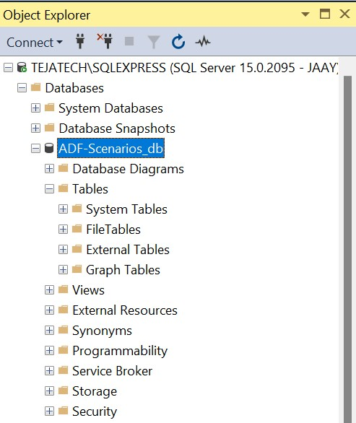

ADF Copy Data Pipeline – General

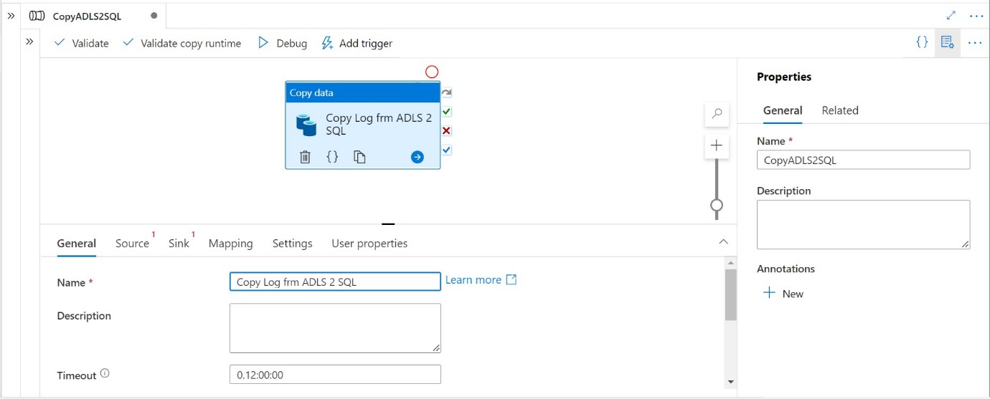

ADF Copy Data Pipeline – Source

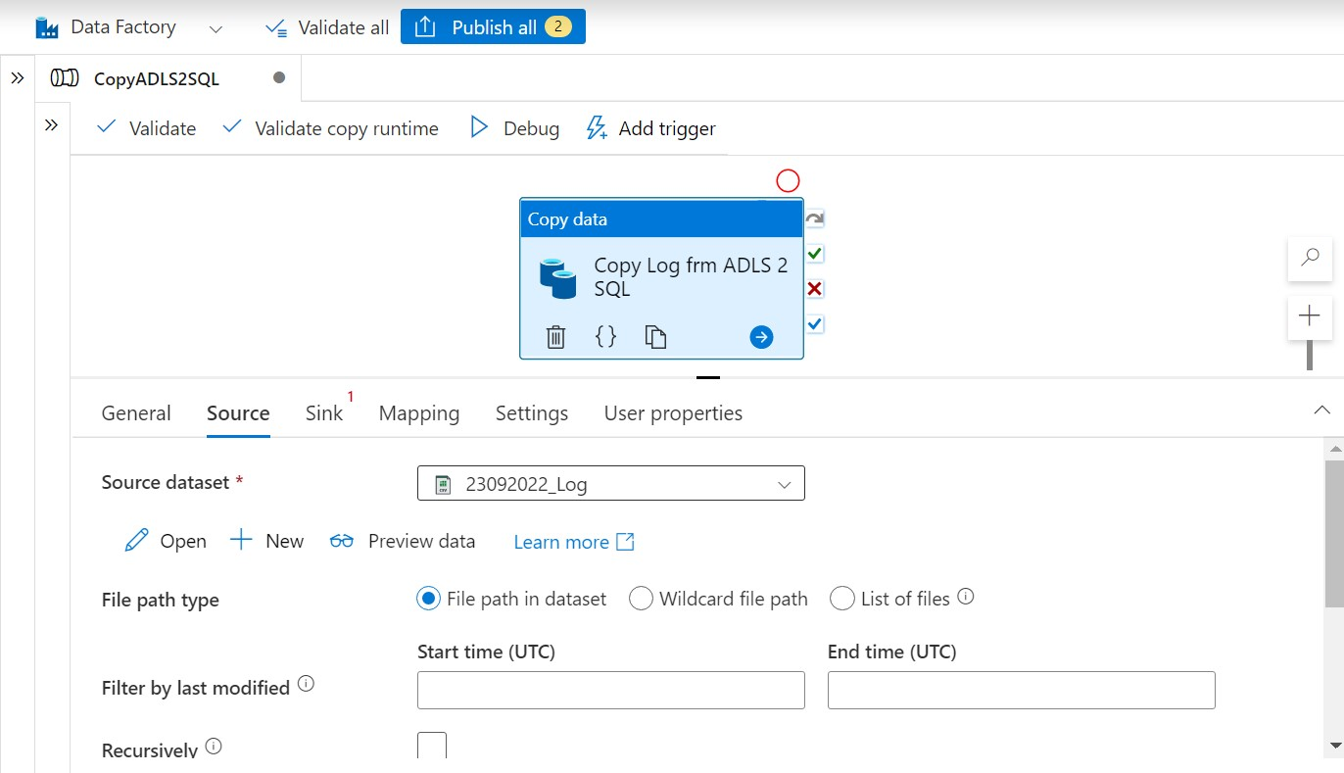

ADF Copy Data Pipeline – Source data set schema

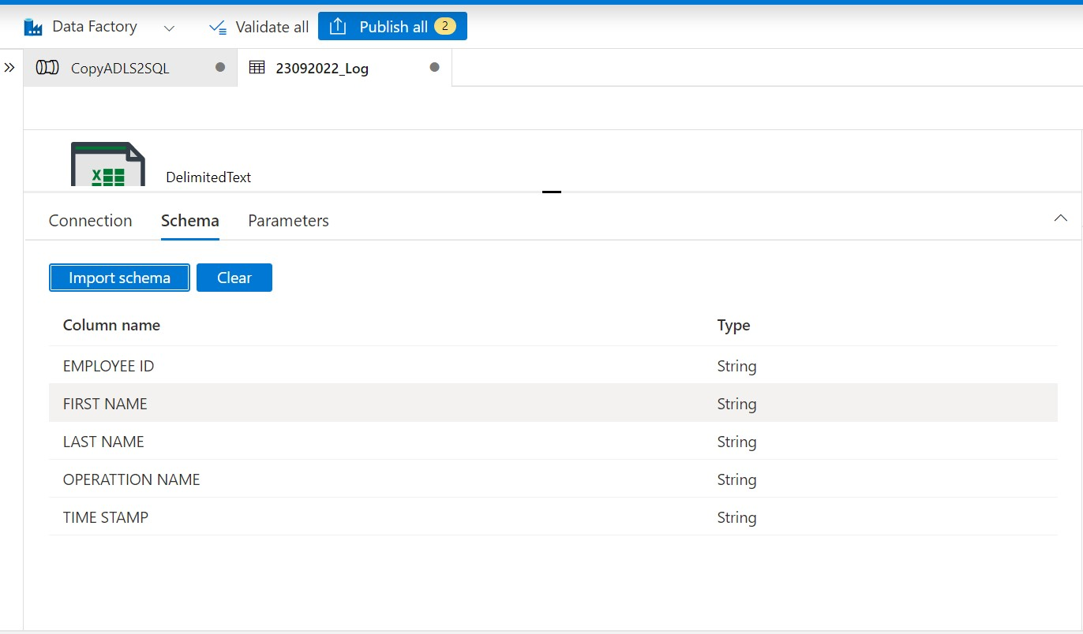

ADF Copy Data Pipeline – Sink

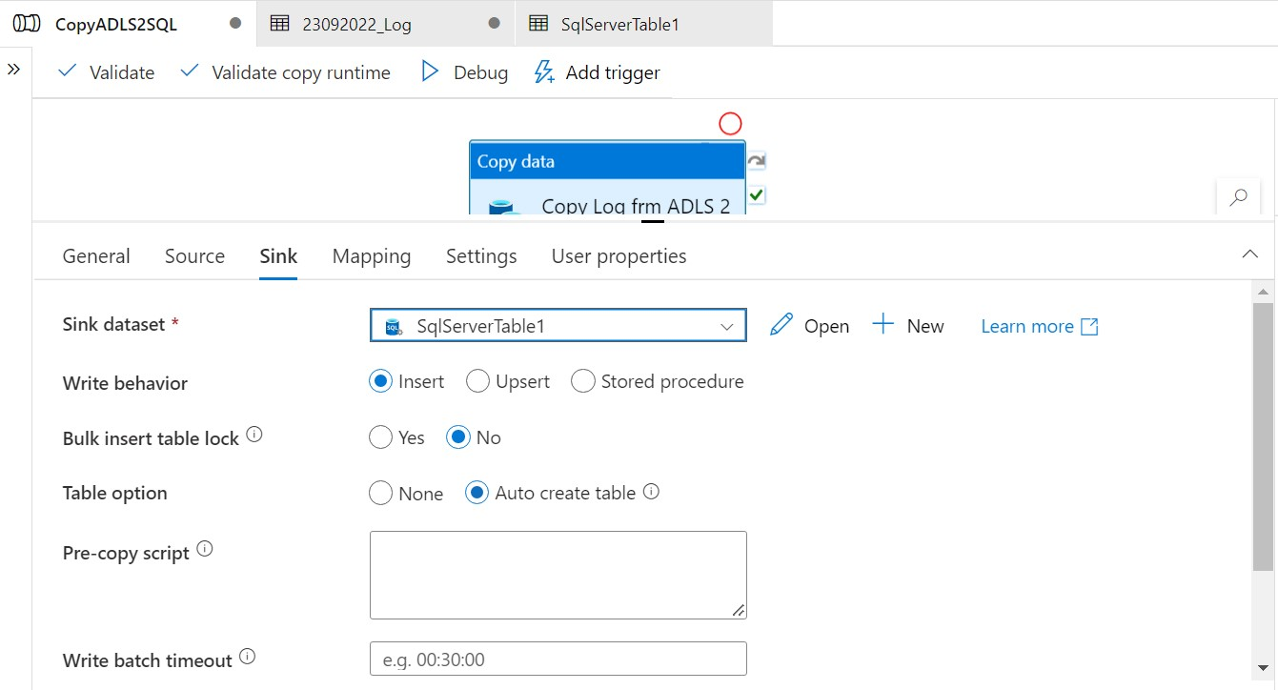

ADF Copy Data Pipeline – Mapping

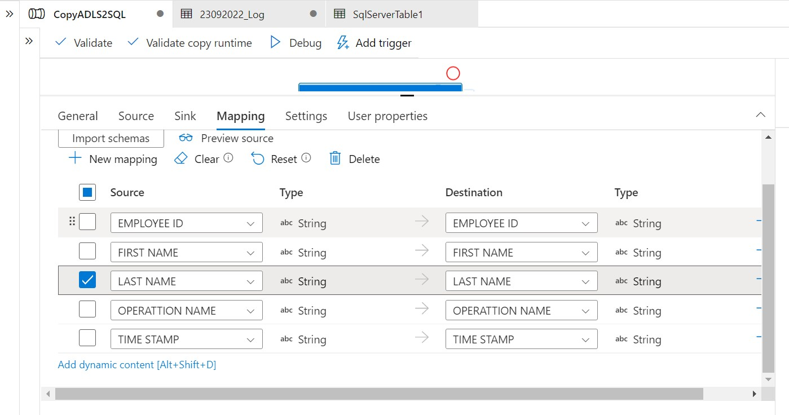

ADF Copy Data Pipeline - Properties

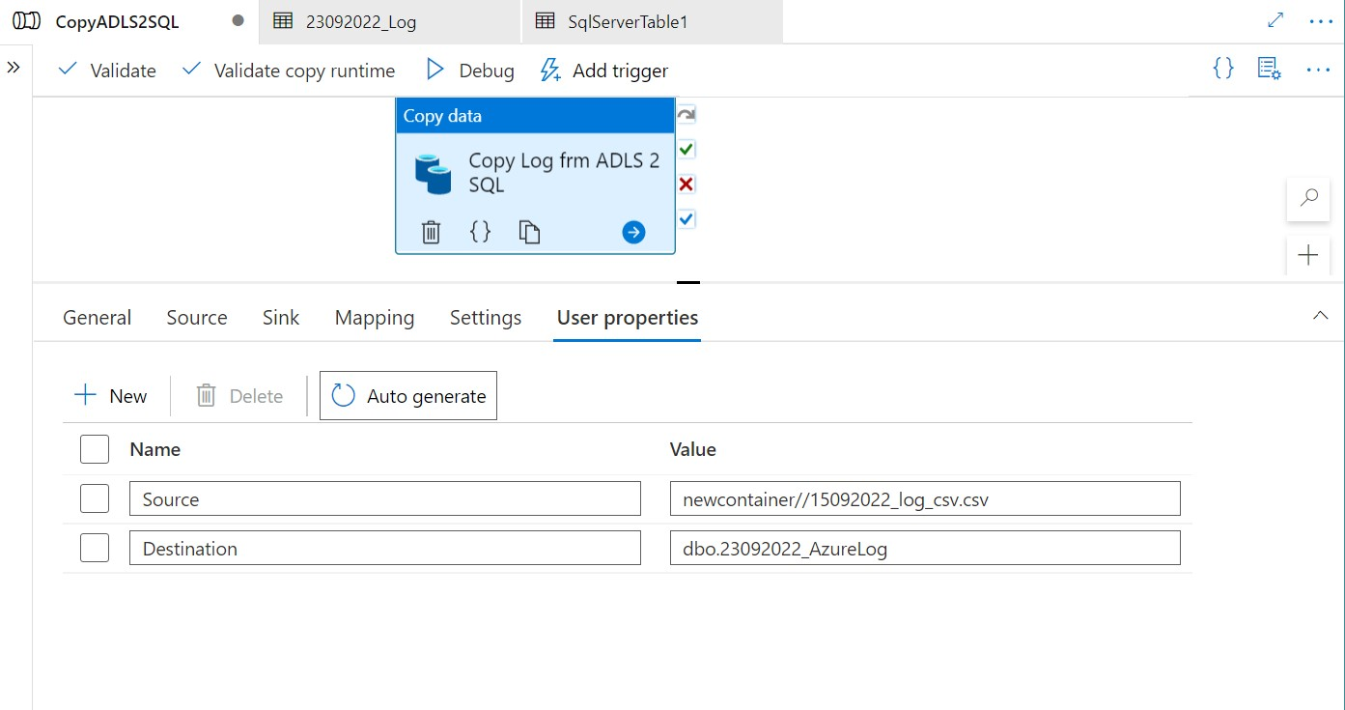

ADF Copy Activity Pipeline & Runtime validations

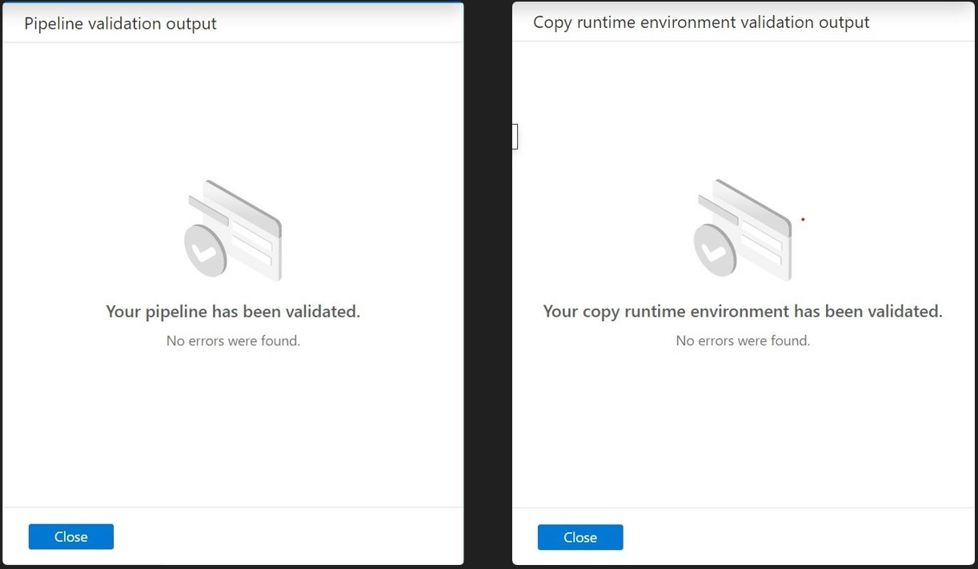

ADF Copy Activity Pipeline - Publish

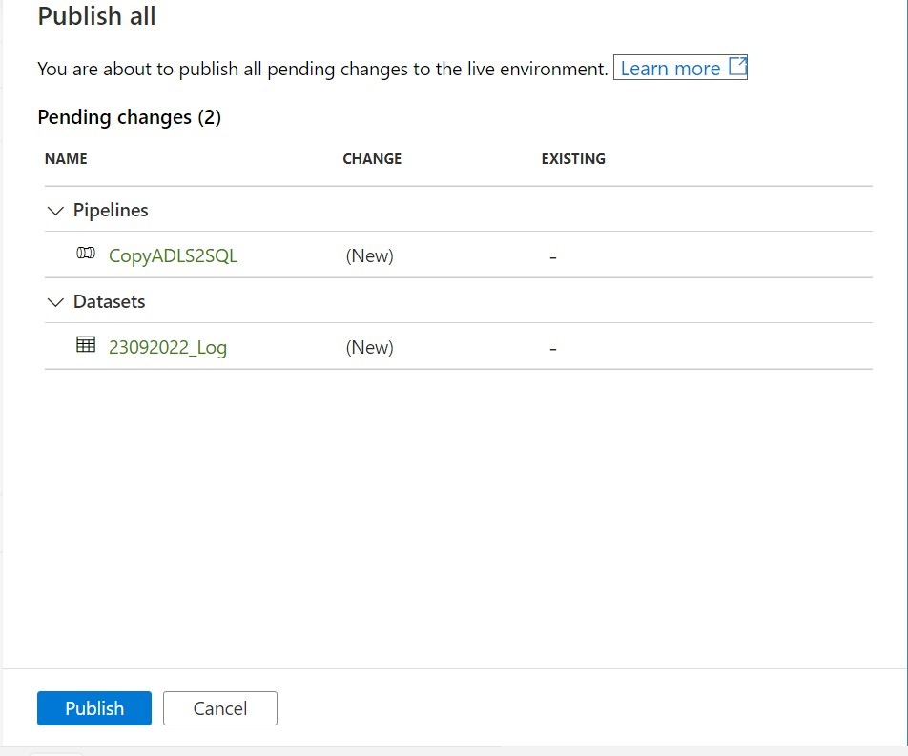

ADF Copy Data Activity Pipeline – Preview Source

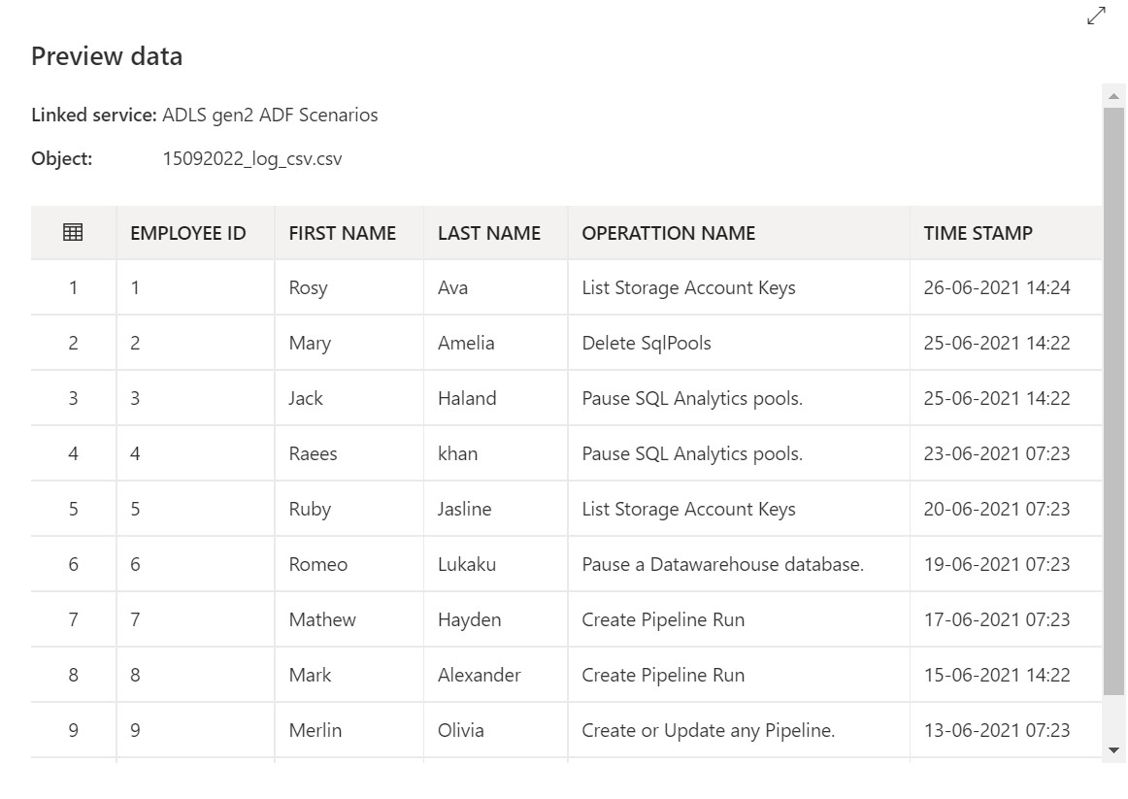

ADF Copy Data Activity – Pipeline Run Trigger

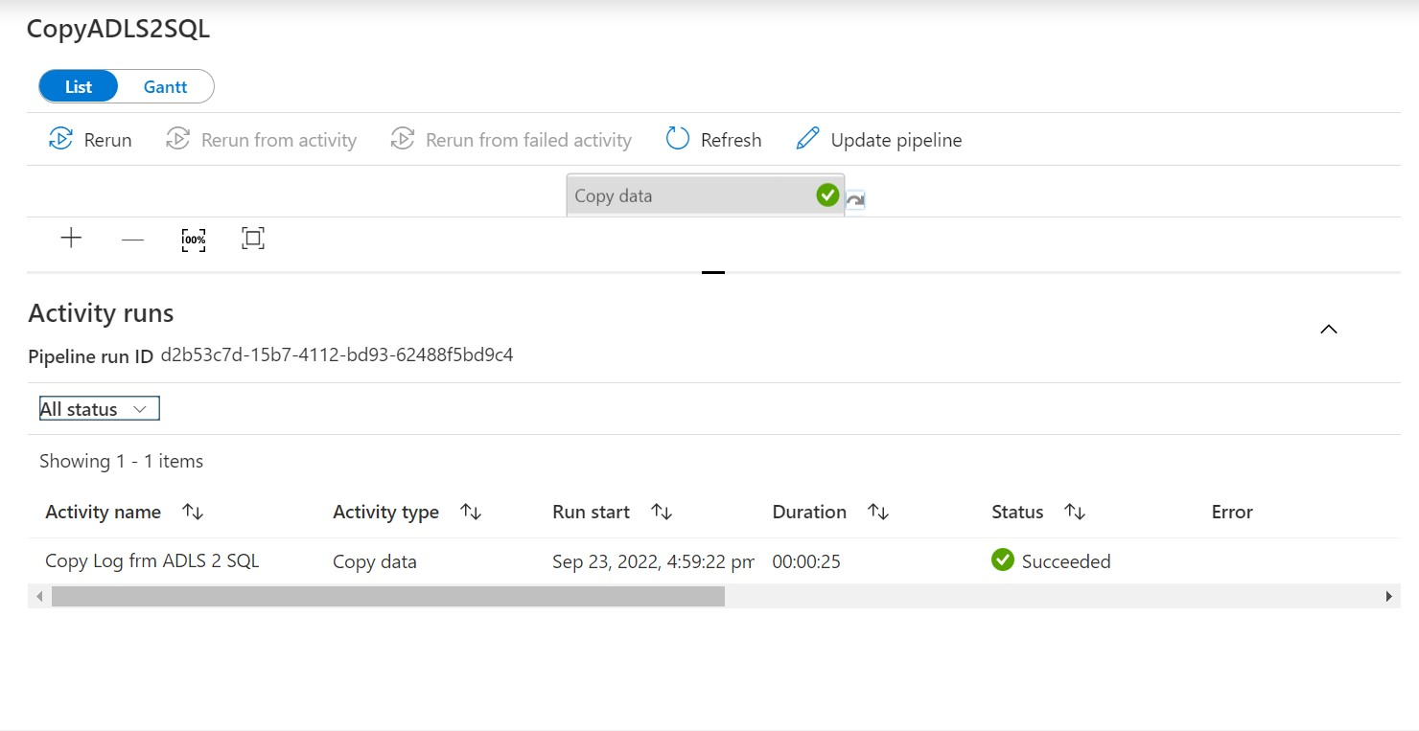

MS SQL Server Data Base after running pipeline

