**ADF Copy Data Activity**

**(On prem SQL to ADLS - CSV to JSON)**

**Problem Statement:**

Copy data from MS SQL Server 2019 SSMS data base to Azure Data Lake Storage gen2 and store the data in JSON format at ADLS.

**Solution:**

ADF Copy Data Activity Pipeline - General

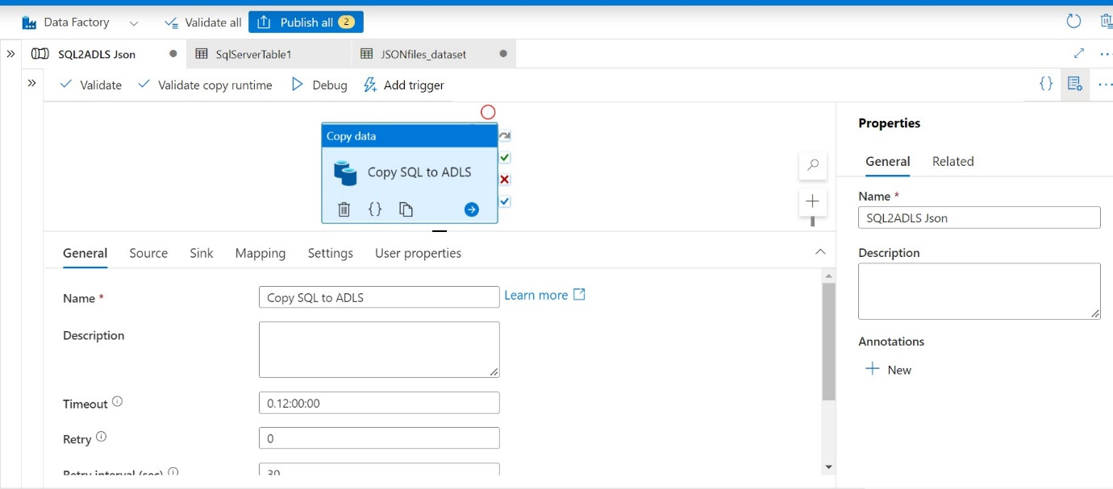

ADF Copy Data Activity Pipeline – Source

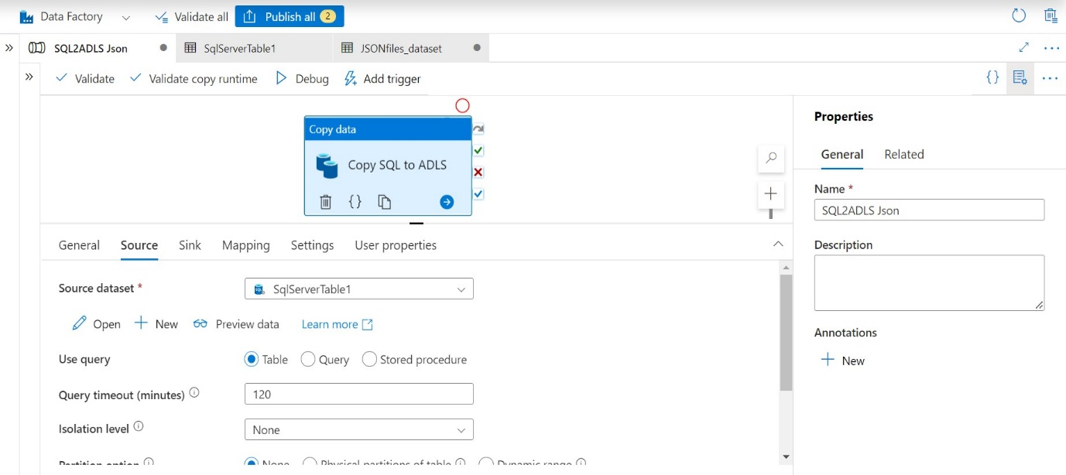

ADF Copy Data Activity Pipeline – Sink

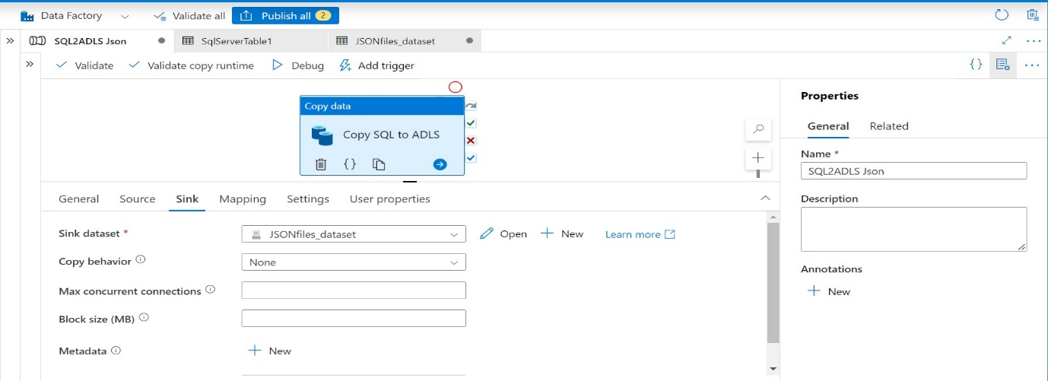

ADF Copy Data Activity Pipeline – Mapping

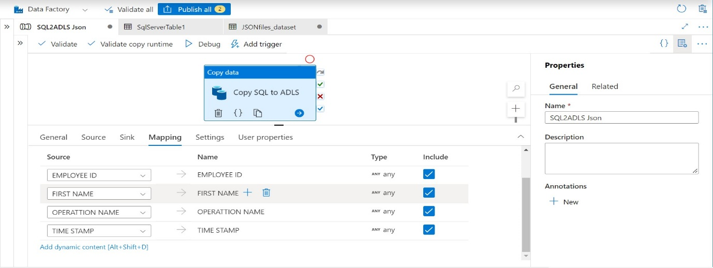

ADF Copy Data Activity Pipeline – User Properties

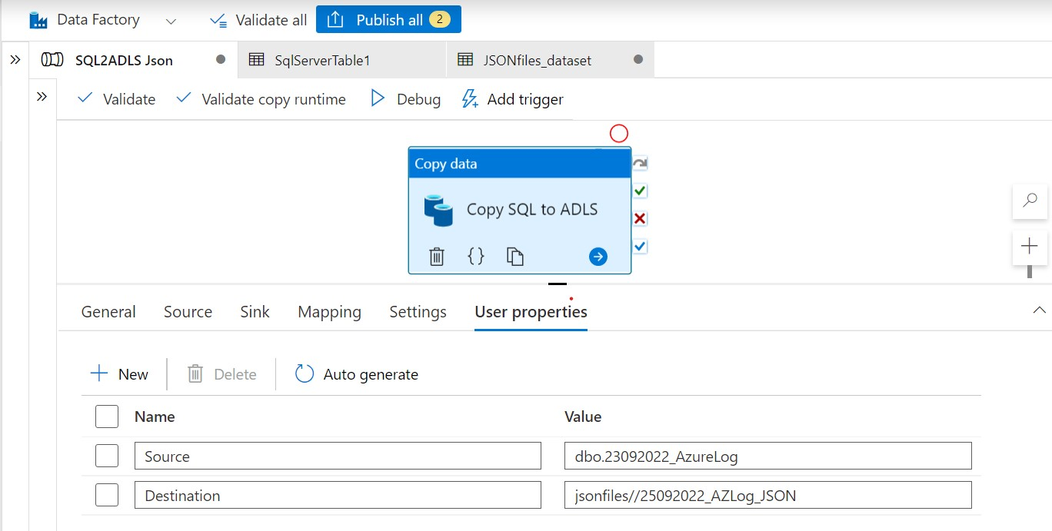

ADF Copy Data Activity Pipeline – Publish

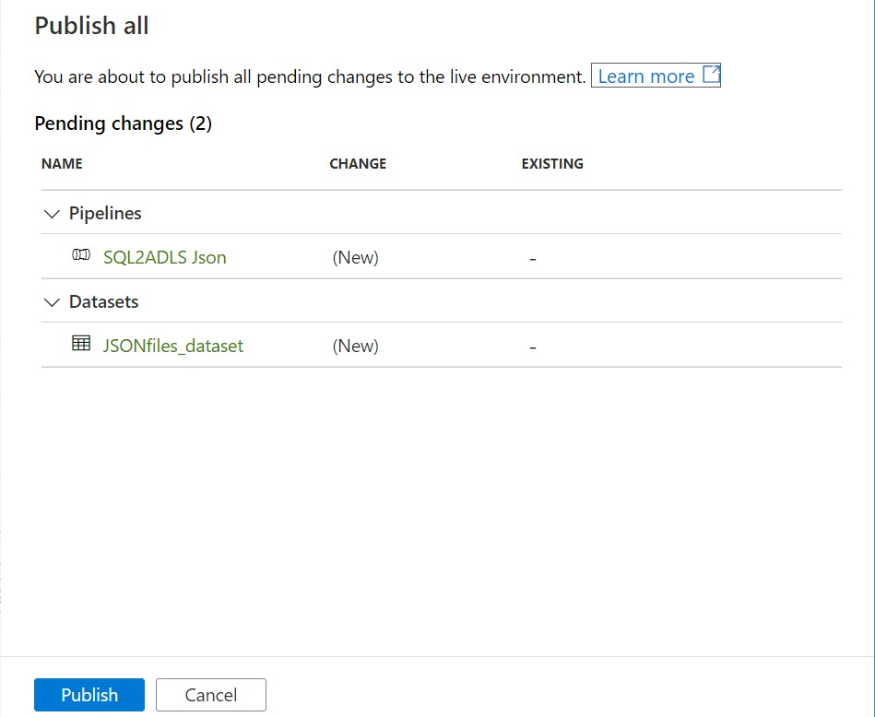

Azure Data Lake Storage before running pipeline

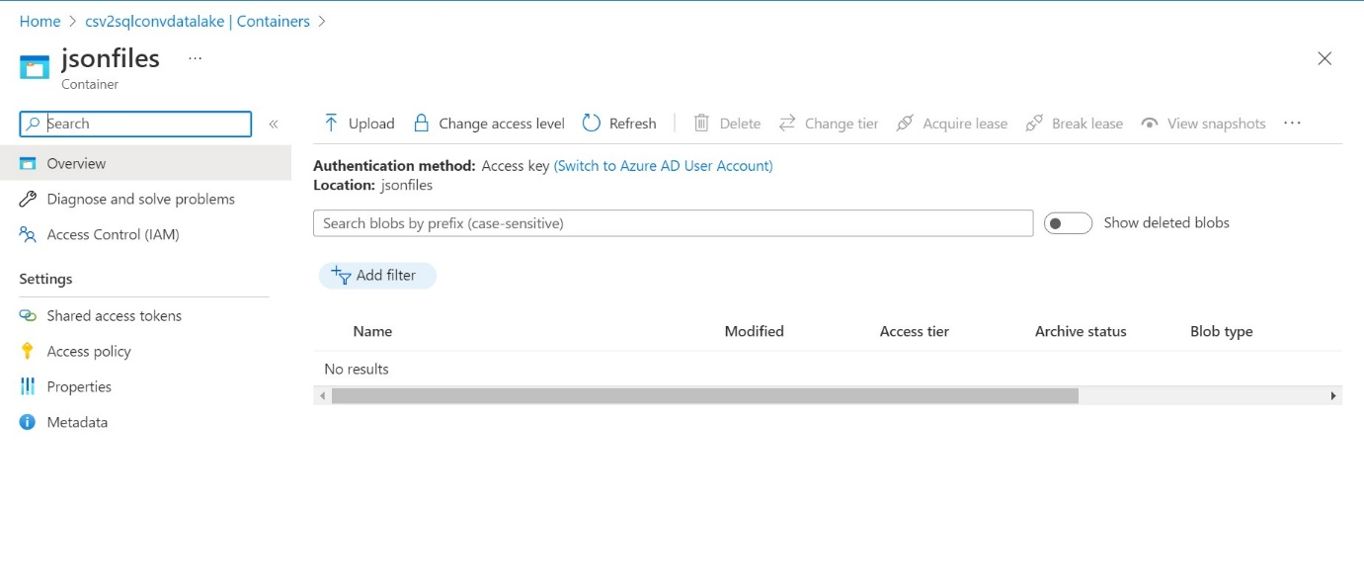

ADF Copy Data Activity Pipeline – Trigger pipeline run

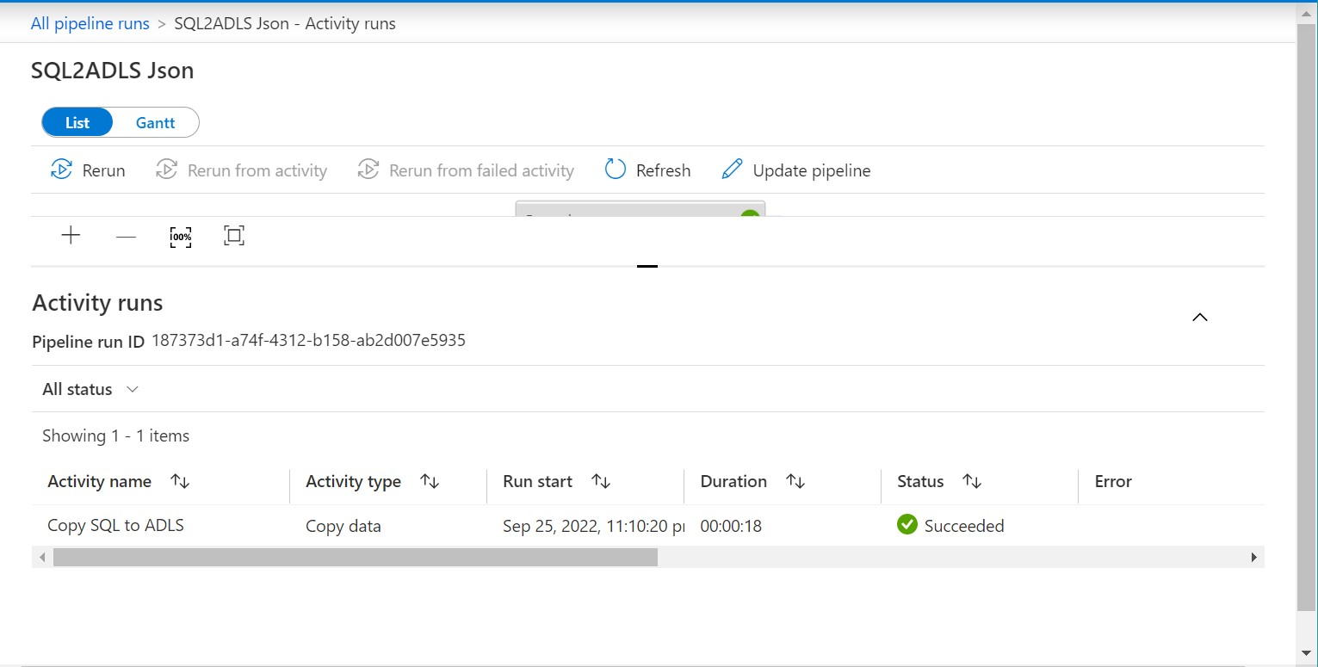

ADLS container after running pipeline

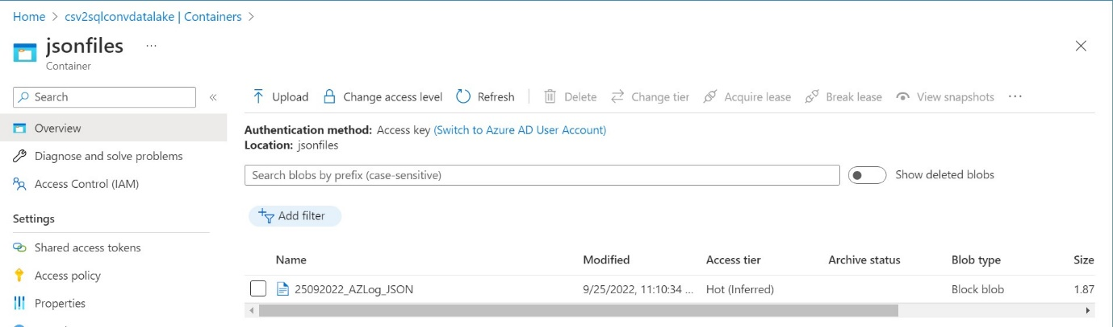

JSON file

