**ADF Copy Data Activity**

**(On Prem SQL to ADLS .csv to Parquet format)**

**Problem Statement:**

Copy data from MS SQL server data base to Azure Data Lake Storage gen2 and store data in Parquet format at ADLS.

**Solution:**

ADF Copy Activity Pipeline – General

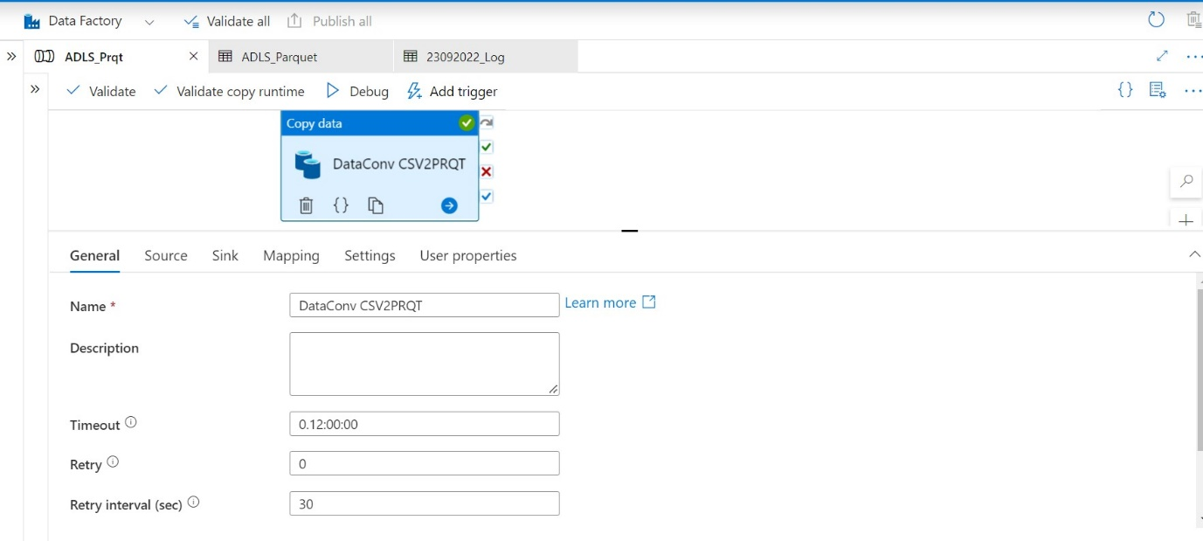

ADF Copy Activity Pipeline – Source

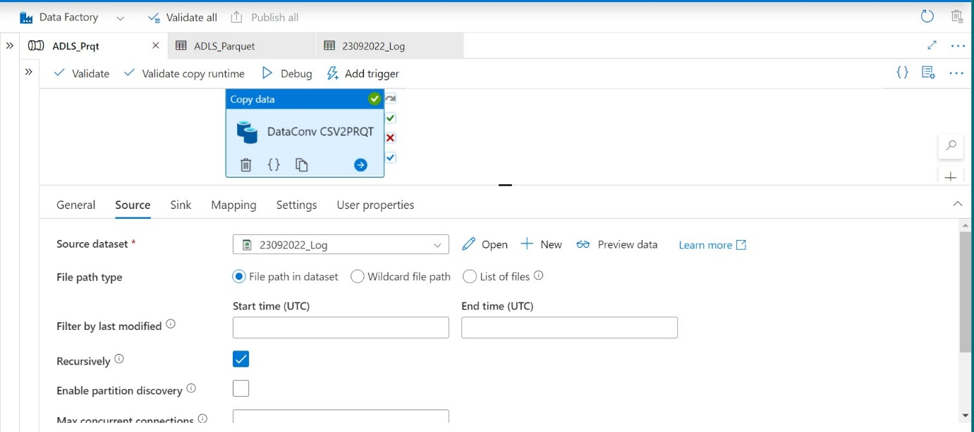

ADF Copy Activity Pipeline – Preview Source data set

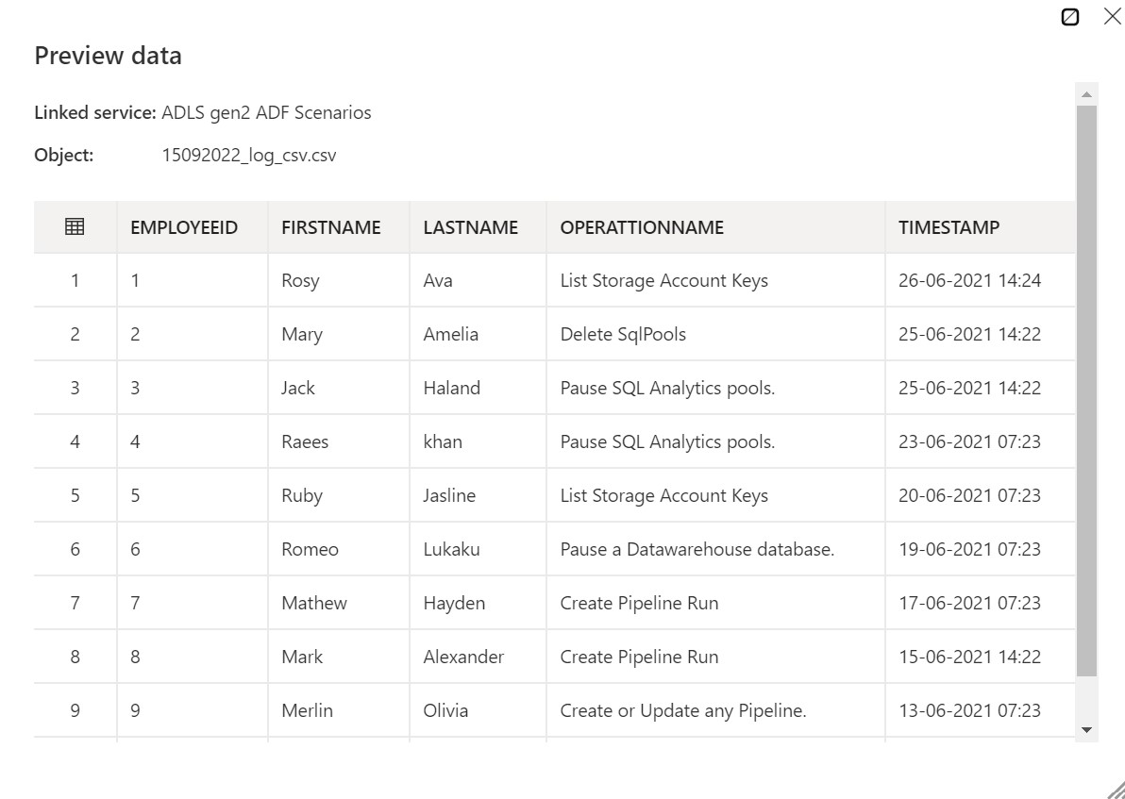

ADF Copy Activity Pipeline – Sink

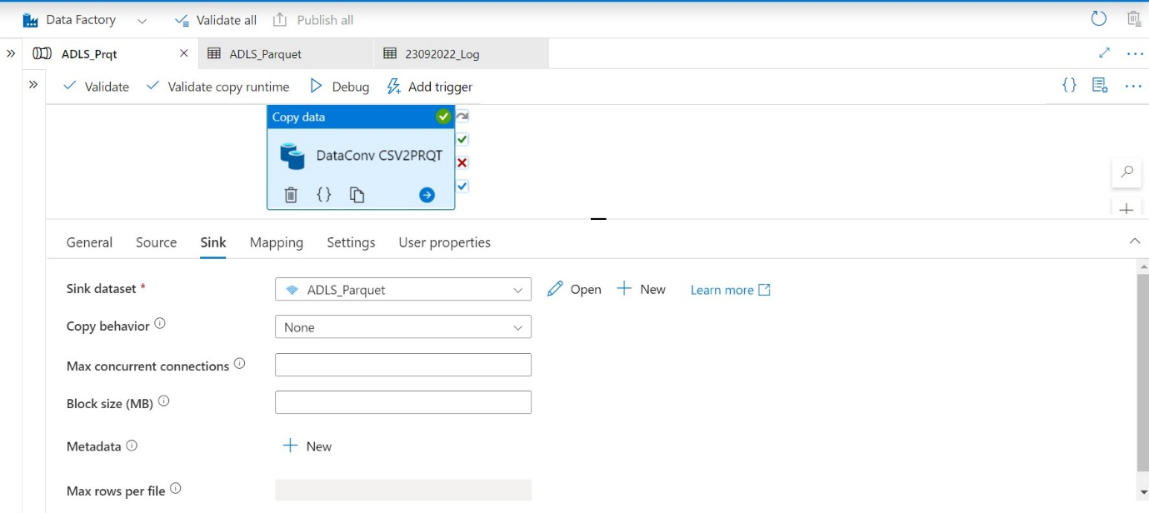

ADF Copy Activity Pipeline – Mapping

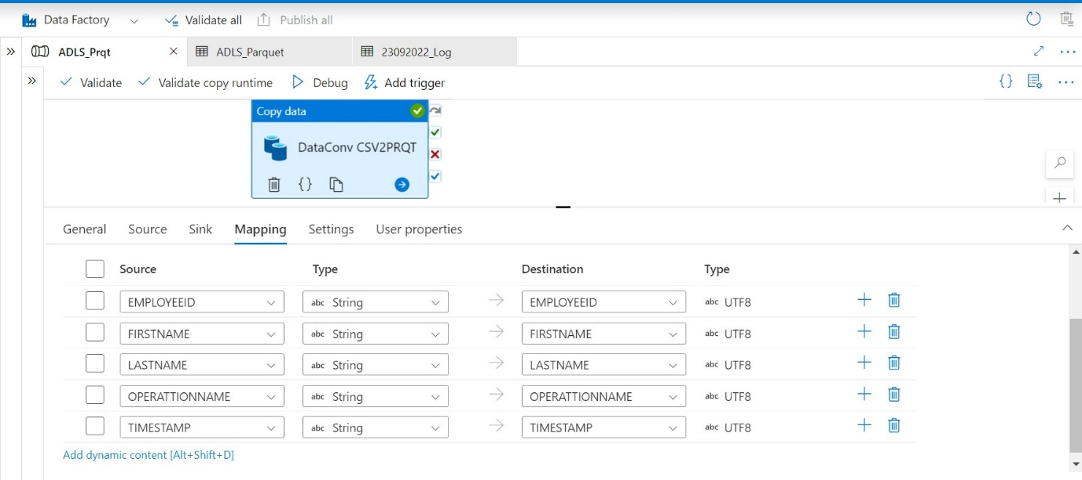

ADF Copy Activity Pipeline – User Properties

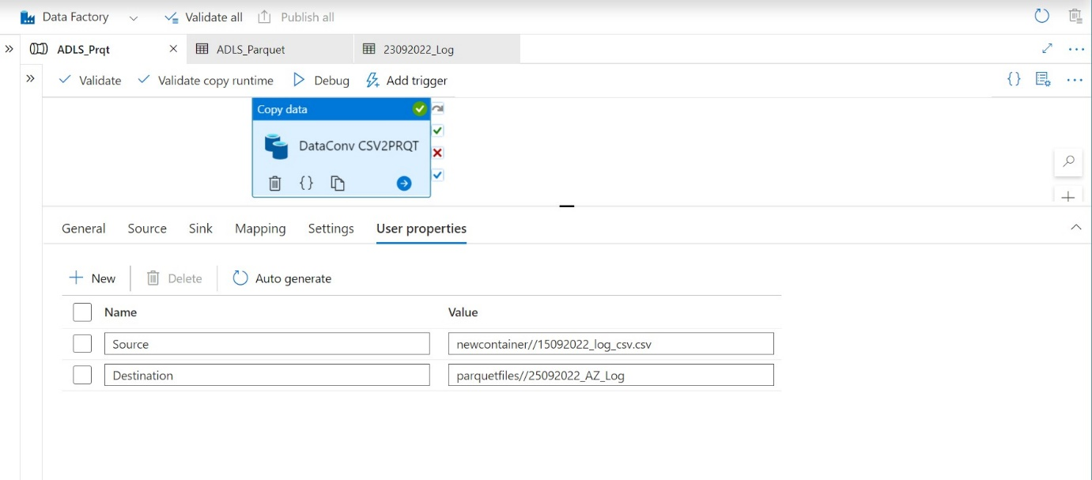

ADF Copy Activity Pipeline – Sink Data set Properties (used snappy)

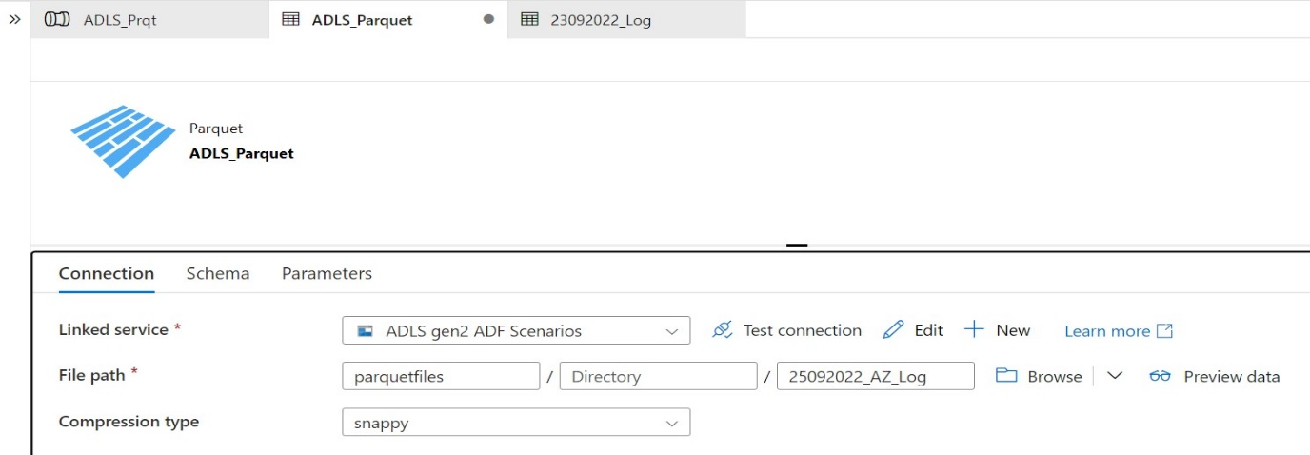

ADF Copy Activity Pipeline – Trigger Pipeline run

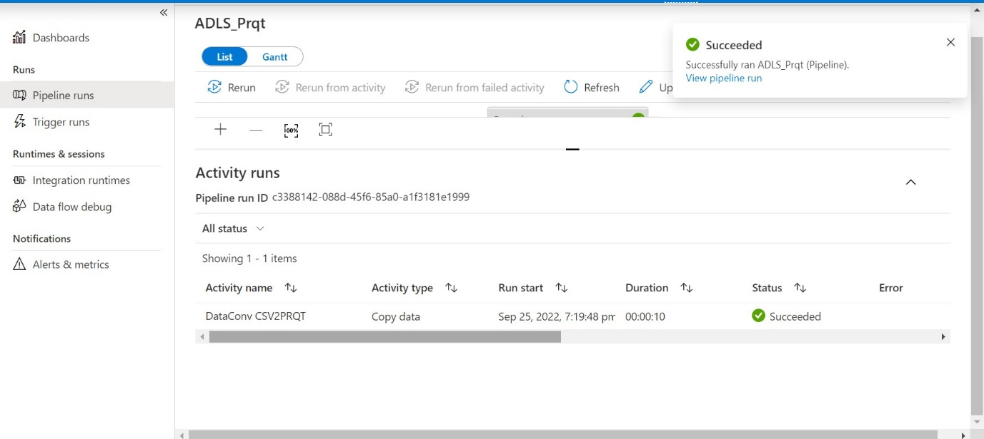

Azure Data Lake Storage container after running pipeline

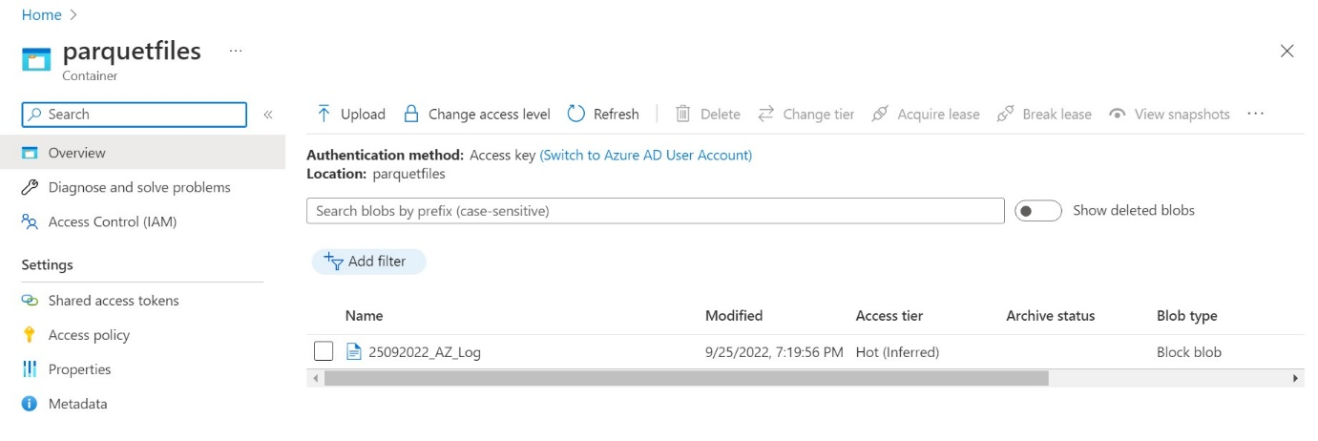

Parquet file

