**SQL BASICS by GOPI.CHOWDAM**

1.CREATE DATABASE

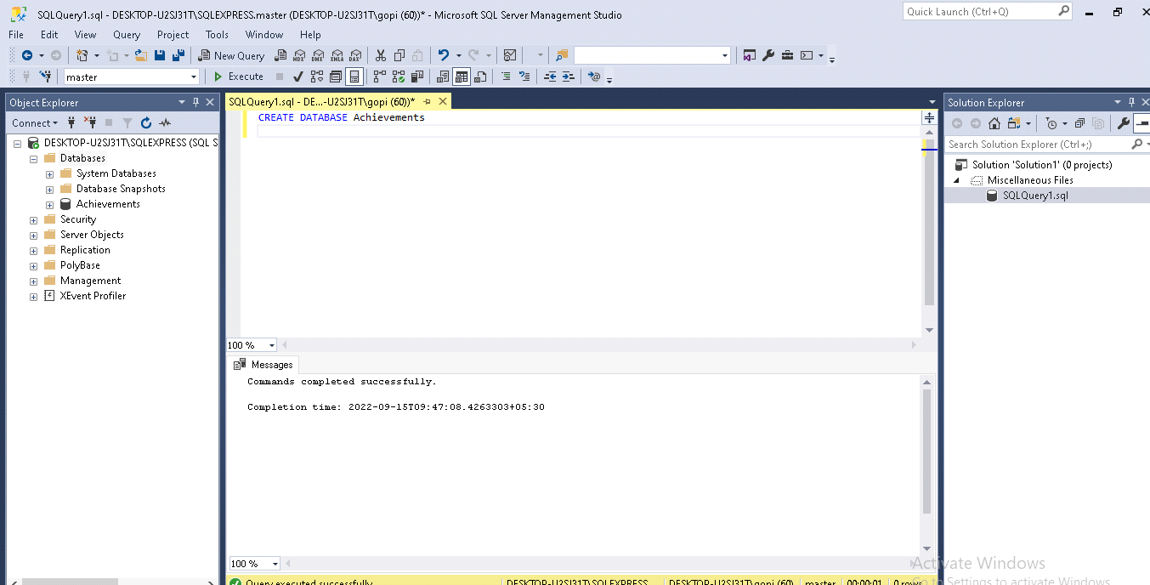

2.DELETE TABLE

Statements:

DROP TABLE PERSON

SELECT * FROM PERSON;

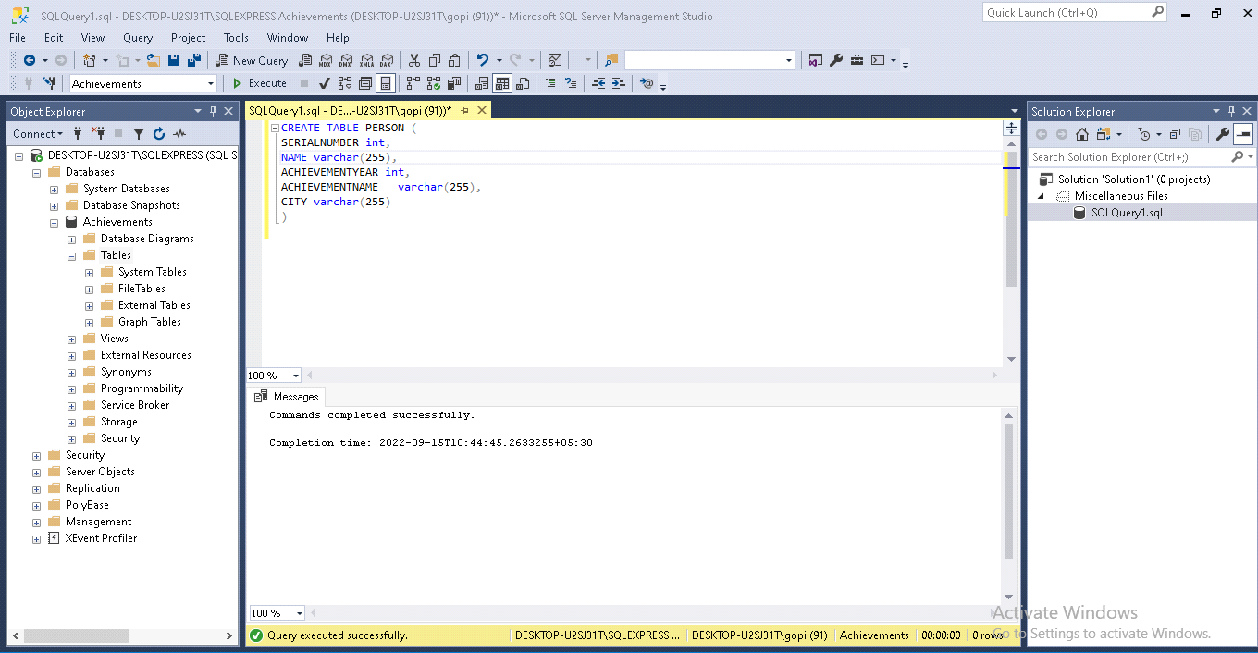

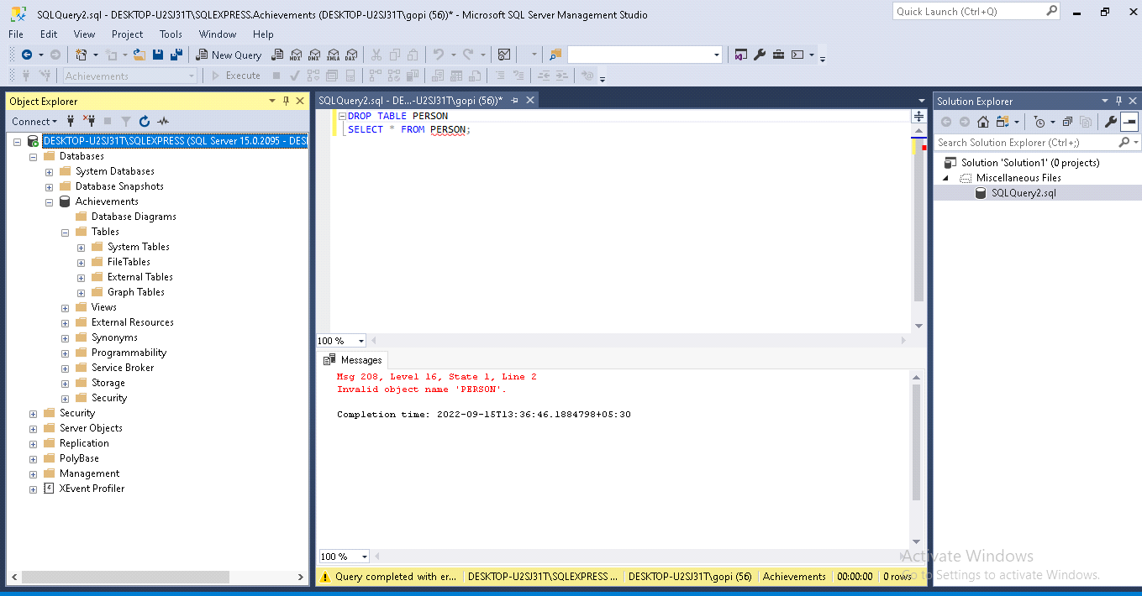

3.ADD COLUMNS

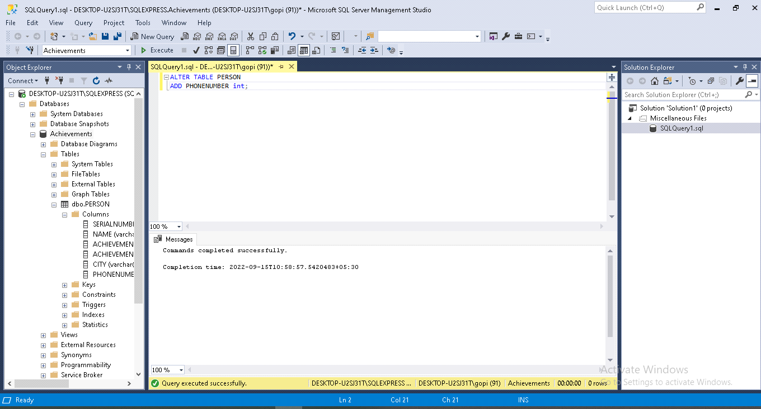

4.Delete all records

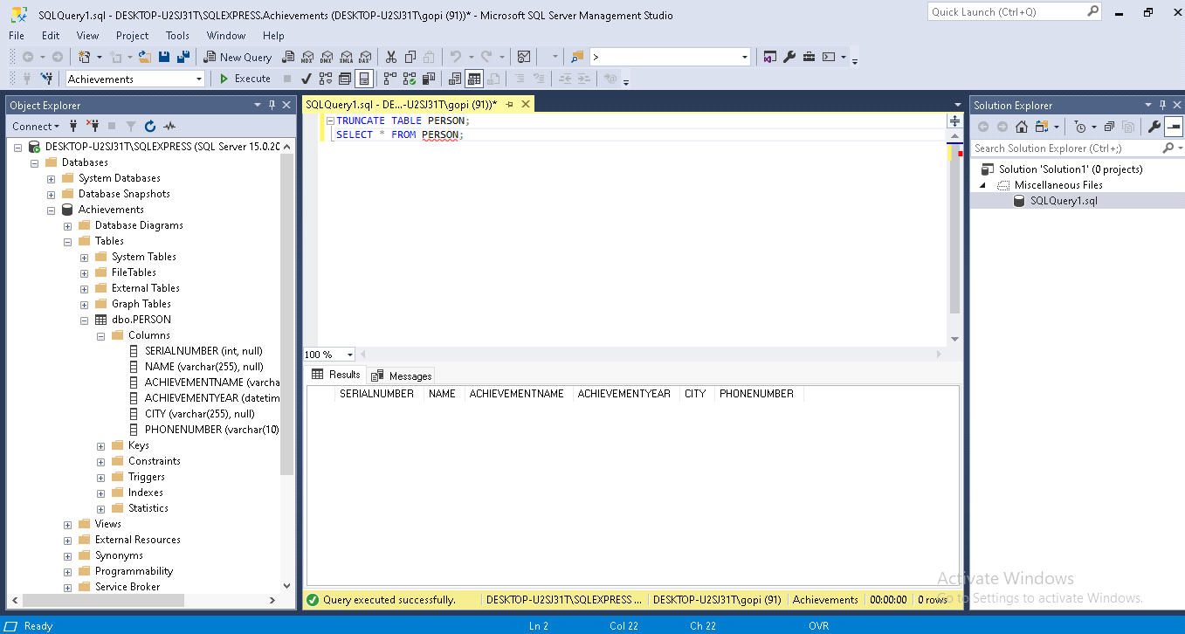

5.Insert data

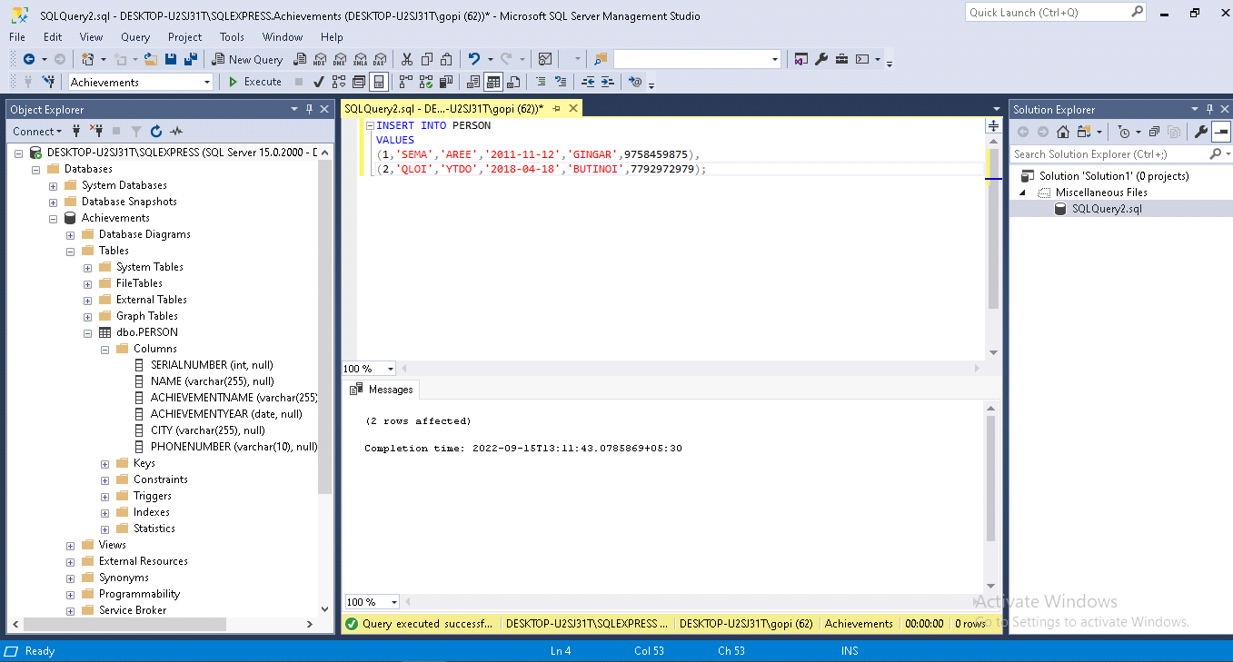Example:INSERT INTO PERSON

VALUES

(1,'SEMA','AREE','2011-11-12','GINGAR',9758459875),

(2,'QLOI','YTDO','2018-04-18','BUTINOI',7792972979);

6.Update column

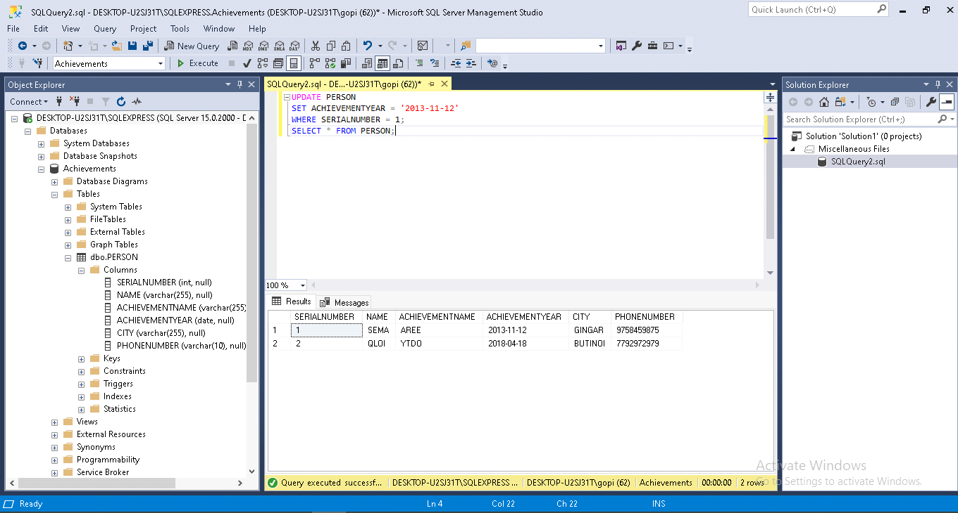

7.Remove specific row

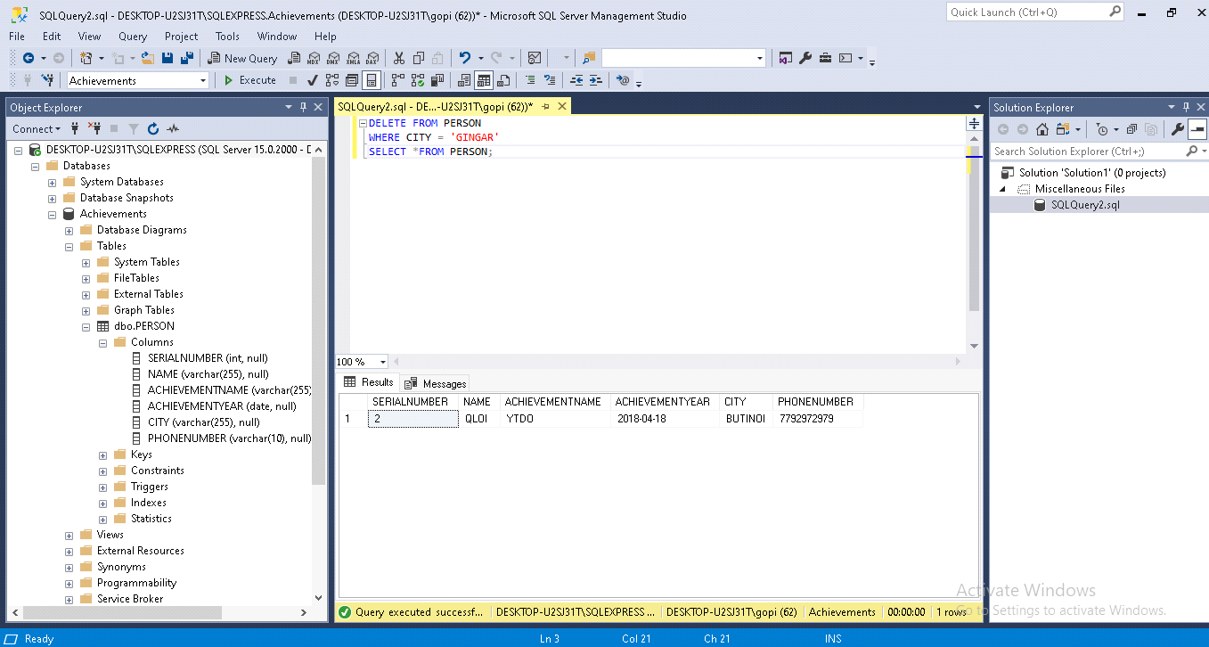

8.Select all records

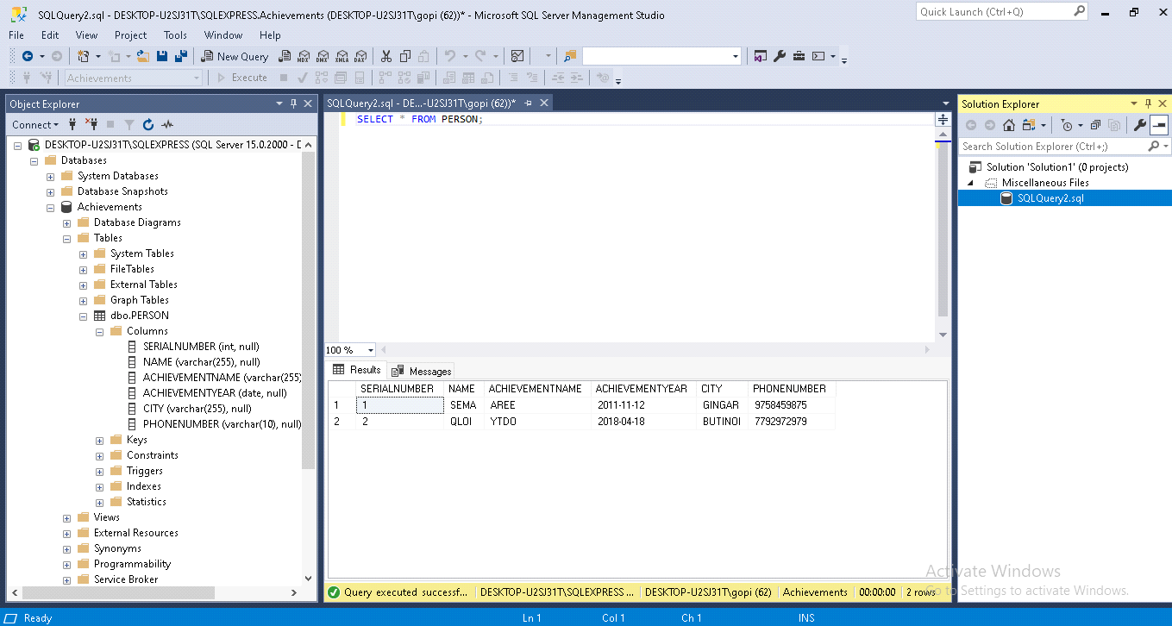

9.Select specific columns from table

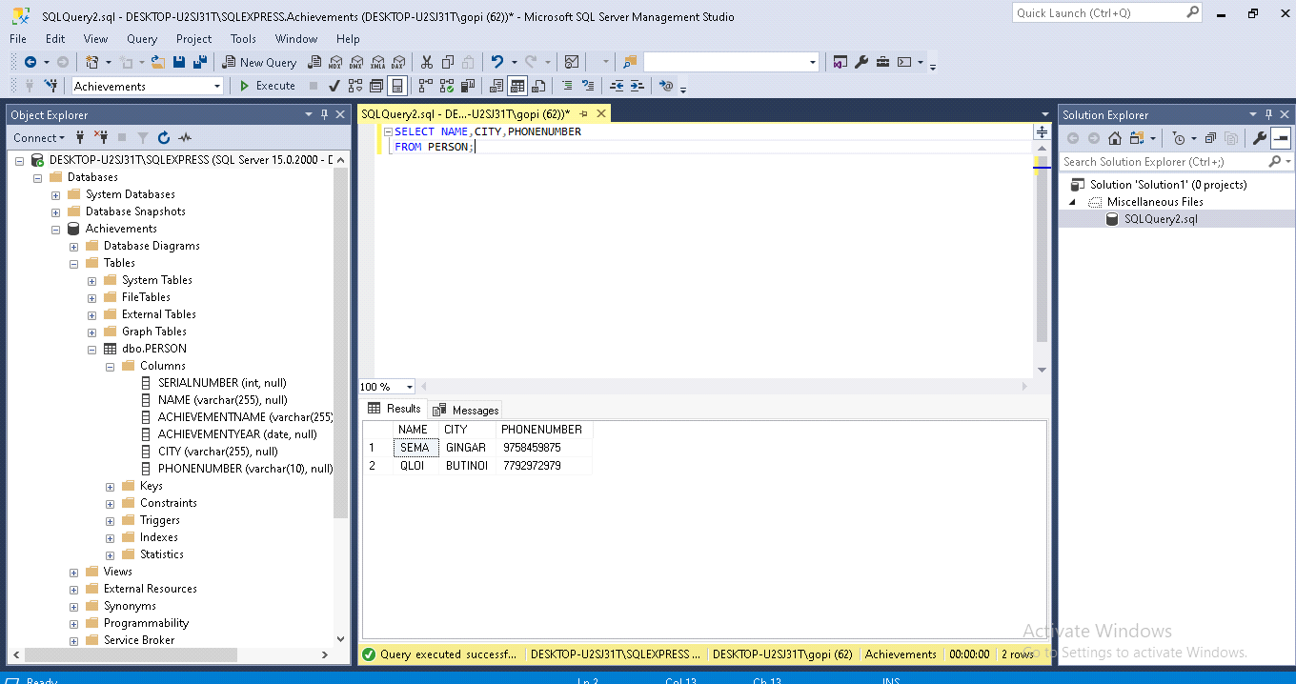

10.Select rows based on conditions

