**One Time Payment Letter**

**Name: {{varName}}**

**Designation: {{varDesignation}}**

**Band: {{****varBand}}**

**{% if varBand != “L”%}Sub Band: {{varSubBand}}{% endif %}**

**Dear** **{{varName}},**

You will be eligible for a onetime payment of **INR {{****varJB}} (Rupees {{varJBWords}} Rupees only)** which will be paid to you in full after completion of 6 months of service from your date of joining with the organization.

This onetime payment will be over and above the compensation structure as per Annexure A of your offer letter.

Please note that necessary taxes as per statute will be deducted at source.

You are required to produce a copy of this letter to HR and Finance before the payroll cut-off adjoining the above specified time period time in order to affect the pay-out.

For Belcan India Pvt Ltd,

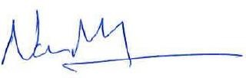

Naveen Munnangi

General Manager & Whole time Director– India Technology Centre