Alishba (559565) Nashmia (546576) Usman (572433) Hassaan (559984)

Applications of ICT
Lab 7 Report BE-IS(6B)

Contents

Introduction 2
System Specification 2
Hardware and Boot Storage 2
Data and Encoding 3
Number Systems and Hashing 3
Web Architecture 3
Network Architecture and My Web Page 3
Conclusion 4
Bibliography 5

Introduction
This report presents the practical work completed for Applications of ICT (CS-117) at MCS, NUST. It covers computer hardware, data encoding, storage systems, number systems, hashing, and web architecture. The machine is described in Table 1 and the network trace appears in Figure 2.

System Specification

Hardware and Boot Storage
This section explains the main hardware components of a computer, virtual machines, disk partitions, and the boot process. It also describes how storage devices organize data and help a computer start.

ITEM | VALUE
CPU model | 13th Gen Intel(R) Core(TM) i7-1355U
Physical/logical cores | 10 physical / 12 logical
RAM | 16 GB
Storage type & size | SSD
Partition style (MBR/GPT) | GPT (GUID Partition Table)
Boot mode (BIOS/UEFI) | UEFI
Windows version | Windows 11
WSL Ubuntu version | Ubuntu 26.04.1 LTS (WSL 2)
Table 1 System specification of my machine

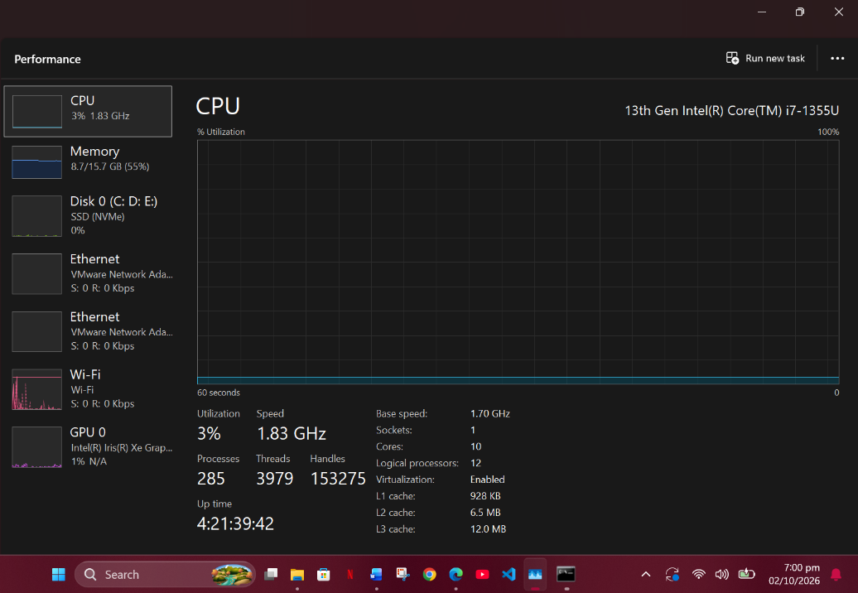
Figure 1:System specs

PS C:\WINDOWS\system32> wsl --list --verbose

NAME STATE VERSION

* Ubuntu Running 2

Data and Encoding

Number Systems and Hashing
This section explores how computers represent, process, and store information using different encoding methods. It highlights the importance of accurate data representation in digital systems.

Input | CyberChef operation | Result
181 | To Binary | 10110101
181 | To Hex | b5
MCS | To Charcode (decimal) | 77 67 83
Alishba | SHA2 (256) | 9d3d37016eb3307eb8a7f1230b3561bab8d23bc3207283a9748a67592b9bedbb
Table 2 Data and encoding
[1]

Web Architecture

Network Architecture and My Web Page
This section describes the basic structure of network communication and how devices exchange information over a network. It also presents the HTML webpage developed as part of the ICT lab work.

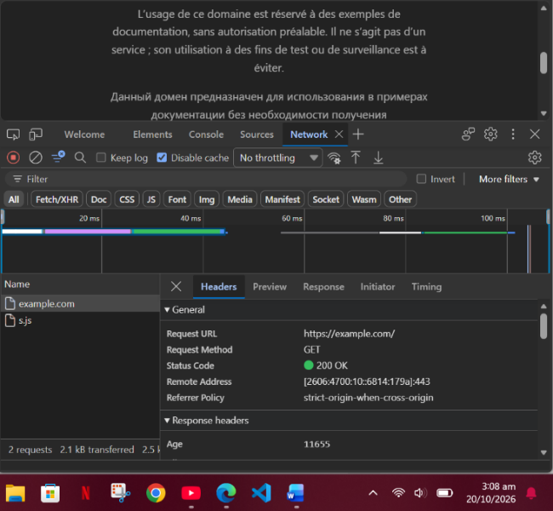
Figure 2:Network Trace

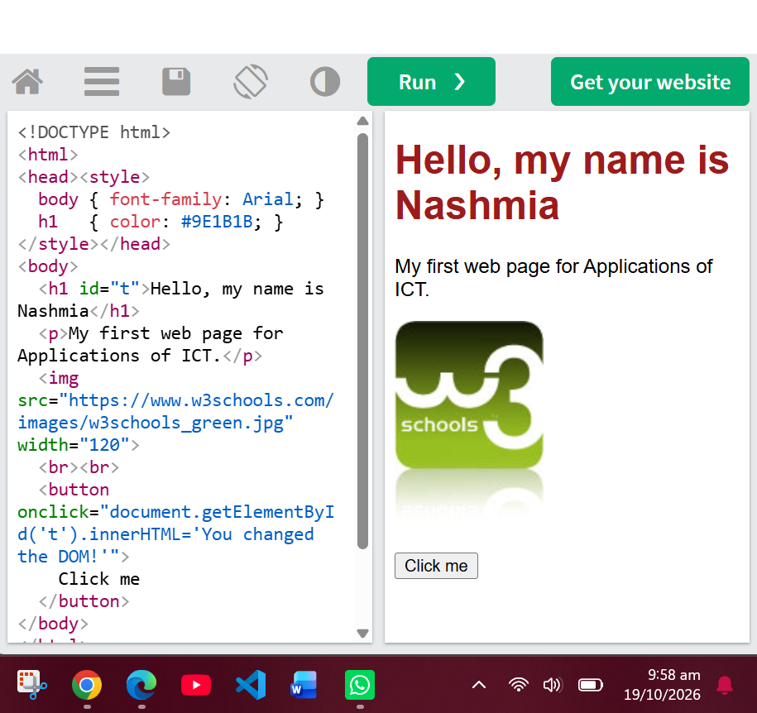
Figure 3:Before

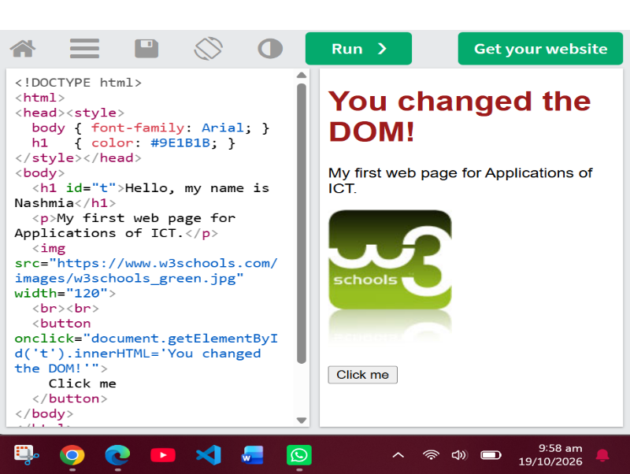
Figure 4:After

[2]

Conclusion
The ICT lab activities provided practical knowledge of computer hardware, data representation, storage, networking, and web development. These exercises helped strengthen the understanding of fundamental computing concepts and their real-world applications.

[3]

Bibliography

[1] | GCHQ, "CyberChef," [Online]. Available: https://gchq.github.io/CyberChef.
[2] | MDN Web Docs, "An overview of HTTP," [Online]. Available: https://developer.mozilla.org/en-US/docs/Web/HTTP/Guides/Overview.
[3] | GitHub, "Hello World," [Online]. Available: https://docs.github.com/en/get-started/start-your-journey/hello-world.

