1. **SDLC**

**What is devops?**

* A culture or practice that improves the organization ability to deliver the applications. (a process of improving quick delivery).
* Devops is also called CI/CD (Continuous Integration and Continuous Delivery). Devops is improve the delivery using automation with good quality along with monitoring.
* **Improving delivery, automation, quality, monitoring and testing.**

Or

* Devops is process of improving the application delivery by ensuring there is proper automation, with good quality, there is a continuous monitoring and continuous testing.
* By this the time for which a project takes 2 weeks gets reduced to 1 week.

It is the ability to deliver your project in short period of time. It is the process of increasing the ability to deliver your application quickly.

DEVOPS:

* Improve the delivery
* Automation
* High Quality
* Moitoring
* Testing
* Deployment

For example you have a chips manufacturing company. You want to increase the production (delivery) and for this what we can do is to remove the manual labor and introduce the Automation. Even after automating we must ensure the Quality of the chips. For this we need Continuous Monitoring of the machines and product. To ensure quality we have to do Continuous Testing. Finally we can Deploy those in to outside use.

**Why is devops?**

* Previously we have different people for each work
* **System administrators** creates a server, **Server administrators** creates the app server to deploy the application into server and **BRE** deploys application into the server. All these people work together to do all the things which takes more time and requires communication between these people.

**Software Development Life Cycle: SDLC**

* A set of standards or process that is followed by software industry to **design, develop and test to deliver the high-quality product**.
* 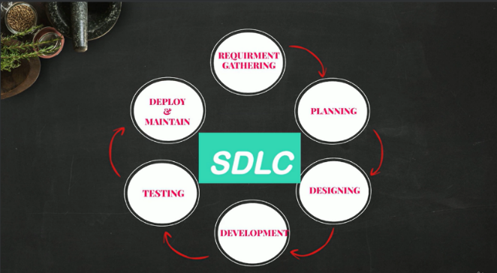The end goal is to deliver the high-quality product.
* Example.com we are developing an e-commerce application.

It includes steps like **Planning, Designing, Developing, Testing and**

**Deploying.**

The application was completed with men and women section.

Now they want to include kids section they will follow the same steps.

There are different phases before we deliver a product.

* Planning
* Defining
* Designing
* Development
* Testing
* Deployment

**A Devops engineer should focus mainly on the Development, Testing and Deployment as these phases can be automated.**

**Planning:** based on the requirements and feedback from the customers the planning is done.

**Defining:**  write the requirements in document which will be software requirements document.

**Designing: HLD** (High level design) and LLD (low level design), high level includes the scalability.

**Development:** writes the code based on the design and moves it to source code repository (GIThub).

**Testing:** application code from repository is taken and deployed in a server. The QA team tests the software application.

**Deployment:** promote to the production and to the customer.

Here the devops comes to picture and automates the **development, testing and deployment** of the application to increase the efficiency.

**Devops writes the automation code to automate the process.**