Evaluation of Machine Learning Algorithms for the Detection of Fake Bank Currency

Now-a-days all countries are facing major financial blow due to fake currency and to overcome from this problem author is employing various machine learning algorithms to predict weather currency is fake or not. As machine algorithms already proves it success in almost all fields such as Healthcare prediction, cyber-attack prediction, credit card fraud detection and many more. So author is suggesting to add machine learning power on fake currency detection.

In propose paper author has used many traditional algorithms such as KNN, Decision Tree, SVM, Random Forest, Logistic Regression and Naïve Bayes but author has not used any advance machine learning algorithms such as ELM, XGBOOST, MLP or LightGBM so as extension we have added LightGBM algorithm and compare its performance with existing algorithms.

To implement this project author has used UCI Machine Learning Fake currency dataset which contains height and width of currency and below is the dataset screen shots

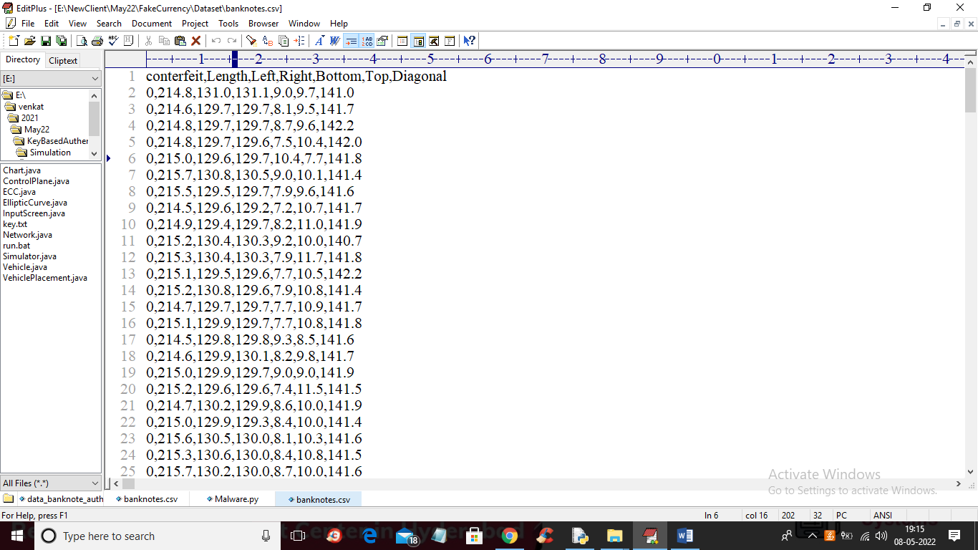

In above dataset screen first row contains dataset column names and remaining are the dataset values and first column contains counterfeit class label where 0 means Genuine and 1 means Fake

SCREEN SHOTS

To run project double click on ‘run.bat’ file to get below output

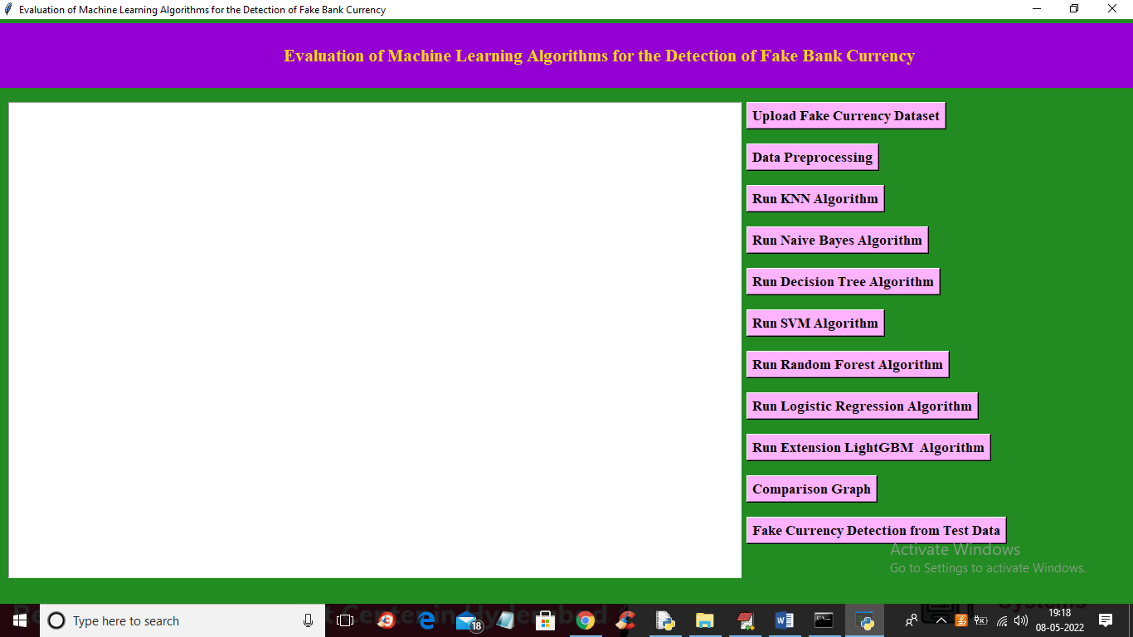

In above screen click on ‘Upload Fake Currency Dataset’ button to upload dataset and to get below output

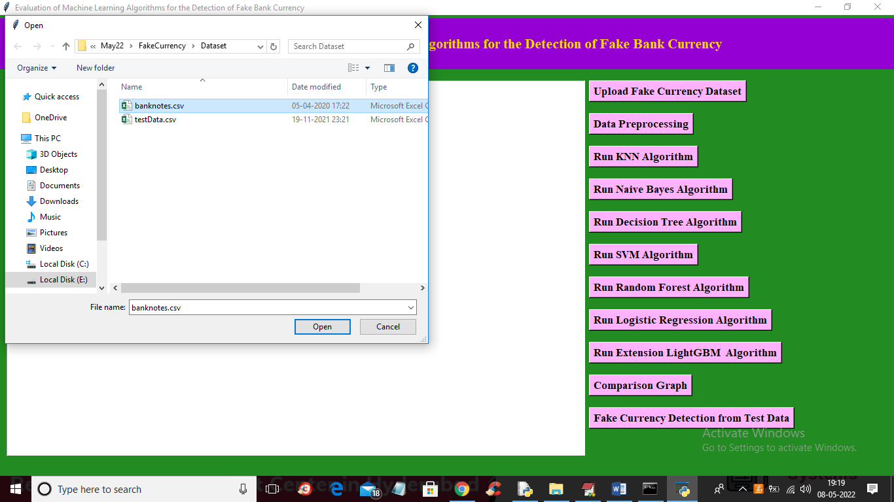

In above screen selecting and uploading “banknotes.csv’ file and then click on ‘Open’ button to load dataset and get below output

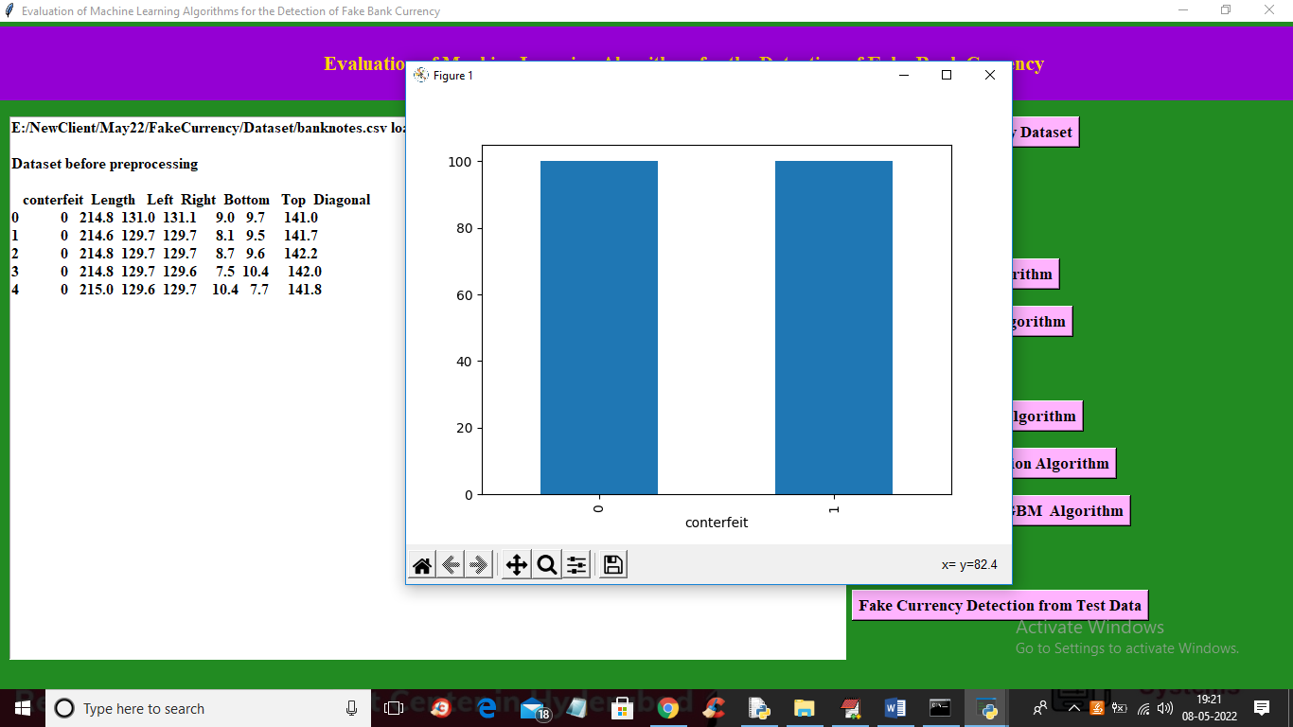

In above screen dataset loaded and in graph x-axis contains class label as 0 and 1 and y-axis contains number of records found in that class label and now close above graph and then click on ‘Dataset Preprocessing’ button to read dataset and then normalize dataset and then replace missing values with 0 and then split dataset into train and test

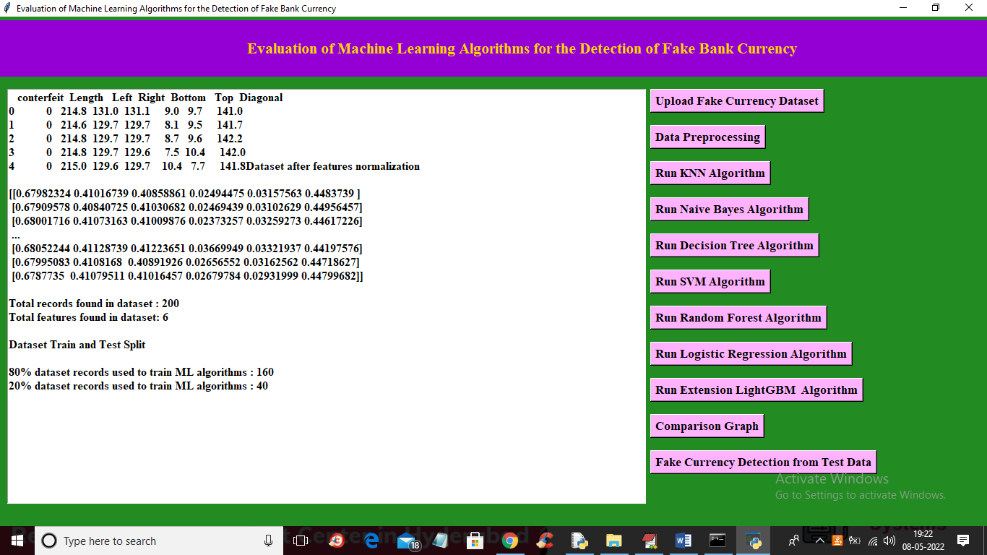

In above screen all values normalized between 0 and 1 and then we can see total dataset records and 80% training data split size and 20 testing data split size. Now dataset train and test is ready and now click on ‘Run KNN Algorithm’ button to train KNN and get below output

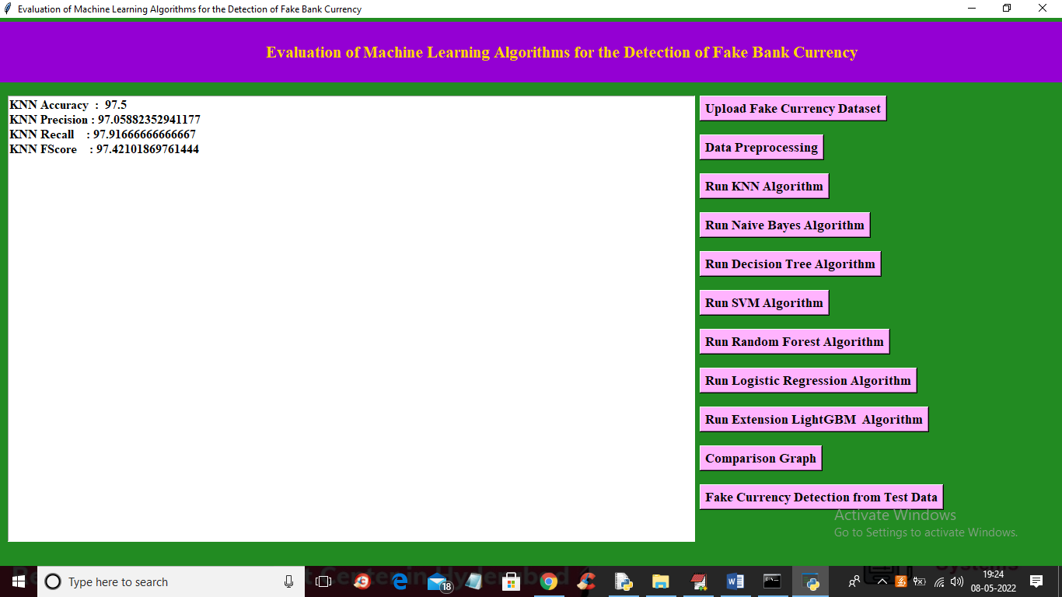

In above screen with KNN we got 97% accuracy and similarly run all algorithms by clicking button

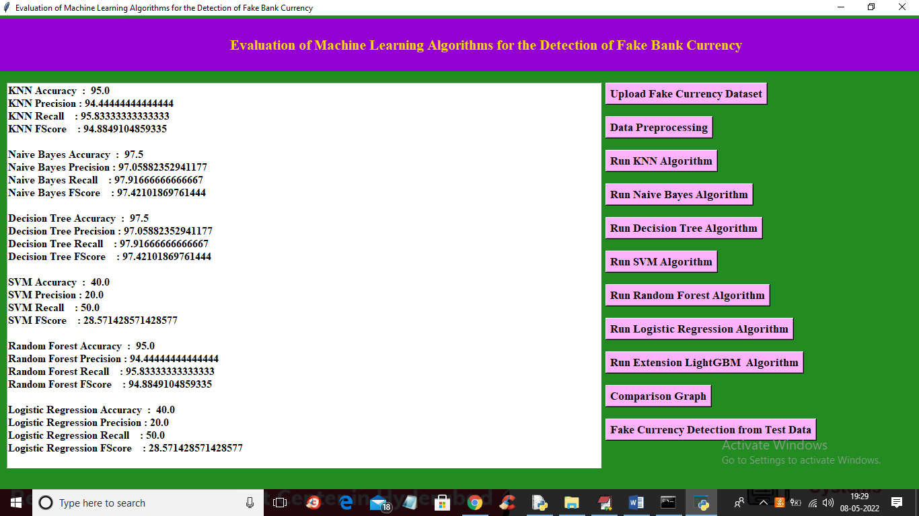

In above screen we got accuracy for all existing algorithms and now click on ‘Run Extension LightGBM Algorithm’ button to run extension algorithm and get below output

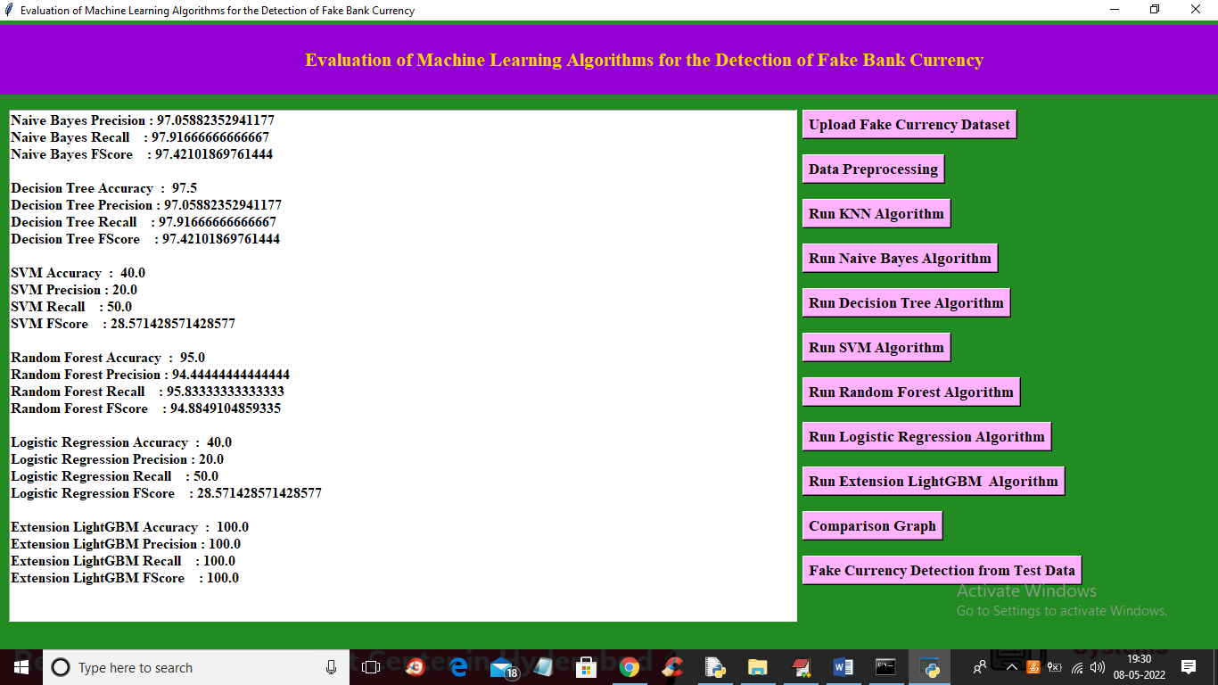

In above screen with extension LightGBM we got 100% accuracy and now click on ‘Comparison Graph’ button to get below output

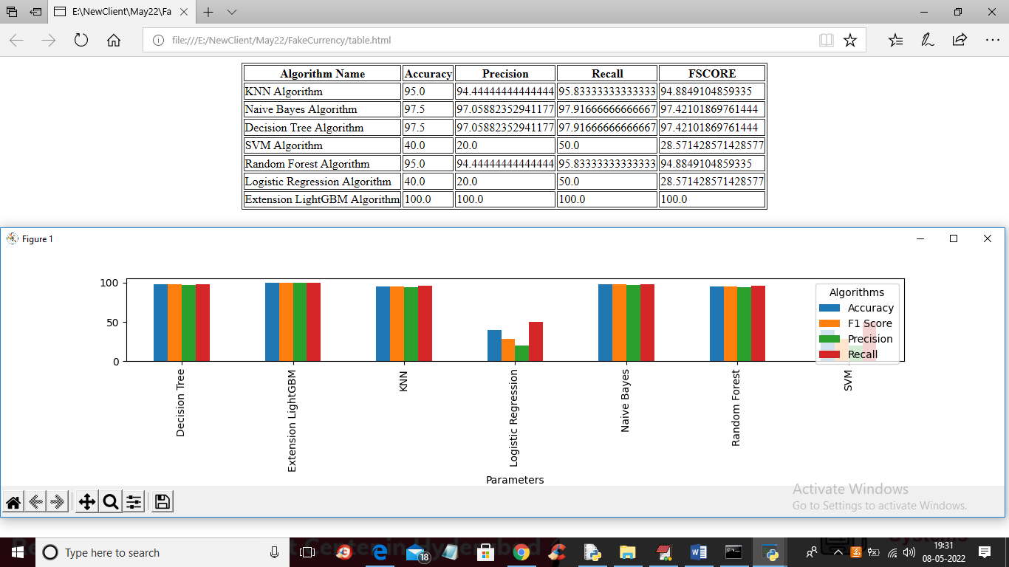

In above screen in tabular format we can see accuracy, precision, recall and FSCORE for each algorithms and we can see its comparison graph also and in all algorithms extension LIGHTGBM got high accuracy. Now click on ‘Fake Currency Detection from Test Data’ button to upload fake currency test data and get below output

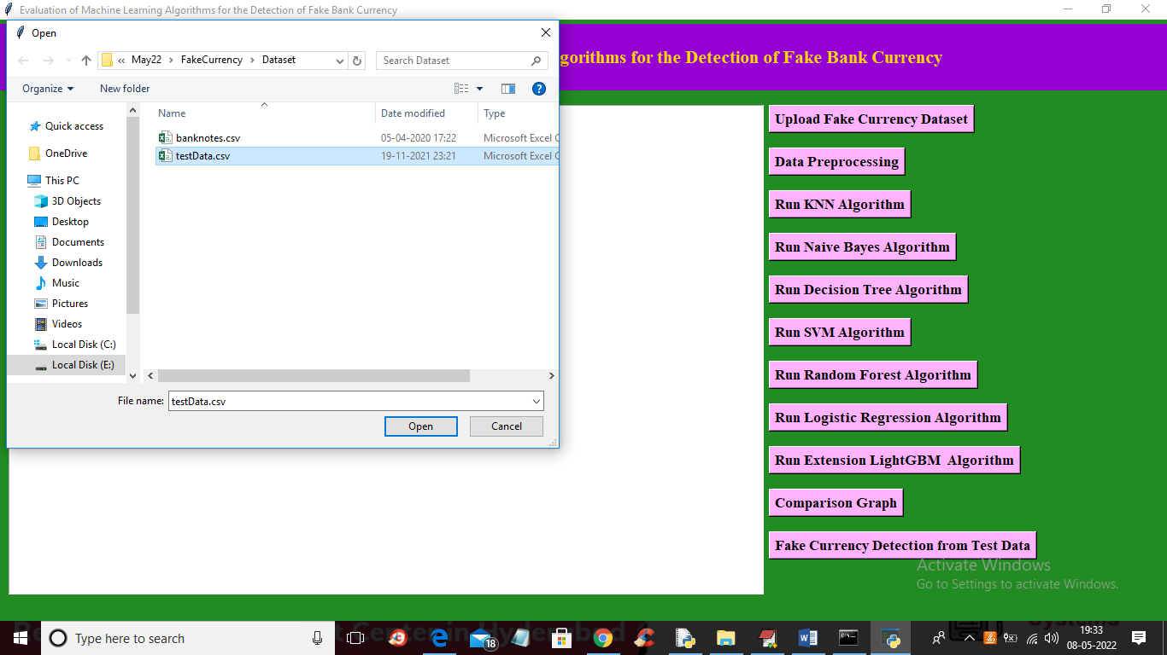

In above screen selecting and uploading ‘testData.csv’ file and then click on ‘Open’ button to get below output

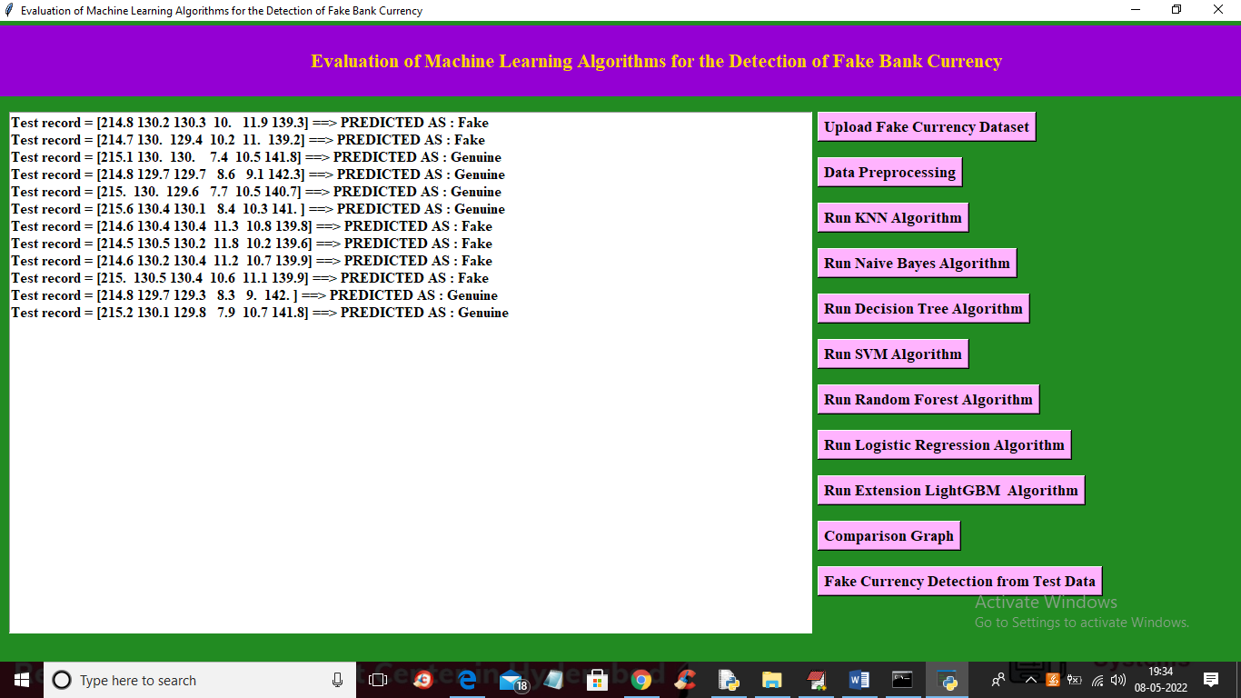

In above screen in square bracket we can see test data and after square bracket we can se predicted result as ‘Genuine or Fake’