Tutorial 4: Class, Sequence and Activity Diagrams

College Information System saves the following data about student: ID, name, and average grade of the last year courses. Additionally the system contains the following information about course: course number, course name, and credits. For a student registered for the course the system can save his homeworks, homework grades, and a final grade of the course.

The initial version of the class diagram for this system is presented below:
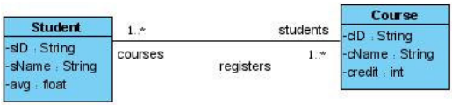

Pay attention on the meaning of association between classes: the Role “courses” on the left side of the association add to the class Student an additional attribute courses for saving a list of courses of the specific student. The Role “students” on the right side of the association add to the class Course an attribute students for saving a list of course participants.

Task to do:

- Construct complete class diagram of College Information System
(add required classes and methods)

- Present sequence diagrams for two of the following use cases:
search for a student
signing up for a course
adding a new student
(show correspondence between class diagram and sequence diagrams)

- Draw activity diagram for the following functionality:
Student can upload his homework,
and see homework grade;
Lecturer can download homework of the specific student,
and add homework grade.
(show using of swimlines)

Activity Diagrams
Activity diagrams show the flow of activities through the system. Diagrams are read from top to bottom and have branches and forks to describe conditions and parallel activities. A fork is used when multiple activities are occurring at the same time. The branch describes what activities will take place based on a set of conditions. All branches at some point are followed by a merge to indicate the end of the conditional behavior started by that branch. After the merge all of the parallel activities must be combined by a join before transitioning into the final activity state.

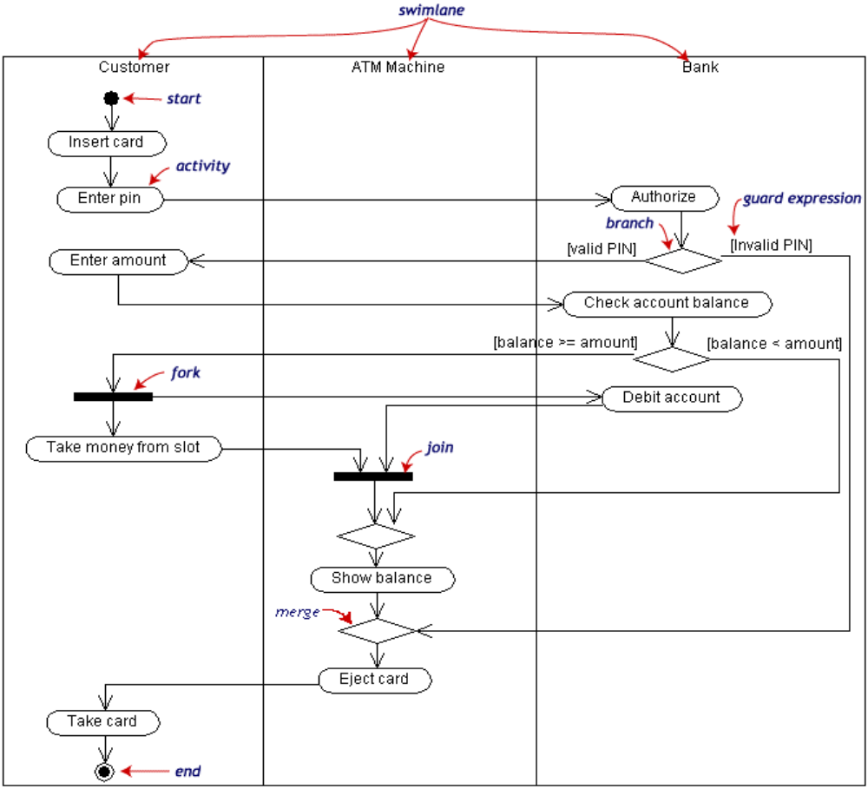

Swimlines indicate where activities take place. Swimlines allow the partition an activity diagram so that parts of it appear in the swimline relevant to that element in the partition.
Partitions may be constructed on the basis of the class and actor doing the activity.

For more details see
http://www.inf.ed.ac.uk/teaching/courses/seoc/2004_2005/notes/LectureNote10_ActivityDiagrams.PDF

