INDEX
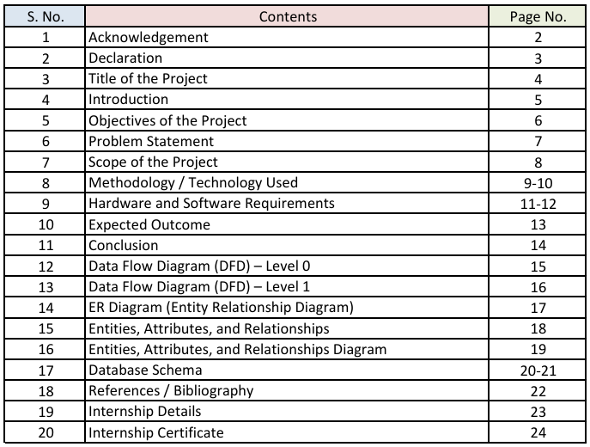

ACKNOWLEDGEMENT

We would like to express our sincere gratitude and heartfelt thanks to all those who have directly or indirectly contributed to the successful completion of our project titled "Bharat Cyber Nyay Portal", submitted in partial fulfilment of the requirements for the award of the degree of Bachelor of Computer Applications (BCA) during the academic session 2023-2026. This project would not have been possible without the continuous support, guidance, and encouragement of many respected individuals.

First and foremost, we express our deep sense of gratitude to our respected Project Guide, Mr. Ritesh Kumar Jha, for his valuable guidance, constant encouragement, constructive suggestions, and continuous support throughout the development of this project. His knowledge, patience, and motivation helped us to understand the project requirements clearly and complete the work successfully within the stipulated time.

We would also like to extend our sincere thanks to our respected Chancellor Sir, Registrar Sir, Dean Sir and Head of the Department (HOD) their leadership, administrative support, and encouragement. Their vision, academic guidance, and commitment to providing quality education created a positive learning environment that enabled us to complete this project successfully. We are also thankful to all faculty members and staff of the Department of Computer Applications for providing the necessary facilities, cooperation, and valuable suggestions during the preparation of this project.

Finally, we are deeply grateful to our parents, family members, friends, and the management and staff of our internship organization for their continuous encouragement, moral support, and cooperation throughout our academic journey. Their support and motivation played an important role in the successful completion of this project. We sincerely acknowledge the contribution of everyone who helped us in any way during the development of this project.

DECLARATION

We hereby declare that the project entitled "Bharat Cyber Nyay Portal" submitted in partial fulfilment of the requirements for the award of the degree of Bachelor of Computer Applications (BCA) to NSU, Jamshedpur, is a record of original work carried out by us under the guidance and supervision of Mr. Ritesh Kumar Jha, Project Guide, Department of Information Technology.

We further declare that this project work has been completed by us independently and has not been submitted, either in part or in full, to any other university or institution for the award of any degree, diploma, or certificate.

We also confirm that all the information, data, and materials used in this project have been properly acknowledged and referenced wherever required. We have complied with all academic rules, regulations, and ethical standards prescribed by the institution. Any assistance received during the development of this project has been duly acknowledged in the acknowledgement section of this report.

We understand that any act of plagiarism or academic dishonesty, if found at any stage, may lead to cancellation of our project and disciplinary action as per the rules of the university.

This project represents our genuine effort and learning during the course of study in the Bachelor of Computer Applications (BCA) program for the academic session 2023-2026.

Student Signatures:
S.No. Name Registration No. Section Signature
1. Arka Dey NSU2303048 B
2. Arijeet Kuiry NSU2303047 B

Project Guide:
Name: Ritesh Kumar Jha
Signature: ______________________
Date: ______________________ Place: Jamshedpur

TITLE OF THE PROJECT
Bharat Cyber Nyay Portal
Submitted in partial fulfilment of the requirements for the award of the
degree of

Bachelor of Computer Applications (BCA)
Academic Session: 2023 – 2026
Submitted By
 | Arka Dey | NSU2303048 | B | 8674894001
 | Arijeet Kuiry | NSU2303047 | B | 9279737669
Course Details
Course Name: Bachelors of Computer Applications (BCA)
Semester: 6th Semester
Department: IT
Under the Guidance of
Guide Name: Ritesh Kumar Jha
Designation: Project Guide

Submitted To
Department of Computer Applications
NSU, Jamshedpur

INTRODUCTION

The Bharat Cyber Nyay Portal is a web-based application designed to simplify and strengthen the process of reporting cybercrime incidents through a secure online platform. In the modern digital era, citizens increasingly use internet banking, UPI services, social media, e-commerce platforms, and mobile applications for daily activities. Along with these benefits, cyber threats such as phishing, identity theft, social media fraud, fake customer care scams, and online financial fraud are growing rapidly. Many victims hesitate to report such incidents due to lack of awareness, fear of identity exposure, complex procedures, or delays in response. Therefore, there is a strong need for a user-friendly and efficient digital system that allows citizens to report complaints quickly and track progress transparently.

Traditional complaint processes are often dependent on manual paperwork, physical visits, and fragmented communication, which can result in delays and poor coordination between complainants and investigating authorities. In many cases, citizens are unable to upload digital evidence properly and do not receive clear status updates regarding their complaints. This lack of transparency reduces confidence in the reporting process. The proposed portal addresses these issues by providing a centralized complaint management system where users can register, submit incident details, upload evidence files, and monitor case status using report identifiers.

The system is designed with role-based functionality to support three key stakeholders: citizens, investigators, and administrators. Citizens can submit complaints and track their progress. Investigators can review assigned cases, examine evidence, add notes, and update complaint status. Administrators can manage users, assign cases, supervise workflow, and generate basic analytical insights. This structured approach improves efficiency and ensures that every complaint follows a traceable path from submission to closure.

From a technical perspective, the portal is developed using modern web technologies to ensure reliability and security. The frontend is built with Next.js and React, while the backend uses Node.js and Express. PostgreSQL is used for secure data storage, and evidence files are maintained with proper validation. Security measures such as authentication, password hashing, and role-based authorization are implemented to protect user and complaint data.

OBJECTIVES OF THE PROJECT

The main objective of the Bharat Cyber Nyay Portal project is to design and develop a secure, user-friendly, and efficient computerized system for reporting cybercrime incidents and managing complaint workflows digitally. The system aims to provide a reliable platform for citizens to submit complaints and for administrators and investigators to process cases in a structured and transparent manner.

The specific objectives of the project are as follows:

1. To develop an online platform that allows citizens to report cybercrime incidents easily from anywhere using the internet.
2. To reduce manual paperwork and delays involved in traditional complaint handling systems.
3. To provide a user-friendly interface that supports smooth navigation for citizens, investigators, and administrators.
4. To enable secure submission and storage of complaint details and related information.
5. To provide a structured evidence upload facility for documents and digital proof.
6. To implement role-based access control for Citizen, Investigator, and Admin users.
7. To enable administrators to assign complaints and monitor case progress effectively.
8. To provide transparent complaint status tracking for users.
9. To improve the speed, accuracy, and accountability of complaint processing.
10. To support anonymous reporting for selected sensitive cybercrime cases.
11. To strengthen platform security through authentication and authorization mechanisms.
12. To generate basic analytical reports for monitoring and decision-making.
13. To create a scalable and maintainable system for future enhancements.

Overall, the objective of this project is to demonstrate the practical implementation of modern web technologies and secure workflow management in solving cybercrime reporting challenges.

PROBLEM STATEMENT

In the current cybercrime reporting environment, many citizens face difficulty in submitting complaints quickly and confidently. Reporting channels are often fragmented, procedures may appear complex, and victims frequently lack clarity about where to report different types of incidents such as phishing, UPI fraud, identity theft, fake social media profiles, and online financial scams. Due to fear, lack of awareness, and limited accessibility, many cybercrime incidents remain underreported, which delays response and weakens preventive action.

From an operational perspective, manual or semi-digital complaint handling creates several challenges for authorities and support teams. Complaint records may be incomplete or inconsistently structured, evidence files are not always linked properly to cases, and status updates are not maintained in a transparent, traceable manner. This can cause delays in assignment, confusion in workflow, difficulty in prioritization, and reduced accountability during investigation and resolution stages.

Another major issue is the absence of a citizen-friendly tracking mechanism in many reporting workflows. Complainants often do not receive timely updates regarding whether their complaint has been reviewed, assigned, or resolved. This lack of visibility reduces trust in the reporting system and discourages victims from actively following up. At the same time, administrators may not have sufficient dashboards or analytics to monitor trends, case loads, and response efficiency for better decision-making.

Security and privacy concerns further increase the problem. Cybercrime reports may contain sensitive personal, financial, and digital evidence data, which require controlled access, secure storage, and proper authentication. Without strong validation, role-based access control, and secure evidence handling, such systems may become vulnerable to misuse, data leakage, or unauthorized modification of records.

Therefore, there is a clear need for a secure, structured, and user-friendly Bharat Cyber Nyay Portal that enables citizens to report incidents digitally, upload evidence, and track complaint progress transparently. The proposed system should support role-based workflows for citizens, investigators, and administrators; improve complaint processing efficiency; enhance data integrity and accountability; and provide actionable analytics for effective cybercrime management.

SCOPE OF THE PROJECT

The scope of the Bharat Cyber Nyay Portal project defines the boundaries, features, and practical application of the system in a real-world digital environment. The primary scope is to develop a secure web-based platform that enables citizens to report cybercrime incidents quickly and conveniently, while allowing administrators and investigators to manage complaints, evidence, and case progression in a structured manner. The system focuses on improving complaint handling efficiency by reducing manual effort and increasing transparency, accuracy, and accountability.

The project covers essential functionalities such as user registration and login, role-based access control, complaint submission with structured incident details, and report tracking through unique report IDs. It includes support for anonymous reporting in selected categories, secure evidence upload and linkage to case records, and complaint lifecycle management through defined status stages such as Submitted, Under Review, Investigation, Resolved, and Closed. These capabilities ensure smooth coordination among citizens, investigators, and administrators.

Another key part of the scope is secure data and workflow management through a database-driven architecture. The system stores user data, complaint information, evidence metadata, and case notes in a structured format for easy retrieval and controlled updates. It also supports analytical reporting for crime type distribution, status trends, and other operational insights to assist administrative monitoring and decision-making. This makes the platform useful not only for case handling but also for improving response planning and resource utilization.

From a technical perspective, the current scope is limited to a full-stack web implementation using modern technologies (Next.js, React, Node.js, Express, and PostgreSQL/Supabase), with deployment suitability for cloud environments such as AWS EC2. The project does not include direct FIR registration with official police databases, court workflow integration, real-time dispatch automation, or nationwide government backend integration in this version. However, the system is designed to be extensible, so future enhancements can include deeper legal integration, advanced analytics, and broader institutional adoption.

METHODOLOGY / TECHNOLOGY USED

The development of the Bharat Cyber Nyay Portal follows a systematic and structured methodology to ensure successful design, implementation, testing, and deployment of the application. The project is developed using an Agile-oriented Software Development Life Cycle (SDLC) approach, which includes iterative planning, analysis, design, development, testing, deployment, and review. This methodology helps in organizing project activities, reducing development risks, and ensuring that the final system meets functional and security requirements effectively.

The methodology adopted in this project consists of the following phases:

• Planning Phase: In this phase, project requirements were identified from the perspectives of citizens, investigators, and administrators. Key issues in traditional cybercrime reporting such as delays, poor evidence handling, and lack of transparency were studied.

• Analysis Phase: Detailed functional and non-functional requirements were defined, including authentication, role-based access control, complaint lifecycle management, and analytics support.

• Design Phase: System architecture, database schema, API structure, and user interface flow were designed using technical documentation and models such as DFD and ER diagrams.

• Development Phase: The system was implemented using a modular full-stack architecture with separate frontend and backend components.

• Testing Phase: Validation checks, integration testing, and performance checks were carried out to ensure correct system behavior.

• Deployment Phase: The system was prepared for deployment in a cloud-ready environment with proper configuration management.

The development phase involved implementing frontend and backend modules in a modular full-stack architecture. The frontend was built with Next.js and React to provide responsive user interfaces for both

public and protected pages. The backend was developed using Node.js and Express to deliver RESTful APIs for authentication, complaint handling, evidence management, assignment workflow, tracking, and analytics. PostgreSQL (Supabase-managed) was used for structured relational data storage, while Supabase Storage was used for file evidence handling with metadata and integrity support.

The testing phase ensured that the platform works correctly across major workflows and user roles. Validation checks were performed for input fields, authentication logic, role authorization, complaint status transitions, and evidence upload constraints. Integration testing verified coordination between frontend, backend, and database layers. Basic reliability and performance checks were also conducted for key operations such as report submission, assignment, and tracking.

The technology stack used in this project includes the following components:

• Frontend Technologies: Next.js, React, Tailwind CSS, Axios, and charting libraries for dashboards.
• Backend Technologies: Node.js, Express.js, Zod for validation, JWT for authentication, Bcrypt for password hashing, and Multer for file uploads.
• Database and Storage: PostgreSQL (Supabase-managed) for relational data and Supabase Storage for file handling.
• Security Mechanisms: Input validation, role-based authorization, authentication tokens, security headers, and request limiting.
• Deployment and Tools: AWS EC2 environment, Git, and GitHub for version control.

The overall system architecture follows a client-server model where the frontend communicates with backend APIs over secure protocols. Data is exchanged in structured formats to maintain consistency. Role-based routing ensures controlled access, and database normalization improves data integrity and performance.

HARDWARE AND SOFTWARE REQUIREMENTS

Since the Bharat Cyber Nyay Portal has been successfully deployed on an AWS EC2 instance, the requirement set is focused on practical production usage with a lightweight local development environment and cloud-based hosting.
Hardware Requirements
• Development System: A laptop or desktop with Intel Core i3 / AMD Ryzen 3 or higher is sufficient for coding, testing, and monitoring.
• RAM: A minimum of 4 GB RAM is required, while 8 GB is recommended for smoother performance.
• Storage: At least 10 GB of free disk space is required for project files and dependencies.
• Network: A stable broadband internet connection is necessary for deployment and remote access.
• Cloud Server: AWS EC2 virtual instance is used for hosting the application.

Software Requirements
• Operating System: Windows, Linux, or macOS for development, and Linux for the server environment.
• Runtime and Package Manager: Node.js (v18+) and npm for application execution and dependency management.
• Frameworks and Core Stack: Next.js and React for frontend, Node.js and Express for backend, and PostgreSQL (Supabase) for database management.
• Cloud and Deployment Tools: AWS EC2, SSH access, and environment configuration tools.

• Database and Storage: Supabase PostgreSQL for data storage and Supabase Storage for file handling.
• Security and Validation: JWT authentication, Bcrypt hashing, Zod validation, and API security middleware.
• Development and Monitoring Tools: Visual Studio Code, Git/GitHub, Postman or Thunder Client, and browser-based tools.

This setup is sufficient for stable deployment, secure operation, and ongoing maintenance of the Bharat Cyber Nyay Portal in a cloud-hosted environment.

EXPECTED OUTCOME

The expected outcome of the Cyber Crime Reporting Portal is the development of a secure, user-friendly, and
role-based digital platform that streamlines cybercrime complaint handling from submission to resolution. The
system will enable citizens to report incidents online, upload evidence, and track complaint status
transparently, reducing dependency on manual processes and improving trust in digital reporting.

At the citizen level, the portal is expected to improve reporting confidence by providing structured complaint
forms, clear status updates, and support for anonymous reporting in sensitive cases. This will lead to faster
submissions, better-quality information, and more complete complaint records, improving readiness for
investigation.

At the administrative and investigation level, the system will enhance operational efficiency through
centralized case management, role-based access, and structured workflows. Administrators will be able to
assign and monitor cases effectively, while investigators can review evidence, update case progress, and
maintain consistent records, reducing delays and improving accountability.

From a technical perspective, the project demonstrates a practical full-stack implementation using modern
web technologies, secure authentication, and cloud deployment. The system is expected to be reliable,
scalable, and maintainable, while also providing basic analytical insights such as complaint trends and status
distribution.

Overall, the project delivers a functional and practical cybercrime reporting solution that supports digital governance and demonstrates real-world application of software development and cybersecurity principles.

CONCLUSION

The Bhara Cyber Nyay Portal project has been successfully designed and developed to provide a secure,
efficient, and structured solution for digital cybercrime complaint management. The system replaces
fragmented and manual reporting methods with a centralized web platform that improves accessibility,
transparency, and operational reliability. It provides a user-friendly interface that allows citizens to submit
complaints, upload evidence, and track case progress, while administrators and investigators can manage
workflows effectively.

This project demonstrates the practical application of full-stack web development and cybersecurity-oriented
software engineering learned during the Bachelor of Computer Applications (BCA) program. The platform
maintains organized records of users, reports, evidence, and case updates in a structured database
environment. It reduces manual dependency, minimizes errors, and improves coordination in complaint
handling through role-based access and structured workflow management.

The implementation of this portal contributes to improved user confidence by enabling faster complaint
submission, better visibility of case status, and traceable handling from submission to closure. It allows
authorities to assign and monitor cases, update investigation progress, and generate insights for decision-
making. The system also ensures security and data integrity through authentication, authorization, validation,
and controlled evidence handling.

In the future, the system can be enhanced by adding advanced features such as improved workflow integration,
broader system connectivity, intelligent analysis, multilingual support, and mobile-based access. These
improvements will increase scalability and usability. Overall, the project fulfills its objectives and highlights
the importance of information technology in improving digital governance and cybercrime response systems.

DATA FLOW DIAGRAM (DFD) – Level 0

The Data Flow Diagram (DFD) Level 0, also known as the Context Diagram, represents the overall structure of the Bharat Cyber Nyay Portal as a single process. It illustrates how the system interacts with external entities such as citizens, investigators, and administrators. This diagram provides a high-level view of the system and shows the flow of data between users and the portal, including complaint submission, evidence handling, case management, and status tracking, without detailing the internal processes of the system.
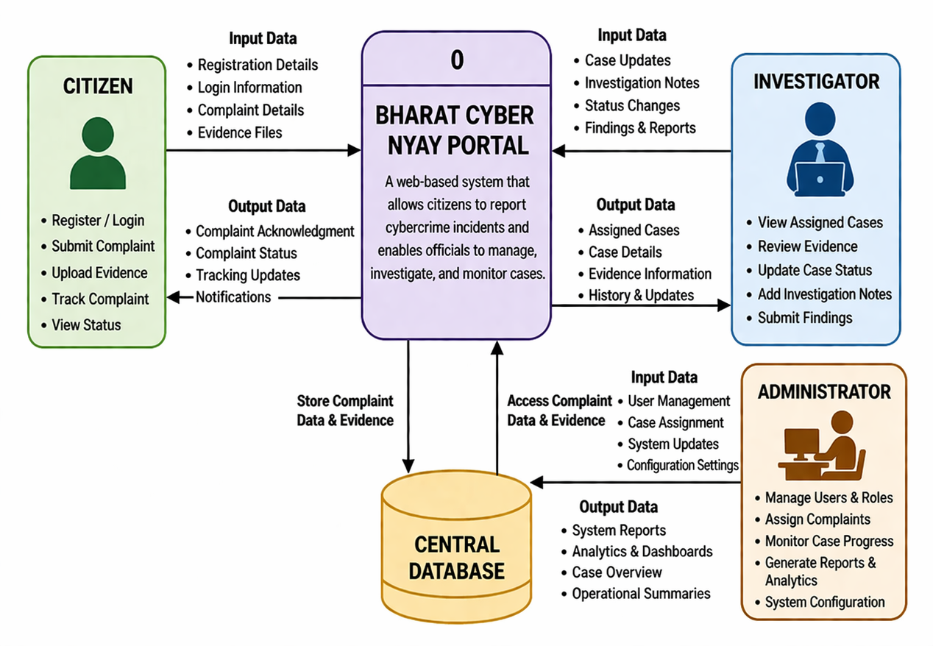

DATA FLOW DIAGRAM (DFD) – Level 1
The DFD Level 1 of the Bharat Cyber Nyay Portal presents a detailed view of how data flows through the system by breaking it into core processes such as user management, complaint registration, evidence handling, case assignment, case tracking, and analytics; it shows how citizens, administrators, and investigators interact with these processes and related data stores to ensure secure, transparent, and efficient complaint lifecycle management.

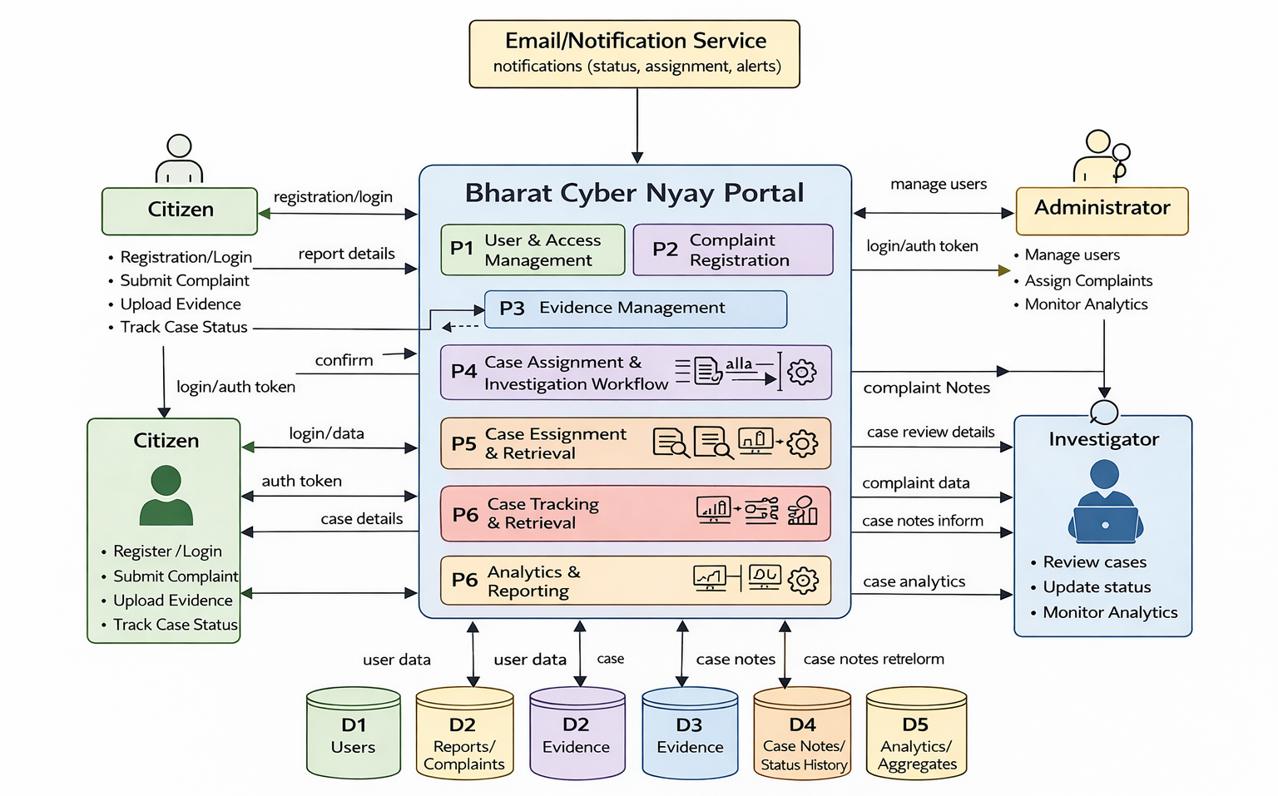

ENTITY RELATIONSHIP DIAGRAM (ER)

The ER Diagram of the Bharat Cyber Nyay Portal illustrates the structural relationship between core entities such as users, reports, evidence, and case notes, showing how citizen-generated complaints are stored, assigned to investigators, supported by uploaded evidence, and tracked through investigation notes and status updates; by defining primary keys, foreign keys, and one-to-many relationships clearly, the ER model ensures data consistency, secure linkage of case records, and efficient retrieval for complaint management, workflow monitoring, and analytical reporting.

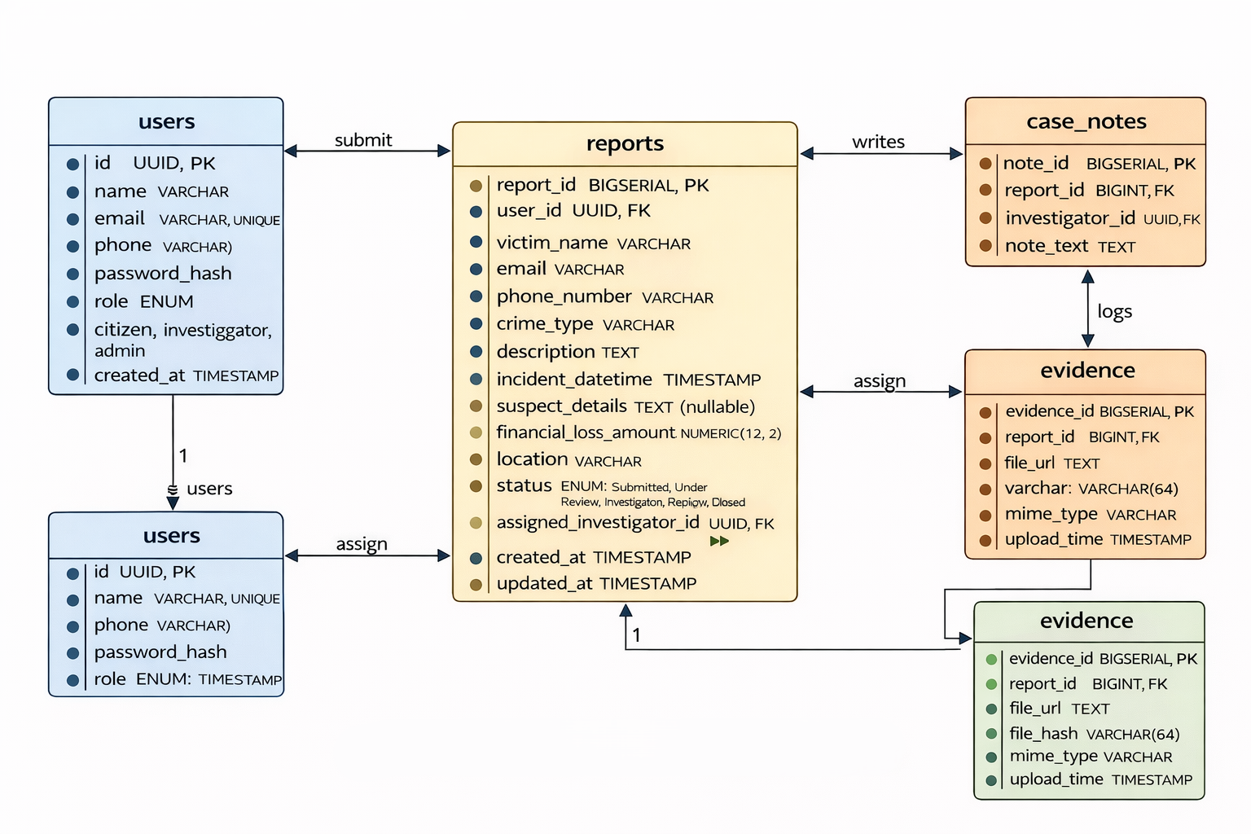

Entity, Attributes and Relationships

Entities represents a real-world object or concept about which data is stored in the system.
In the Bharat Cyber Nyay Portal, the main entities are:

- User
- Report
- Evidence
- Case_Note
- Attributes of Entities

Attributes are the properties or characteristics of an entity.

- User: id, name, email, phone, password_hash, role, created_at
- Report: report_id, user_id, victim_name, email, phone_number, crime_type, description, incident_datetime, suspect_details, financial_loss_amount, location, status, assigned_investigator_id, created_at, updated_at
- Evidence: evidence_id, report_id, file_url, file_hash, mime_type, original_name, upload_time
- Case_Note: note_id, report_id, investigator_id, note_text, created_at

Relationships define how entities are connected to each other in the database.
- One User (Citizen) can create many Reports.
- One User (Investigator) can be assigned many Reports.
- One Report can have many Evidence records.
- One Report can have many Case_Note records.
- One User (Investigator) can write many Case_Note records.

Entity, Attributes and Relationships Diagram
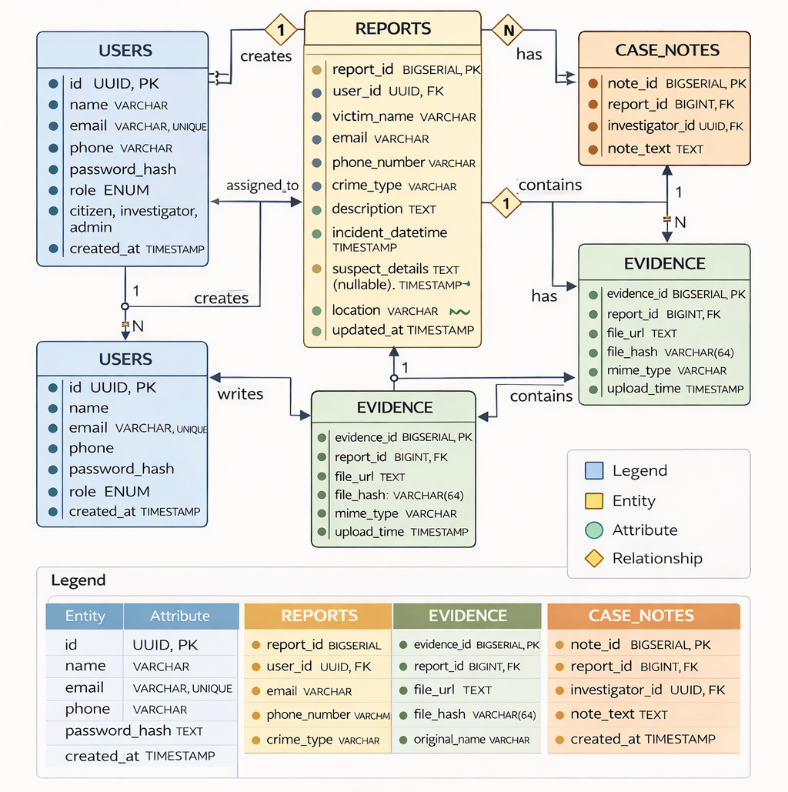

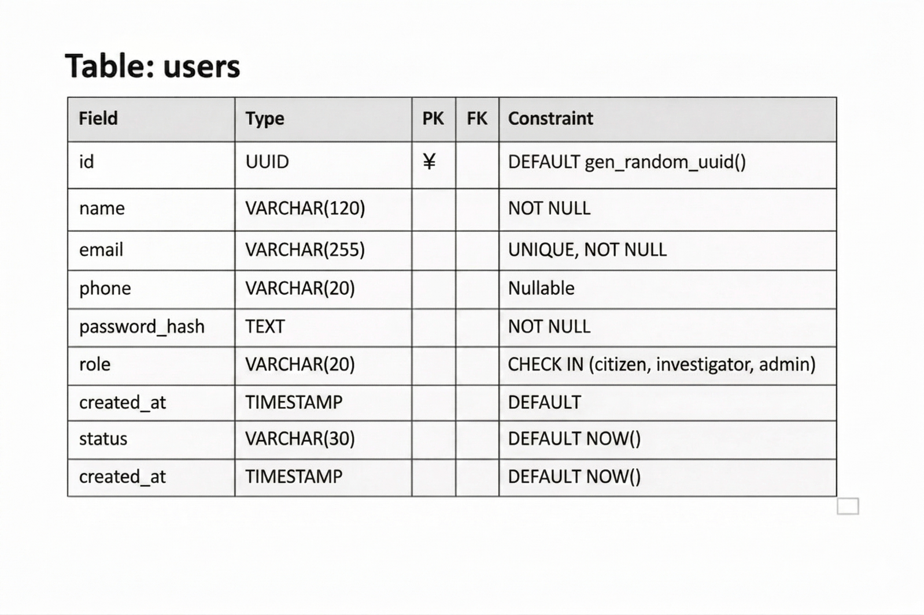
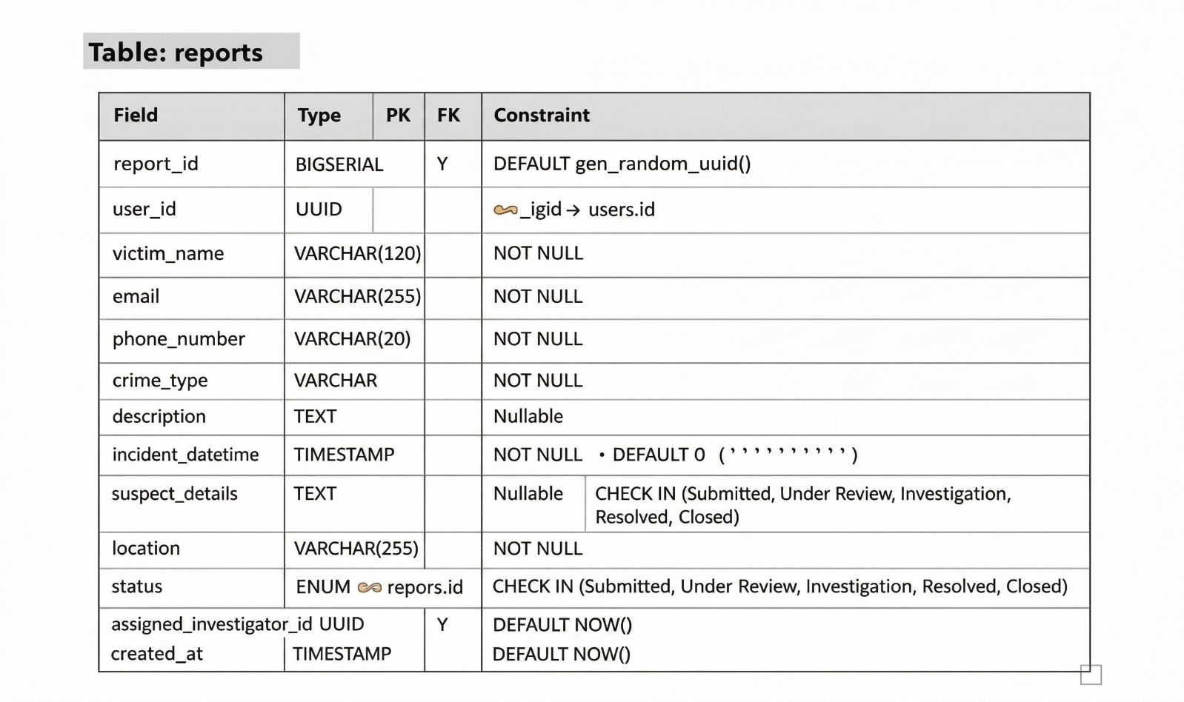
Database Schema

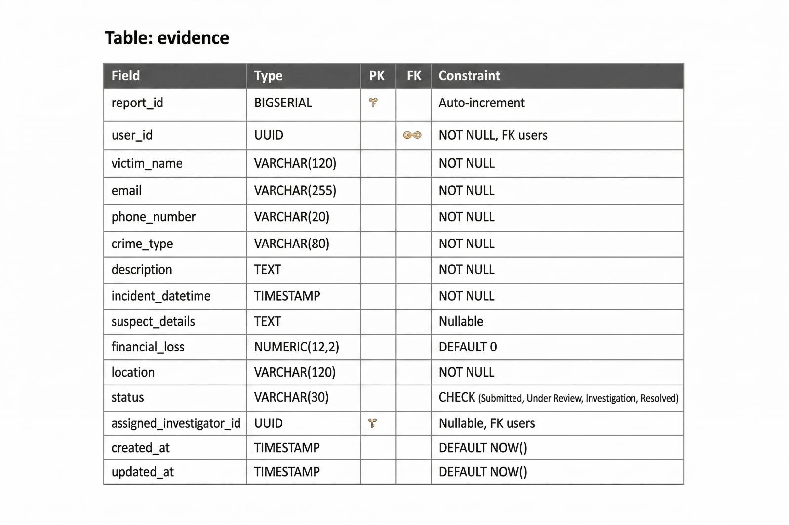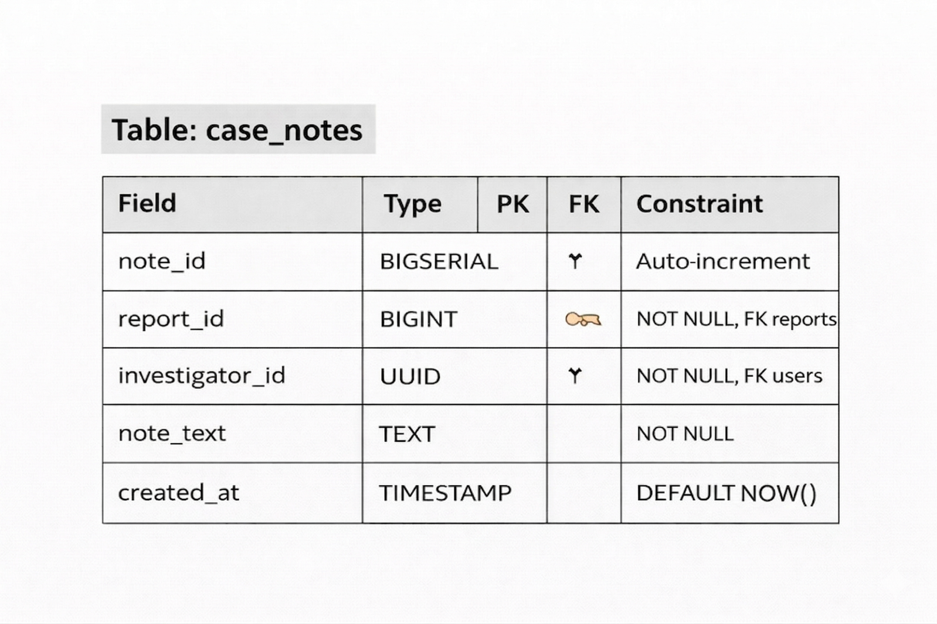

REFERENCES /BIBLIOGRAPHY

The successful completion of the Bharat Cyber Nyay Portal project was made possible with the help of various books, websites, and online resources. These references provided valuable knowledge about web development, database management, cybersecurity practices, and system design concepts used in developing this project.

Books:

1. Korth, H. F., & Silberschatz, A.
Database System Concepts
McGraw-Hill Education

2. Elmasri, R., & Navathe, S. B.
Fundamentals of Database Systems
Pearson Education

3. Pressman, Roger S.
Software Engineering: A Practitioner’s Approach
McGraw-Hill Education

4. Stallings, William
Cryptography and Network Security
Pearson Education

Websites:

1. www.w3schools.com
2. www.geeksforgeeks.org
3. www.javatpoint.com
4. www.tutorialspoint.com
5. www.postgresql.org
6. www.supabase.com
7. www.nodejs.org
8. www.react.dev
9. www.nextjs.org
10. www.github.com

INTERNSHIP DETAILS

Student Name Arka Dey
Company Name Gurugram Cyber Police Station
Email arkadey62@gmail.com
Contact Number +91 8674894001

Duration 30 Days
Start Date 2nd June, 2025
End Date 2nd July, 2025

Supervisor Name Dr. Rakshit Tandon

Supervisor Designation Cyber Crime Investigator

Nature of work Cybercrime Investigation, Digital Forensics,
Evidence Handling, Case Management, and
Cyber Awareness

INTERNSHIP CERTIFICATE

