Applied Mathematics: Regression Project (Group )

Experimentally measured ion concentration data often comes with noise due to biological variability or measurement error. Investigate how to estimate parameters k3 and v2 from noisy data.

Model description:

Li-Rinzel is a two-variable model (Ca and h) for fluctuation in concentration of ion.
- dCadt = c1*v1*p3*n3*h3*(CaER-Ca) + c1*v2*(CaER - Ca) - v3*Ca2Ca2+ k32
- dhdt = h*(1-h) -h*h

where
h =hh
h =1-hh
p =IP3IP3 + d1
n =CaCa + d5
Q2 = d2*IP3 + d1IP3 + d3
h =1a2*Q2 + Ca
h = Q2Q2 + Ca
CaER =c0 - Cac1

Parameter details
IP3 = 0.5; v1 = 6; v2 = 0.11; v3 = 0.9; c0 = 2; c1 = 0.185; a2 = 0.2; d1 = 0.13; d2 = 1.049; d3 = 0.9434; d5 = 0.08234; k3 = 0.1.
Initial conditions
Ca(1) = 0.1; h(1) = 0.1;
Write a MATLAB/python program to simulate the model using Euler’s scheme.

import numpy as np
import matplotlib.pyplot as plt

# Parameters
IP3 = 0.5
v1 = 6
v2 = 0.11
v3 = 0.9
c0 = 2
c1 = 0.185
a2 = 0.2
d1 = 0.13
d2 = 1.049
d3 = 0.9434
d5 = 0.08234
k3 = 0.1
time = np.arange(0, 100.1, 0.1)
dt = 0.1

# Initial conditions
Ca = np.zeros(len(time))
h = np.zeros(len(time))
Ca[0] = 0.1
h[0] = 0.1

# Deterministic model
for t in range(1, len(time)):
CaER = (c0 - Ca[t-1]) / c1
pinf = IP3 / (IP3 + d1)
ninf = Ca[t-1] / (Ca[t-1] + d5)
Q2 = d2 * (IP3 + d1) / (IP3 + d3)
tauh = 1 / (a2 * (Q2 + Ca[t-1]))
hinf = Q2 / (Q2 + Ca[t-1])
alphah = hinf / tauh
betah = (1 - hinf) / tauh
dh = alphah * --------
dCa = -------------
Ca[t] = ---------------
h[t] = -----------

# Plotting
plt.plot(time, Ca, '-b', linewidth=2)
plt.xlabel('Time, s')
plt.ylabel('Ca^{2+}')
plt.grid(True)
plt.title('Deterministic Li-Rinzel Model')
plt.show()

Data: The experimental data is shared in excel and sample simulated data is shown below:
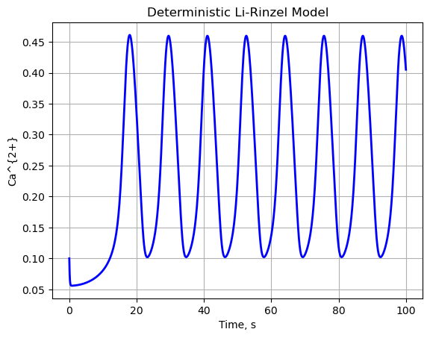

Preprocessing
Apply baseline correction to the raw data and display the visualizations. Also normalize the data to avoid shooting values for RMSE. Mention clearly the method of normalizer used.
From the figure above it is clear that the experimental and simulated signals have significant mismatches.
Monte Carlo simulation
Assumption of k3, v2 as random variable to refine the fit.
The goal of this project is to improve the match between experimental and simulated signals by generating templates from random combination of k3, v2. The project involves varying the parameters d5, a2​ using random sampling from uniform distribution, over a range of k3, v2 If 30 values are sampled from each parameter, 30x30 simulations can be generated. Calculate the frequency of each combination and choose a set of parameters that yields the minimum difference in oscillation frequency as well as Kl divergence between the data. Choose the appropriate Kl distribution that captures the statistics. Also show the continuity of the function to be integrated for calculating Kl divergence.
Try to build a code, where you can vary all the all the parameters randomly and create a search space. How do you save computational time while doing the random search vs systematic search using for loop.
Evaluation metrics
Evaluate the fit between experimental and simulated signals using KL divergence. Plot the RMSE also as a function of k3, v2.

