# DL – Lab 4 – IT21237904 Gunawardana U.G.C.D

1. Why are there 1783 boxes? Explain the reason for it. What is the maximum number and minimum number you can get for that?

**Answer**:

The shape of the tensor is [19,19,5,4], therefore it is a 19x19 grid cells resulting in 1805 boxes. Out of this 1805, only 1783 boxes have a confidence score that meet or exceed 0.5 threshold.

Max – 19 x 19 x 5 = 1805 boxes

Min – 0 boxes

1. yolo_anchors.txt contains 10 values. They can be considered as height and width of 5 anchor boxes. What is the advantage of using such anchor boxes? What was the method used to determine the sizes of these anchor boxes?

**Answer**:

Anchor boxes allow YOLO to predict multiple objects of different sizes and shapes within a single grid cell. Without anchor boxes, an object would need to be centered within a specific grid cell to be detected. Anchor boxes allow objects that are not perfectly centered in a grid cell to still be detected.

The size of the anchor boxes is determined through k-means clustering on the dimensions of the bounding boxes of the training dataset.

1. Upload traffic image: changed threshold to 0.3

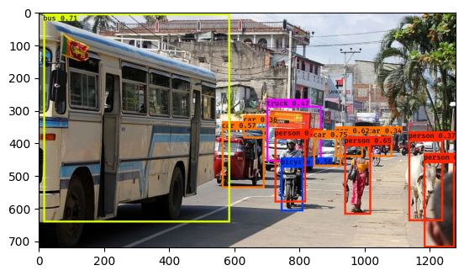

1. Observe the bounding boxes in the autonomous driving dataset

**Image 0114.jpg:**

Nothing is detected in this image.

Predicted image:

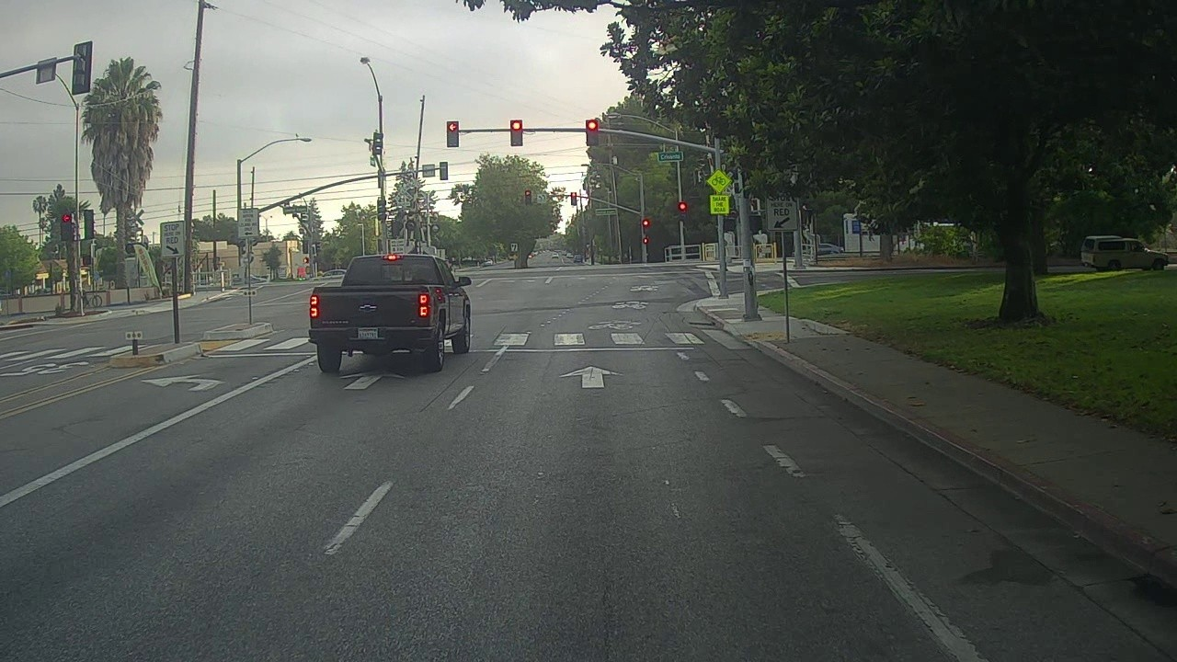

Original:

**Image 0103.jpg:**

Predicted**:**

We can see the bus is correctly predicted with a confidence score of 0.75, but the car and truck are not predicted.

Also, the traffic lights are not predicted.

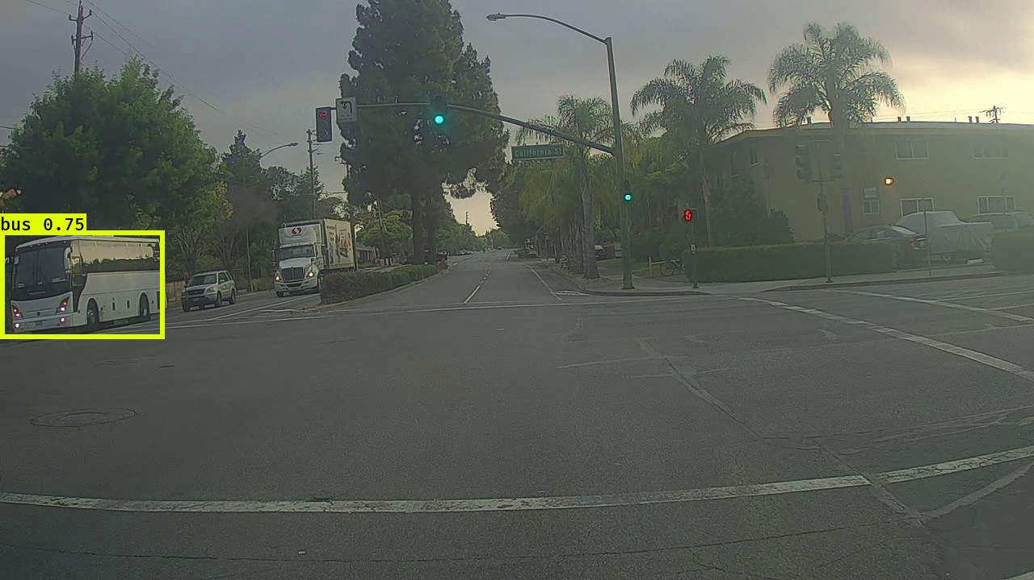

Original: 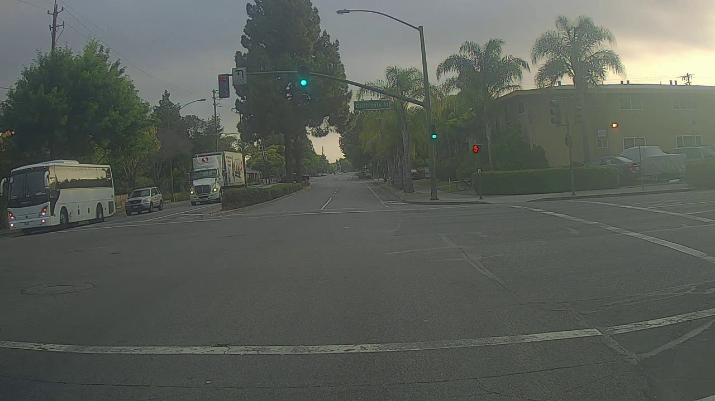

1. Adjusting parameters like max_boxes, score_threshold, and iou_threshold of the yolo_eval function can potentially address the limitations.

**Change the max_boxes: 50**

No improvement.

**Change the score_threshold : 0.5**

0114.jpg – No Improvement

0103.jpg – Detected car with 0.51, incorrectly detected bus 0.53, detected traffic light 0.51

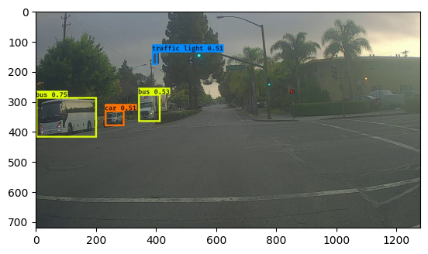

**Change the score_threshold : 0.4**

0114.jpg – Correctly detected car and traffic light

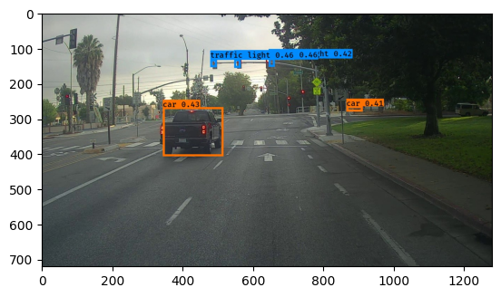

0103.jpg – Identified more traffic lights

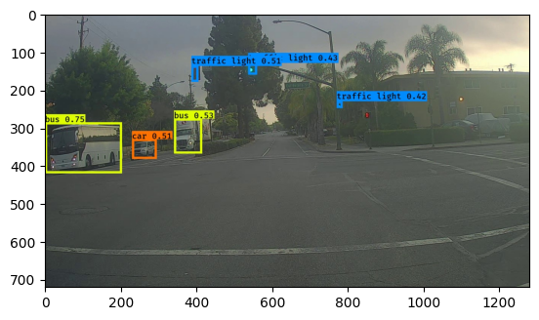

**Change the iou_threshold**

Did not improve results.