Supplementary Material
The CD4+ T cell regulatory network mediates inflammatory responses during acute hyperinsulinemia: a simulation study
M.E. Martinez-Sanchez, M. Hiriart, E. R. Alvarez-Buylla*
* Correspondence: Corresponding Author: eabuylla@gmail.com

Supplementary Data
Supplementary File 1: References of the CD4+ T cell regulatory network. <ThInsulin-References.xls>
Supplementary File 2: Simplification of the CD4+ T cell regulatory network. <ThInsulin-Transitions.xls>
Supplementary File 3: Perturbation tables of the CD4+ T cell regulatory network. <ThInsulin-Transitions.xls>

Supplementary Figures and Tables

Supplementary Figures

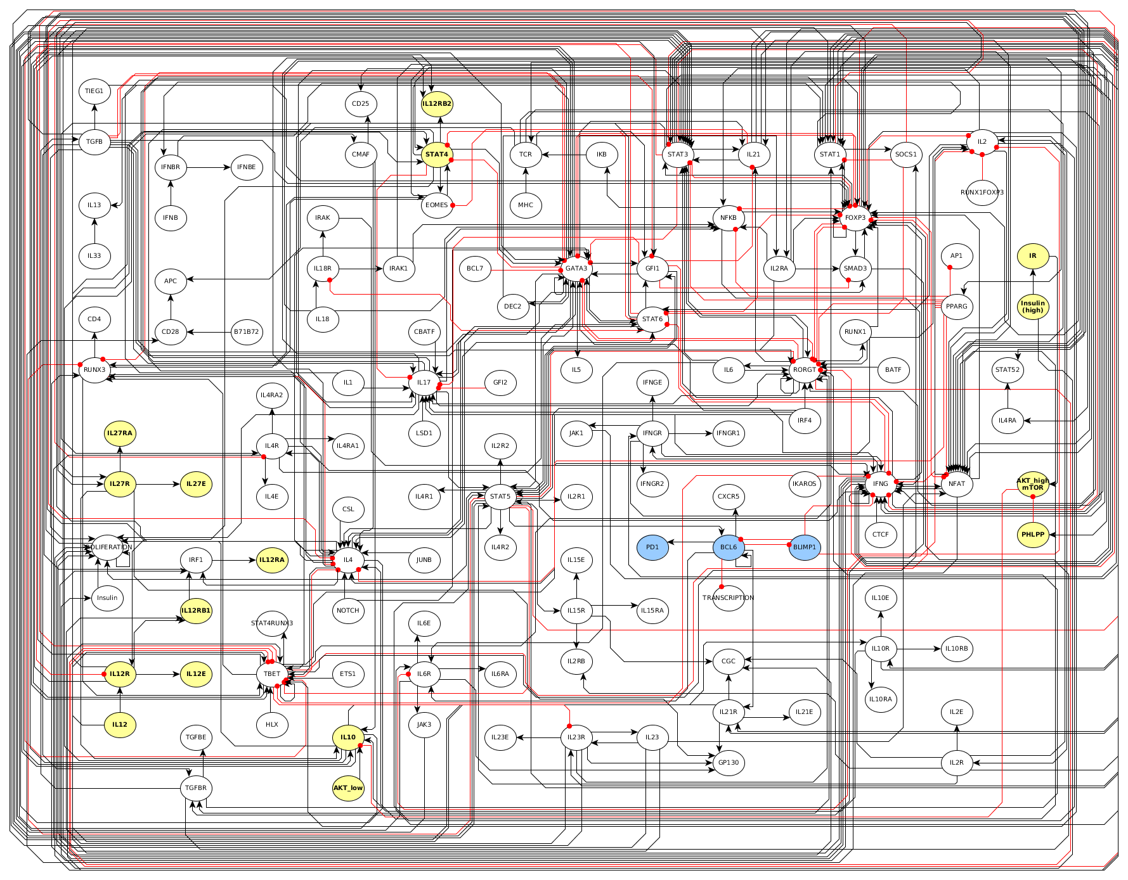
Supplementary Figure 1: Extended CD4+ T cell regulatory network. The CD4+ T cell regulatory network includes transcription factors, intrinsic cytokines and their signaling pathways (including STAT and SOCS proteins), and extrinsic cytokines and insulin, among others. Yellow nodes correspond to molecules added in this paper with respect to previous network [13], and blue nodes correspond to molecules removed for this paper with respect to those in [13]. The interactions proposed in the network between elements are grounded on experimentaly verified interactions. Activations between elements are represented with black arrows, and inhibitions with red dotted arrows. The network was then simplified using methods that maintain the dynamics of the system (see Supplementary material).

Supplementary Tables

Supplementary Table 1. Node simplification of the CD4+ T cell regulatory network.
Node | Biological molecules
TBET | T-bet, Eomes, Runx3, Ets1, Hlx, RELB
IFNG | IFNγ, IFNγR, STAT1
GATA3 | GATA3, Dec2, Fli1, Gfi1, Irf4, TCF1, Ikaros
IL2 | IL-2, IL2-R(α,β,γ), STAT5
IL4 | IL-4, IL-4R, STAT6
RORGT | RORγt, Irf4, BATF, Runx1, c-REL, EBF1
IL21 | IL-6, IL-6R, IL-21, IL-21R, IL-23, IL-23R, STAT3
FOXP3 | Foxp3, Et1, FOXO1, CREB, c-Rel, opera, PHLPP
TGFB | TGFβ, TGFβR, SMAD3, TGFβ signaling pathway, TIEG1
IL10 | IL-10, IL-10R, IL10 signaling pathway, c-maf, CREB, IRF1, SP1
IL12e | IL-12, IL-12R, IRAK1
IL21e | Extrisic IL-6, IL-21, and IL-23
TCR | AP-1, ICOS, NFAT, NFkB, CD28, Jun, etc
Insulin -| IL-10 | Akt (high), mTOR
IL10 -| IFNG | SOCS3
IL4 -| IFNG | SOCS3
TGFB -| IFNG | SOCS3
STAT3 -| IL2 | SOCS1
IL10 -| IL2 | SOCS2
IFNG -| IL2 | SOCS1, SOCS2
STAT3 -| IL4 | SOCS1
IFNG -| IL4 | SOCS1
IL10 -| STAT3 | SOCS3
IL4 -| STAT3 | SOCS3
IFNG -| STAT3 | SOCS3

Supplementary Table 2. Rules of the CD4+ T cell regulatory network.
Node | Function
TBET | ((IFNG | (IL12e & ! (IL21 | IL4 | IL10)) ) | TBET) & ! (IL4 | GATA3 | IL21)
IFNG | (IFNGe | ((IFNG | TBET) & ! (GATA3 | TGFB))) & ! (IL21 | IL4 | IL10)
GATA3 | ((IL2 & IL4) | GATA3) & ! (TBET | TGFB | IL21 | IFNG)
IL2 | (IL2e | (IL2 & ! FOXP3)) & ! (IFNG | IL21 | (IL10 & ! FOXP3))
IL4 | (IL4e | (GATA3 & (IL2 | IL4) & ! TBET)) & ! (IFNG | IL21)
RORGT | (IL21 & TGFB) & ! (TBET | FOXP3 | GATA3)
IL21 | (IL21e | IL21 | RORGT) & ! (IFNG | IL4 | IL10 | IL2)
FOXP3 | (IL2 & (TGFB | FOXP3)) & ! (IL21 | RORGT)
TGFB | TGFBe | ((TGFB | FOXP3) & ! IL21 )
IL10 | IL10e | (IL10 & (IFNG | IL21 | TGFB | GATA3 | IL27e) & ! INSULIN)
IFNGe | IFNGe
IL12e | IL12e
IL2e | IL2e
IL4e | IL4e
TGFBe | TGFBe
IL10e | IL10e
IL27e | IL27e

Supplementary Table 3. Labeling rules of the CD4+ T cell regulatory network.
Labels | Rules
Th0 | ! (TBET | GATA3 | RORGT | FOXP3 | IL10 | TGFB)
Th1 | (TBET & IFNG) & ! (IL10 | TGFB | FOXP3)
TBET+ | TBET & ! (IFNG | IL10 | TGFB | FOXP3)
Th1R | TBET & (IL10 | TGFB | FOXP3)
TH2 | (GATA3 & IL4) & ! (IL10 | TGFB | FOXP3)
GATA3+ | GATA3 & ! (IL4 | IL10 | TGFB | FOXP3)
Th2R | GATA3 & (IL10 | TGFB | FOXP3)
Th17 | RORGT & IL21 & ! IL10
RORGT+ | RORGT & ! (IL21 | IL10)
iTreg | FOXP3 & TGFB & ! (TBET | GATA3 | RORGT)
IL10+ | IL10 & ! (TBET | GATA3 | FOXP3 | RORGT)
TGFB+ | TGFB & ! (TBET | GATA3 | FOXP3 | RORGT)
Not Th1/17 example | IL10 & !(TBET)
Not Th1/17/1R | !((TBET & IFNG) & ! (IL10 | TGFB | FOXP3))  &!(TBET & (IL10 | TGFB | FOXP3))
  &!(RORGT & IL21 & ! IL10)

