臻享家
Standard Living Management
托管交给臻享，安心交给我们

专为海外投资者打造的吉隆坡物业管理服务
Professional Property Management for Expats in KL
海外拥有房产，有时会让您内心隐隐不安，疑惑一切是否真的安好,担心看不见的隐患，在疑问出现时感到茫然。我们懂那种感受—因为我们陪伴过太多像您一样的业主。而我们在这里，就是要加入您的旅程，让您不再独自承担。
Owning property overseas can quietly make you feel insecure. Wondering if everything is really okay, worrying about hidden problems you can’t see,feeling alone when questions arise. We understand that feeling - because we’ve been there with so many owners like you. And we’re here to join your journey, so you never have to carry it alone again.

我们每时常都听到 We Hear It Every Day
“我不知道维修是不是真的必要，价格是否合理” “I don’t know if the repairs are really necessary or fairly priced”
“文件看不懂，事情不清楚”“I can’t read the documents or understand what’s happening”
“我感觉和自己的投资脱节了”“I feel disconnected from my own investment”
CTA--(Rename)
Scan To Whatsapps
WhatsApp: [+6010-3343184]



我们不只是管理房产，我们加入您的旅程
We don’t just manage properties — we join your journey
- YOUR DEDICATED RELATIONSHIP MANAGER 您的专属伙伴 One person who stays with you long-term, knows your story, and protects your peace of mind. 一位长期陪伴您、了解您故事、守护您安心的伙伴
- TENANT CARE THAT BUILDS LASTING SECURITY 用心照顾租客，带来持久安心 Happy, well-supported tenants mean fewer worries and steadier income for you. 满意的租客 = 更少的担忧 + 更稳定的收入
- WE BRIDGE EVERY DISTANCE 我们跨越每一份距离 Speaking your language, understanding your culture — so you always feel close, never far away. 用您熟悉的语言、文化，让您永远感觉近在咫尺
- ALWAYS BY YOUR SIDE 一直在您身边 Immediate help in emergencies, same-day care otherwise — because real partners show up. 紧急即时响应，非紧急同日跟进——真正的伙伴会在您需要时出现
Two levels of companionship — choose how closely we walk with you (Refine)
两种陪伴程度 — 选择我们与您并肩的深度(Refine)
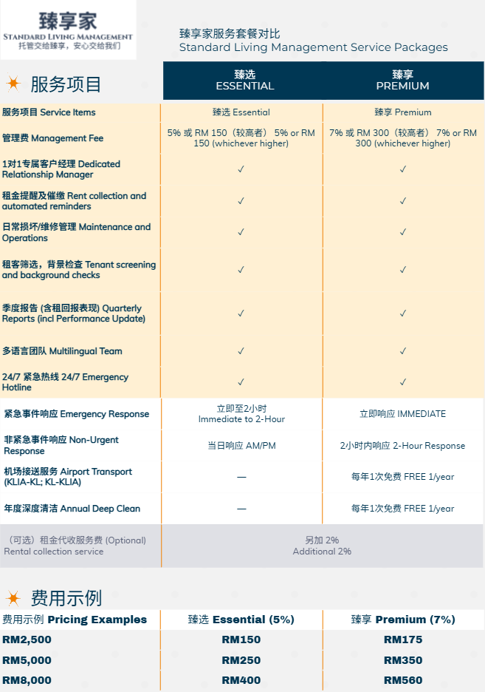

BOTTOM CTA
We’re ready to walk beside you — whenever you’re ready.
我们已经准备好与您同行—只要您愿意。


Scan for conversation
扫码开始对话

PAGE 3: SERVICES & FINAL CLOSE – The journey promise
TOP
Support for every chapter of your KL property story
为您吉隆坡房产故事的每一个篇章提供支持
(Keep service descriptions almost identical — they’re already strong. Optional small emotional taglines:
“VIP Handover – We stand with you from day one”
“Defect Inspection – So you never have to wonder”)
TRUST HEADLINE
Our promise: We join your journey with 100% openness and care
我们的承诺：以100%坦诚与关怀，加入您的旅程
(Keep pillars)
FINAL CTA – Strong emotional landing
Your investment should feel secure — not insecure.
您的投资，理应让您安心，而不是不安。
Let us be the companion who helps make that true, step by step, year after year.
让我们成为那位一步一步、年复一年帮助您实现安心的伙伴。
[Large QR Code]
WhatsApp Us – The journey feels lighter when shared
通过WhatsApp联系我们 – 旅程有人分享，就会轻松许多
Standard Living Management (臻享家)
Not just management. Real companionship.
不只是管理，是真正的陪伴。

Roles and responsibilities | 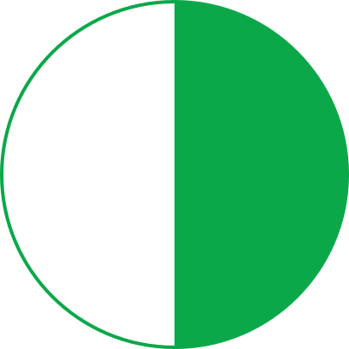

Milestones | 

Audit evidence checklist |  |  |  | 
Category | Required documents | Owner
Policies & Controls | Updated copliance policy, risk matrix | Compliance Officer
HR Records | Training logs, certification records | HR Partner
IT Security | Access logs, vulnerability scans | IT Security
Finance | Expense reports, vendor contracts | Finance Lead
Operations | SOPs, incident records | Ops Manager

Final sign-off | 
The Audit Lead schedules a readiness review call to capture outstanding items, assigns corrective actions, and obtains final executive approval. Once complete, the Audit Readiness Log is archived, and the audit folder is locked for retention compliance.

