Getting the example project running on Windows 10
4/28/2022 Corwin Hansen

This assumes you have a 64bit Windows 10 installed.

- Install Visual Studio Command Line Tools
  - Go to https://visualstudio.microsoft.com/downloads/
  - Scroll down to, and open Tools for Visual Studio 2022
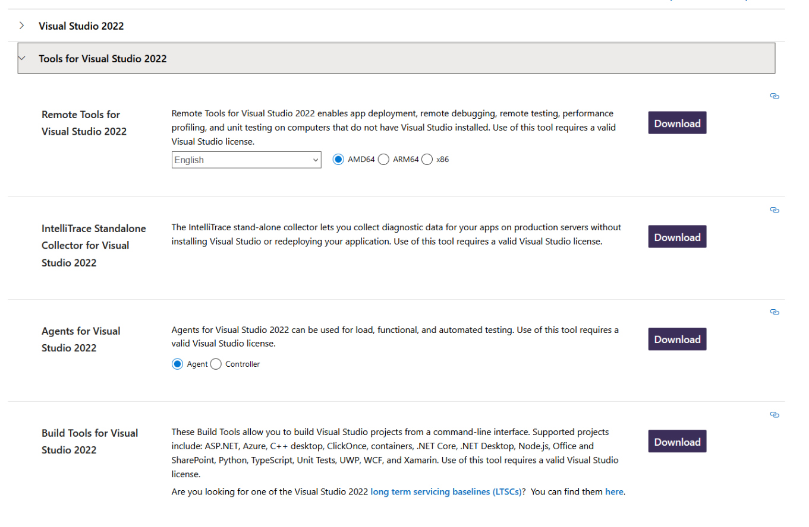
  - Download Build Tools for Visual Studio 2022
  - Run vs_BuildTools.exe
  - Click on Continue
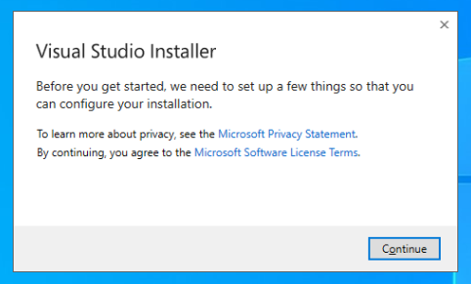

  - Select Desktop development with C++ then click on install
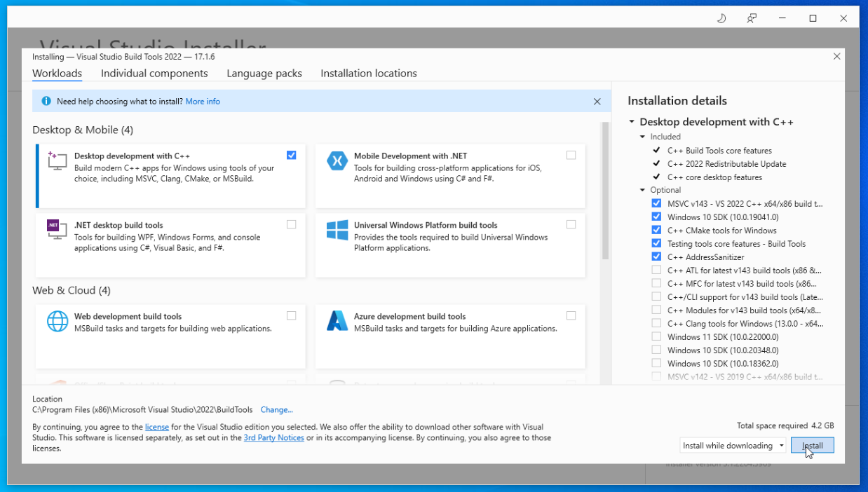
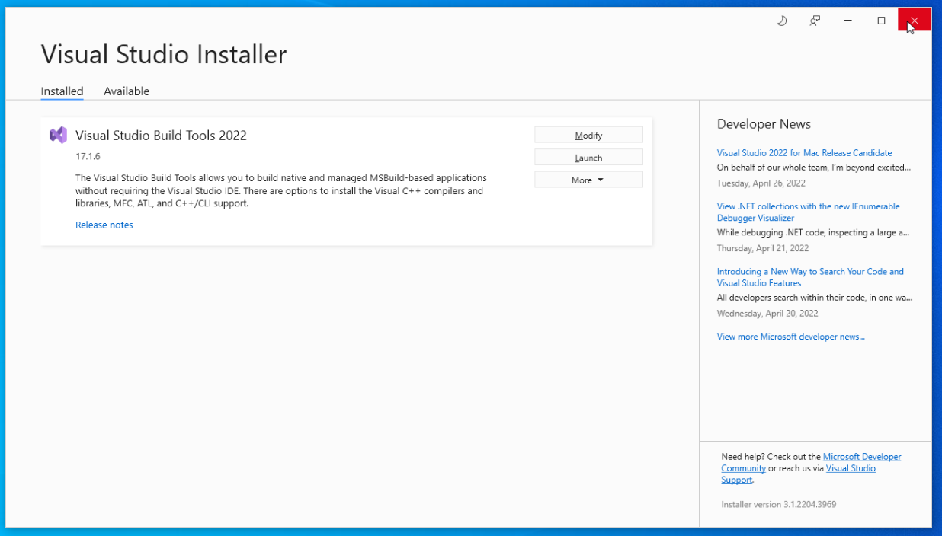
  - After the wait, command line tools for visual studio should be installed. You can close the installer window now. This tool will allow you to compile the code from command line, without logging in to the windows account.

- Install a programming text editor
  - You can install and use any editor you are comfortable with, but I suggest using Atom, and later steps in this section will follow the installation of atom. If you already have an editor in mind or installed, feel free to skip this section.
  - Go to https://atom.io/ and click on download

  - Run AtomSetup-x64.exe
  - Atom should be installed now. It is recommended to pin it to the taskbar.

- Search, run, and pin Command Prompt to taskbar

- Install Cmake
  - Go to https://cmake.org/download/
  - Download the Windows x64 Installer
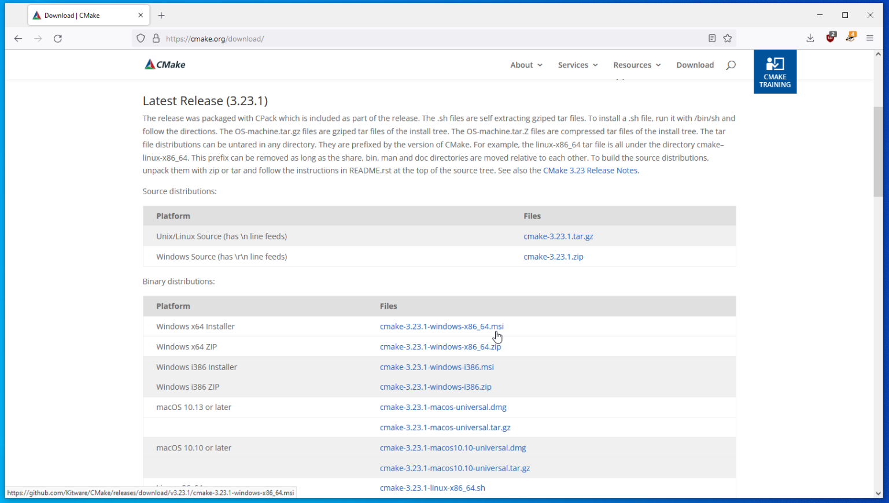
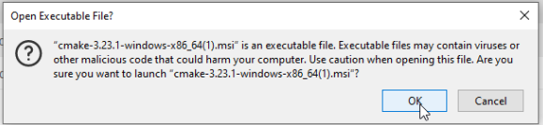
  - Run the downloaded installer. Click on ok on executable file warning.

  - Click on Next
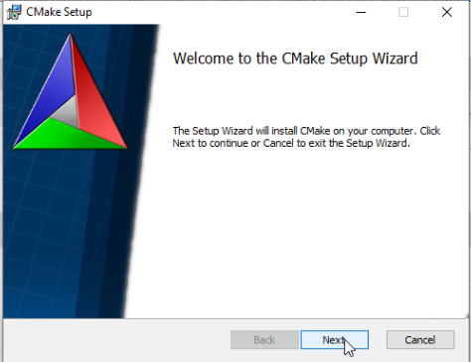
  - Agree to the license then click on next
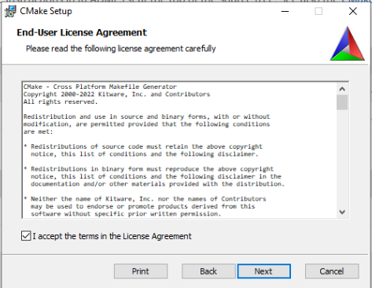

  - Select Add Cmake to system PATH for all users, check Create CMake Desktop Icon, then click on next
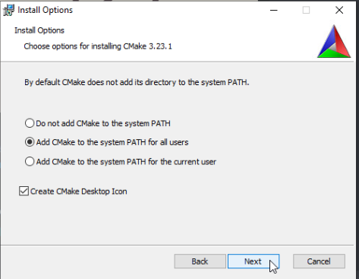
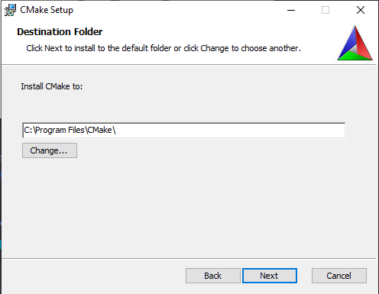
  - Click on next without changing the default path

  - Click on install. Allow the app to make changes.
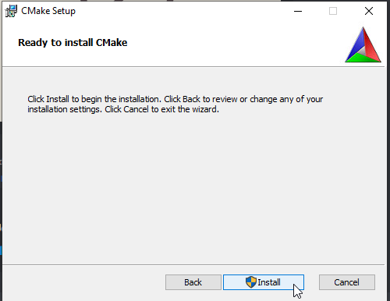
  - Wait for install to finish and click on Finish to close the window. CMake should be installed now. It is recommended to pin CMake to the taskbar.

- Compile and run the template project
  - Unzip Project_Template_Files_Windows_10_x64.zip to a convenient directory(folder). Desktop will be used in this example.
  - Open CMake (cmake-gui)
  - Click on Browse Source
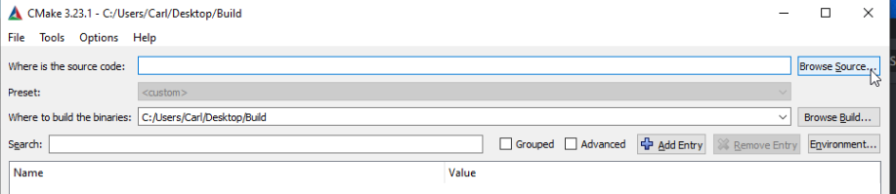
  - Navigate to SDL2_Project_Template folder within the unzipped folder, and select that folder. This folder is where the programs source is stored,
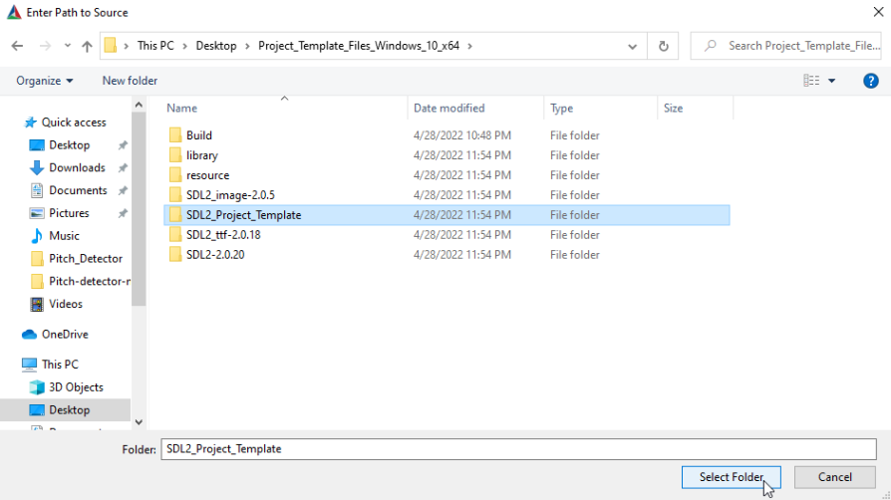
  - Click on Browse Build
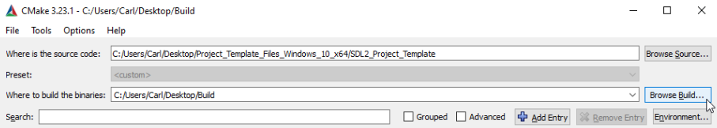

  - Navigate to Build folder within the unzipped folder, and select that folder.
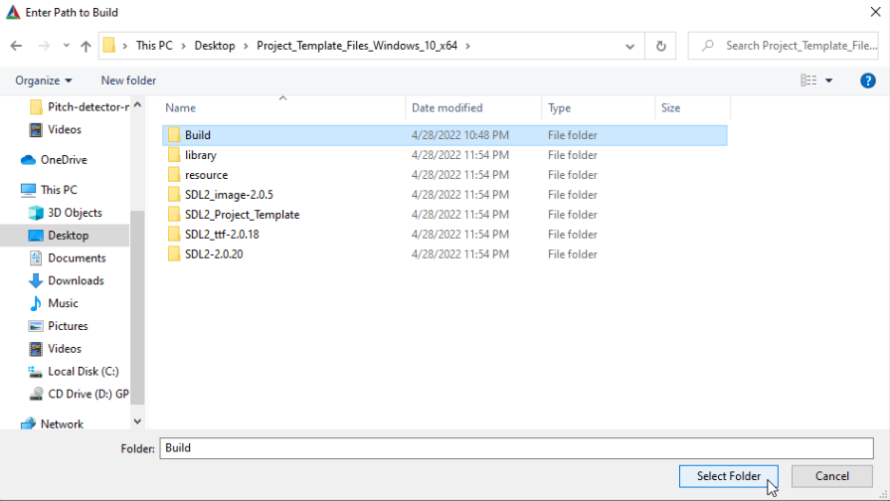
  - Click on Configure
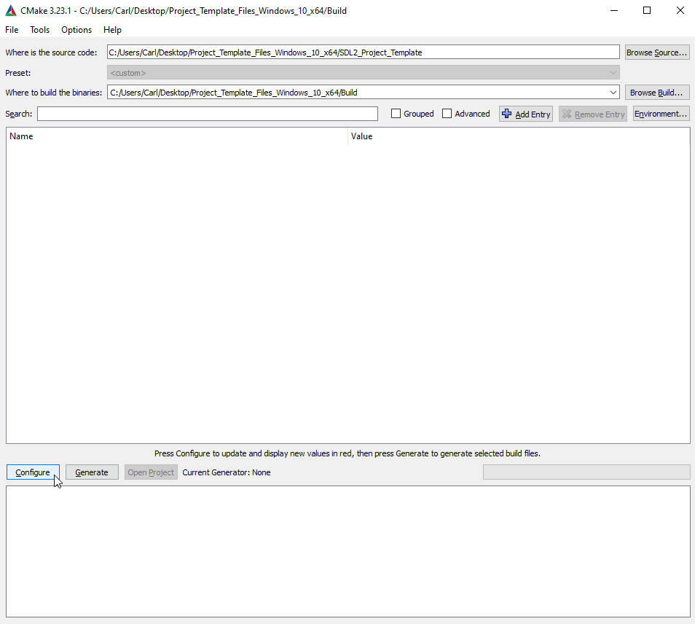
  - Use default setting for the generator, and click on finish.
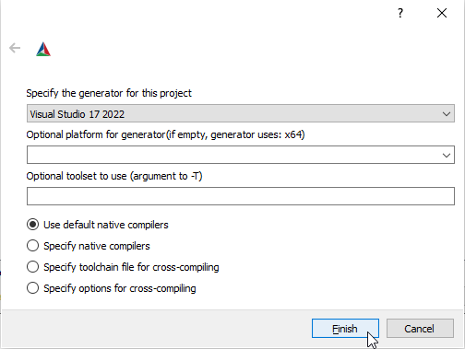
  - It will spit out an error. This is normal. Click on ok and continue to next step.
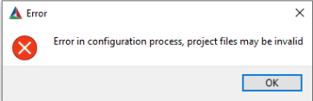
  - Click on the SDL2MAIN_LIBRARY, then the … part on the right of SDL2MAIN_LIBRARY-NOTFOUND
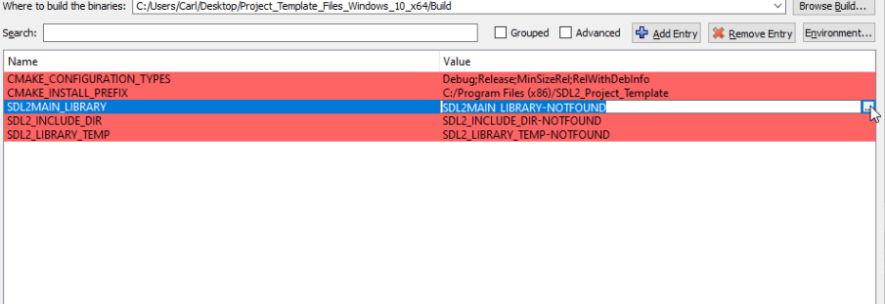

  - Navigate to Unzipped_File/SDL2-2.0.20/lib/x64/SDL2main.lib then click on Open.
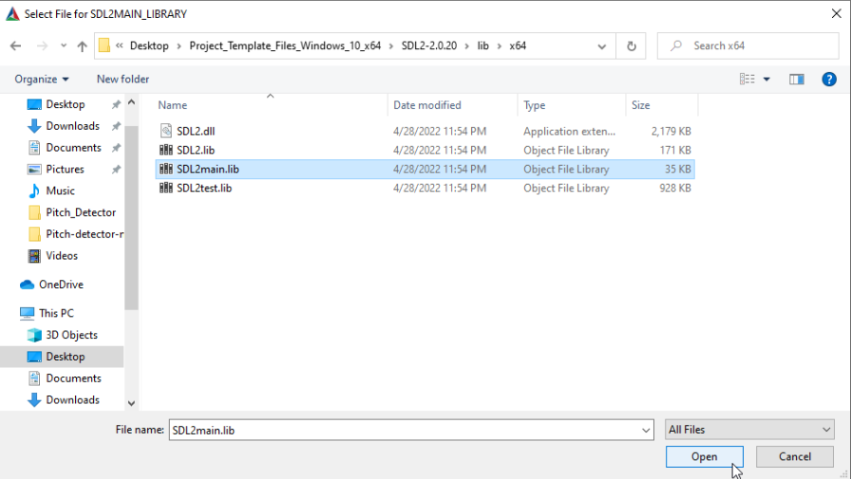
  - Click on the SDL2_LIBRARY_TEMP, then the … part on the right of SDL2_LIBRARY_TEMP-NOTFOUND, then navigate to Unzipped_File/SDL2-2.0.20/lib/x64/SDL2.lib then click on Open.
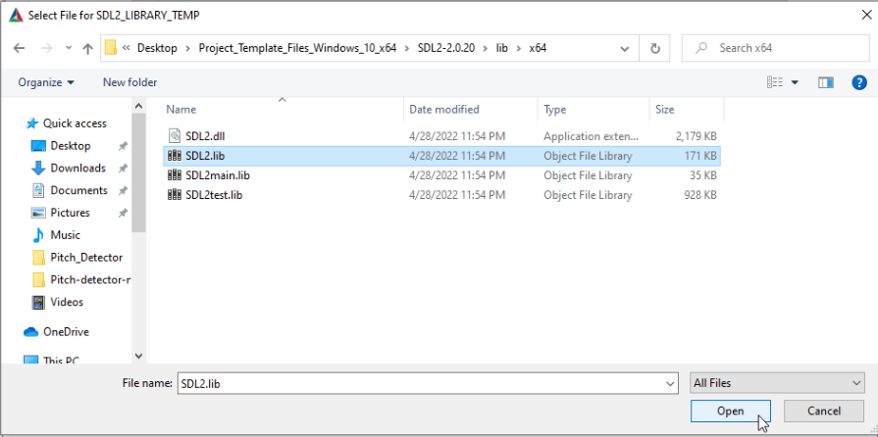

  - Click on the SDL2_INCLUDE_DIR, then the … part on the right of SDL2_INCLUDE_DIR-NOTFOUND, then navigate to Unzipped_File/SDL2-2.0.20/include/ then click on Select Folder.
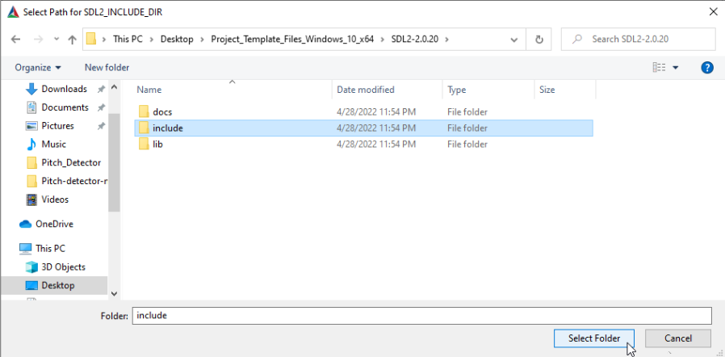
  - Click Configure again
  - Click on the SDL2_IMAGE_LIBRARY_TEMP, then the … part on the right of SDL2_IMAGE_LIBRARY_TEMP-NOTFOUND, then navigate to Unzipped_File/SDL2_image-2.0.5/lib/x64/SDL2_image.lib then click on Open.
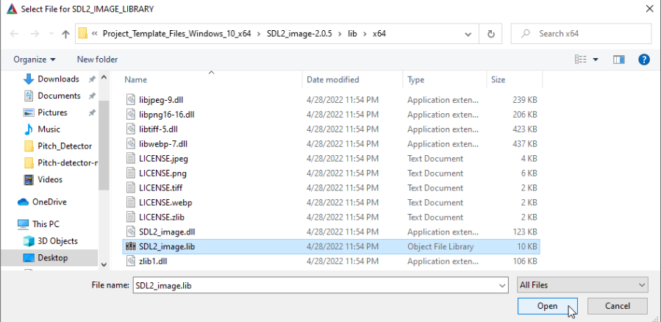

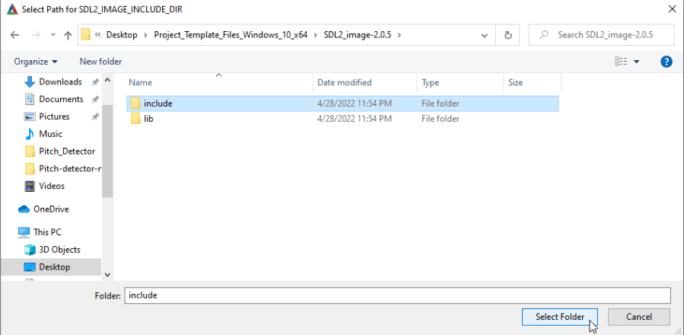
  - Click on the SDL2_IMAGE_INCLUDE_DIR, then the … part on the right of SDL2_IMAGE_INCLUDE_DIR-NOTFOUND, then navigate to Unzipped_File/SDL2_image-2.0.5/include/ then click on Select Folder.
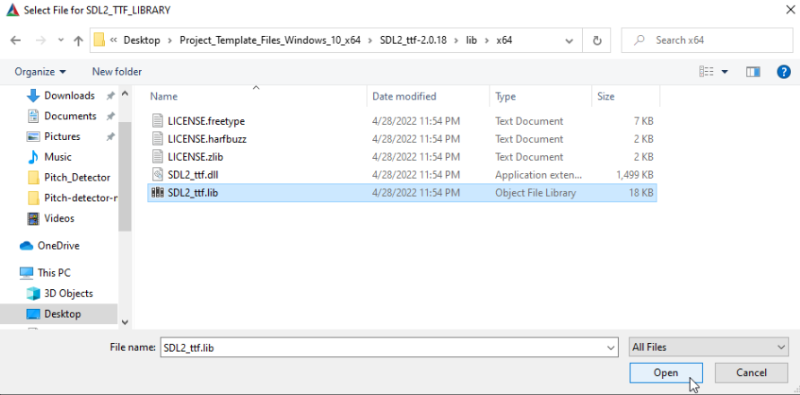
  - Click on the SDL2_TTF_LIBRARY_TEMP, then the … part on the right of SDL2_TTF_LIBRARY_TEMP-NOTFOUND, then navigate to Unzipped_File/SDL2_ttf-2.0.18/lib/x64/SDL2_ttf.lib then click on Open.

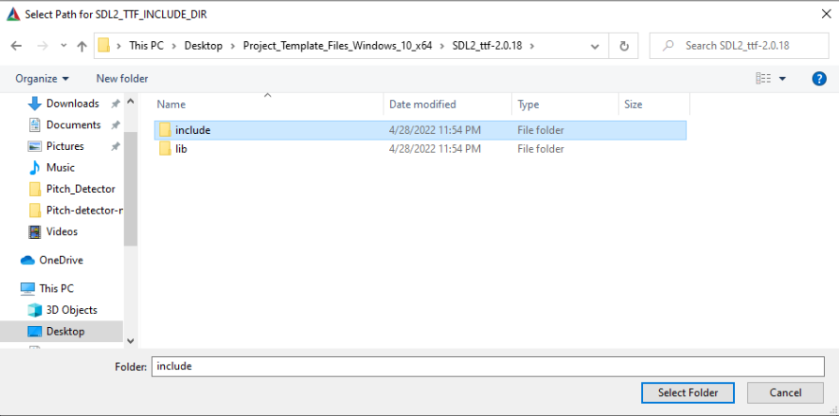
  - Click on the SDL2_TTF_INCLUDE_DIR, then the … part on the right of SDL2_TTF_INCLUDE_DIR-NOTFOUND, then navigate to Unzipped_File/SDL2_ttf-2.0.18/include/ then click on Select Folder.
  - Click Configure again. No value should be red.
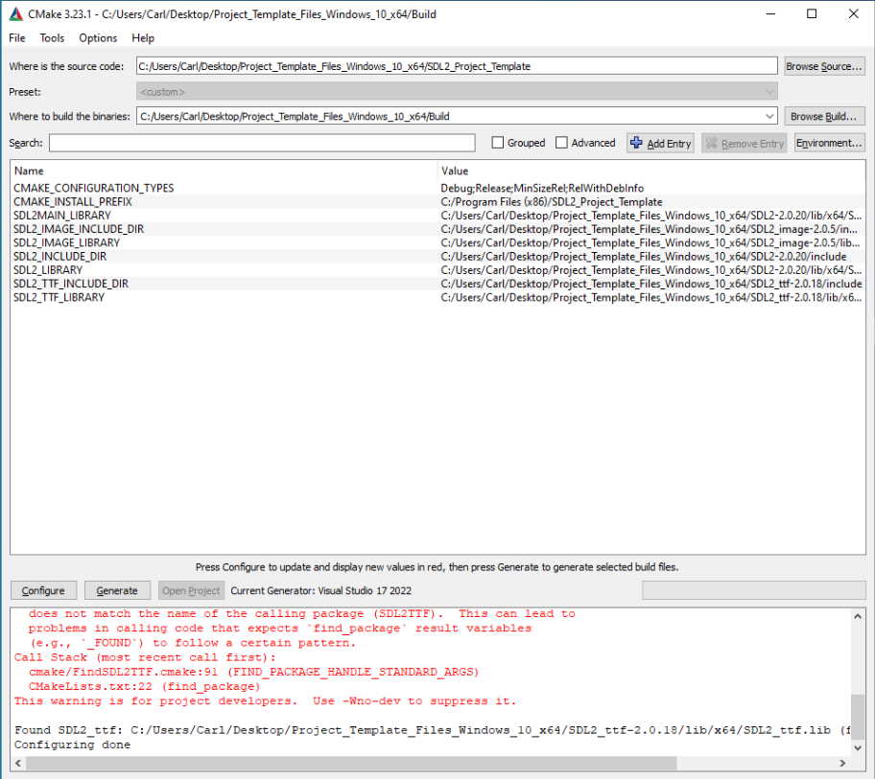
  - Click Generate
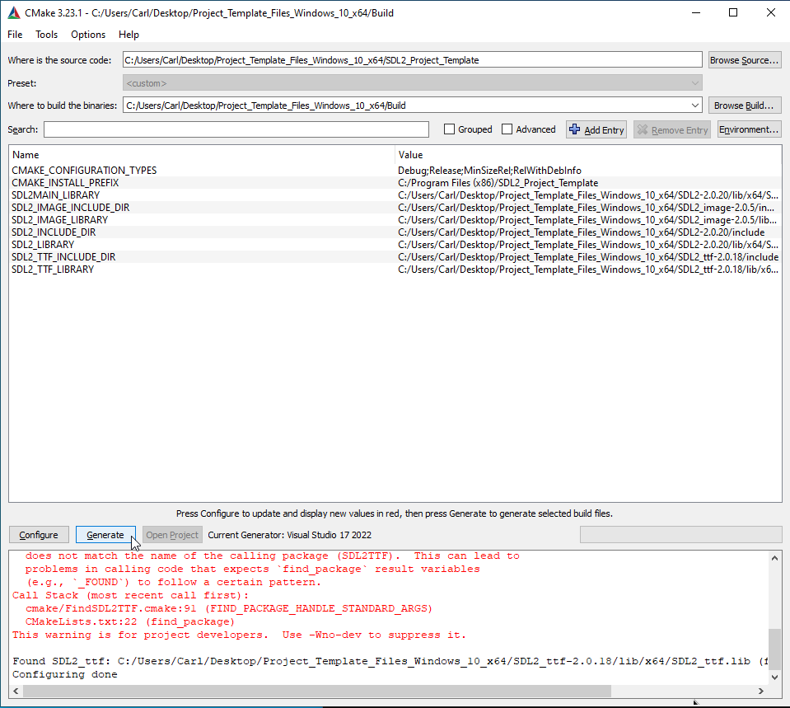
  - You can close CMake now.

  - Open Command Prompt.
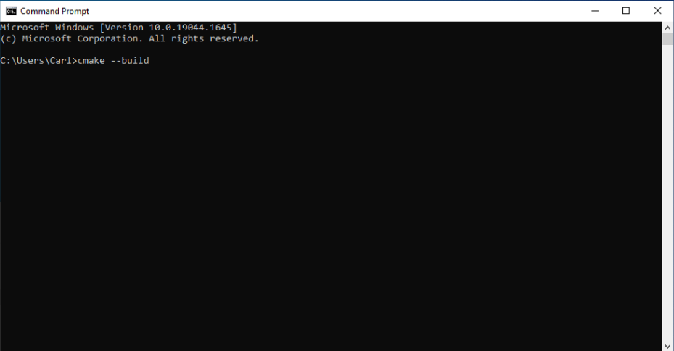
  - Type in to the command prompt “cmake –build “ You do need to have the extra space after the –build part.
  - Navigate to the Unzipped folder in file explorer, then drag and drop the Build folder on to the command prompt. This should insert the folders full path where the text cursor is in the command prompt.
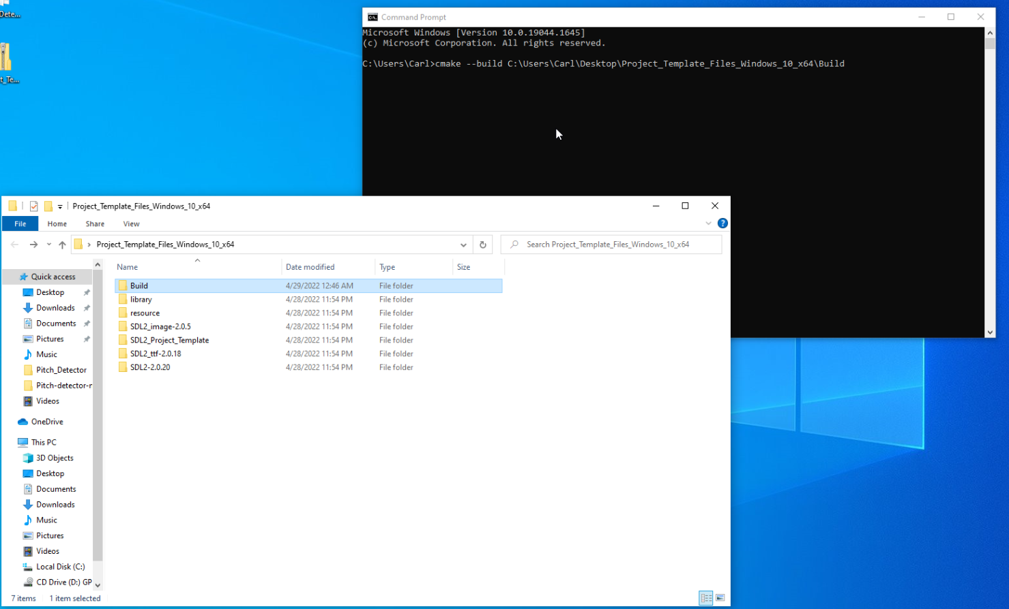

  - Go to command prompt and hit enter. The compilation process should begin, outputting all the warnings and errors, and if everything goes well, finish compiling everything. Warnings can be ignored, unless unintended stuff starts happening in the program, but errors will cause the compiler to stop. If there are any errors, fix them. Your newly compiled software should be in the Debug folder within the Build folder.
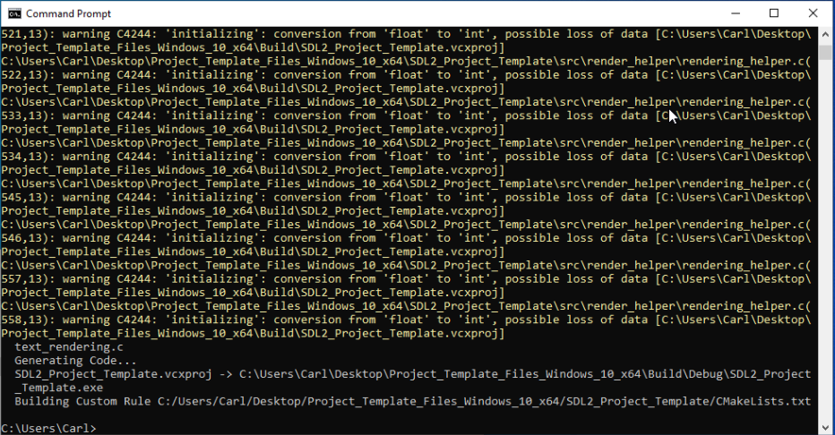
  - Copy and paste contents of library folder inside the Unzipped folder in to the Debug folder. These are the library runtime that are needed where the software can find them, and the easiest place to put them in is the same directory as the software. Usually, these files are stored inside the library’s lib folders, but it was gathered separately for ease of use.
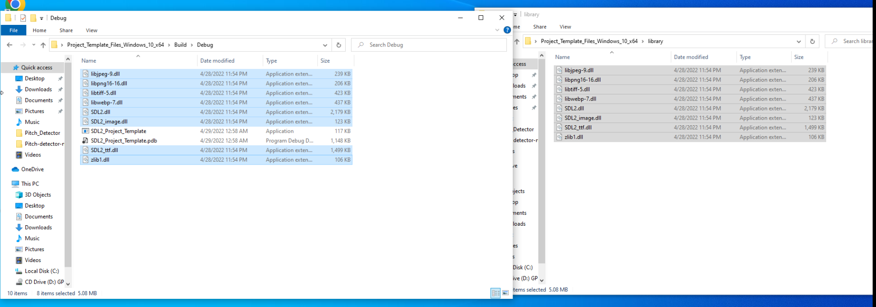

  - Copy and paste contents of resource folder inside the Unzipped folder in to the Debug folder. These are the resource files like images and fonts that are needed where the software can find them, and the easiest place to put them in is the same directory as the software. Usually, these files are stored inside the resource folder with the program source, but it was gathered separately for ease of use.
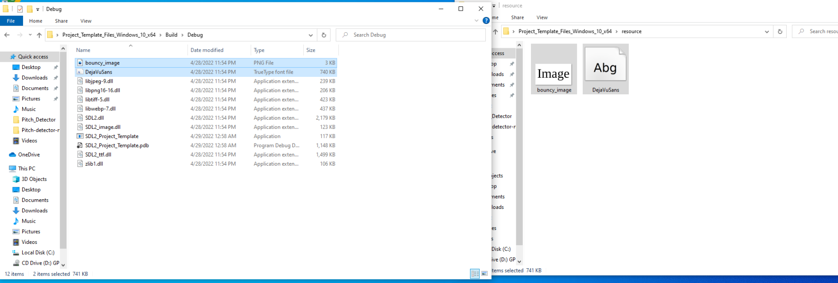
  - Double click on SDL2_Project_Template in the Debug folder, and it should run the software.
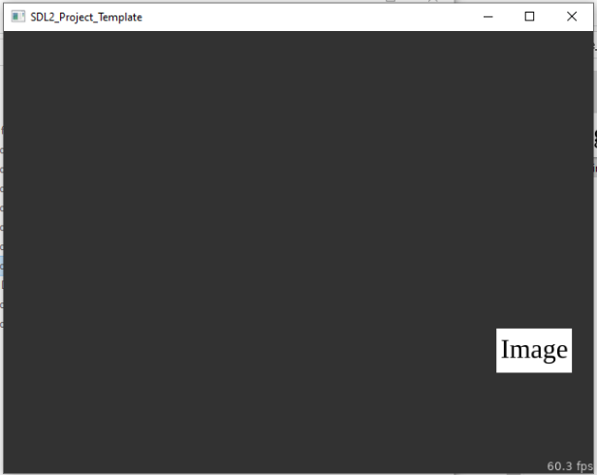

  - Click on the image bouncing around to get a prompt. You can hit OK to exit out of the prompt. The program window should be able to be resized.
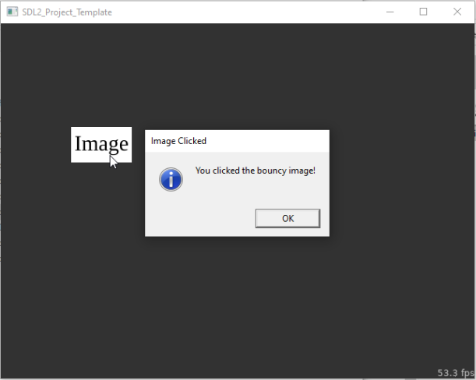
  - To recompile the software after changing some of the source code, repeat steps 22-25. Your program should be recompiled. The source files are in Unzipped_Folder/SDL2_Project_Template/src/. Most of the important code is in main.c, with some in constants.h. Try reading and editing some values in them to see what happens.
  - To recompile software after adding or deleting source files, open CMake, then repeat steps 19-25.
  - If new resource files are added or resource files are edited, copy the new files in to Unzipped_Folder/Build/Debug, the same folder as where the software is.
  - The software doesn’t need to stay in the Debug folder, and should be able to be placed anywhere as long as the library runtime files and resource files stays with it in the same place as the software.

