PS2_1.1：

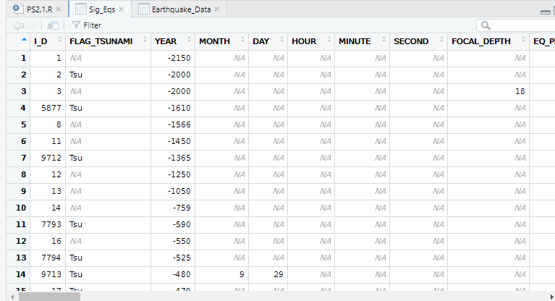

PS2_1.2：

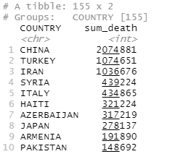

PS2_1.3:

科学文化和信息技术的发展迅速，近代信息记录较早期更为完整和清晰，所以近代地震信息更丰富。

With the rapid development of science, culture and information technology, the modern information record is more complete and clear than the early one, so the modern seismic information is more abundant.

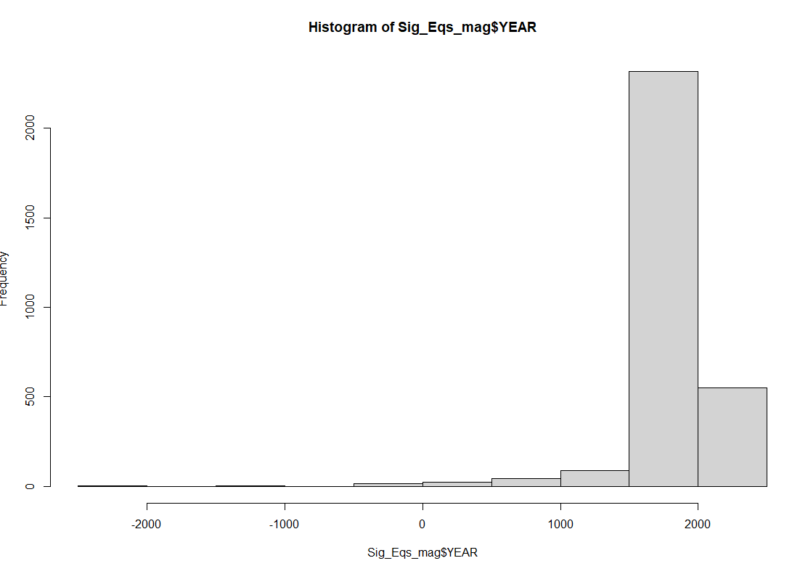

PS2_1.4:

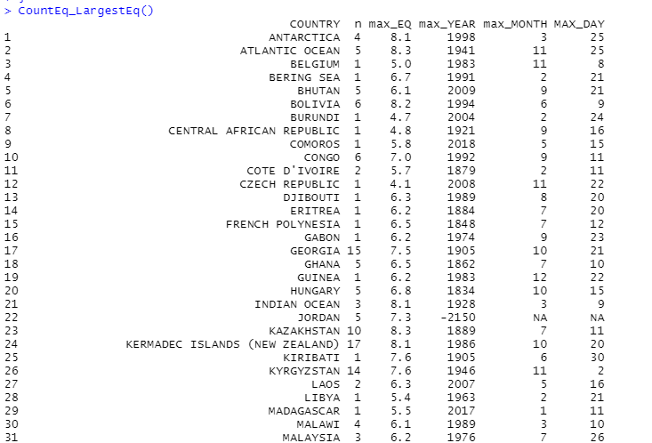

PS2_2

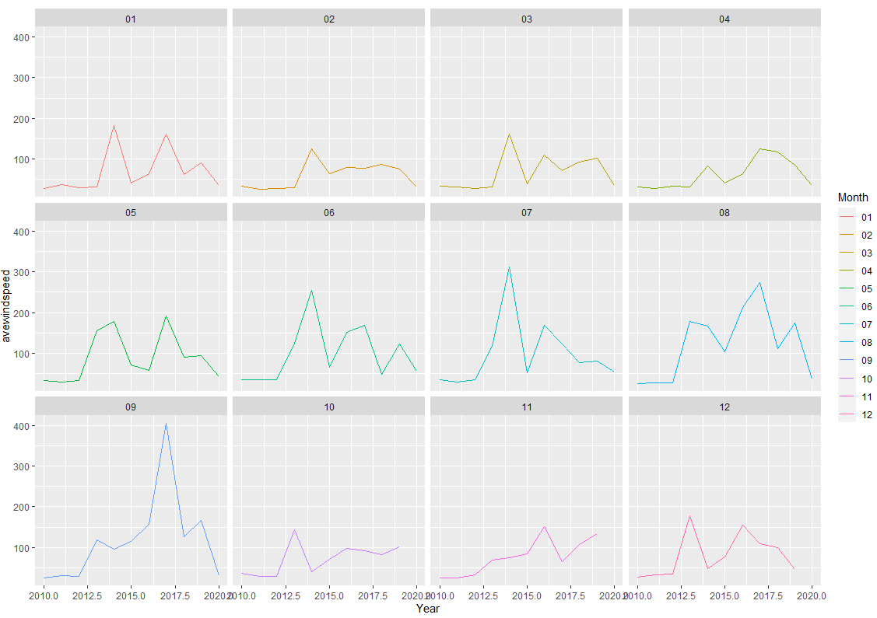

PS2_3

只有一个月的就按天算了

Here is data for only one month. So the Y axis is labeled by “DAY”.

