Financial Service Token System
Documentation

Theory of Operation

Operation of Module

Communication protocol

The communication happens over a I2C TWI (Two Wire Interface) network and all the packets are broadcast over the network to all the modules present. Each module has an address of 0 and initializes itself as a slave when in an idle state. There are two commands used over the network, one is UPPER_RANGE_CMD, and the other one is CUR_NUM_CMD, each one has 1 argument of 1 byte length. UPPER_RANGE_CMD is sent by the token dispenser to announce that it has just dispensed one more token, the argument carries the number of the token dispensed. This command is received by all counter modules, and the argument is used to update their internal UpperRange variable, to make sure counting stops when that number is reached. All other modules ignore this command. CUR_NUM_CMD is sent by counter modules every time one number is called, and it is received by all other counter modules, which use the argument to update their internal LowerRange variable, to make sure that the receiving module will not count to the same number that has just been called by the sending module. This command is also received by the General Status Monitor which displays the number received in the argument. All other modules ignore this command.

Hardware

Parts list
Below is documented the list of parts required to put together one module (not including external pushbutton/power adapter or casing):

Description | Qty. | Element14 part#
Audio Jack | 1 | 35RAPC4BHN2
5V regulator MCP1702 | 1 | MCP1702-5002E/TO
Diode | 1 | 1N4004-T
10uF Capacitor | 1 | MCMHR16V106M4X7
47uF Capacitor | 1 | ECA1CM470
10K Resistors | 3 | SFR16S0001002JA500
RJ45 Jacks | 2 | MULTICOMP - MTJ-881X1
7-segment decoder HEF4543PTH | 2 | HEF4543BP,652
Transistor array NPN ULN2003AN | 2 | ULN2003ANE4
8-pin RMC header | 2 | N/A came from PDY
2 DIP-SWITCH | 1 | ADE0204
300 ohm resistor | 1 | N/A came from PDY
LED | 1 | N/A came from PDY
100nF Capacitor | 1 | MCDR50104X7RK0100
20-pin IC base | 1 | N/A came from PDY
ATtiny2313 Microcontroller | 1 | ATTINY2313A-PU
LEDs for display | 42 | N/A came from PDY
68 ohm resistors | 14 | N/A came from PDY
8-pin RMC cable | 2 | N/A came from PDY
Main board PCB | 1 | N/A came from PCB Power
Single digit PCB | 2 | N/A came from PCB Power

Schematics & Board layout
The schematics and board layout are saved in Eagle format as 4 separate files in the schematics/ folder in this git repository.
main_board.sch The schematic of the main board
main_board.brd The board layout of the main board
single_digit.sch The schematic of the single digit board
single_digit.brd The board layout of the single digit board

On the main board layout there is a mistake in the silk screen marking of which way the MCP1702 should go in. Make sure to insert the MCP1702 the opposite way as shown on the board. It has been decided that for the RMC cables going from the main board to the single digit board the purple cable should be used for the common VCC. There are four components which should not be soldered on the main board, these are R3, Q2, JP3 and M01PTH on the schematic, as these are for an optional buzzer that is currently not implemented. There is one LED on the main board which is currently being used as a power indicator.

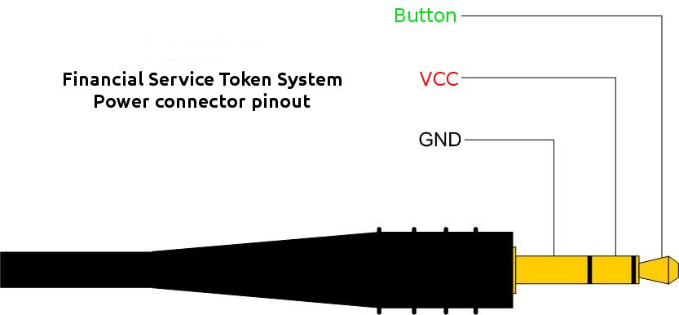
Specifications
These are the electrical specifications of one module:
7.5V DC 200 mA

These are the physical specifications of one module:
1 Main board: 78.80 X 58.10 MM
1 Single Digit: 84.80 X 48.20 MM

Software

Diagram of version 1

Notes

Configuration and Usage

DIP-switch settings
This is a list of possible settings for the DIP-switch, where 1 and 2 correspond to the numbers printed on the DIP-switch and ON and OFF correspond to the ON/OFF print on the DIP-switch.
Token Dispenser:
1 ON
2 OFF

Counter Module:
1 OFF
2 ON

General Status Monitor:
1 ON
2 ON

Display connections
To connect the display boards to the main board please follow the label on the main board to make sure you connect the correct digit to the correct connector on the main board.
digit 0: is the Tens digit
digit 1: is the Units digit

Wiring
To connect all the modules together, connect them using standard straight-crimped ethernet cable forming a chain from one module to the next. It does not matter which module is at which position in the chain. To connect the modules to power, connect the GND pin of the audio connector to the GND of your power source, VCC to the + of your power source, and BUTTON through a normally open pushbutton to the GND.

