Financial Service Token System
Documentation

Table of Contents
1.Theory of operation 1
1.1. Overview 1
1.2.Communication Protocol 1
2.Hardware 2
2.1.Parts list 2
2.2.Schematics & Board layout 2
2.3.Specifications 3
3.Software 3
3.1.Diagram of code 4
3.2.Notes 5
4.Configuration and Usage 5
4.1.DIP-switch settings 5
4.2.Display connections 5
4.3.Wiring 5

Theory of operation

User's overview

- The code will be described from the point of view of one of the users being serviced.
- The system consists of one or more token dispenser(s), some counter module(s), and one or more general status monitor(s).
- First the user enters and dispenses a token by pressing the button on the token dispenser. The user notes his token, by looking at the number on the display after having pressed the button. In order to ensure that the user doesn't dispense two tokens we have implemented a 2 second de-bounce delay.
- The token dispenser announces that there is a new token to be called, and allows the counter modules to count up to that number.
- The desk modules accumulate all the tokens that have been dispensed in consecutive order, and call the tokens accordingly. When they reach the same token as the token dispenser they stop calling, to prevent counting further than the last dispensed token.
- In order to make sure the same token is not called twice, the module that just called a token, increments it's lower bound of the to do list and broadcasts it to all the other modules.
- The general status monitor is to display the token that has been called last in order to keep track of the three to four desks that are calling tokens. This means that every time a token is called, the general status monitor displays the token that has just been called. One of these modules is placed on the outside of the door to make sure that the users can sit outside and keep track of their turn, and they can also sit inside without having to watch all three displays...
NOTE:
All modules are identical in hardware and software. They determine what their task is by referring to the dip switch settings that are physically set on the main board, please refer to the configuration and usage section [4.1] for more details.

Communication Protocol
The communication happens over a I2C TWI (Two Wire Interface) network and all the packets are broadcast over the network to all the modules present. Each module has an address of 0 and initializes itself as a slave when in an idle state. There are two commands used over the network, one is UPPER_RANGE_CMD, and the other one is CUR_NUM_CMD, each one has 1 argument of 1 byte length. UPPER_RANGE_CMD is sent by the token dispenser to announce that it has just dispensed one more token, the argument carries the number of the token dispensed. This command is received by all counter modules, and the argument is used to update their internal UpperRange variable, to make sure counting stops when that number is reached. All other modules ignore this command. CUR_NUM_CMD is sent by counter modules every time one number is called, and it is received by all other counter modules, which use the argument to update their internal LowerRange variable, to make sure that the receiving module will not count to the same number that has just been called by the sending module. This command is also received by the General Status Monitor which displays the number received in the argument. All other modules ignore this command.

Hardware

Parts list
Below is documented the list of parts required to put together one module (not including external pushbutton/power adapter or casing):

Description | Qty. | Element14 part#
Audio Jack | 1 | 35RAPC4BHN2
5V regulator MCP1702 | 1 | MCP1702-5002E/TO
Diode | 1 | 1N4004-T
10uF Capacitor | 1 | MCMHR16V106M4X7
47uF Capacitor | 1 | ECA1CM470
10K Resistors | 3 | SFR16S0001002JA500
RJ45 Jacks | 2 | MULTICOMP - MTJ-881X1
7-segment decoder HEF4543PTH | 2 | HEF4543BP,652
Transistor array NPN ULN2003AN | 2 | ULN2003ANE4
8-pin RMC header | 2 | N/A came from PDY
2 DIP-SWITCH | 1 | ADE0204
300 ohm resistor | 1 | N/A came from PDY
LED | 1 | N/A came from PDY
100nF Capacitor | 1 | MCDR50104X7RK0100
20-pin IC base | 1 | N/A came from PDY
ATtiny2313 Microcontroller | 1 | ATTINY2313A-PU
LEDs for display | 42 | N/A came from PDY
68 ohm resistors | 14 | N/A came from PDY
8-pin RMC cable | 2 | N/A came from PDY
Main board PCB | 1 | N/A came from PCB Power
Single digit PCB | 2 | N/A came from PCB Power

Schematics & Board layout
The schematics and board layout are saved in Eagle format as 4 separate files in the schematics/ folder in this git repository.
main_board.sch The schematic of the main board
main_board.brd The board layout of the main board
single_digit.sch The schematic of the single digit board
single_digit.brd The board layout of the single digit board

On the main board layout there is a mistake in the silk screen marking of which way the MCP1702 should go in. Make sure to insert the MCP1702 the opposite way as shown on the board. It has been decided that for the RMC cables going from the main board to the single digit board the purple cable should be used for the common VCC. There are four components which should not be soldered on the main board, these are R3, Q2, JP3 and M01PTH on the schematic, as these are for an optional buzzer that is currently not implemented. There is one LED on the main board which is currently being used as a power indicator.

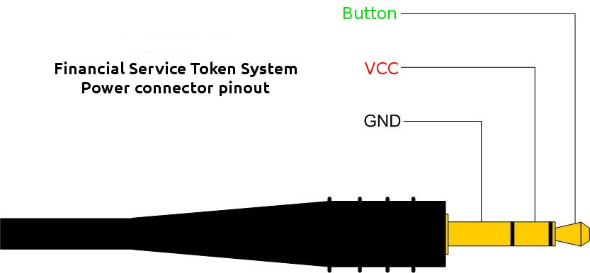
Specifications
These are the electrical specifications of one module:
7.5V DC 200 mA

These are the physical specifications of one module:
1 Main board: 78.80 X 58.10 MM
1 Single Digit: 84.80 X 48.20 MM

Software

Flowchart
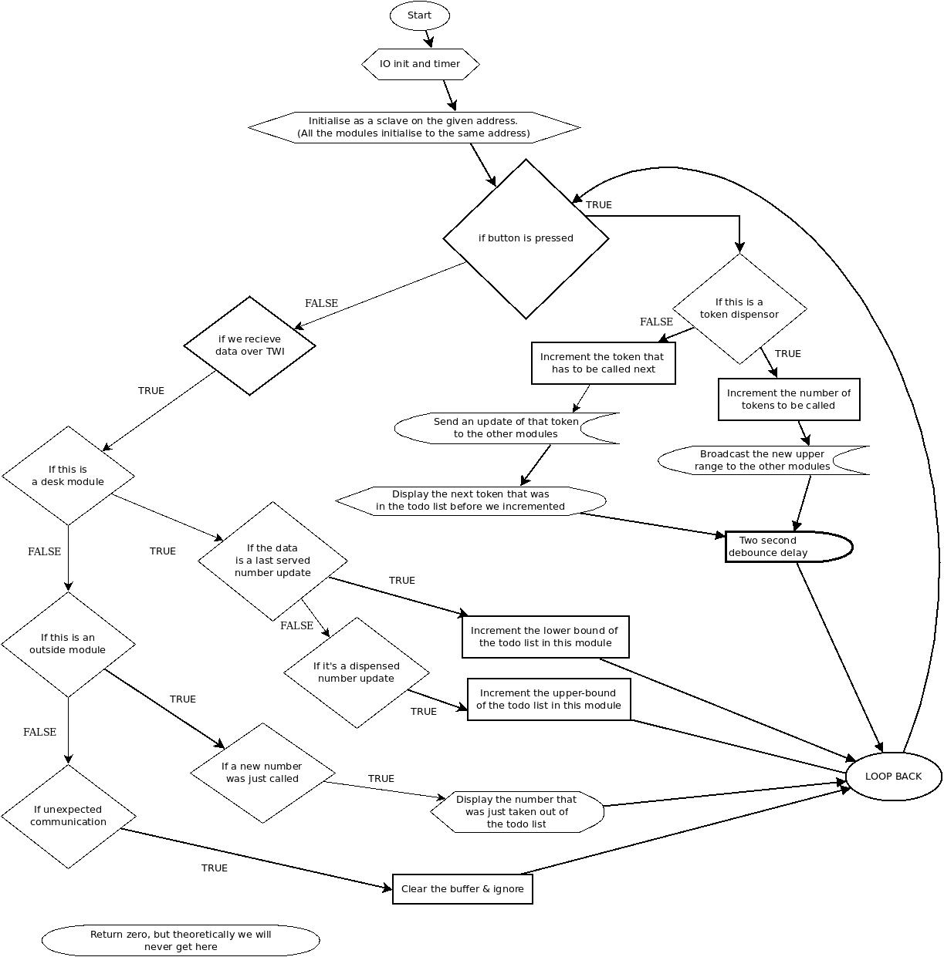

Notes
The program finds out what kind of a module that it has to act as by referring to the dip switch settings that are physically set on the main board, please refer to the configuration and usage section [4.1] for more details.

Configuration and Usage

DIP-switch settings
This is a list of possible settings for the DIP-switch, where 1 and 2 correspond to the numbers printed on the DIP-switch and ON and OFF correspond to the ON/OFF print on the DIP-switch.
Token Dispenser:
1 ON
2 OFF

Counter Module:
1 OFF
2 ON

General Status Monitor:
1 ON
2 ON

Display connections
To connect the display boards to the main board please follow the label on the main board to make sure you connect the correct digit to the correct connector on the main board.
digit 0: is the Tens digit
digit 1: is the Units digit

Wiring
To connect all the modules together, connect them using standard straight-crimped ethernet cable forming a chain from one module to the next. It does not matter which module is at which position in the chain. To connect the modules to power, connect the GND pin of the audio connector to the GND of your power source, VCC to the + of your power source, and BUTTON through a normally open pushbutton to the GND.

