Software Design Specification

for

<Project>

Version <1.0> approved <date created>

Prepared by <author>

Table of Contents

Table of Contents…………………………………………………………………………………2
1. INTRODUCTION……….…………………………………………………………….…1
1.1 Purpose of the Document ……………………………………………………………………….…2
1.2 Scope of the System …………………………………………………………………….……2
1.3 Overview of the Document …………………………………………………………………….……3
1.4 Project Overview……………………………………………………………………………….……3
2. PRELIMINARY DESIGN…………………………………………………………….…8
2.1 System Architecture……..………………………………………………………………………..…2
3. DETAILED DESIGN……………………………………………………………….……8
3.1 Graphic User Interface…….…………………………………………………………………..……10
3.2 Schema Design Diagram……………………………………………………………………..…..…11
3.3 Data Dictionary…………………………………………………………………………………..…12
3. INTERFACE DESIGN………………………………………………………………..…13
4.1 Process Interface…………..…………………………………………………………………..….…14

- INTRODUCTION
  - Purpose of the document
< Describe the purpose of this document >

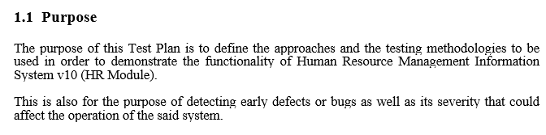
Example:
Figure 2: Purpose example. Source: Test_plan_HRMISv10(HR Module).docx

  - Scope of the system
<Describe the scope of this document>

  - Overview of the document
< Provide an overview of the entire document>

Example:
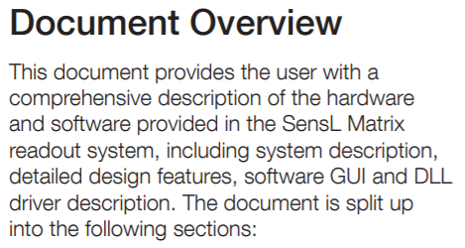
Figure 1: Document Overview example. Source: http://sensl.com/downloads/ds/UM-MatrixB.pdf

  - Project Overview
< Identify the system/product using any applicable names and/or version numbers. Describe the scope of the project which describes the domain problem and what part of it will be addressed. Indicate the limitations and disclaimers the reader should know>

Example:

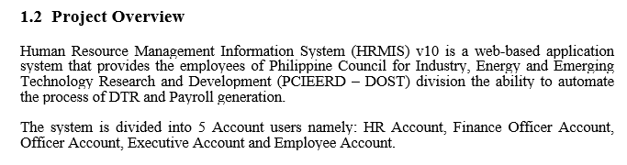
Figure 4: Project Overview example. Source: Test_Plan_HRMISv10(HR Module).docx

- PRELIMINARY DESIGN
  - System Architecture
< Include graphical representation depicting the overall application architecture. The design should use package diagram and design class diagram.>

Example:

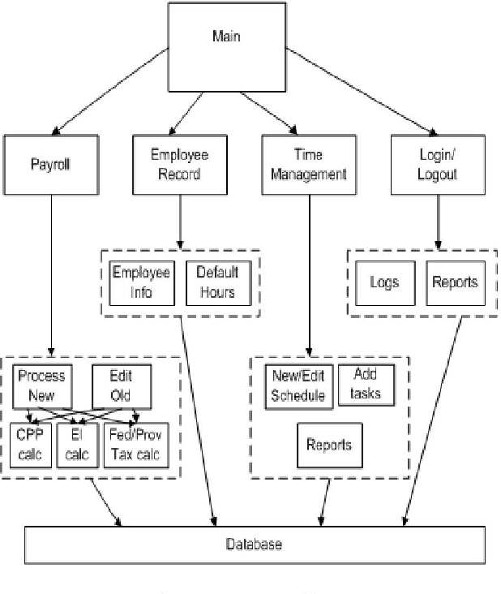

- DETAILED DESIGN
  - Graphical User Interface
< In this section rough out the user interface including any application menus, screens or forms, reports, etc. This may include a graphical depiction of the ff:>

  - Schema Design Diagram
< This section shall include a graphical representation of the physical structure of the database tables and a textual description of those tables. Use attributed ERD.>

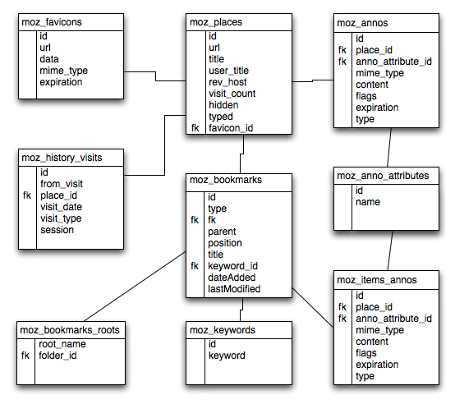
Example
Figure 11: Schema Design Diagram example. Source: http://wiki.mozilla.org/Places:Design_Overview

  - Data Dictionary
< This section shall include a list of all data elements included in the physical schema. At a minimum, each data element should contain the following:

- Data Element Name
- User Defined Name
- Definition
- Data Type
- Data Format/Length
- Synonyms
- User Synonyms
- Specifications/Algorithms for Derived Data
Use this is specifying the coding standard>

Example:

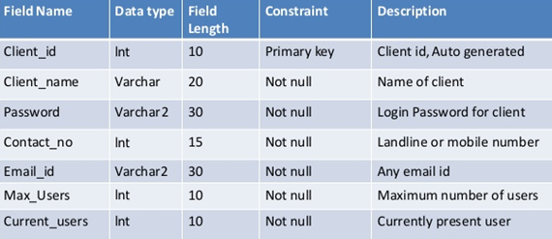

- INTERFACE DESIGN
  - Process Interface
<Identify and provide each process in the system. Module and process can both be provided or provide only one of the two subsections.>

Example:
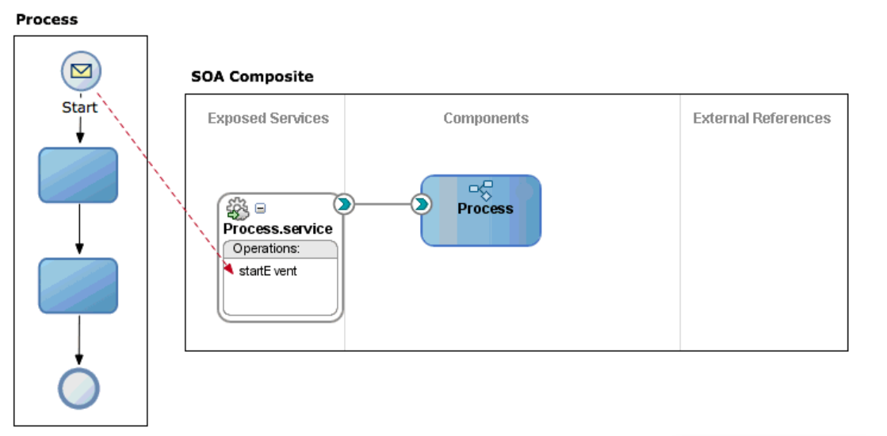
Figure 12: Process Interface example. Source: https://docs.oracle.com/cd/E17904_01/doc.1111/e15176/defining_proc_iface_bpmpd.htm#BPMPD663

