Software Design Specification

for

LitPath AI — AI-Powered Thesis Search System
Version 1.0 approved — February 26, 2026
Prepared by:
- Jenine Elaine Dulay — Project Lead
- Tracie Tomon — QA Tester
- Charijoy Cempron — Developer
- Marielle Kloie Concepcion — Developer

1. INTRODUCTION

1.1 Purpose of the Document
This Software Design Specification (SDS) document provides a comprehensive description of the design and architecture of the LitPath AI — AI-Powered Thesis Search System. It serves as a technical reference for the development team, stakeholders, and future maintainers by detailing the system architecture, database schema, user interface design, and process interfaces.
The document is intended to:
- Communicate the system design to all members of the PBL team and project stakeholders.
- Serve as a blueprint for implementation, testing, and maintenance.
- Define the structural and behavioral aspects of each module and component within the system.
- Provide a traceable mapping from system requirements to design artifacts.

1.2 Scope of the System
LitPath AI is a web-based, AI-powered academic thesis search and discovery system developed for the Department of Science and Technology — Science and Technology Information Institute (DOST-STII) thesis repository. The system enables users to perform AI-powered semantic searches over a curated collection of theses and dissertations, leveraging a Retrieval-Augmented Generation (RAG) pipeline.
In-Scope:
- AI-powered semantic search over thesis documents using vector embeddings and a ChromaDB vector database.
- Natural language query understanding with LLM-based query rewriting (Google Gemini AI).
- AI-generated summaries from relevant thesis sources.
- Template-based citation generation (APA, MLA, Chicago, IEEE, Harvard) using structured metadata — no AI is used for citations.
- User authentication system with role-based access control (Guest, User, Staff, Admin).
- Bookmarking, research history tracking, and citation generation (APA, MLA, Chicago, IEEE, Harvard).
- Librarian/Admin dashboard with analytics: KPIs, trending topics, material ratings, feedback triage, usage analytics, and citation tracking.
- Client Satisfaction Measurement (CSM) feedback system aligned with government standards.
- Material view tracking, most/least browsed materials, and dormant document detection.
- Password reset via email (SMTP).
Out-of-Scope:
- Full-text PDF viewing/download within the application.
- Integration with external academic databases (Scopus, Web of Science, etc.).
- Offline mode or local-only deployment without internet access (Gemini API requires connectivity).

1.3 Overview of the Document
This document is organized into four major sections:
- Section 1 — Introduction: Provides the purpose, scope, and project overview.
- Section 2 — Preliminary Design: Describes the high-level system architecture, including the package diagram and design class diagram.
- Section 3 — Detailed Design: Covers the graphical user interface screens, the physical database schema (ERD), and the complete data dictionary for all tables.
- Section 4 — Interface Design: Details each API process interface (RESTful endpoints), including request/response specifications and module descriptions.

1.4 Project Overview
LitPath AI (version 1.0) is an AI-powered thesis search system that makes the DOST-STII thesis collection accessible through conversational, AI-powered search. It replaces traditional keyword-only search with a Retrieval-Augmented Generation (RAG) approach that understands natural language queries — including queries in Filipino/Tagalog/Taglish — and returns synthesized, citation-backed answers.
Key capabilities:
Feature | Description
Semantic Search | Uses SentenceTransformers (all-mpnet-base-v2) embeddings stored in ChromaDB to find relevant thesis chunks by meaning, not just keywords.
LLM Query Rewriting | Google Gemini 2.5 Flash Lite rewrites/translates user queries for optimal retrieval.
LLM-based Reranking | Gemini 2.5 Flash reranks retrieved chunks for precision before generating answers.
AI Answer Generation | Gemini 3.0 Flash generates comprehensive, citation-backed research summaries via streaming.
Conversational Follow-ups | Pronoun resolution and entity tracking maintain context across multi-turn conversations.
Metadata Filters | Natural language parsing extracts year ranges and subject filters from queries automatically.
37 Subject Categories | Controlled vocabulary for subject classification (Agriculture, Biology, Computer Science, etc.).
Role-Based Access | Four roles: Guest, User, Staff, Admin — each with distinct permissions.
Admin Dashboard | Comprehensive analytics for librarians including KPIs, trending topics, citation stats, and feedback triage.
CSM Feedback | Government-standard Client Satisfaction Measurement survey with demographics.
Limitations and Disclaimers:
- The system’s AI-generated summaries are based solely on the indexed thesis collection and do not access external sources.
- Accuracy of metadata extraction (title, author, degree, subjects) depends on the formatting consistency of the source thesis documents.
- The system requires a valid Google Gemini API key for AI features; without it, only basic vector search is available.
- The current deployment is designed for a single institutional repository (DOST-STII).
Technology Stack:
Layer | Technology
Frontend | React 19, Vite 7, Tailwind CSS 3, React Router 7, Lucide React Icons, Chart.js
Backend | Django 5.0, Django REST Framework, Python 3.10+
Database | PostgreSQL (Supabase)
Vector Database | ChromaDB (persistent, on-disk)
AI/ML | Google Gemini AI (2.5 Flash Lite, 2.5 Flash, 3.0 Flash), SentenceTransformers (all-mpnet-base-v2)
PDF Processing | PyPDF2, Tesseract OCR (fallback)
Email | Django SMTP (Gmail)
Auth | Custom token-based authentication — on login, the server generates a cryptographic token via secrets.token_urlsafe(32), stores it in the sessions table, and returns it to the client. The frontend stores this token in localStorage and includes it as a Bearer token in the Authorization HTTP header for all authenticated requests. The backend validates the token by looking it up in the sessions table. Sessions expire after 24 hours of inactivity. Each user can only have one active session at a time (creating a new session deletes the previous one). Guest users receive an anonymous session token with the same mechanism but without an associated user_accounts record.

2. PRELIMINARY DESIGN

2.1 System Architecture
The LitPath AI system follows a three-tier client-server architecture with a dedicated RAG (Retrieval-Augmented Generation) pipeline layer.

2.1.1 Package Diagram
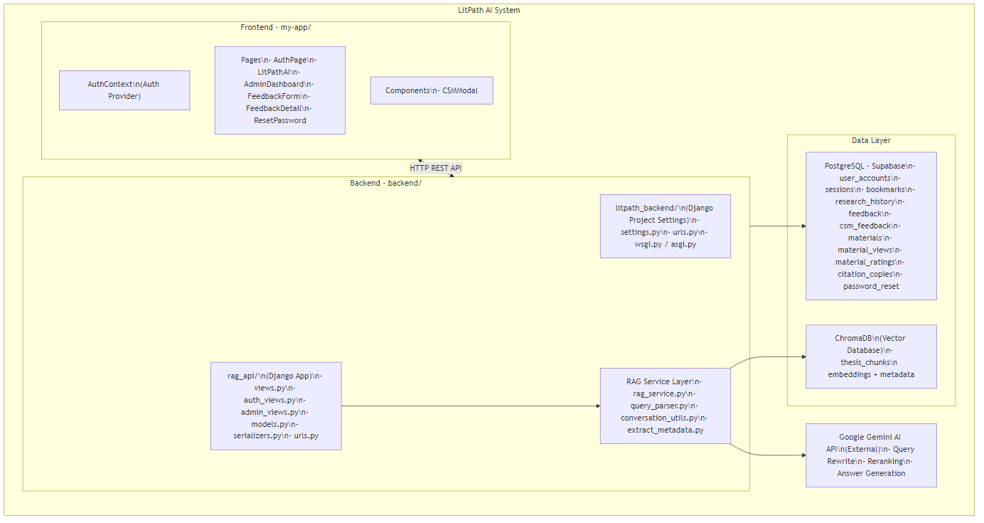

2.1.2 Design Class Diagram
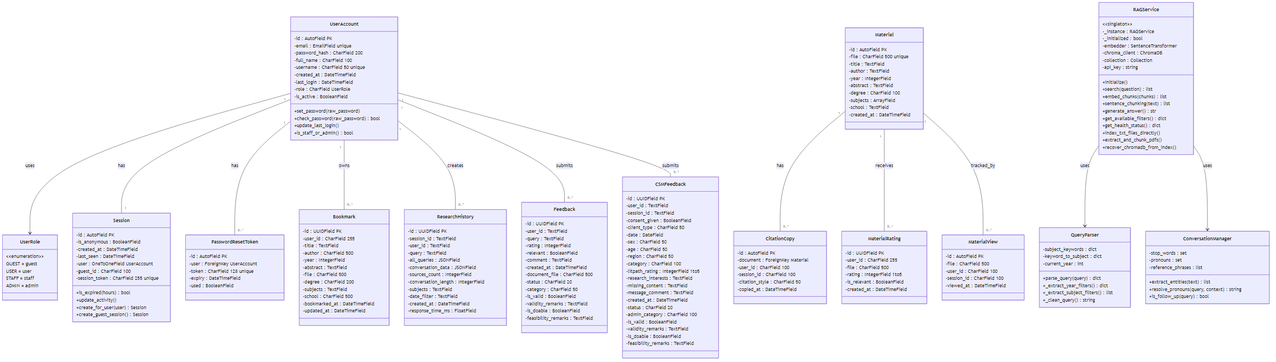

2.1.3 Architectural Overview
The system operates through the following flow:
- Client Layer (React SPA): The user interacts with the React frontend served by Vite. All API calls are made to http://localhost:8000/api/ via fetch().
- API Layer (Django REST Framework): Incoming HTTP requests are routed through litpath_backend/urls.py → rag_api/urls.py to the appropriate view functions/classes. CORS is handled by django-cors-headers.
- Authentication Layer: Session-based token authentication. On login/guest-session, a unique session_token is generated and stored in the sessions table. The frontend stores this in localStorage and includes it in headers for authenticated requests.
- RAG Pipeline (Singleton Service):
  - Query Parsing: QueryParser extracts year and subject filters from natural language.
  - Query Rewriting: Google Gemini 2.5 Flash Lite rewrites/translates the query.
  - Embedding: SentenceTransformers (all-mpnet-base-v2) encodes the query into a 768-dimensional vector.
  - Vector Search: ChromaDB performs cosine similarity search over pre-indexed thesis chunks.
  - Reranking: Gemini 2.5 Flash reranks top candidates for relevance.
  - Answer Generation: Gemini 3.0 Flash generates a streamed, citation-backed summary.
  - Conversation Context: ConversationManager tracks entities and resolves pronouns for follow-up queries.
- Data Layer:
  - PostgreSQL (Supabase): Stores user accounts, sessions, bookmarks, research history, feedback, materials, ratings, and citations.
  - ChromaDB: Stores vector embeddings and metadata for thesis chunks in the thesis_chunks collection.
  - File System: Thesis .txt / .pdf files stored in RAG/theses/.

3. DETAILED DESIGN

3.1 Graphical User Interface
The LitPath AI user interface is a single-page application (SPA) built with React and styled with Tailwind CSS. Below are the major screens and their descriptions.

3.1.1 Authentication Page (AuthPage.jsx)
Element | Description
Welcome Screen | Landing page with DOST branding, system introduction, and two entry points: “Login” and “Continue as Guest”.
Login Form | Email + password fields, “Forgot Password” link, show/hide password toggle. On success: redirects to /search (users) or /admin/dashboard (staff/admin).
Forgot Password | Email input field, sends password reset link via SMTP email.
Guest Access | Creates an anonymous session with limited features (no bookmarks persistence across sessions).
User Flow: 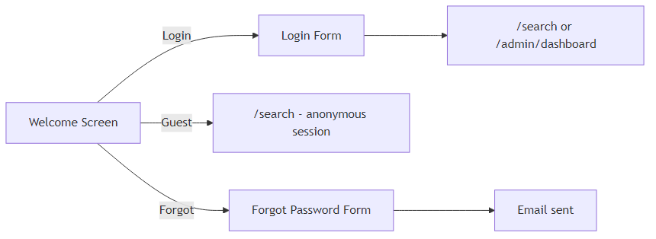

3.1.2 Main Search Page (LitPathAI.jsx)
Element | Description
Header Bar | DOST-STII logo, “LitPath AI” title, user menu (profile, account settings, logout), bookmarks icon with count badge.
Search Bar | Central text input with autocomplete example questions. Supports natural language queries.
Most Browsed Carousel | Horizontal slider showing top 5 most-viewed thesis materials with title, author, year, and view count.
Conversation Panel | Chat-style interface showing user queries and AI-generated responses. Includes thumbs-up/thumbs-down feedback buttons.
Source Cards | Expandable cards for each cited thesis source showing: title, author(s), year, degree, school, abstract preview, subjects, and star rating.
Citation Overlay | Modal for generating citations in APA, MLA, Chicago, IEEE, or Harvard format with copy-to-clipboard. Citations are generated client-side using template-based string formatting from thesis metadata (no AI is used).
Bookmark Overlay | Side panel listing saved bookmarks with delete capability.
Research History Sidebar | Collapsible sidebar showing past research sessions. Click to restore a previous conversation.
Account Settings Modal | Tabs for Profile (edit name, username) and Security (change password).
CSM Feedback Modal | Government-standard satisfaction survey triggered after 3 queries (24-hour cooldown).
Feedback Overlay | Quick feedback form with thumbs-up/thumbs-down, comment text area, and submit button.
User Flow: 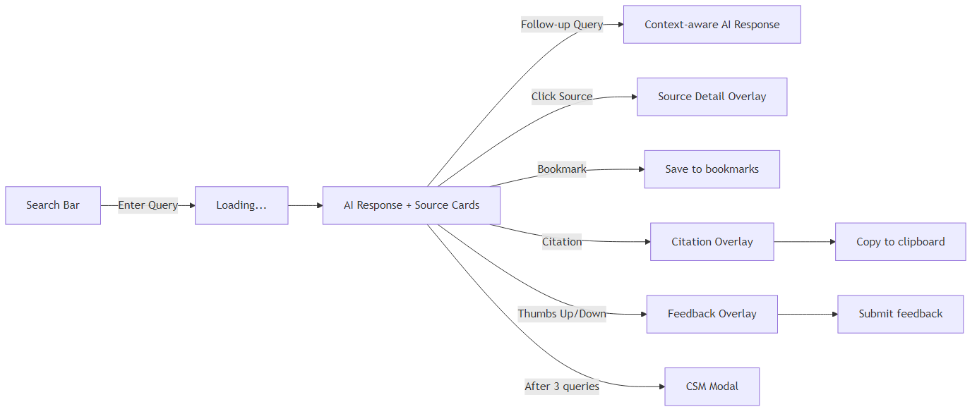

3.1.3 Admin Dashboard (AdminDashboard.jsx)
Element | Description
Sidebar Navigation | Collapsible sidebar with tabs: Overview, Feedback Manager, CSM Feedback, Material Ratings, Account Settings.
Date Range Filter | Global filter: Year, Month, Last 7 Days, Custom Range. Applies to all dashboard data.
KPI Cards | Total Documents, Total Searches, Accessed Documents, Utilization %, Failed Queries, Avg Response Time.
Trending Topics Chart | Bar chart of most searched topics over the selected period.
Top Theses Table | Table of most-viewed materials with title, author, view count.
Least Browsed / Dormant | Count of materials with zero views (dormant) and least-browsed list.
Activity Trends Chart | Line chart of search activity by monthly/weekly/daily granularity.
Usage by Category | Pie/bar chart of CSM respondent categories (Student, Researcher, etc.).
Age Distribution Chart | Bar chart of CSM respondent age brackets.
Citation Statistics | Total citation copies, top-cited materials, citation trends over time.
Feedback Manager Tab | Filterable table of user feedback. Each row shows: query, rating, comment, status, category. Click to open detail for triage (set status, validity, feasibility, remarks).
CSM Feedback Tab | Filterable table of CSM survey responses with admin triage fields.
Material Ratings Tab | List of materials with average ratings, individual user ratings.

3.1.4 Feedback Form Page (FeedbackForm.jsx)
Element | Description
CSM Survey Form | Full-page Client Satisfaction Measurement form with: Data Privacy consent checkbox, Client Profile (type, date, sex, age, region, category), Feedback & Evaluation (1-5 star rating, research interests, missing content, general comments).
Validation | Required fields: consent, client type, date, sex, age, region, category. Rating is optional.
Submission | POST to /api/csm-feedback/ + duplicate write to Supabase general_feedback table.

3.1.5 Reset Password Page (ResetPassword.jsx)
Element | Description
Reset Form | Token-based password reset. Fields: New Password (min 8 chars), Confirm Password. Validates token from URL parameter.
Success Flow | On success, shows confirmation message and redirects to login after 2 seconds.

3.2 Schema Design Diagram
The following Entity-Relationship Diagram (ERD) represents the physical database schema:
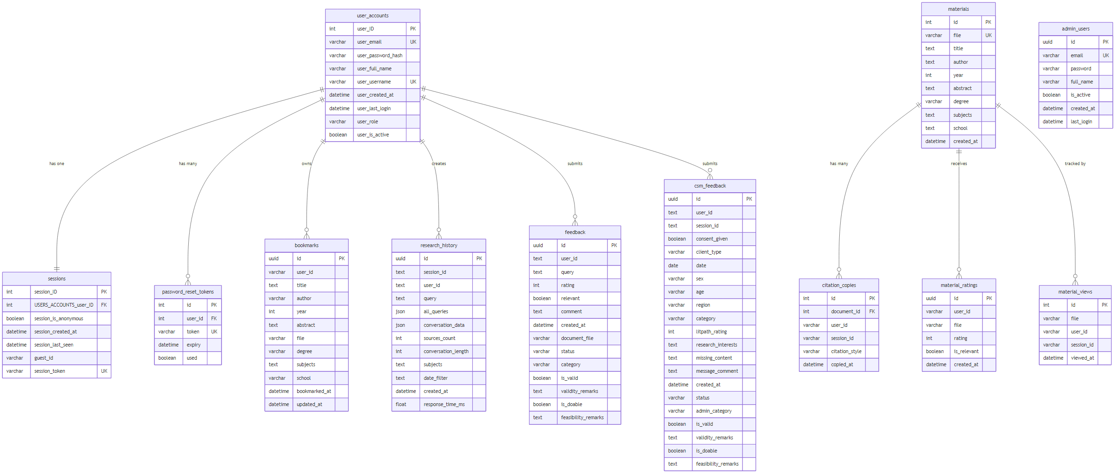
ChromaDB Collection: thesis_chunks (Vector Database — not in PostgreSQL):
Field | Type | Description
id | string | Chunk identifier, e.g. filename.txt_chunk_0
embedding | float[768] | L2-normalized vector from all-mpnet-base-v2
document | string | Raw chunk text (~500 words)
metadata.file | string | Source thesis filename
metadata.title | string | Thesis title
metadata.author | string | Thesis author
metadata.publication_year | string | Publication year
metadata.degree | string | Academic degree
metadata.university | string | Issuing university
metadata.subjects | string | Comma-separated subjects
metadata.chunk_idx | integer | Position index within document
Relationships:
Relationship | Type | Description
user_accounts → sessions | One-to-One | Each user can have exactly one active session at a time.
user_accounts → password_reset_tokens | One-to-Many | A user can have multiple reset tokens (only latest is valid).
materials → citation_copies | One-to-Many | Each material can have multiple citation copy records.
materials → material_ratings | One-to-Many | Each user can rate each material once (unique user+file).
bookmarks.user_id → user_accounts.id | Logical FK | User bookmarks (unique per user+file).
research_history.user_id → user_accounts.id | Logical FK | Tracks all search sessions per user.
feedback.user_id → user_accounts.id | Logical FK | Links feedback to users.
csm_feedback.user_id → user_accounts.id | Logical FK | Links CSM surveys to users.

3.3 Data Dictionary

Table: user_accounts
Data Element Name | User Defined Name | Definition | Data Type | Format/Length | Synonyms
user_ID | User ID | Auto-incrementing primary key | AutoField | Integer | id, PK
user_email | Email Address | User’s email, must be unique | EmailField | VARCHAR(50) | email
user_password_hash | Password Hash | Bcrypt-hashed password | CharField | VARCHAR(200) | password
user_full_name | Full Name | User’s display name | CharField | VARCHAR(100), nullable | full_name
user_username | Username | Unique login username | CharField | VARCHAR(50) | username
user_created_at | Created At | Account creation timestamp | DateTimeField | ISO 8601 | created_at
user_last_login | Last Login | Most recent login timestamp | DateTimeField | ISO 8601, nullable | last_login
user_role | Role | User access level | CharField | VARCHAR(50) | role
user_is_active | Is Active | Account active status | BooleanField | Boolean | is_active
Specifications: user_role must be one of: 'guest', 'user', 'staff', 'admin'. Default is 'user'. Password hash is generated using Django’s make_password() (PBKDF2 by default).

Table: sessions
Data Element Name | User Defined Name | Definition | Data Type | Format/Length | Synonyms
session_ID | Session ID | Auto-incrementing primary key | AutoField | Integer | id, PK
session_is_anonymous | Is Anonymous | Whether this is a guest session | BooleanField | Boolean | is_anonymous
session_created_at | Created At | Session creation timestamp | DateTimeField | ISO 8601 | created_at
session_last_seen | Last Seen | Last activity timestamp | DateTimeField | ISO 8601 | last_seen
USERS_ACCOUNTS_user_ID | User FK | Foreign key to user_accounts | OneToOneField | Integer, nullable | user_id
guest_id | Guest ID | Unique identifier for anonymous sessions | CharField | VARCHAR(100), nullable | —
session_token | Session Token | Cryptographic session token | CharField | VARCHAR(255), unique | token
Specifications: session_token is generated using Python secrets.token_urlsafe(32). Sessions expire after 24 hours of inactivity. Creating a new session for a user deletes any existing session (enforcing one-to-one).

Table: bookmarks
Data Element Name | User Defined Name | Definition | Data Type | Format/Length | Synonyms
id | Bookmark ID | UUID primary key | UUIDField | UUID v4 | PK
user_id | User ID | Owner of the bookmark | CharField | VARCHAR(255) | —
title | Title | Thesis title | TextField | Unlimited | —
author | Author | Thesis author(s) | CharField | VARCHAR(500), nullable | —
year | Year | Publication year | IntegerField | Integer, nullable | —
abstract | Abstract | Thesis abstract text | TextField | Unlimited, nullable | —
file | File | Source filename reference | CharField | VARCHAR(500) | —
degree | Degree | Academic degree | CharField | VARCHAR(200), nullable | —
subjects | Subjects | Subject categories | TextField | Unlimited, nullable | —
school | School | University/Institution | CharField | VARCHAR(500), nullable | —
bookmarked_at | Bookmarked At | Timestamp of bookmark creation | DateTimeField | ISO 8601 | —
updated_at | Updated At | Last update timestamp | DateTimeField | ISO 8601 | —
Specifications: Unique constraint on (user_id, file) prevents duplicate bookmarks.

Table: research_history
Data Element Name | User Defined Name | Definition | Data Type | Format/Length | Synonyms
id | History ID | UUID primary key | UUIDField | UUID v4 | PK
session_id | Session ID | Conversation session identifier | TextField | Unlimited | —
user_id | User ID | User who initiated the search | TextField | Unlimited | —
query | Query | Initial search query text | TextField | Unlimited | —
all_queries | All Queries | JSON array of all queries in session | JSONField | JSON, nullable | —
conversation_data | Conversation Data | Full Q&A conversation in JSON | JSONField | JSON, nullable | —
sources_count | Sources Count | Number of sources found | IntegerField | Integer, nullable | —
conversation_length | Conversation Length | Number of turns in conversation | IntegerField | Integer, nullable | —
subjects | Subjects | Subject filters applied | TextField | Unlimited, nullable | —
date_filter | Date Filter | Date/year filter applied | TextField | Unlimited, nullable | —
created_at | Created At | Record creation timestamp | DateTimeField | ISO 8601 | —
response_time_ms | Response Time | Query response time in milliseconds | FloatField | Float, nullable | —
Specifications: sources_count = 0 indicates a “failed query” (no results found), used for the Failed Queries KPI on the admin dashboard.

Table: feedback
Data Element Name | User Defined Name | Definition | Data Type | Format/Length | Synonyms
id | Feedback ID | UUID primary key | UUIDField | UUID v4 | PK
user_id | User ID | User who submitted feedback | TextField | Unlimited | —
query | Query | The search query being rated | TextField | Unlimited, nullable | —
rating | Rating | Numeric quality rating | IntegerField | Integer, nullable | —
relevant | Relevant | Was the result relevant? | BooleanField | Boolean, nullable | —
comment | Comment | Free-text feedback comment | TextField | Unlimited, nullable | —
created_at | Created At | Submission timestamp | DateTimeField | ISO 8601 | —
document_file | Document File | Specific file being rated | CharField | VARCHAR(500), nullable | —
status | Status | Admin triage status | CharField | VARCHAR(20) | —
category | Category | Admin classification | CharField | VARCHAR(50), nullable | —
is_valid | Is Valid | Validity check by admin | BooleanField | Boolean, nullable | —
validity_remarks | Validity Remarks | Admin notes on validity | TextField | Unlimited, nullable | —
is_doable | Is Doable | Feasibility check by admin | BooleanField | Boolean, nullable | —
feasibility_remarks | Feasibility Remarks | Admin notes on feasibility | TextField | Unlimited, nullable | —
Specifications: status is one of: 'Pending', 'Reviewed', 'Resolved'. category is one of: 'Positive', 'Issue', 'For Improvement'.

Table: csm_feedback
Data Element Name | User Defined Name | Definition | Data Type | Format/Length | Synonyms
id | CSM ID | UUID primary key | UUIDField | UUID v4 | PK
user_id | User ID | Respondent user identifier | TextField | Unlimited | —
session_id | Session ID | User’s session identifier | TextField | Unlimited, nullable | —
consent_given | Consent Given | Data privacy consent | BooleanField | Boolean | —
client_type | Client Type | Citizen/Business/Government | CharField | VARCHAR(50) | —
date | Date | Survey date | DateField | YYYY-MM-DD | —
sex | Sex | Female/Male/Prefer not to say | CharField | VARCHAR(50) | —
age | Age | Age bracket | CharField | VARCHAR(50) | —
region | Region | Philippine region code | CharField | VARCHAR(50) | —
category | Category | Respondent category | CharField | VARCHAR(100) | —
litpath_rating | LitPath Rating | Satisfaction rating (1-5) | IntegerField | Integer, nullable | —
research_interests | Research Interests | Free-text research interests | TextField | Unlimited, nullable | —
missing_content | Missing Content | Content gaps identified | TextField | Unlimited, nullable | —
message_comment | Message/Comment | General feedback comment | TextField | Unlimited, nullable | —
created_at | Created At | Record creation timestamp | DateTimeField | ISO 8601 | —
status | Status | Admin triage status | CharField | VARCHAR(20) | —
admin_category | Admin Category | Admin classification label | CharField | VARCHAR(100), nullable | —
is_valid | Is Valid | Validity assessment | BooleanField | Boolean, nullable | —
validity_remarks | Validity Remarks | Admin validity notes | TextField | Unlimited, nullable | —
is_doable | Is Doable | Feasibility assessment | BooleanField | Boolean, nullable | —
feasibility_remarks | Feasibility Remarks | Admin feasibility notes | TextField | Unlimited, nullable | —
Specifications: client_type: 'Citizen' | 'Business' | 'Government'. age brackets: '10 and below' through '61 and above'. region: Philippine standard region codes ('NCR', 'CAR', 'R01'–'R13', 'BARMM', 'N/A'). category: 'Student' | 'DOST Employee' | 'Other Government Employee' | 'Librarian/Library Staff' | 'Teaching Personnel' | 'Administrative Personnel' | 'Researcher'.

Table: materials
Data Element Name | User Defined Name | Definition | Data Type | Format/Length | Synonyms
id | Material ID | Auto-incrementing primary key | AutoField | Integer | PK
file | File | Source filename (unique) | CharField | VARCHAR(500) | —
title | Title | Thesis title | TextField | Unlimited | —
author | Author | Author name(s) | TextField | Unlimited | —
year | Year | Publication year | IntegerField | Integer, nullable | —
abstract | Abstract | Thesis abstract | TextField | Unlimited | —
degree | Degree | Academic degree | CharField | VARCHAR(100) | —
subjects | Subjects | Subject categories array | ArrayField(CharField) | Array of VARCHAR(200) | —
school | School | University/Institution | TextField | Unlimited | —
created_at | Created At | Record creation timestamp | DateTimeField | ISO 8601 | —

Table: material_views
Data Element Name | User Defined Name | Definition | Data Type | Format/Length | Synonyms
id | View ID | Auto-incrementing primary key | AutoField | Integer | PK
file | File | Filename of viewed material | CharField | VARCHAR(500) | —
user_id | User ID | Viewer’s user ID | CharField | VARCHAR(100), nullable | —
session_id | Session ID | Viewer’s session ID | CharField | VARCHAR(100), nullable | —
viewed_at | Viewed At | View timestamp | DateTimeField | ISO 8601 | —

Table: material_ratings
Data Element Name | User Defined Name | Definition | Data Type | Format/Length | Synonyms
id | Rating ID | UUID primary key | UUIDField | UUID v4 | PK
user_id | User ID | Rater’s user ID | CharField | VARCHAR(255) | —
file | File | Rated material filename | CharField | VARCHAR(500) | —
rating | Rating | Star rating (1-5) | IntegerField | Integer | —
is_relevant | Is Relevant | Relevance to query | BooleanField | Boolean | —
created_at | Created At | Rating timestamp | DateTimeField | ISO 8601 | —
Specifications: Unique constraint on (user_id, file) — one rating per user per material.

Table: citation_copies
Data Element Name | User Defined Name | Definition | Data Type | Format/Length | Synonyms
id | Citation ID | Auto-incrementing primary key | AutoField | Integer | PK
document_id | Document FK | Foreign key to materials table | ForeignKey | Integer | —
user_id | User ID | User who copied | CharField | VARCHAR(100), nullable | —
session_id | Session ID | Session of the copy event | CharField | VARCHAR(100), nullable | —
citation_style | Citation Style | Format used (APA/MLA/etc.) | CharField | VARCHAR(50) | —
copied_at | Copied At | Copy event timestamp | DateTimeField | ISO 8601 | —
Specifications: citation_style is one of: 'APA', 'MLA', 'Chicago', 'IEEE', 'Harvard'.

Table: password_reset_tokens (PasswordResetToken)
Data Element Name | User Defined Name | Definition | Data Type | Format/Length | Synonyms
id | Token ID | Auto-incrementing primary key | AutoField | Integer | PK
user_id | User FK | Foreign key to user_accounts | ForeignKey | Integer | —
token | Token | Unique reset token string | CharField | VARCHAR(128), unique | —
expiry | Expiry | Token expiration timestamp | DateTimeField | ISO 8601 | —
used | Used | Whether token has been consumed | BooleanField | Boolean | —

ChromaDB Collection: thesis_chunks
Data Element Name | User Defined Name | Definition | Data Type | Format/Length
id | Chunk ID | Unique chunk identifier | String | {filename}_chunk_{index}
embedding | Vector Embedding | 768-dimensional embedding vector | float[768] | L2-normalized
document | Chunk Text | Raw text of the thesis chunk | String | ~500 words per chunk
metadata.file | File | Source thesis filename | String | —
metadata.title | Title | Thesis title | String | —
metadata.author | Author | Thesis author | String | —
metadata.publication_year | Publication Year | Publication year | String | —
metadata.degree | Degree | Academic degree | String | —
metadata.university | University | Issuing university | String | —
metadata.subjects | Subjects | Comma-separated subjects | String | —
metadata.chunk_idx | Chunk Index | Position index within document | Integer | —
Specifications: Embeddings are generated by SentenceTransformers all-mpnet-base-v2 and L2-normalized. Chunks are created using sentence-based chunking with 500-word windows and 20% overlap. Collection uses cosine similarity for search. Distance threshold: 1.5 (values below are considered relevant).

4. INTERFACE DESIGN

4.1 Process Interface
All API endpoints are prefixed with /api/ and served by the Django backend at http://localhost:8000. The frontend communicates with the backend via fetch() HTTP requests using JSON payloads.

4.1.1 Module: Authentication (auth_views.py)
# | Process Name | Endpoint | Method | Description
1 | User Login | /api/auth/login/ | POST | Authenticates user with email + password. Returns user object and session token.
2 | User Registration | /api/auth/register/ | POST | Creates a new user account. Returns user object and session token.
3 | Guest Session | /api/auth/guest-session/ | POST | Creates an anonymous guest session. Returns guest user object and session token.
4 | Validate Session | /api/auth/validate-session/ | POST | Checks if a session ID is still valid and not expired. Returns {valid: bool}.
5 | Logout | /api/auth/logout/ | POST | Invalidates the user’s session by deleting it from the database.
6 | Delete Guest Data | /api/auth/delete-guest-data/ | POST | Deletes all data associated with a guest session (bookmarks, history, feedback).
7 | Get Current User | /api/auth/me/ | GET | Returns current user profile based on session token in Authorization header.
8 | Change Password | /api/auth/change-password/ | POST | Changes user password. Requires current password verification.
9 | Update Profile | /api/auth/update-profile/ | POST | Updates user’s full_name and/or username. Requires Bearer token.
10 | Password Reset Request | /api/auth/password-reset-request/ | POST | Sends password reset email link. Always returns success for security.
11 | Reset Password | /api/auth/reset-password/ | POST | Consumes reset token and sets new password.
Sample — Login Request:
POST /api/auth/login/
{
"email": "user@example.com",
"password": "securepassword123"
}
Sample — Login Response:
{
"success": true,
"user": {
"id": 1,
"email": "user@example.com",
"username": "johndoe",
"full_name": "John Doe",
"role": "user"
},
"session": {
"session_id": 5,
"session_token": "abc123...xyz",
"created_at": "2026-02-26T10:00:00Z",
"is_anonymous": false
}
}

4.1.2 Module: Search & RAG (views.py → rag_service.py)
# | Process Name | Endpoint | Method | Description
1 | Health Check | /api/health/ | GET | Returns system health: status, document count, chunk count, file counts, RAG initialization state.
2 | Search (Standard) | /api/search/ | POST | Performs full RAG pipeline: query parsing → rewriting → embedding → vector search → reranking → AI generation. Returns AI answer + source documents.
3 | Search (Streaming) | /api/search/stream/ | POST | Same as standard search but returns AI answer via Server-Sent Events (SSE) for real-time streaming.
4 | Get Filters | /api/filters/ | GET | Returns available subject categories and year ranges from the indexed collection.
5 | RAG Evaluation | /api/evaluate/ | POST | Runs RAG accuracy evaluation benchmark.
Sample — Search Request:
POST /api/search/
{
"question": "How does climate change affect rice production in the Philippines?",
"subjects": ["Agriculture"],
"year_start": "2020",
"year_end": "2025",
"conversation_id": "conv_abc123",
"conversation_history": []
}
Sample — Search Response:
{
"answer": "Based on the reviewed theses, climate change significantly impacts rice production...",
"sources": [
{
"title": "Effects of Climate Change on Rice Yield...",
"author": "Juan Dela Cruz",
"year": 2022,
"degree": "Master of Science in Agronomy",
"school": "University of the Philippines Los Baños",
"abstract": "This study investigates...",
"subjects": "Agriculture, Environmental Science",
"file": "thesis_2022_001.txt",
"relevance_score": 0.85
}
],
"query_info": {
"original": "How does climate change affect rice production...",
"rewritten": "Impact of climate change on rice production Philippines",
"filters_applied": {"year_start": "2020", "year_end": "2025", "subjects": ["Agriculture"]}
}
}
RAG Pipeline Process (Internal): 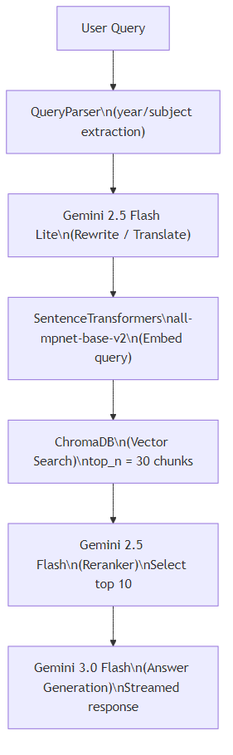

4.1.3 Module: Bookmarks (views.py)
# | Process Name | Endpoint | Method | Description
1 | List/Create Bookmarks | /api/bookmarks/ | GET / POST | GET: Lists all bookmarks for a user. POST: Creates a new bookmark (user_id, file, title, etc.).
2 | Delete Bookmark by ID | /api/bookmarks/<bookmark_id>/ | DELETE | Deletes a specific bookmark by its database ID.
3 | Delete Bookmark by File | /api/bookmarks/delete-by-file/ | POST | Deletes a bookmark by matching user_id + file name.

4.1.4 Module: Research History (views.py)
# | Process Name | Endpoint | Method | Description
1 | List/Create History | /api/research-history/ | GET / POST | GET: Retrieves user’s research sessions. POST: Saves a new research session with conversation data.
2 | Delete History | /api/research-history/<session_id>/ | DELETE | Deletes a specific research history entry.

4.1.5 Module: Feedback (views.py)
# | Process Name | Endpoint | Method | Description
1 | List/Create Feedback | /api/feedback/ | GET / POST | GET: Lists feedback entries (filterable by status, date). POST: Submits new feedback (rating, comment, query).
2 | Feedback Detail | /api/feedback/<uuid:pk>/ | GET / PUT / PATCH / DELETE | GET: Single feedback detail. PUT/PATCH: Admin updates (status, category, validity, feasibility). DELETE: Remove feedback.

4.1.6 Module: CSM Feedback (views.py)
# | Process Name | Endpoint | Method | Description
1 | List/Create CSM | /api/csm-feedback/ | GET / POST | GET: Lists CSM survey responses. POST: Submits new CSM form data (also writes to Supabase general_feedback table).
2 | CSM Detail | /api/csm-feedback/<uuid:pk>/ | GET / PUT / PATCH / DELETE | Admin triage: update status, admin_category, validity, feasibility.

4.1.7 Module: Material Tracking (views.py)
# | Process Name | Endpoint | Method | Description
1 | Track Material View | /api/track-view/ | POST | Records a material view event (file, user_id, session_id).
2 | Get Most Browsed | /api/most-browsed/ | GET | Returns top N most-viewed materials with view counts.
3 | Get Source Ratings | /api/sources/ratings/ | GET | Returns materials with their average ratings.
4 | Get Material Rating Detail | /api/materials/rating/ | GET | Returns detailed rating information for a specific material.
5 | Get Sources Stats | /api/sources/stats/ | GET | Returns aggregate source statistics.

4.1.8 Module: Citation Tracking (views.py)
# | Process Name | Endpoint | Method | Description
1 | Track Citation Copy | /api/track-citation/ | POST | Records when a user copies a citation (file, style, user_id, session_id).

4.1.9 Module: Admin Dashboard Analytics (views.py)
# | Process Name | Endpoint | Method | Description
1 | KPI Summary | /api/dashboard/kpi/ | GET | Returns key performance indicators: total documents, searches, accessed documents, utilization %, failed queries count, avg response time.
2 | Trending Topics | /api/dashboard/trending-topics/ | GET | Returns most searched topics/subjects in the given date range.
3 | Failed Queries Count | /api/dashboard/failed-queries-count/ | GET | Returns count of searches that returned 0 results.
4 | Usage by Category | /api/dashboard/usage-by-category/ | GET | Returns CSM feedback breakdown by respondent category.
5 | Age Distribution | /api/dashboard/age-distribution/ | GET | Returns CSM feedback breakdown by age bracket.
6 | Monthly Trends | /api/dashboard/monthly-trends/ | GET | Returns search activity aggregated by month.
7 | Weekly Trends | /api/dashboard/weekly-trends/ | GET | Returns search activity aggregated by week.
8 | Daily Trends | /api/dashboard/daily-trends/ | GET | Returns search activity aggregated by day.
9 | Citation Stats | /api/dashboard/citation-stats/ | GET | Returns total citation copies and top-cited materials.
10 | Citation Monthly | /api/dashboard/citation-monthly/ | GET | Citation copy counts by month.
11 | Citation Weekly | /api/dashboard/citation-weekly/ | GET | Citation copy counts by week.
12 | Citation Daily | /api/dashboard/citation-daily/ | GET | Citation copy counts by day.
13 | Top Theses | /api/dashboard/top-theses/ | GET | Returns most-viewed theses.
14 | Least Browsed | /api/dashboard/least-browsed/ | GET | Returns materials with lowest view counts.
15 | Dormant Count | /api/dashboard/dormant-count/ | GET | Returns count of materials with zero views.

4.2 External Interface Dependencies
Interface | Purpose | Protocol | Configuration
Google Gemini AI API | Query rewriting (2.5 Flash Lite), Reranking (2.5 Flash), Answer generation (3.0 Flash) | HTTPS REST | GEMINI_API_KEY env variable
PostgreSQL (Supabase) | Primary relational database | TCP port 5432 | DATABASE_URL env variable or individual DB_* variables
Gmail SMTP | Password reset emails | SMTP (TLS, port 587) | EMAIL_HOST_USER, EMAIL_HOST_PASSWORD env variables
ChromaDB | Vector similarity search | Local file I/O (persistent) | RAG_CHROMADB_PATH setting → RAG/chromadb_data/
SentenceTransformers | Text-to-vector embedding | Local Python library | Model: all-mpnet-base-v2 (downloaded on first run)

End of Software Design Specification for LitPath AI v1.0

