Chapter - 1
INTRODUCTION

Agriculture is essential to support the world population and to ensure economic growth, that is why, it is important in developing countries such as India. A big percentage of the population is reliant on agriculture as the main income source and a source of livelihood. Nevertheless, the conventional method of farming can be based on extensive dependence on observation, experience, and seasonal trends, which can contribute to the inefficient use of resources, and uneven crop yields. To sustain the growing global food needs and the constrained supply of natural resources like water and arable soils, enhancement of food production has emerged as a major concern. Emerging technologies have provided a fresh prospect to change and transform agricultural farming to be more effective and data oriented.
The Internet of Things (IoT), artificial intelligence (AI), and machine learning are the technologies that allow monitoring the state of the environment in the process of its constant dynamics and give smart suggestions to support agricultural decision-making. Smart farming adopts sensors and digital technology to gather information about the state of the soil, temperature, humidity, and the health of crops, which can be used by farmers to optimize irrigation, use of fertilizers, and crop choice.
The project under consideration is called Enhancing Farmer Productivity through Innovative Technology Solutions and aims to create a digital platform that will analyze the information about agriculture and give smart suggestions to farmers. The system incorporates the features of soil analysis, crop recommendation and agricultural advisory system into a web-based platform that helps farmers make informed decisions. The suggested system is expected to enhance the productivity of crops, maximize the use of resources, and advance sustainable agriculture through the integration of the application of modern computing technology with the agricultural knowledge.
  - Background
1. Agriculture has been an aspect of economic growth and power to produce food traditionally. Agriculture helps millions of individuals in various countries as a source of employment and food security. Nevertheless, there are a number of challenges facing the agricultural sector such as climate variability, soil degradation, poor irrigation techniques and inaccessibility to modern agricultural technology.
2. Conventional agriculture is usually carried out using manual monitoring and experience to be able to know the suitability of crops, when they need irrigation and when they need fertilizers. Such approaches are not always accurate because of the variability in the environmental conditions and the lack of access to real-time information. This can lead to the low productivity of crops and low efficiency in the use of resources by farmers.
3. Current technological developments create the possibility to go round these obstacles. Smart agriculture uses a combination of sensing devices, a communication network, and data analysis methodologies to gather data on agricultural environments and aid in decision-making. IoT monitoring systems are able to continuously monitor the soil moisture, soil temperature, humidity, and soil nutrient levels. This data can be analysed using artificial intelligence and machine learning algorithms to give recommendations on the choice of crops, irrigation, and added use of fertilizers.
4. Development of intelligent agricultural support systems with the integration of these technologies allows helping farmers to optimize their productivity, but on a smaller environmental footprint. The project Enhancing Farmer Productivity through Innovative Technology Solutions intends to adopt such technological applications to take advantage of this technology with the view of giving farmers a digital decision-support system, which improves agricultural efficiency and sustainability.
1.2 Statistics
The Indian economy and the job market rely greatly on farming. As Government of India reports point out, it is estimated that about 45-50 percent of the Indian labour force is occupied in the agricultural fields, whilst the sector is also contributing about 17-18 percent of the national Gross Domestic Product (GDP). Notwithstanding its significance, the agricultural production in most parts of the world has been uneven because of among other things, unreliable weather patterns, inefficient irrigation programs, and inaccessibility to up to date agricultural knowledge. In Karnataka state, agriculture is significant in the rural livelihood. Some of the crops being practised are paddy, maize, sugarcane and pulses. But the productivity of crops is often influenced by the differences of soil fertility, water and climate conditions. Research has dictated that the misuse of fertilizers and inefficient irrigation methods are one of the major reasons why agricultural production ranks low and environmental degradation is also on the increase. As the world grows in population, food production will be in high demand in the next few decades. In order to satisfy this need, there is a need to embrace the use of the modern technologies that will enhance agricultural productivity and at the same time conserve the natural resources. Agricultural technologies aligning with the uptake of data collection, analysis, and decision-support can facilitate informed choices by farmers, resulting in better crop production, effective use of resources, and environmentally-friendly agriculture.
1.3 Prior existing technologies
A number of agricultural monitoring and productivity technology solutions have emerged over the past years as efforts to enhance farming productivity and monitoring. The conventional method of managing agriculture practices is derived through manual soil testing, and observational techniques in which farmers assess soil fertility and climatic conditions according to their experience and seasonal changes. Although these strategies have been in application over the decades, they might fail to give realistic and timely data to manage farms properly. Recent studies have proposed agricultural monitoring systems based on IoT that involves the use of sensors to monitor the environment of agricultural fields. Some of the parameters that these sensors can measure include soil moisture, temperature, humidity and nutrient levels and forward the recorded data to central benchmarks where analysis is done on the collected data. These systems allow real-time measurements of farm conditions and allow farmers to optimise irrigation and the use of fertilizers. Machine Learning and AI have been further used in the field of agriculture to recommend crops, detect diseases and predict yields. Crop recommendation systems examine the characteristics of the soil and weather conditions to know the best crops that should be grown. On the same note, intelligent irrigation systems will automatically control the amount of water distributed depending on the level of soil moisture, which enhances water savings and healthy crops. Even with these developments, several of the current systems are more oriented towards individual agricultural parameters as opposed to offering a holistic solution. Others are merely focused on automatizing irrigation practices whilst others are focused on the prediction of a crop by ignoring the analyze of soil nutrient and economic considerations. Consequently, the agricultural platforms, which integrate soil analysis, crop recommendation, fertilizer planning, and market intelligence in a single platform are required.

1.4 Proposed approach
- Aim of the Project
The primary objective of the project The Enhancing Farmer Productivity through Innovative technology Solutions is to come up with a system of smart agriculture that reads soil and environmental data to give advice on crop choice, irrigation schedule as well as fertilizer use.
- Motivation
The farmers are mostly faced with the problems of deciding on the right crops, use of the right fertilizers and effective irrigation techniques. Inefficient resource use and low crop productivity can be a result of the lack of access to real-time information on agriculture and technological support. This project was driven by the need to offer a digital platform through which farmers can receive intelligent advice on agriculture founded on data interpretation and the use of modern technology.
- Proposed Approach
The proposed system gathers soil parameters including its moisture level, pH and nutrient content using agricultural data and/or sensor data. Intelligent decision algorithms are used to analyse these parameters and provide crop and soil compatibility information and give advice on irrigation and fertilizer application. Data is analyzed and stored in the relational database and presented in the form of a web-based dashboard on which farmers can access the soil conditions, crop recommendations, and advice.
- Applications of the Project
Also, the system incorporates market intelligence and government agricultural schemes to help farmers make economic beneficial decisions. The system is a decision-support platform designed to provide farmers with a complete set of tools by integrating agricultural data analysis, machine learning techniques and web technologies. Applications of the Project can be classified as follows: The system that evolved through this project can be applicable in diverse agricultural environments including crop guidance, monitoring of soil state, planning of fertilizers, irrigation, and guidance of farm advisory services. It can help farmers and agricultural researchers as well as policymakers to enhance farm management and agricultural productivity.
- Limitations of the Proposed Approach
Despite the fact that the system is capable of making smart suggestions, as a result of data analysis, the effectiveness of the system is subject to availability and accurateness of agricultural data. Real-time data collection may be in difficulty in rural areas that might have weak sensor infrastructure or internet connection. In addition, the existing system is mainly interested in paddy crop production and it might be necessary to develop further to accommodate various types of crops and expanded geographical areas
1.5 Objectives
The project goals are as follows: to increase the productivity of the farmers using innovative technology solutions.
1. Behaviour Objective: To design a Web-based farm application that will help farmers to input their soil data and get an advice on planting crops and using fertilizers.
2. Analysis Objective: To measure the parameters of the soil like moisture content, pH level and the nutrient composition to establish the compatibility of crops and soils.
3. System Management Objective: To develop a database-based system, which keeps the information available on farmers, soil data, and recommendations results to effectively manage agricultural data.
4. Security Objective: To introduce safe user authentication measures that will make sure that only key players are allowed to access the agricultural advisory platform.
5. Deployment Objective: To implement smart agriculture monitoring system as scalable web application which can be accessed by farmers through use of internet-enabled devices.

1.6 SDGs
The project Enhancing Farmer Productivity through Intelligent technology Solutions resonates with a few of the United Nations Sustainable Development Goals (SDGs) that increase sustainable development measures and solution of global problems, in lieu of food security, economic growth and environmental protection.
SDG 2 – Zero Hunger: By offering crop recommendations and resource management strategies that enhance production and the productivity of food and agriculture, the proposed system is beneficial towards sustainable agriculture.

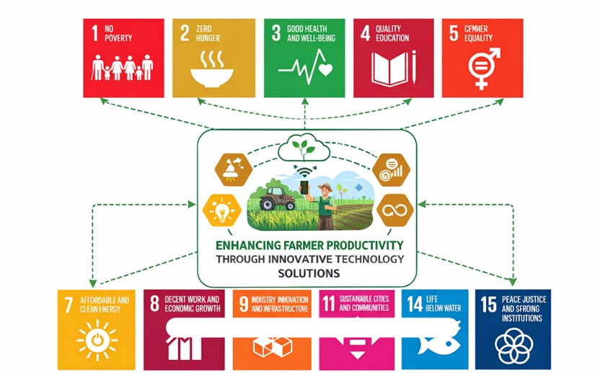
Fig 1.1 Sustainable development goals

SDG 9 – Industry, Innovation and Infrastructure: The combination of up-to-date technologies, including IoT, artificial intelligence, and data analytics, facilitates agricultural innovation and helps to create a network of digital infrastructure that leads to smart farming.
SDG 12 – Responsible Consumption and Production: The system promotes or enhances efficient use of agricultural resources through optimization of fertilizer use and irrigation effects, thereby minimizing harm to the environment.
SDG 13 – Climate Action: It allows farmers to make informed decisions that would permit them to adjust to the environment changes and use agricultural resources more efficiently.
1.7 Overview of project report
This project report provides the design and implementation of the system named: Enhancing Farmer Productivity with the use of Innovative Technology Solutions.
- Chapter 1: introduces the background of the project, highlights the need for technological advancements in agriculture, discusses prior existing technologies, and outlines the objectives and alignment with Sustainable Development Goals (SDGs).
- Chapter 2: will offer an extensive literature review of the available research and technological solutions associated with smart agriculture, IoT-based monitoring systems and machine learning in agriculture.
- Chapter 3: will detail the methodology to be used in the project including the development approach, data collection process and system workflow.
- Chapter 4: presents the project management aspects i.e. the project planning, project timeline, risk analysis and budgeting.
- Chapter 5: outlines the analysis and design of the proposed system such as system requirements, block diagram, system flowcharts, communication models, and deployment architecture.
- Chapter 6: is a demonstration of the hardware and software that were utilized in the system and the implementation details and development tools.
- Chapter 7: will review the proposed system performance by providing the test cases and results as well as analyse the functionality of the system.
- Chapter 8: reviews the social, legal, ethical, sustainability and safety issues related to the project.
- Chapter 9: is a concluding support of the project findings and also presents the future improvements, which might be implemented to enhance the system even more and increase its capacity.

Chapter 2
LITERATURE REVIEW
Over the past years, the popularity of smart agricultural research, Internet of things (IoT), artificial intelligence, and machine learning are growing as the necessity to practice sustainable and efficient farming methods of doing things increases. The goal of the modern agricultural systems is to enhance productivity, decrease the use of resources and offer the real-time monitoring with the help of advanced technologies. According to [1], Miller et al. provide an overview of the studies on the combination of IoT and artificial intelligence in the agricultural sector highlighting the role of smart sensing devices in ascending the state of the soil, health of crops, and other environmental indicators. Their study demonstrates the usefulness of sensor network and intelligent analysis of data in precision farming and improvement of the agricultural decision-making. In [2], Rafi et al. deal with the question of trustworthy and economical solutions based on IoT connectivity to smart agriculture. The authors are preoccupied with communication technologies which make the mass introduction of sensors and devices on the fields possible in order to refer to the need of permanent connection to transmit and monitor data in real time. In [3], Mansoor et al. also discuss how smart sensors and IoT technologies are applied in precision farming. Their work elaborates on how the enhanced sensing technology will help farmers monitor the growth of crops, soil moisture, and the environment, therefore, making farm management more accurate. The modern research in the field of agriculture is also associated with a deep learning and machine learning. The Zhang et al. developed a deep learning-based crop recommendation system ([4]) that relies on the soil and weather information to suggest that correct crop based on the agricultural conditions of the region. Their method enhances better prediction and helps farmers to adopt crops that would give the highest production. Dhanasekar and Kumar ([5]) present the latest developments and challenges in precision agriculture based on IoT, and highlight data management, sensor reliability and scalability of the system as some of the key issues. Besides, Babar and Akan in [6] discuss the idea of sustainable agriculture on the Internet of Everything (IoE). Their study includes how the interconnected devices, sensors, and intelligent systems can be utilized to transform traditional farming into automated and data-driven forms of farming. The combination of these two technologies has also enhanced the agricultural monitoring systems through IoT and cloud technologies. Li et al. introduce a real-time crop monitoring system in [7], which is based on the gathering and analysis of agricultural information remotely with the help of IoT devices and cloud computing platforms. Such a system helps farmers maintain the check of the situation in the fields and make decisions. Once again artificial intelligence has been used to increase the efficiency of agriculture. In the article [8], AlZubi and Galyna discuss the potential of AI and Internet of Things in the sphere of sustainable agricultural system. In their article, they point out that agricultural data is typically very large and so through application of intelligent algorithms, special attention can be applied on large volumes of agricultural data in order to aid crop management, disease and yield prediction. In the same manner, Kumar and Patel in [9] suggested a system to identify crop diseases using IoT sensors and is based on a deep learning model. Their analysis indicates that automated disease detection systems could help farmers to identify disease in their crops to prevent huge losses. Previous studies have also been done on agriculture monitoring systems that are based on IoT. In [10], Sharma et al. present the smart agricultural monitoring system based on IoT, as per which the sensors measure the environmental data and send it to the farmers who have access to it and may make better decisions on the basis of this information. In [11], Patel and Kumar present the crop suggestion system, where soil data are processed keeping in consideration of soil properties (pH, soil moisture and soil nutrient amounts) which determines the kind of crop that could be cultivated. Gupta and Mehta present more developments in smart agriculture in [12], who succeed in creating the system that can combine IoT devices and machine learning algorithms to predict crop yield and maximize agricultural productivity. Another study that has been undertaken by use of a survey has also provided me with an insight regarding the new technologies in the agricultural industry. Friha et al [13] give a comprehensive discussion of the IoT technologies and IoT applications in smart farming and the challenges that could occur in the future such as interoper ability, security and energy efficiency. In addition, Sharma et al. in [14] present the applications of ma chine learning in precision agriculture (crop monitoring, yield prediction and automated decision support system). Their article emphasizes the increased significance of data driven approaches in the contemporary agricultural systems. Lastly, Jayashree et al. [15] suggest implementing an IoT and artificial intelligence-based smart irrigation system that can automatically regulate the water flow rate based on the soil moisture and environmental conditions and aid in water conservation and crop more productively. Overall, these articles demonstrate that IoT, artificial intelligence, machine learning, and big data technologies can have a significant value in transforming the traditional agriculture into smart and sustainable agricultural machine. Such technologies make it possible to monitor in real-time, provide predictive analytics, and make decisions automatically, which can en hance crop production and the use of resources. However, the cost of infrastructure is high, data reliability and system scalability, and heterogeneous technology demands are a few of the challenges that remain open research opportunities that can be met in the future. quantity and quality of yield.
Table 2.1 Summary of Literature reviews
S# | Article Title, Published Year, Journal | Methods | Key Features | Merits | Demerits
1 | Miller et al., IoT and AI in Agriculture: Smart Sensing Technologies Review, 2025 | IoT sensors with AI data analytics | Integration of sensors to monitor soil conditions, crop health and environmental parameters | Enables real-time monitoring and improved decision making | Requires large sensor infrastructure and reliable connectivity
2 | Rafi et al., Reliable and Cost-Efficient IoT Connectivity for Smart Agriculture, 2025 | IoT communication technologies | Focuses on communication networks for large-scale agricultural monitoring | Provides efficient data transmission for IoT devices | Connectivity issues may occur in rural environments
3 | Mansoor et al., Integration of Smart Sensors and IoT in Precision Agriculture, 2025 | Smart sensors with IoT | Uses sensors to track crop growth, soil moisture, and environment | Improves precision farming and resource utilization | Sensor maintenance and calibration challenges
4 | Zhang et al., Deep Learning Based Crop Recommendation System, 2024 | Deep learning algorithms | Predicts suitable crops using soil and weather data | Improves crop prediction accuracy | Requires large datasets and computational resources
5 | Dhanasekar & Kumar, IoT in Precision Agriculture: Issues and Advancements, 2024 | IoT architecture and data analytics | Discusses modern developments in precision agriculture | Provides comprehensive overview of IoT systems | Challenges in scalability and data management
6 | Babar & Akan, Sustainable Agriculture with Internet of Everything, 2024 | IoE architecture | Combines connected devices and intelligent systems for automated agriculture | Enhances sustainability and automation | Complex system integration
7 | Li et al., Real-Time Crop Monitoring System Using IoT and Cloud, 2023 | IoT sensors with cloud computing | Remote monitoring of crop conditions through cloud platforms | Enables remote monitoring and data storage | Dependence on cloud infrastructure
8 | AlZubi & Galyna, AI and IoT for Sustainable Farming, 2023 | AI-based predictive analytics | Uses AI algorithms to analyze agricultural datasets | Improves crop yield prediction and farm management | Requires advanced computing resources
9 | Kumar & Patel, Deep Learning Based Crop Disease Detection, 2023 | Deep learning and IoT sensors | Detects crop diseases using image processing and sensor data | Helps early disease detection | Requires image datasets and training
10 | Sharma et al., IoT Based Smart Agriculture Monitoring System, 2022 | Sensor-based IoT system | Collects environmental data from fields for monitoring | Improves decision making for farmers | Hardware cost and deployment complexity
11 | Patel & Kumar, Crop Suggestion System Based on Soil Data, 2022 | Soil analysis with recommendation algorithms | Suggests crops based on soil pH, moisture and nutrients | Helps farmers select suitable crops | Limited dataset coverage
12 | Gupta & Mehta, Smart Farming Using IoT and Machine Learning, 2022 | Machine learning with IoT sensors | Predicts crop yield using environmental data | Enhances agricultural productivity | Requires large training datasets
13 | Friha et al., IoT Technologies in Smart Farming: A Survey, 2021 | IoT survey study | Comprehensive overview of smart farming technologies | Identifies future research directions | Discusses challenges but lacks practical implementation
14 | Sharma et al., Machine Learning Applications in Precision Agriculture, 2021 | Machine learning models | Applications include yield prediction and crop monitoring | Provides advanced predictive capabilities | Data dependency and model training complexity
15 | Jayashree et al., Smart Irrigation System Using IoT and AI, 2021 | IoT sensors with AI control | Automatically regulates irrigation based on soil moisture | Saves water and improves irrigation efficiency | Requires reliable sensor deployment

Table 2.1 provides a summary of the most important research contributions on the topic of smart agriculture technologies, which apply Internet of Things (IoT), artificial intelligence, machine learning, and data analytics to enhance the productivity of agriculture. These studies reveal the increasing significance of technology-oriented solutions in the modern agricultural sector to enhance monitoring of the crop, decision-making, and utilization of the available resources effectively. The initial three papers in target agricultural monitoring of IoT-based sensing technologies. According to Miller et al. the integration of IoT and artificial intelligence in agriculture is reviewed and smart sensing technologies which monitor the soil conditions and environmental parameters are highlighted. Likewise, Rafi et al. talk of dependable and affordable connectivity options that are necessary in implementing IoT on a large scale in agricultural fields. Mansoor et al. also elaborate how smart sensors operate to track crop development, soil moisture, and the environment to enhance precision farming activities. research is dedicated to the application of the latest technologies e.g. deep learning or Internet of Everything (IoE) to agriculture. Research by Zhang et al suggests a system of crop recommendations using deep learning, which interprets the data of the soil and weather to define the appropriate crop. Dhanasekar and Kumar explore the innovations and obstacles in the development of IoT-based precision agriculture systems especially obstacles in scalability and data management. Babar and Akan emphasise the power of networked devices and smart systems to turn conventional farming into environmental friendly and automated agricultural systems. Research accentuates real-time surveillance and intelligent agro regulation systems. Li et al. suggest a crop monitoring platform that is a cloud-based system, which gathers agricultural data remotely with the use of IoT devices. AlZubi and Galyna discuss the application of artificial intelligence and IoT in enhancing agriculture both in efficiency and sustainability. In Kumar and Patel an example of a deep learning-based crop disease detection system is given. Sharma et al. present an intelligent system of agricultural monitoring that gathers the environmental information with the help of sensors and offers data to farmers to make improved decisions. Ongoing works are dedicated to crop recommendation and prediction of yields, as well as to smart irrigation technologies. Patel and Kumar present a system of crop recommendations in which the properties of soil to consider include pH, moisture, and nutrients. Gupta and Mehta use IoT sensors and machine learning to anticipate crop yield to improve agriculture productivity. Friha et al. present an in-depth overview of IoT technologies in smart farming. Precision agriculture in Sharma et al. State that machine learning is used to monitor crops, predict yields. Jayashree et al discuss a smart irrigation system allowing it to automatically regulate the amount of water supplied to the soil depending on its soil moisture to enhance water efficiency. In general, the reviewed papers included in prove that IoT, artificial intelligence, machine learning, and cloud technologies integration has a major influence on the transformation of the conventional agriculture into smart and sustainable farming systems. Nevertheless, high infrastructure cost, data reliability issues, and scalability of the system, continue to be challenges. It is with the aim of alleviating these problems that the proposed system, entitled: Enhancing Farmer Productivity: Innovative Technology Solutions intends to offer a solution to the issues by offering a software-based system of agricultural advisory services that would examine soil data and render ingenious crop and fertilizer prescription.

Chapter 3
METHODOLGY
The verification phase in V-Model approach is aimed at system requirements analysis and system components design prior to implementation. This stage has the requirement analysis, system design, architectural design, and module design. The design of the system is done as per specifications of the project in each stage so that the software cannot cause any adverse effects to the system during execution. Validation takes place following the implementation and aims at the testing of the developed modules in order to ensure that the modules meet specifications.
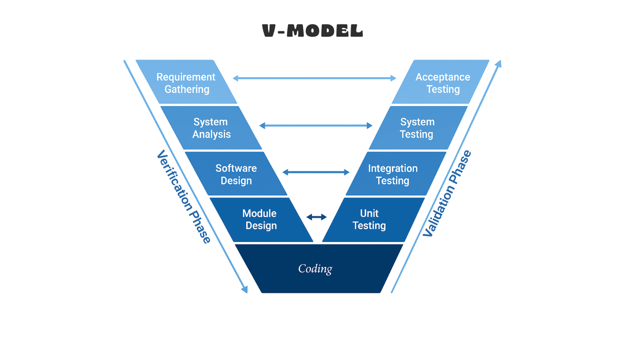
Fig 3.1 The V model methodology
The V-Model is used to identify mistakes early as every development stage is mapped to a testing stage and the system is of better quality. In the case of the designed project, the stages of the V-Model are outlined in the following way:
• Requirements Analysis: Deliberation of the problem statement and literature review pertaining to the smart technologies in agriculture. System Design: Construction of the architecture of the agricultural monitoring system database structure, and web platform elements.
• Functional Design: Designing modules like soil data analysis, crop recommendation, fertilizer recommendation and market intelligence.
• Unit Design: Design on single software modules such as database modules, data processing modules and user interface modules.
• Unit Testing: This is a test of separate modules to ensure that the functionality is right. • Integration Testing: The integration of all modules to make certain that components interact in a proper way.
• System Testing: Performing a test of the entire system in terms of performance, reliability and functionality.
• Validation: Making sure that the system fulfils the user requirements and project aims.
Under the unit design stage, specific software modules like the data analysis module, recommendation module and user interface are executed. Unit testing is done after development to ensure that each module works. Integration testing is then performed to test the modules in combination to make sure that there is appropriate interaction between system components. System testing is carried out in order to determine the performance and reliability as well as the functionality of the application. Lastly, validation will ensure the system developed has fulfilled the project goals and will satisfy the user requirements, thus offering the effective platform to help the farmers increase agricultural productivity.
SDLC Phases
Software Development Life Cycle (SDLC) offers an organized method of developing software programs by a series of steps such as planning, analysis, designing, developing programs, testing them and deploying the software programs.
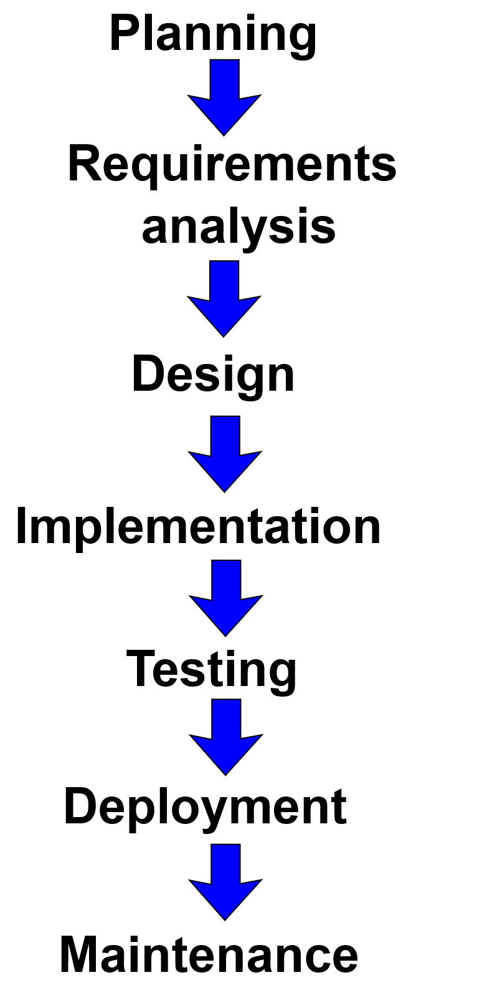
Fig 3.2 SDLC phases

This fig 3.2, the SDLC phases are:
1. Planning: Statement of the problem and project objectives.
2. Requirement Analysis: An understanding of requirements and literature review.
3. System Design: Architecture, Database and application module design.
4. Implementation: The building of the agricultural monitoring system web-based.
5. Testing: unit testing, integration testing and system testing.
6. Deployment: Installing the system into user-accessibility and testing.
Table 3.1 provides the comparison of some of the project management methods such as Agile, Waterfall, Scrum, Kanban, Lean, Six Sigma and PRINCE2. All the methodologies possess their advantages and limitations based on the project needs and development settings. Agile and Scrum give flexibility and the ability to develop in an iterative manner, whereas Waterfall gives the structured and predictable flow of work. But in case of the system development, Enhancing Farmer Productivity Through Innovative Technology Solutions, a formal approach to the problem, identification of clear verification and validation phases, is desirable. Consequently, V-Model and SDLC principles have been chosen to be utilized in implementing the proposed system.

Table 3.1 Comparison of Project Management Methodologies
S# | Methodology | Pros | Cons
1 | Agile Methodology | Flexible and adaptive to changes in requirements. Encourages collaboration between team members and continuous feedback throughout development. | Difficult to predict timelines and cost. Requires experienced team members and may be challenging to manage for large projects.
2 | Waterfall Methodology | Simple and structured approach with clearly defined phases. Easy to manage and suitable when requirements are well defined. | Limited flexibility once development begins. Changes in requirements are difficult to incorporate.
3 | Scrum Methodology | Encourages teamwork and continuous improvement through iterative development cycles called sprints. Provides frequent feedback from stakeholders. | Requires experienced team members and strong coordination. Difficult to manage large-scale projects.
4 | Kanban Methodology | Provides visual workflow management and helps teams track progress easily. Supports continuous delivery and flexible task management. | Less structured compared to other methodologies. Requires disciplined team management to avoid workflow delays.
5 | Lean Methodology | Focuses on efficiency and reducing waste in the development process. Encourages continuous improvement and optimized resource utilization. | Limited flexibility in certain situations and may require experienced teams for effective implementation.
6 | Six Sigma Methodology | Data-driven methodology focused on improving quality and reducing defects. Helps achieve high process efficiency and reliability. | Implementation can be complex and time-consuming. Requires specialized training and expertise.
7 | PRINCE2 Methodology | Structured project management framework with clear documentation and risk management practices. Suitable for complex projects. | Can be time-consuming and rigid. Requires experienced project managers and strict adherence to processes.
Reference:
[13] Friha, O., Ferrag, M.A., Shu, L., Maglaras, L. and Wang, X., 2021. The future of smart agriculture: Internet of Things—A survey of emerging technologies. IEEE/CAA Journal of Automatica Sinica, 8(4), pp.718–752.

Chapter 4
PROJECT MANAGEMENT
Project management is significant in the successful completion and development of a project within the planned time and resources. It entails scheduling, assigning tasks, keeping track of the progress as well as dealing with possible risks that could occur in the process of development. Projects Good projects are managed efficiently to ensure that there is a well organized workflow and every part of the project is carried out in a systematic fashion. Project management techniques are applied in the design of the system entitled Enhancing Farmer Productivity With Innovative Technology Solutions by defining the schedule in which tasks will be performed, which risks may occur and which are the ways to reduce risks. The project schedule highlights the significant stages of the project development such as requirement analysis, system design, functional design, implementation, testing, and deployment. Besides, a risk analysis is conducted to determine possible technological, operational and environmental issues that are likely to impact the project. The chapter thus demonstrates the project schedule in a Gantt chart, and the risk analysis in a planned framework, which assists in making sure that the proposed system implementation runs smoothly to a successful completion.
4.1 Project timeline
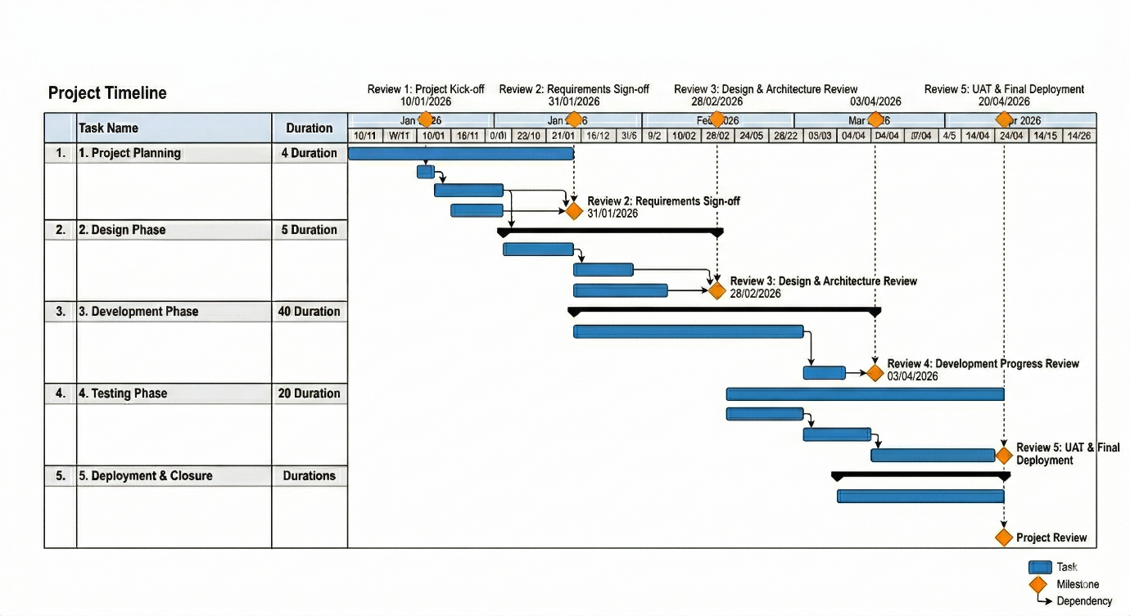
Fig 4.1 Project Timeline Gantt Chart
In the Figure 4.1. The diagram implies the project phases such as project planning, design, development, testing and deployment. The lifecycle of activities is expressed in horizontal bars which represent the time spent on activities during each phase of the project. The timeline also highlights important review milestones such as Review-1 (10-01-2026), Review-2 (31-01-2026), Review-3 (28-02-2026), Review-4 (03-04-2026), and Review-5 (20-04-2026). These reviews can be used to review the development of the project at various stages and adhere to the development activities within the scheduled plan. On balance, the timeline gives a clear graphical representation of the dependencies and milestones of the project.
Table 4.1 Project implementation timeline
S# | Task / Activity | Start Date | End Date | Milestone
1 | Problem Identification and Topic Selection | 01-01-2026 | 10-01-2026 | Project topic finalized (Review-1)
2 | Literature Survey and Research Paper Review | 10-01-2026 | 31-01-2026 | Literature review completed (Review-2)
3 | Requirement Analysis and Problem Definition | 31-01-2026 | 10-02-2026 | System requirements documented
4 | System Architecture and Design Planning | 10-02-2026 | 28-02-2026 | System design finalized (Review-3)
5 | Database Design and Data Collection | 01-03-2026 | 15-03-2026 | Dataset prepared
6 | Module Design (Crop Recommendation, Soil Analysis, Dashboard) | 15-03-2026 | 03-04-2026 | Functional modules designed (Review-4)
7 | Implementation and Development | 01-03-2026 | 10-04-2026 | Core system implemented
8 | Testing and Debugging | 05-04-2026 | 15-04-2026 | System testing completed
9 | Documentation and Report Preparation | 10-04-2026 | 18-04-2026 | Final project report completed
10 | Final Project Review and Submission | 20-04-2026 | 20-04-2026 | Final Viva
Reference:
[10] Sharma, A., Verma, R. and Singh, P., 2022. Smart agriculture monitoring system using IoT. IEEE Access, 10, pp.45678–45689.
Table 4.1 indicates the project timeline and milestones to develop the system, Enhancing the farmer productivity based on innovative technology solutions. The actual project will start with identification of the problem and literature review to familiarize with the available agricultural technology and scope of the project. This is then succeeded by requirement analysis and system architecture design where the functional structure and database elements of the system are designed. The following phase, module design and implementation is implemented to build the main features, namely crop recommendation, soil analysis, and a dashboard visualization. Testing and debugging of the system is performed after its implementation, to make sure the system works and behaves correctly. Lastly, documentation is made and project handed in under the final review and viva to ensure that all the process of the development is done in order and within the set schedule of time.
4.2 Risk analysis
Risk analysis is a key aspect of project management that assists with determining possible risks that can influence successful of a project completion. Early risk analysis in the development process can help in implementing the appropriate mitigation strategies to minimise their effect. The PESTLE framework is used to analyze risks in this project but it considers risks based on technological, economic, social, legal, and environmental factors. The risk analysis will help in assuring that the system named as Enhancing Farmer Productivity With Innovative Technology Solutions will be developed and deployed efficiently and reduce the uncertainties that may come along during its development and implementation stage.

In Table 4.2 The risk analysis of the proposed system, namely, to improve the productivity of Farmer with the help of innovative technological solutions, is conducted. The table recognizes possible risks that can occur during system development and deployment, and prioritizes the risks on the basis of their probability, impact and severity. Technological risks are associated with the problems with the reliability of the system and software that could be reduced by adopting well-established structures and ongoing testing of the modules. The risk exposed to the economy is also mitigated by use of open-source tools that help in lowering the cost of development. Social risks are also user adoption risks, which can be addressed by creating an easy to use interface that user farmers can use. Law risks are following the correct data processing and adhering to privacy rules. System integration risks of its deployment can be minimized by extensive testing, and adequate documentation. Environmental risks are based on modification in the farm conditions and the system is structured to give adaptive advice based on the soil and weather information.

Table 4.2 PESTLE Risk Analysis for the Proposed System

S# | Risk Type | Probability | Impact | Severity | Mitigation Strategy
1 | Technological Risks | Medium | High | Critical | Use reliable software frameworks and perform regular testing of modules to ensure system stability and performance.
2 | Economic Risks | Medium | Medium | High | Use open-source development tools and technologies to minimize development and deployment costs.
3 | Social Risks | High | Medium | Moderate | Provide a user-friendly interface and simple dashboard so farmers can easily understand and use the system.
4 | Legal Risks | Low | High | Moderate | Ensure proper handling of user data and follow digital data privacy and security regulations.
5 | Deployment Risks | Medium | High | High | Conduct detailed testing before system deployment and maintain proper system documentation.
6 | Environmental Risks | Medium | High | High | Design the system to adapt to environmental changes and provide flexible agricultural recommendations based on soil and weather conditions.

Reference:
[5] Dhanasekar, S. and Kumar, P., 2024. Existing problems and developments of IoT in precision agriculture. Computer Science Review, 50, pp.101–115.
In Table 4.3 The PESTEL analysis of the suggested system, In order to increase the productivity of farmers using innovative technology solutions, is presented. The external factors analysed include those that could impact on the development and uptake of the system. The political aspects will involve government policies toward agriculture, and digital farming projects, which can facilitate the adoption of smart agriculture technologies. Economics takes into account the cost of technical solutions and access to digital infrastructure among farmers.
Table 4.3 Example of PESTEL analysis
S# | PESTEL Factor | Description | Impact on the Project | Mitigation / Strategy
1 | Political Factors | Government agricultural policies, subsidies, and digital agriculture initiatives influence technology adoption in farming. | Support from government programs may encourage farmers to adopt smart agriculture systems. | Align the system with government agricultural schemes and digital farming initiatives.
2 | Economic Factors | Development and deployment costs, affordability for farmers, and availability of digital infrastructure. | High cost of sensors or digital tools may limit adoption among small-scale farmers. | Use cost-effective technologies and open-source tools to reduce system development cost.
3 | Social Factors | Farmers’ awareness, education level, and willingness to adopt digital farming technologies. | Lack of digital literacy among farmers may affect system usability. | Provide a simple user interface and training materials to help farmers use the platform effectively.
4 | Technological Factors | Availability of IoT devices, internet connectivity, cloud computing, and data analytics technologies. | Limited internet connectivity in rural areas may affect system performance. | Design the system to work efficiently with minimal connectivity and optimize data processing.
5 | Environmental Factors | Climate change, soil fertility variations, and water availability influence agricultural productivity. | Environmental changes may affect crop recommendations and farming decisions. | Integrate environmental monitoring data and adaptive recommendation mechanisms.
6 | Legal Factors | Data privacy regulations, agricultural policies | Improper handling of user data may create legal issues. | Ensure secure data storage and compliance with data protection regulations.
Reference :
[13] Friha, O., Ferrag, M.A., Shu, L., Maglaras, L. and Wang, X., 2021. The future of smart agriculture: Internet of Things—A survey of emerging technologies. IEEE/CAA Journal of Automatica Sinica, 8(4), pp.718–752.
4.3 Project budget
It is an academic project of college based on the requirements of the B. Tech program. The project, called Improving Farmer Productivity using Innovative Technology Solutions, has been completed with the sole purpose of academic learning, research and development of skills. No outside sponsor or organization or funding agency is in support of this project. The student team undertakes all the development activities with guidance of the faculty members of the institution. The software of the project is full and as such, therefore, the project does not have any specific hardware infrastructure or external financial investments. It is mainly implemented through the usage of already available computing facilities including the personal computers, and internet connection and open source software tools. The students have easy access to these resources both at home and in the school. The project will aim to identify new technological solutions that will benefit farmers with smart recommendations and insights based on agricultural data. Therefore, the project is entirely created in the academic setting through the academic program.

Chapter 5
ANALYSIS AND DESIGN
Design and analysis are two crucial stages towards the creation of any system. The analysis stage aims at comprehension of the problem, system requirements and resultant inputs and outputs of the system. It entails research on the challenges there are and collecting all the information needed to develop the system. Design phase on the other hand involves creation of a structured solution as per the requirements identified in the analysis stage. It decides how the system is to be implemented in terms of system architecture, modules, interfaces, and workflow. In the proposed project Enhancing Farmer Productivity Through Innovative Technology Solutions, analysis phase will be devoted to finding out the problem the farmers are struggling with: inefficient choice of crops, the wrong use of fertilizers, and absence of access to the agricultural information.
  - Requirements
The requirement analysis stage determines the system purpose, behavioural and functional system requirements. It will be an agricultural system collecting data on the farm, analysing soil parameters, and giving recommendations that can enable farmers to maximize their crop production.
Table 5.1 Summarizing Requirements for the Proposed System
Requirement Type | Description
Purpose | The system “Enhancing Farmer Productivity Through Innovative Technology Solutions” aims to assist farmers in improving crop productivity by analyzing soil parameters and providing intelligent recommendations for crop selection, irrigation, and fertilizer usage.
Behaviour | The system provides two main functionalities: (1) Soil and crop analysis based on agricultural data, and (2) Recommendation generation for fertilizers, irrigation schedules, and suitable crops.
System Management | The system should allow users to access agricultural insights through a web-based dashboard where farmers can view soil analysis results, crop recommendations, and market information.
Data Analysis | The system analyzes soil data such as moisture level, pH value, and nutrient content to determine crop–soil compatibility and generate recommendations.
Application Deployment | The application will be deployed as a web-based platform that can be accessed using internet-enabled devices such as laptops or smartphones.
Security | The system provides user authentication and ensures secure storage of farmer data and agricultural information.
Reference :
[10] Sharma, A., Verma, R. and Singh, P., 2022. Smart agriculture monitoring system using IoT. IEEE Access, 10, pp.45678–45689.
System Software Requirement
1. Identify Initial Conditions The system needs an online platform which can gather user inputs and analyse farm data.
2. Determine Input Parameters The input information is represented by soil parameters, crop records and environmental conditions, given by the user or stored in the database.
3. System Outcomes The system generates analytical reports, crop recommendations, fertilizer recommendations and graphical presentations of the farm data.
4. Formulate Relations Data analysis algorithms in the software analyse the characteristics of the soil and identify and apply appropriate crop patterns to the data.
  - Block diagram
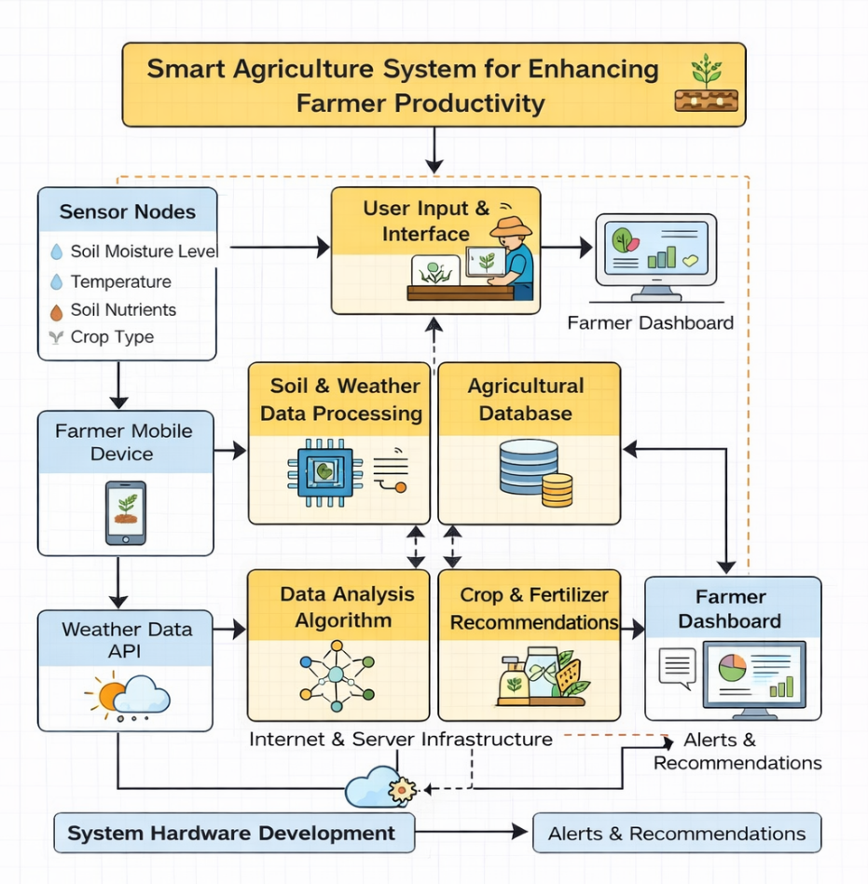
Fig 5.1 Functional block diagram

The block diagram shows the system architecture of the system named Enhancing Farmer Productivity Through Innovative Technology Solutions. The technology will be developed to gather farm data, analyze it with analytical algorithms and give smart suggestions to farmers. The diagram shows the interaction between various modules such as sensor data collection, user input interface, data processing unit, agricultural database, data analysis algorithm, and the farmer dashboard. The initial phase of the system consists of data entry and interaction with the users. During this phase the data about soil moisture and soil nutrients, temperature, and type of crop are gathered using sensor nodes or manual operations by entering the data via a web interface or a mobile device by the farmer. Data gathered is then sent to the system where it is processed using the soil and weather data processing module. This module will make the data collected valid and ready to be analyzed. The processed data can then be stored in the agricultural database that serves as the centralized repository to store the soil parameters, crop information and previous agricultural records. The data analysis algorithm module is then used to analyse the stored data during the next stage.
5.3 System Flow chart
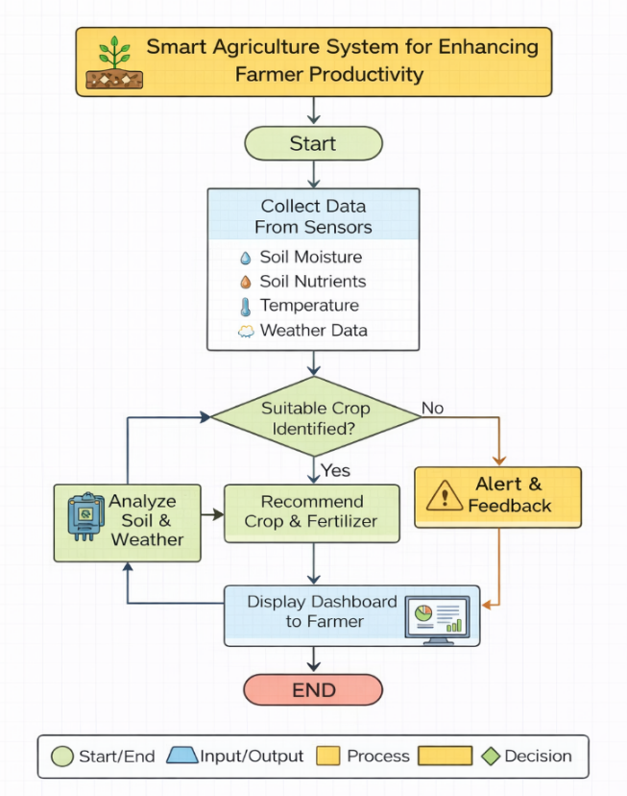
Fig 5.2 System Flow Chart
Figure 5.2 involves the system flowchart of the proposed system which is called: Enhancing Farmer Productivity Through Innovative Technology Solutions. The flowchart begins by visualizing the steps used in the process of getting agricultural data, analyzing soil and environmental parameters, and advising farmers. It graphically shows interactions among various modules of a system to present intelligent decision support to enhance agricultural productivity. The process starts with starting node, where the system can start the data collection process. The system takes sensor or user measurements in the next stage, this data may consist of soil moisture, soil nutrient status, soil temperature and weather conditions among others. These input parameters play a critical role in analyzing the agricultural environment and deciding the appropriateness of crops to a given soil situation. The information gathered is then sent to the data analysis module where the system works with to process and judge the soil and environmental parameters. The system executes a decision step after analysis of the collected data to decide whether a suitable crop is identifiable or not using the parameters analysed. Upon identification of an appropriate crop, the system will then generate crop and fertilizer recommendations. Such recommendations assist farmers to know the kind of crops that are best suited in their soils and what type of fertilizers or irrigation techniques to use. The recommendations are then presented in a farmer dashboard where farmers can conveniently access insights and be guided to make judicious decisions about crop cultivation. In case the system identifies that there is no identifying suitable crop because of inadequate or unsystematic information, the system sends messages of warning or feedback to highlight the problem to the user. This is to enable farmers or administrators revise the input data or adjust parameters to be analysed better. Lastly, the dashboard presents the results and recommendations and the system is at the final stage of the process. The flowchart therefore illustrates the rational flow of the proposed system and indicates how the data collection, data analysis, and data recommendation modules are going to collaborate in enhancing the productivity of farmers.
5.4 Choosing devices
When developing IoT-based agricultural monitoring systems, one of the critical challenges should be the choice of hardware devices including processors, sensors, and actuators that allow gathering the environmental data and regulating the agriculture activities. Common parameters measured by these gadgets include soil moisture, temperature, humidity and the environmental condition that are utilized in crop monitoring and decision making. The suggested system though is intended to be an agricultural advisory platform, a software platform to improve farmer productivity through innovative technologies solutions. The system interprets agricultural data and soil parameters that are provided by users to come up with crop and fertilizer prescriptions. Thus, the current project does not implement physical hardware components, e.g. sensors, microcontrollers, and actuators. However, to realize how these systems may be scaled to real-world IoT-based agricultural monitoring systems a comparative analysis of popular processors and sensors is provided in the following tables. Microcontrollers or processors are employed in IoT-based agriculture systems to retrieve sensor-related data and send the data to the cloud or server to be processed. Many processors are widely used in the IoT like Arduino, Raspberry Pi, Node MCU, and ESP32. Chosen IoT Extension gadget. Despite the fact that the existing system is completely software-only, ESP32 would be the most appropriate processor to integrate into hardware in the future due to its built-in Wi-Fi, Bluetooth functionality, several GPIOs, and powerful processing, which would be appropriate to smart farming monitoring systems.
5.5 Designing units
The process of designing units is also a significant phase in the development of systems as dividing the entire system into smaller functional parts or units. All units have a task assigned to them and they interact with other modules to complete the functions of the system. Dividing the system into various units enhances maintainability, scalability and efficiency of the application
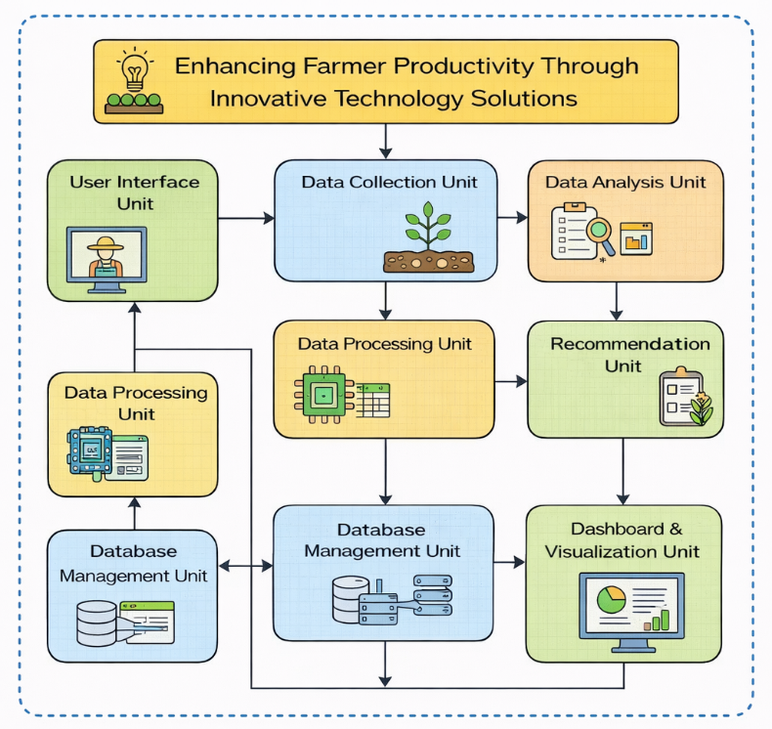
Fig 5.3 Farmer Productivity through Tech Solutions
In the Above Fig 5.3 the designing units of the proposed system, “Enhancing Farmer Productivity through Innovative Technology Solutions divide the application into a few functional modules which interactively come together to provide intelligent agricultural recommendations. The system starts at the User Interface Unit whereby farmers input information regarding soil and crop related information. The Data Collection Unit collects the necessary agricultural data which is processed by Data Processing Unit to make it accurate and consistent. The Data Analysis Unit processes the data to identify the appropriate crops and the amount of fertilizer needed. According to the analysis findings, the Recommendation Unit comes up with crop and fertilizer recommendations. The Database Management Unit stores and manages all the relevant data and the results and recommendations are presented to the farmer by the Dashboard and Visualization Unit in a clear and understandable format. These units collaborate with each other to create a complete software system that can assist farmers to make informed agricultural choices and enhance crop yield.
5.6 Standards
Standards are a significant part in developing systems since they guarantee that they are interoperable, secure, exchange information and communicate between various parts of a system with high levels of reliability. Standards offer technical description which enable various technologies and platforms to collaborate effectively. They specify communication protocol policies, data format, system structure and security policy. The proposed system Enhancing Farmer Productivity Through Innovative Technology Solutions primarily involves web technologies, data communication protocols, data formats and security practices of current software systems. Following standardized technologies helps ensure compatibility, scalability, and reliability of the agricultural advisory platform.
1. Communication Protocol Standards The protocols of communication determine the transmission of data between devices and systems. Various communication protocols are in use in web-based systems and IoT setting. The default form of communication in web applications is HTTP / HTTPS which is used to exchange information between the client and the server. The HTTPS offers secure communication through encryption of the information with the help of theSSL/TLS protocols. MQTT (Message Queuing Telemetry Transport) and CoAP (Constrained Application Protocol) are the most popular protocols used in the IoT communication in smart agriculture systems. These are the protocols that enable an effective relay of sensor data among the devices and cloud systems. Wi-Fi (IEEE 802.11) and Bluetooth (IEEE 802.15) are commonly used as wireless communication technologies in IoT-based agriculture in order to connect sensors and devices.
2. Data Format Standards Data format standards are standards that establish structures of information exchange and form between and among systems. Commonly used data formats in the modern web application and IoT platforms are:
  - JSON (JavaScript Object Notation) – lightweight data representation format that is used to send data between server and client-side applications. XML (Extensible Markup Language) - structured representation of data that is used to store and transfer it.
  - CSV (Comma Separated Values) - popular format to store agricultural datasets. The processes of agricultural data and storage of information relating to the crop are carried out through a system that serves the purpose of processing and storing the data in the form of JSON and CSV.
3. Security Standards Security standards guarantee that user data, system integrity and safe communication between system components are guaranteed. Some of the key security criteria consist of:
  - TLS (Transport Layer Security) - is used in secure communication on the internet via HTTPS. ISO/IEC 27001 - international standard on information security management systems.
  - ISO / IEC 27701 - privacy and protection of personal data standard. These standards should assist in keeping the user data, agricultural data and system communications safe.
4. Architecture and Interoperability Standards. Systems based on architecture standards are designed to offer a guideline on building scalable and interoperable systems. Among the key standards is ISO/IEC 30141 that forms the IoT Reference Architecture used to develop interoperable systems of the Internet of Things. Even though the suggested system is software-driven, adherence to the pillars of architecture aids in contingent development of scalable and modular apps. The other influential interoperability standard is the ISO/IEC 21823 that concentrates on interoperability among various IoT systems and platforms.
5. IT Management Standards Information technology employs several standards to guarantee good management, quality control and reliability of services. The ISO 9001 standard is a quality management standard which ensures reliability and quality processes of the system.
  - ISO 20000- the IT service management standard that deals with IT service management.
  - ISO 22301- Standard of business continuity management, which provides system availability and recovery in case of failures. These best practices can preserve the quality of the system, its reliability, and constant availability of service.
6. Benefits of Using Standards Standardized technologies and structures have a number of benefits to the creation of modern software systems. First, standards help decrease development expenses by offering standard frameworks and protocols that developers can use rather than developing others. Second, standards enhance interoperability whereby various systems and platforms can share information with each other without complications. It is especially vital in intelligent farming where a variety of technologies can interplay. Third, standards help in improving security as they establish the best practices of protecting data, encrypting data, and system authentication. Lastly, standards facilitate innovation and scalability and allow the system to tie in with other technologies and even grow in future.

5.7 Mapping with IoTWF reference model layers (in tabular form)
The reference model of the Internet of Things systems in IoT World Forum (IoTWF) determines a layered architecture. It divides IoT systems into several layers that explain the manner in which data gets collected, processed, analyzed and utilized to make decisions. The model is useful in providing interoperability, scalability, and efficient data management in IoT-based applications. Even though the proposed system Enhancing Farmer Productivity With Innovative Technology Solutions is more of a software platform of agricultural advisor, this system can be conceptually mapped to the IoTWF reference model layers. The present mapping demonstrates the way the system may be combined with the Agricultural monitoring systems that are based on the IoT in the future. In addition, this mapping lays an emphasis on the value-creation path of the system. By fitting within the IoTWF model, the platform will make sure that raw environmental data in the field (Layer 1) does not simply sit as a collection of numbers, but is systemically refined into Smart Data (Layer 5) and finally into Actionable Intelligence (Layer 7). This systematic method enables the system to be scaled towards simple monitoring to full automation decision-support engine, which could give farmers accurate, data-driven interventions that can directly translate into crop yields and resource efficiency.

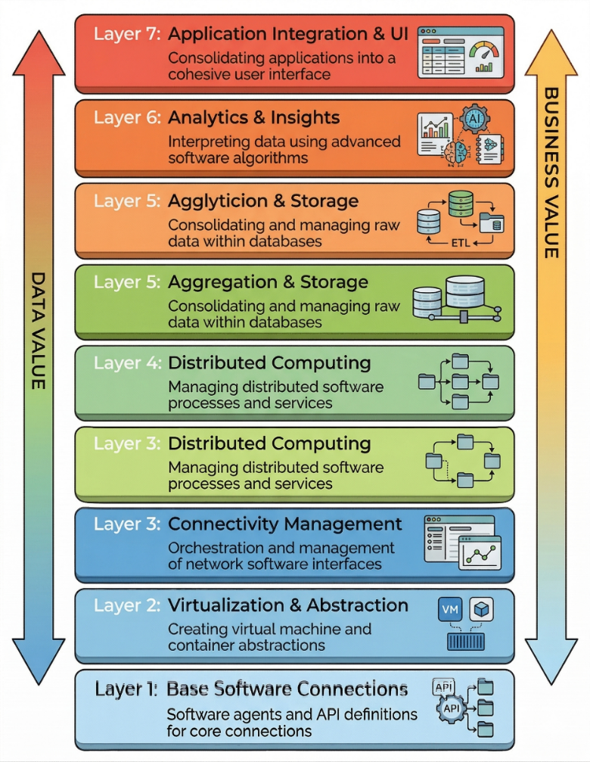

Fig 5.4 The IoT World Forum Reference Model
The IoT World Forum (IoTWF) reference model as illustrated in figure 5.4 gives a layer-based model of designing Internet of Things systems. Under this model, the system is structured into several layers that regulate the manner in which the data is gathered, relayed, processed, analyzed and made available to the customers. The base layers are concerned with data generation and connectivity and the upper layers are concerned with data processing and analytics and application services. Within the proposed system, Enhancing Farmer Productivity Through Innovative Technology Solutions the lower layers will be collection and transmission of agricultural data, and the upper layers will be data storage, analysis, and user interface of the system which will give recommendations to the farmers. This tiered structure assists in achieving modular system design, data management, and scalability to achieve future integration with the IoT devices and real-time monitoring systems.
Table 5.2 Mapping Project layers with IoTWFRM
Layer | IoTWF Layer Name | Description | Mapping to Proposed System
Layer 1 | Base Software Connections | Defines APIs and software interfaces used for communication between system components. | Web APIs and backend services used to exchange data between the user interface and the database.
Layer 2 | Virtualization & Abstraction | Provides abstraction for computing resources and system services. | Cloud or server environment hosting the web application and database services.
Layer 3 | Connectivity Management | Manages network communication and data transfer between devices and systems. | Internet connectivity using HTTP/HTTPS protocols for data transmission between users and the platform.
Layer 4 | Distributed Computing | Handles processing of data across different computing resources. | Backend processing modules that handle agricultural data processing and recommendation logic.
Layer 5 | Aggregation & Storage | Collects and stores raw data for further analysis. | Database system storing soil data, crop information, and agricultural datasets.
Layer 6 | Analytics & Insights | Performs data analysis and generates insights using algorithms. | Data analysis module that processes soil and environmental data to generate crop and fertilizer recommendations.
Layer 7 | Application Integration & UI | Provides user interface and integrates different services for end users. | Web-based dashboard where farmers view recommendations, reports, and agricultural insights.
Reference :
[13] Friha, O., Ferrag, M.A., Shu, L., Maglaras, L. and Wang, X., 2021. The future of smart agriculture: Internet of Things—A survey of emerging technologies. IEEE/CAA Journal of Automatica Sinica, 8(4), pp.718–752.
Table 5.2 shows the mapping of the proposed system Enhancing Farmer Productivity Through Innovative Technology Solutions to the layers of the IoT World Forum (IoTWF) Reference Model. The layers of the IoTWF architecture correspond to the functions of the proposed system. The bottom layers deal with system connectivity, software interfaces, and infrastructure that provides communication and data exchange. The intermediate layers involve processing and storage of data which includes agricultural data and soil parameters. The higher layers are concerned with data analytics and application services, in which the system interprets agricultural information and offers crop and fertilizer advice via a user-friendly dashboard.
5.8 Domain model specification
The domain model explains the key concepts, entities and objects that will be involved in the system. It delimits the connections among various entities and how the flow of information is conducted in the system. The domain model gives a system-independent representation of the system. The domain model in the proposed system Enhancing Farmer Productivity Through Innovative Technology Solutions presents the agricultural entities (farmers, soil data, crop information, and agricultural recommendations).
Table 5.3 Description of Domain model
Domain Component | Description
Physical Entity | The physical entities in the system include agricultural fields, soil conditions, crops, and environmental factors such as temperature and humidity. These represent the real-world agricultural environment for which the system generates recommendations.
Virtual Entity | The virtual entity represents the digital model of the physical entities. In this project, soil parameters, crop data, and environmental conditions are represented digitally in the system database and used for analysis and recommendation generation.
Device | Devices act as a medium between physical and digital systems. In this software-based system, user devices such as laptops, smartphones, or web browsers act as the interface through which farmers interact with the platform and input agricultural data.
Resource | Resources include software components used by the system such as the database, data processing modules, agricultural datasets, and analytical algorithms used for crop and fertilizer recommendation.
Service | Services provide functionality to users through the system interface.

Reference:
[7] Li, J., Zhou, J. and Wang, H., 2023. IoT and cloud computing-based real-time crop monitoring system. IEEE Internet of Things Journal, 10(2), pp.2101–2110.
The domain model of the proposed system is a representation of the association between the real-world agricultural objects and the digital parts of the system. The physical objects like farmland and soil conditions are digitalized as virtual objects of the system database. The interface is offered by user devices that enable the interaction between the farmers and the system and allow them to submit agricultural data. The system services utilize software resources (databases and analytical modules) to run the collected information, and the recommendations are offered through a user-friendly dashboard. This domain model assists in grasping the system structure and gives a conceptual framework to implement smart agriculture advisory platform.
5.9 Communication model
Communication models are the way data is shared among various parts of a system. In IoT and web based system, communication models are used to establish how the devices, applications and services can communicate with one another and share information effectively. Choosing the right communication model guarantees high-quality transfer of data, efficient functioning of the system and enhances scalability. For the proposed system “Enhancing Farmer Productivity Through Innovative Technology Solutions,” the Request–Response communication model is the most suitable communication mechanism. The communication primarily takes place between the user interface (client) and the backend server since the system is installed as a web-based application.
Request–Response Communication Model
Request-Response model of communication is considered to be one of the most popular models of communication in web based systems. In this model, a client makes a request to a server in regards to a specific information or service and the server processes the request and responds accordingly. With the proposed agricultural advisory system, the farmer will interact with the system via a web interface. Each time the user enters the soil parameters or information related to the crop using the interface, a request is posted to the server. The server takes the data received and analyzes it through data analysis algorithms and retrieves information in the database. The server responds to the request after which the response is sent back in the form of crop suggestions, fertilizer suggestions or agricultural knowledge. Request-response model provides effective communication between the database system, user interface and application server. It enables farmers to communicate with the system in real-time and gets immediate recommendations depending on the input data. This is a straightforward, dependable, and effective method of communication that is suitable in web-based agricultural advisory services.
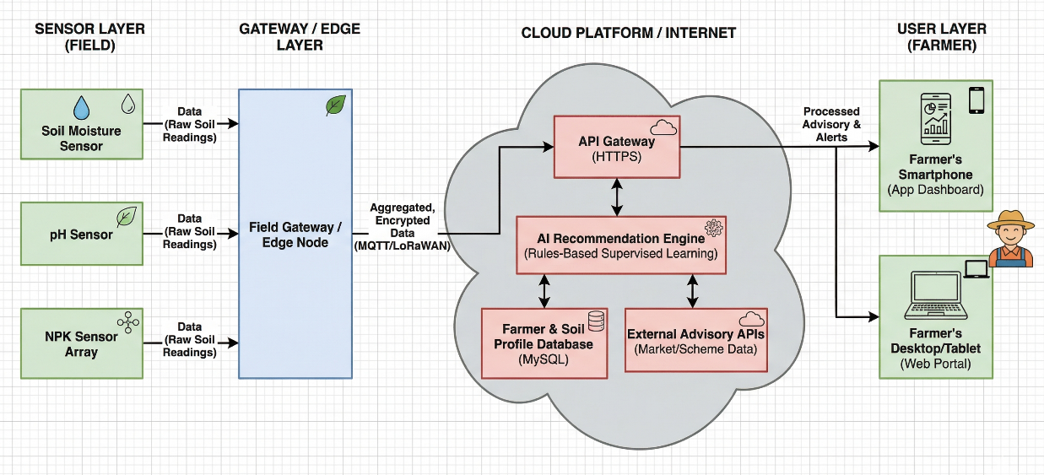
Fig 5.5 Communication model
Figure 5.5 shows the general structure and flow of communication of the proposed system, Enhancing Farmer Productivity Through Innovative Technology Solutions. The architecture is further broken down into four broad layers which include: Sensor Layer, Gateway/Edge Layer, Cloud Platform Layer, and User Layer. These layers cooperate with each other to obtain agricultural information, analyze it with analytical codes, and provide farmers with recommendations through digital tools. Sensor Layer (Field Layer) is the data gathering phase where various agricultural sensors of soil moisture sensors, pH sensors, NPK nutrient sensors, etc. collect raw soil data of the farmland. These sensors keep on tracking the soil conditions and produce environmental data needed in the analysis of agriculture. The raw data obtained is then relayed to the following step using communication channels. The Gateway/Edge Layer is an interim processing unit that takes in data on the sensors. The gateway can consolidate and encrypt the information obtained, then send it to the cloud platform via communication protocols like MQTT or LoRaWAN. This layer also lowers the overhead of communication and also guarantees the secure flow of field data to the cloud environment. The Cloud Platform/Internet Layer would store, process, and analyze agricultural data. The cloud system has a number of elements including API Gateway (HTTPS) to secure communication, AI Recommendation Engine to analyze the rule or supervised learning and databases such as Farmer and Soil Profile Database (MySQL). External advisory APIs may also be incorporated to access information like market prices, government schemes, or advisories to farmers. Lastly, the User Layer (Farmer Layer) avails access to processed information and recommendations. The dashboard is a smartphone application that enables farmers to view insights and alerts, or a web portal on desktop or tablet devices. Such platforms show processed advisory outputs like crop advice, fertilizer advice, and alerts to enable farmers to make informed agricultural choices.
5.10 IoT deployment level
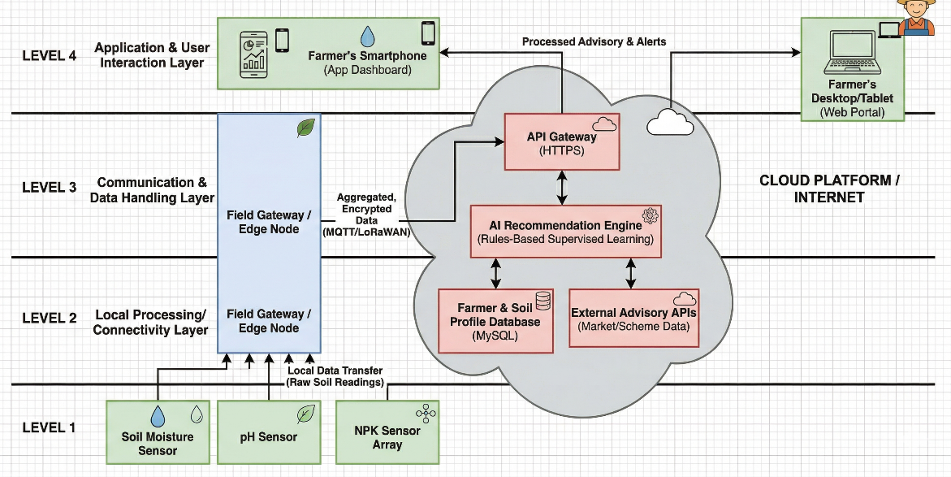
Fig 5.6 IoT deployment level
Figure 5.6 shows the IoT implementation architecture to the proposed system, which is entitled, Enhancing Farmer Productivity Through Innovative Technology Solutions. The architecture is designed into four levels, which represent a step in the gathering, processing, transmission and use of agricultural information. This hierarchical deployment architecture provides effective communication between field components, processing units, cloud services and end users. On Level 1- Sensor Layer, in the agricultural field, multiple sensors are placed in the field like soil moisture sensors, pH sensors, and NPK nutrient sensors. These sensors are constantly working on the state of the soil and obtain uncoded environmental information in terms of the moisture level, acidity of the soil, and the content of the soil. The data obtained reflects the current agricultural conditions on which the decision is made. Level 2 Field Gateway or Edge Node: The level is where a data is gathered using several sensors.
At Level 3 - Communication and Data Handling Layer, the aggregated data is sent safely to the cloud platform via an API Gateway via the use of HTTPS protocols. In the cloud, the system analyses the agricultural data with the help of the AI Recommendation Engine, which employs rule-based or supervised learning to analyse the soil conditions. The system is also connected to Farmer & Soil Profile Database (MySQL) and external advisory APIs that give market information or agricultural scheme data. Lastly, at Level 4 -Application and User Interaction Layer, recommendations and alerts are processed and provided to farmers by digital means like smartphone applications and desktop or tablet device web portals. With an interactive dashboard, farmers can access crop recommendations, fertilizer suggestions, and advisory alerts that help them to make informed decisions in farming. Altogether, the IoT implementation architecture shows how agricultural data is transmitted between field sensors and edge devices and cloud computing platforms to the application interface of the farmer.
5.11 Functional view
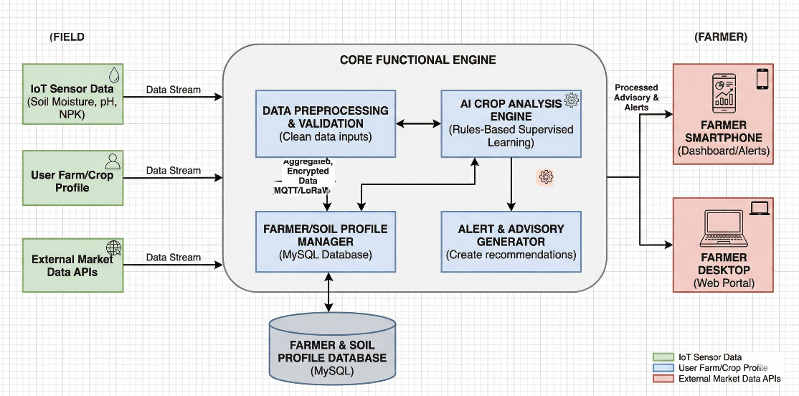
Fig 5.7 Functional view for Home automation
The functional view of the proposed system is as shown in figure 5.7, which is, Enhancing Farmer Productivity Through Innovative Technology Solutions. The functional perspective provides the interactions of various functional groups in order to gather agricultural data, process it, and give smart recommendations to farmers. The system is structured into a number of functional units such as device layer, communication layer, service layer, management layer, security layer and application layer which collectively make the agricultural advisory platform effective in its operation. The IoT sensor data sources that create environmental information of the agricultural field are the device function, which includes soil moisture sensors, pH sensors, and NPK sensors. Besides sensor data, the system is also fed with user farm and crop profile information and external agricultural market data via APIs. These data streams are the major feeds to the system. Communication aspect deals with data transfer between the data sources and the processing system. The sensor, user and external API collected data are sent as data streams to the core functional engine. Communication protocols provide reliable and secure communication between the field environment, cloud processing modules and the user interfaces. The service operation is fulfilled by the main modules of the system such as data preprocessing/validation, end-of-crop analysis engine, the farmer/soil profile manager, and the alert and advisory generator. The preprocessing module cleans and validates incoming data, and the AI analysis engine processes soil and environmental parameters by uniform rule-based or supervised learning to identify the appropriate crops and farming practices. Recommendations and alerts to farmers are then generated by the advisory generator. Management functionality is involved in storing and sorting agricultural data using the Farmer and Soil Profile Database (MySQL). This database contains data with regards to soil parameters, crop profiles and information about farmers which allows easy retrieval and analysis of agricultural data. The application process provides the processed information to the end users. Through smartphone dashboards or web-based desktop portals, farmers can gain access to recommendations, alerts and agricultural insights to enable them make informed decisions in farming. The security feature provides security of data communication and storage processes by using secure protocols and controlled access to systems. Altogether, the functional perspective illustrates the interaction between various system components that are used to gather data, process agricultural data and provide farmers with decision-support services to create an intelligent and scalable smart agriculture platform.

5.12 Mapping deployment level with functional blocks
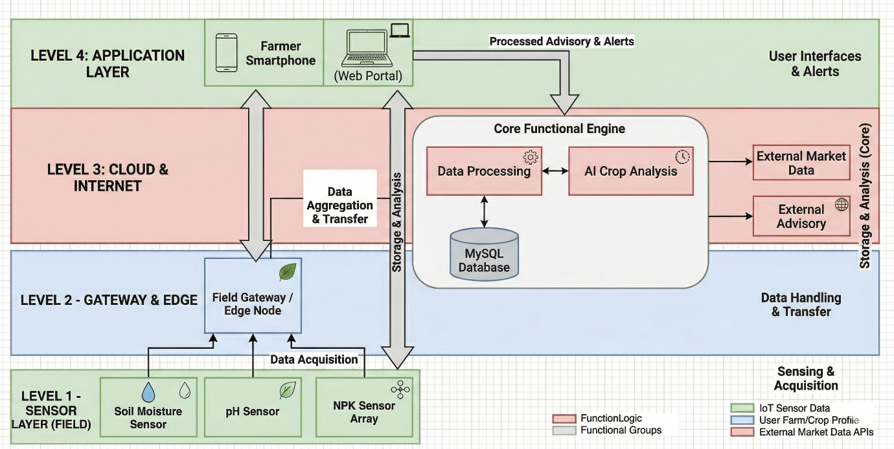
Fig 5.8 mapping IoT deployment level with functional view
The architecture of the proposed system, which is depicted in Figure 5.8, involves the implementation of the IoT deployment levels, as well as the functional modules of the system, integrated. The architecture is divided into four layers: Sensor Layer, Gateway and Edge Layer, Cloud and Internet Layer, and Application Layer. The layers collaborate with one another to gather farming information, analyze it with smart algorithms, and provide farmers with valuable information in a digital format. In Level 1 - Sensor Layer (Field Layer), there are different sensors used in the agricultural field to measure the environment, which includes soil moisture sensors, pH sensors, and NPK nutrient sensors. These sensors are always checking the status of the soil and produce raw data as regards to the moisture, acidity and nutrients in the soil. This information is the IoT system sensing and acquisition phase. At Level 2 -Gateway and Edge Layer, the data of various sensors is received by the Field Gateway or Edge Node. The gateway does the initial data acquiring and prepares the data to be transmitted. The core data processing and analysis is done at Level 3 - Cloud and Internet Layer. The Core Functional Engine is found in this layer and it consists of data processing modules, AI-based crop analysis, and a MySQL database to store the data of farmers and their soils profile. External market data and advisory APIs may also be part of the system to improve agricultural prescriptions. The cloud layer does data aggregation, storage and sophisticated analysis. Lastly, on Level 4 Application Layer, the processed recommendations and alerts are sent to farmers via user interfaces, e.g., smartphone applications and web portals. The dashboard enables farmers to see crop advisories, fertilizer advisories, and advisory notifications, which allows them to make informed agricultural decisions.
5.13 Operational view
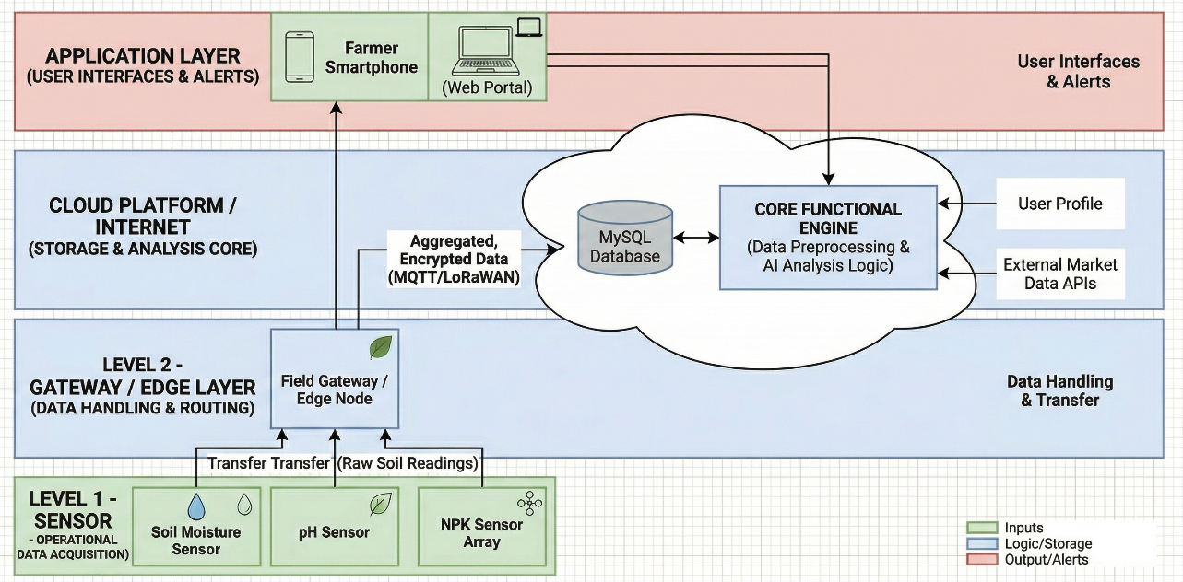
Fig 5.9 Operational view
The functioning perspective of the proposed system, which is entitled: Enhancing Farmer Productivity through Innovative Technology Solutions is provided in Figure 5.9. The diagram indicates the interaction between various parts of the operations to gather agricultural information, process and analyze it in the cloud and provide helpful information to farmers. The architecture consists of several operational layers such as Sensor Layer, Gateway/Edge Layer, Cloud Platform Layer, and the Application Layer, which are combined to facilitate effective monitoring and decision-making in smart farming. The sensors at Level 1 sensor layer include soil moisture sensor, pH sensors, and NPK nutrient sensors, which are installed in the farm. These are sensors that constantly check the soil level and gather crude environmental information such as moisture, acidity and nutrient content. The data collected is the first operation phase where data on the environment is obtained in the field. The sensor data received is sent to Level 2 - Gateway/ Edge Layer where the Field Gateway or Edge Node accepts and processes the raw soil data. This layer undertakes simple data processing and routing tasks and then transmits the data to the cloud platform. It provides secure information exchange among the sensors in the field and the central processing unit. On the Cloud Platform / Internet Layer, the aggregated and encrypted information is sent with the help of communication protocols like MQTT or LoRaWAN. The system is located on the cloud where the data is stored in a MySQL database and processed in the Core Functional Engine that carries out data preprocessing and AI-based analysis Lastly, processed results and advisory alerts are distributed to farmers via the Application Layer where farmers can access the system via a smartphone application or a web portal on a desktop or tablet device. Using these interfaces, farmers will be able to see suggestions, notifications and agronomic data that will enable them to make better decisions on selection of crops, application of fertilizers and farm management. In general, the operational perspective illustrates the flow of data between field sensors and cloud-based analytics, and finally, to user applications, to create an intelligent and efficient agricultural decision-support system.
5.14 Other Design aspects
The architecture of the proposed system encompasses various other factors that characterize the way the system handles information, data and delivers services to users. These factors contribute to the effectiveness of the work of the system and contribute to the goals of the smart agriculture platform.
1. Process Specification: The process specification outlines the list of the processes that the system undergoes to produce agricultural recommendations. The system starts with collecting data about agriculture like soil moisture, pH levels, and nutrient data by users or datasets. The data is then forwarded to data preprocessing module whereby the data is validated and cleaned. The AI Crop Analysis Engine analyses the data after preprocessing and uses rule-based or supervised learning methods to assess the soil condition and suitability of crops. According to the results of the analysis, the system will provide recommendations regarding the choice of crops, the use of fertilizers, and farming procedures. Lastly, the advisory information generated is displayed to farmers via a dashboard interface, either on smartphones or using web portals.
2. Information Model Specification: The proposed system relies on a relational database (MySQL) to store the data associated with the profiles of farmers, soil parameters, crop data, advisory results. The data sets are structured into tables that establish correlations between the soil properties, crop needs and agricultural prescriptions. The database provides effective storage, retrieval and management of agricultural information. This hierarchical data model will enable the system to do the right analysis and deliver useful information to farmers.
3. Service Specification: The service specification is a document that outlines the services that the proposed system will render to the end users. The system provides some services such as soil data analysis, crop recommendation services, fertilizer advisory services and agricultural alert notifications. These services are enacted in the form of processing modules in the background and are available on the web-based application interface. The database and analysis engine interact with the services to access information and provide recommendations. The services are available to farmers via mobile apps or web portals to get real-time insights and advisory alerts.
4. Additional Design Considerations: Other design factors are scalability of the system, security, and usability. The system is to process the growing volumes of agricultural data and serve several users in parallel. Mechanisms like authentication and secure communication protocols are put in place to safeguard user information and resources of the system. Moreover, the user interface will be easy and user-friendly to allow the farmers to review recommendations and interpret farm insights without being a technical challenge.

Chapter 6
SOFTWARE AND SIMULATION
The system being proposed is called Enhancing Farmer Productivity Through Innovative Technology Solutions which is a fully software-based system that aims to give agricultural advice based on data analysis methods. There are no physical hardware items like microcontrollers, sensors or actuators used in the project. Rather, it takes agricultural data and user-entered soil values to provide crop and fertilizer prescriptions via a web-based platform. Software technologies are used to implement all system functionalities such as the data processing, analysis, database management and user interface development. The system has a server-based system in which the user connects with the system via web interface or mobile platform. Because the entire implementation of the project is in a software environment, the development process is mainly concerned with programming tools, database systems, testing frameworks and deployment platforms. As such, the major content of this chapter is a description of the software development tools and programming environment and the simulator platforms to be used to implement the proposed system. Those tools will help with coding, testing, data management and deployment of the application.
  - Software development tools
Modern software applications require software development tools in order to design, implement, test and deploy them. These tools simplify software development lifecycle by automating code development, aiding debugging, collaborating effectively, and ensuring code quality. In the suggested system Enhancing Farmer Productivity Through Innovative Technology Solutions a number of software tools and platforms are deployed to facilitate development processes (coding, version control, database management, testing, and deployment).
Tools used in Software Development.
- Visual Studio Code (VS Code) - Code editor / IDE to develop an application.
- Python - Python is a programming language that is applied in the development of the back-end and processing of data.
- CSS, JavaScript, HTML- Developed to create the web - based user interface.
- MySQL - Database management system to store farmers and soil data.
- Git- Version control system to track the changes in code.
- GitHub - Distantly hosted collection of project source code.
    - Software code
The proposed system, Enhancing Farmer Productivity Through Innovative Technology Solutions, has modules of data input, soil parameter processing, crop recommendation and database interaction as the information that will be implemented in the software. The software is created based on Python and web technologies to examine soil parameters and produce appropriate crop recommendations.
The required standard libraries are imported and the variables used for soil parameters are initialized.
ALGORITHM
Step 1: Start the program.
Step 2: Import the required libraries for data processing and database connectivity.
Step 3: Initialize the soil parameters including soil moisture, soil pH, nitrogen level, phosphorus level, and potassium level.
Step 4: Establish a connection with the MySQL database to store and retrieve agricultural data.
Step 5: Accept soil parameter inputs from the user such as soil moisture value, soil pH value, nitrogen level, phosphorus level, and potassium level.
Step 6: Validate the input values to ensure they are within acceptable ranges.
Step 7: Analyze the soil parameters using predefined conditions in the crop recommendation logic.
Step 8: If the soil moisture is greater than 40 and soil pH is between 6 and 7.5, then recommend Rice.
Step 9: Else if the soil moisture is greater than 30 and soil pH is between 6 and 7, then recommend Wheat.
Step 10: Else if the soil moisture is greater than 20 and soil pH is between 5.5 and 7, then recommend Maize.
Step 11: If none of the above conditions are satisfied, display the message “Suitable crop not found.”
Step 12: Display the recommended crop to the user.
Step 13: Store the input data and recommendation result in the database for future analysis.
Step 14: End the program.
The program reads the soil parameters, processes the values through the crop recommendation function, and outputs the recommended crop for the given soil conditions. The results can also be stored in the database for future analysis and reporting.
  - Simulation
Simulation can be defined as the process of testing and evaluation of a system in a virtual environment, prior to its real implementation. It enables developers to study system behavior, test functionality and identify errors without the need to use physical hardware. Simulation is used to test algorithms, data processing modules, and user interface behavior, under various input conditions, in software-based systems.
Simulation is carried out in the proposed system Enhancing Farmer Productivity Through Innovative Technology Solutions with the help of software development environments and testing tools. As the system will be deployed in the form of a web-based agricultural advisory system, the simulation will be aimed at testing the functionality of data processing modules, database interaction, and user interface.
6.2.1 Web Application Simulation
Simulation of the system is done in a local development server environment in which the web application can be run and tested prior to implementation. This simulated system enables developers to test the functionality of the system, database interplay, and crop recommendation modules.
6.2.2 Backend Simulation and API.
The testing tools of API are created to simulate the communication between client interface and backend services. These tools aid in testing the correctness of the data requests and responses that the application deals with.

6.2.3 Functional Simulation
Functional simulation will be carried out to ensure that the system can handle soil parameters properly and provide the right agricultural advice. The system is fed with different input values including soil moisture, pH level and nutrient content to test the accuracy of the recommendation algorithm.
This simulation assists in making sure that the system would give reliable outputs and it would work effectively in various agricultural conditions.
- Developed Software Tools to use in Simulation.
- Visual Studio Code: Visual studio code execution and debugging.
- Python Run Environment - Testing and simulation of algorithms.
- MySQL Database Server - Simulation of data storage.
Web Browser (Google Chrome): Simulation of the user interface.
Free Software Platforms used.
- Visual Studio Code
- Python Programming Environment
- MySQL Community Server
- Postman API Testing Tool
- Google Chrome Web Browser
Chapter 7
EVALUATION AND RESULT
This chapter assesses the performance of the proposed system Enhancing Farmer Productivity through innovative technology solutions. The steps of evaluation include locating test points in the system modules, creating test plans of each of the functional units, interpreting the results of the testing procedure and making conclusions on the basis of the observed results.
7.1 Test Points
Test points are particular places in the system that can be used to test functionality and performance. Test points in various functional modules, including data input, data processing, recommendation engine, interaction with databases, and dashboard visualization, are defined in the proposed system.
The test points of the proposed system are indicated as TP1, TP2, TP3, TP4, and TP5 to check the proper functioning of each functional module.
TP1 – Data input Module.
This test point ensures that soil parameters like soil moisture, pH value, nitrogen, phosphorus and potassium are properly getting the user inputs.
TP2 - Data Processing Module.
This is the test point that verifies that the input data has been properly checked and preprocessed prior to analysis.
TP3 - Crop Recommendation Engine.
This test point is used to measure the precision of the algorithm of advice which examines the parameters of the soil and recommends appropriate crops.
TP4- Database Interaction Module.
This test point will ensure that the data and recommendations results of soils are properly stored and read within the database.
TP5- User Interface Dashboard.
This test point would guarantee that the processed result and recommendations are shown properly on the web dashboard.
Example Test Scenarios
Scenario 1: Test the crop recommendation algorithm with soil parameters (pH, moisture, and nutrient levels).
Scenario 2: Authenticate inaccurate or missing input values are processed correctly by the system.
Scenario 3: Check that the database is able to store farmer data and retrieve it to be analyzed further.
Scenario 4: Asset that the system dashboard presents the crop recommendations, and advisory warnings appropriately.
7.2 Test Plan
The test plan stipulates the manner in which every functional aspect of the system is tested. It provides the testing conditions, expected results and performance standards in every test point.
TP1: The system should properly record soil parameters like soil moisture, pH level, nitrogen, phosphorus and potassium values inputted by the user.
TP2: The system should check the input values and not allow the wrong or missing data into the system.
TP3: The crop recommendation algorithm should produce relevant crop recommendations according to the soil parameters and preset agricultural regulations.
TP4: The system should store the data on the farmer and soil in the database and be able to retrieve them.
TP5: The dashboard should be able to show the user the recommended crop and advisory details.
Testing Methods Used
1.Black Box Testing - testing functionality of the system based on various input scenarios.
2.Unit Testing- verifying individual modules of the system like recommendation engine, database modules etc.
3.Integration Testing- ensuring that modules communicate.
4.System Testing- comparing the general system performance.
5.Validation Testing - ensuring the system is in line with user requirements.
7.3 Test Results
The results of the evaluation process in the form of a test are summarized in a tabular form. The findings reveal the correlation between the soil parameters as input and the crop recommendations produced.
Table 7.1 Observations of Crop Recommendation Unit
Soil Moisture | Soil pH | Nitrogen Level | Recommended Crop | System Output
45 | 6.5 | High | Rice | Rice
30 | 6.2 | Medium | Wheat | Wheat
25 | 5.8 | Medium | Maize | Maize
35 | 6.8 | High | Rice | Rice

Observations
Based on Table 7.1, it is possible to see that the system is able to produce correct crop recommendations using the given soil parameters. The suggested crops are appropriate to the anticipated agricultural situations, which indicate proper operation of the recommendation engine. The correctness of the recommendation outputs denotes that the data processing and analysis modules are efficient. The system is able to translate input soil parameters into actionable agricultural insights. Trends of soil conditions and crop recommendations under various agricultural conditions can also be analysed by use of graphs and visualisation techniques.
7.4 Insights
The analysis of the suggested system gives some valuable information on the performance and reliability of the system. The system effectively manipulates the soil data and gives crop reference according to set agricultural conditions. The results of testing prove that the recommendation engine is able to give correct output provided that valid input data are given. The system performance is however dependent on the accuracy and completeness of the input data. Soil parameters can be incorrect or incomplete and it may influence the results of the recommendations. As such, the input validation mechanisms are applied to guarantee performance reliability by the system. The system will be scalable and capable of supporting multiple user inputs at a time. The system can also be enhanced by incorporating more data like weather data or market data to make the agricultural recommendations even more accurate. The additions that can be made in the future are the incorporation of real-time IoT sensors to collect automatic soil data, more complex machine learning algorithms to make more precise predictions, and the user interface to add more visualization capabilities. On the whole, the analysis findings affirm that the suggested system has achieved its goal of helping farmers enhance their productivity in farming by providing recommendations based on intelligent technology.

Chapter 8
Social, Legal, Ethical, Sustainability and Safety aspects
Modern technological systems development should be developed with a keen eye on social responsibility, legal adherence, ethical conduct, environmental sustainability, and safety standards. These factors make sure that the technology is useful to society with minimal risks or abuse. The suggested system “Enhancing Farmer Productivity Through Innovative Technology Solutions” will offer technological aids to farmers by using smart agricultural suggestions. When developing and deploying such systems, it is necessary to consider the effects of these systems on society, the law of using the data, ethical consequences of deploying technologies, environmental friendliness, and the security of the system.
8.1 Social Aspects
Social considerations revolve around the effect of the proposed system to society especially the farmers and agricultural societies. The system is meant to enhance agricultural yields through crop advices and farm insights using soil parameters and farm data. Among the significant positive social effects of the system is the fact that the system enhances access to agricultural information among the farmers. A significant portion of the farmers do not have modern knowledge of agriculture and tools of making decisions based on data. The suggested system assists farmers to make sound choices on the choice of crops and the application of fertilizers that can enhance the crop production and minimize waste of resources. The other beneficial effect is the encouragement of digital agriculture. The system promotes the use of modern agricultural practices that can enhance productivity and sustainability by introducing technology-based farming practices to the farmers. Nevertheless, this can be met with certain challenges based on the digital divide where farmer having limited access to internet connectivity or digital devices may not get full advantages of the system. In response to this challenge, the site has an easy and friendly interface that can be effectively utilized by the farmers with less technical expertise. On the whole, the system is a positive contribution to the development of rural areas, as it helps farmers with the available agricultural knowledge, and enhances the ability to make decisions.

8.2 Legal Aspects
Legal considerations look at the adherence to legislation and regulations regarding data privacy, online platforms and information use. The fact that the proposed system gathers and analyzes data related to agriculture means that the information about the user needs to be stored in a secure and responsible manner. Laws on data privacy, including the Digital Personal Data Protection Act (DPDPA) 2023 in India and other international laws like the General Data Protection Regulation (GDPR) give the principles that govern how the personal data is collected, stored and processed. Such laws demand organizations to seek user consent prior to gathering personal information and to securely handle sensitive data. The system should make sure that data of farmers, data of soils and other agricultural data are kept safely and can be utilized to achieve the purpose of giving agricultural advice. Proper authentication mechanisms and secure data storage methods should be used to ensure that unauthorized users do not access their data. Adherence to the legal requirements would make the proposed system responsible and safeguard the rights and privacy of people using the system.
8.3 Ethical Aspects
Ethical considerations deal with morality that drives technology development and utilization. The engineers and developers should see to it that the system is developed in a manner that will be beneficial to the society without causing any harm or abuse. The proposed system will enhance the productivity and livelihood of farmers by giving them good agricultural advice. The developers should also be fair and transparent in the recommendation algorithms adopted by the system. Wrong or prejudiced data would result in wrong recommendation, which may have a negative effect on farmers. Thus, the system should be created in such a way that it offers understandable explanations and credible outputs. The other ethical factor is that the technology should not override human decision-making but rather as a decision-support tool, it should help the farmers make informed decisions. The system promotes ethical technology development within the agricultural sector by being transparent, just, and accountable. Robotics: The rights of robots, the application of AI in deadly autonomous weaponry, and the way of instilling moral sound judgments in autonomous systems also bring up ethical issues. Generative AI: Copyright and intellectual property are another area of ethical concern, as generative AI algorithms are conditioned by the already existing human-made data.

8.4 Sustainability Aspects
The aspects of sustainability look at the environmental and economic effects of the proposed system. Sustainable design aims at minimizing the environmental impact and enhancing resource efficiency. The suggested system helps in the sustainability by ensuring that agricultural resources like water, fertilizers and soil nutrients are used efficiently. The system assists farmers in avoiding unnecessary use of fertilizers and soil degradation by analysing the soil parameters and prescribing the appropriate crops. The system also promotes production of agriculture that is resource efficient. The project is software based hence does not need physical production or hardware parts so the effects on the environment are minimized during development. Moreover, the site motivates farmers to use sustainable farming techniques that enhance crop productivity without harming the natural resources.
8.5 Safety Aspects
The safety aspects are aimed at making sure that the system is stable and will not harm users or the environment. Cybersecurity and data protection can be considered as safety in digital systems. The proposed system is safe as it uses secure data storage and access control measures that safeguard user-information. The unauthorized access to the platform can be restricted with the help of authentication mechanisms. The system also needs to make sure that the agricultural prescriptions are trustworthy and founded on confirmed data. Notable wrong advice can influence the decision making in farming and therefore, the system should offer concise advisory messages and enable the users to confirm the advisory messages before implementing them in the actual field farming conditions. They can also employ cybersecurity measures like ensuring the use of secure communications protocols and data encryption to prevent possible cyber threats to the system. In general, the proposed platform ensures the safety and reliability of the data analysis and the operation of the system, which facilitates a safe and reliable technology solution to agricultural decision support.
Chapter 9
CONCLUSION
The project Enhancing Farmer Productivity through Innovative Technology Solutions is aimed at designing a technology-based platform that will help farmers to enhance agricultural productivity by providing smart advice and data analysis. The system was created to examine soil parameters and farming data to offer appropriate crop recommendations and farming information. The proposed solution incorporates current software technologies to develop a user-friendly platform that will assist farmers to make informed agriculture choices. The project has been implemented in a manner that achieves the goals outlined in the introduction. The system can collect soil parameters, process agricultural data and produce crop recommendations via an organized data analysis module. An interface was built using the web to enable the user to communicate with the system and see the recommended crops and advisory information. The results of the evaluation and testing reveal that the system properly works with input values and gives corresponding recommendations depending on the soil conditions. The database management system provides effective storage and retrieval of agricultural data and the application interface offers a convenient and easy to access platform through which farmers can access pertinent information. The outcomes of the testing stage prove that the suggested system works effectively to analyse soil data and crop recommendations. The system enhances the decision making of the farmers by transforming raw agricultural information into useful insights. The project can help in enhancing agricultural productivity and management of the resources by promoting data-driven farming practices. The system can be improved further in the future by the addition of real-time IoT sensors to collect soil data and monitor the environment. More complex machine learning algorithms can also be included to enhance the accuracy of prediction and offer more customized farming recommendations. Also, the site can be expanded to cover weather forecasting information, market price analysis and multilingual assistance to render the system more user-friendly to farmers in various regions. On the whole, the presented system shows how contemporary technology can revolutionize the traditional farming techniques to turn them into intelligent and data-driven farming systems. The project offers a scalable platform that has the potential to help farmers enhance productivity, optimize resource use, and sustainable agricultural development through the integration of agricultural knowledge with digital technologies.
References
[1] Miller, T., Smith, J. and Clark, R., 2025. Review of smart sensing technologies in agriculture: IoT and AI. Sensors, 25, pp.1–18.
[2] Rafi, M.S.M., Behjati, M. and Rafsanjani, A.S., 2025. Dependable and affordable IoT connectivity to smart agriculture. IEEE Internet of Things Journal, 12(2), pp.2103–2115.
[3] Mansoor, S., Khan, A. and Ali, H., 2025. Precision agriculture with smart sensor and IoT. Frontiers in Plant Science, 16, pp.1-14.
[4] Zhang, L., Chen, Y. and Wu, H., 2024. Crop recommendation system on the basis of deep learning with soil and weather data. IEEE Transactions on Artificial Intelligence, 5(1), pp.89 98.
[5] Dhanasekar, S. and Kumar, P., 2024. Existing problems and developments of IoT in precision agriculture. Computer Science Review, 50, pp.101–115.
[6] Babar, A.Z. and Akan, O.B., 2024. Internet of Everything (IoE) sustainable and precision agriculture. IEEE Access, 12, pp.56789–56802.
[7] Li, J., Zhou, J. and Wang, H., 2023. IoT and cloud computing-based real-time crop monitoring system. IEEE Internet of Things Journal, 10(2), pp.2101–2110.
[8] AlZubi, A.A. and Galyna, K., 2023. Smart farming and artificial intelligence and Internet of Things. IEEE Access, 11, pp.78686–78692.
[9] Kumar, R. and Patel, S., 2023. IoT sensors to detect crop diseases with deep learning. Computers and Electronics in Agriculture, 205, pp.1-10.
[10] Sharma, A., Verma, R. and Singh, P., 2022. Smart agriculture monitoring system using IoT. IEEE Access, 10, pp.45678–45689.
[11] Patel, S. and Kumar, R., 2022. Crop suggestion based on soil data. I: Proceedings of the International Conference on Communication Systems and Network Technologies (CSNT).
[12] Gupta, P. and Mehta, R., 2022. Crop yield prediction using IoT and machine learning in smart farming. IEEE Access, 10, pp.76543–76555.
[13] Friha, O., Ferrag, M.A., Shu, L., Maglaras, L. and Wang, X., 2021. The Future of smart agriculture: Internet of Things: A survey of the emerging technologies. IEEE/CAA Journal of Automatica Sinica, 8(4), pp.718752.
[14] Sharma, A., Jain, A., Gupta, P. and Chowdary, V., 2021. Precision agriculture machine learning applications: A literature review. IEEE Access, 9, pp.4843–4873.
[15] Jayashree, R.S., Praveena, T. and Karthik, K.S., 2021. Internet of Things and artificial intelligence-based smart irrigation system. Journal of Ambient Intelligence and Humanized Computing, 12, pp.1231 1242.

Base Paper
Friha, O., Ferrag, M.A., Shu, L., Maglaras, L. and Wang, X., 2021. Internet of Things for the future of smart agriculture: A comprehensive survey of emerging technologies. IEEE/CAA Journal of Automatica Sinica, 8(4), pp.718–752.
Appendix
- Publication

- GitHub Demo Link
https://github.com/cha638/Enhancing-Farmer-Productivity-Through-Innovative-Technology-Solutions

- Few Images of Project

