PROGRAMMING 5 (PROGRAMOZÁS 5) — PROJECT PROPOSAL
EduGen: Distributed Microservices Platform for Automated Question Generation, Deterministic Evaluation, and Assessment Delivery
Course & Faculty: | Programming 5 (PTE MIK — Faculty of Engineering & IT)
Instructor / Professor: | Prof. Gergely Laborci
Student & Neptun ID: | Storcz (Neptun: ZA0P52)
Architectural Target: | 4 Independent Microservices + Web Client (Docker Compose Orchestration)

1. Project Executive Summary & Motivation
Modern university curricula in computer engineering require continuous, diagnostic testing to reinforce complex conceptual mechanisms. However, constructing high-quality Multiple-Choice Questions (MCQs) manually is notoriously labor-intensive: educators must craft unambiguous problem stems while formulating plausible, non-trivial distractors (incorrect alternatives). While Large Language Models (LLMs) can generate questions at high velocity, naive generation suffers from hallucinations, format drifts, and trivial giveaway options.
This project proposes EduGen, a cloud-native, distributed microservices platform designed to operationalize Automated Item Generation (AIG) and empirical pedagogical evaluation. The project directly satisfies all requirements of Programming 5 by implementing 4 decoupled microservices and a modern client application, managed via Docker Compose. Furthermore, this project directly operationalizes the candidate's BSc thesis research ('LLM Comparative Framework for Automated Technical Question Generation'), transforming an offline research pipeline into a scalable, observable, and production-grade software system.
2. High-Level Architectural Blueprint
The system adheres to Domain-Driven Design (DDD) principles with strict separation of concerns. Rather than an arbitrary technical split, each microservice encapsulates an independent bounded context with its own distinct lifecycle, data model, and API contracts:
Service Component | Bounded Domain / Responsibility | Technology Stack
Service 1: API Gateway & Orchestrator | Routing, JWT authentication, batch workflow coordination, and real-time generation progress streaming (SSE). | Python / FastAPI, SQLite, EventSource
Service 2: AIG Generation & Multi-Agent Engine | Prompt injection, LLM provider abstraction (OpenAI / NIM / Mock mode), and multi-agent drafting (Examiner-Critic loop). | Python / FastAPI, Pydantic, HTTP Client
Service 3: Deterministic Evaluation Service | Independent NLP engine computing 'The Three Pillars': Semantic Alignment, Flesch-Kincaid Complexity, and Distractor Plausibility. | Python / FastAPI, textstat, scikit-learn, NumPy
Service 4: Assessment & Psychometrics Delivery | Test bank management, timed student quiz delivery, automated scoring, and real-time item difficulty (p-value) analytics. | Python / FastAPI, SQLite, SQLAlchemy
Client Application (Web Portal) | Interactive Single-Page Application (SPA) offering an Instructor Studio, Live Metric Badges, and a Student Exam Room. | React 18 / Vite / Tailwind CSS

3. Combined Functional & Technical Specification Requirements
To provide a rigorous blueprint for evaluation, the functional capabilities (what the system accomplishes for users) and technical specifications (how the underlying architecture implements them) are paired systematically across every component.
3.1 Service 1: API Gateway & Orchestrator Service
The API Gateway acts as the single entry point for external traffic, managing security, request routing, and lifecycle state.
- FR-1.1 (Centralized Routing & Reverse Proxy): The gateway shall ingest all client requests and dispatch them to downstream services (Generation, Evaluation, Quiz) while shielding internal network topologies.
- TR-1.1 (Gateway Architecture): Implemented as an asynchronous FastAPI application running on Uvicorn. Exposes CORS-configured REST endpoints and proxies internal microservice requests over an isolated Docker virtual network.
- FR-1.2 (Role-Based Authentication & Session Handling): The service shall distinguish between Instructor accounts (generation privileges, metric inspection) and Student accounts (quiz-taking privileges only).
- TR-1.2 (Security Tokens): Issues cryptographically signed JSON Web Tokens (JWT) with HS256 algorithm. Requests to protected endpoints validate claims via dependency injection middleware.
- FR-1.3 (Pipeline Orchestration & Job Tracking): Allows instructors to initiate a generation-and-evaluation batch run for a selected topic, tracking execution state across stages (INIT -> GENERATING -> EVALUATING -> COMPLETED -> FAILED).
- TR-1.3 (State Management): Maintains job execution state in an internal SQLite database using Write-Ahead Logging (WAL) to prevent lock contention during parallel status queries.
- FR-1.4 (Real-Time Generation Progress Streaming): Provides a live progress feed to the client UI as questions are synthesized and evaluated, avoiding long polling.
- TR-1.4 (Streaming Protocol): Implements Server-Sent Events (SSE) via FastAPI's EventSourceResponse, streaming granular event packets (`status_update`, `question_generated`, `question_evaluated`) to connected clients.
3.2 Service 2: AIG Generation & Multi-Agent Engine
This service isolates the non-deterministic generative models from the rest of the application, enforcing strict schema validation.
- FR-2.1 (Multi-Strategy Question Synthesis): Supports multiple question generation strategies: Baseline Zero-Shot (single prompt injection), RAG-grounded generation (retrieving syllabus text chunks), and Multi-Agent refinement (Examiner drafts -> Critic audits distractors -> Editor finalizes).
- TR-2.1 (Prompt & Pipeline Architecture): Modular template managers format prompts with topic titles, domains, and source texts. Structured outputs are parsed and strictly validated against Pydantic schemas (`MCQItemSchema`: question_stem, options A/B/C/D, correct_option, explanation).
- FR-2.2 (LLM Provider Abstraction & Dual-Mode Execution): Provides support for live external foundation models (OpenAI GPT-4o, NVIDIA NIM Llama 3.3 / Mistral) alongside a 100% deterministic Local Mock / Replay Mode.
- TR-2.2 (Offline Resilience & Mock Provider): The Local Mock Provider delivers pre-cached, realistic technical MCQs from the thesis benchmark dataset ($N=2,080$). This guarantees zero dependency on active internet connection, zero API credit costs, and 100% demo stability during professor audits.
- FR-2.3 (Batch Synthesis Endpoint): Accepts requests specifying topic domain, item count (1 to 10), and model alias, returning structured question objects with latency and token usage metrics.
- TR-2.3 (API Contract): Exposes `POST /generate/batch` accepting JSON payload `{topic_id, domain, source_text, strategy, model_name, count}` and returning `{questions: [...], latency_seconds, token_usage}`.
3.3 Service 3: Deterministic Evaluation Service ('The Three Pillars')
A specialized NLP microservice that computes mathematical, non-biased quality metrics without relying on subjective 'AI-judging-AI'.
- FR-3.1 (Pillar 1 — Semantic Alignment & Hallucination Guard): Computes the factual proximity of the generated question stem to the authorized syllabus reference text to detect hallucinations.
- TR-3.1 (Mathematical Implementation): Implements Term Frequency-Inverse Document Frequency (TF-IDF) vectorization and Cosine Similarity over normalized n-grams. Emits an alignment score bounded in $[0.0, 1.0]$.
- FR-3.2 (Pillar 2 — Linguistic Complexity & Readability): Assesses the readability and academic grade level of the question stem to ensure it targets undergraduate engineering students.
- TR-3.2 (Readability Algorithm): Calculates Flesch-Kincaid Grade Level and Flesch Reading Ease via the `textstat` library using syllable counts and sentence lengths.
- FR-3.3 (Pillar 3 — Distractor Plausibility & Foil Diversity): Measures how challenging and plausible the incorrect options (foils) are relative to the correct answer, ensuring distractors are not giveaway trivialities.
- TR-3.3 (Foil-to-Key Similarity Metrics): Computes pairwise Jaccard Token Similarity and lexical overlap between each distractor and the correct answer, plus pairwise inter-distractor divergence to verify distinct misconceptions.
- FR-3.4 (Automated Quality Gate & Flagging): Flags questions that fail minimal pedagogical criteria (e.g., duplicated options, extreme length imbalance between options, or zero semantic overlap with syllabus).
- TR-3.4 (Stateless REST Evaluation API): Exposes `POST /evaluate/item` and `POST /evaluate/batch`. Being completely stateless, this service can scale horizontally without shared database locks.
3.4 Service 4: Assessment & Psychometrics Delivery Service
Bridges automated item generation with authentic educational consumption, simulating real exam sessions and student response analysis.
- FR-4.1 (Test Bank Repository & Exam Publishing): Maintains approved questions in organized question pools, allowing instructors to package items into published exams with time limits and passing thresholds.
- TR-4.1 (Persistence Schema): Relational SQLite/PostgreSQL schema tracking `exams` (id, title, duration_minutes), `exam_questions` (foreign keys to approved items), and `student_submissions`.
- FR-4.2 (Interactive Student Exam Delivery): Serves active exams to students with randomized option shuffling (to prevent positional bias) while hiding the ground-truth key.
- TR-4.2 (Secure Quiz Payload): Exposes `GET /exams/{id}/take`, returning questions with randomized option labels and strictly sanitizing out `correct_option` and `explanation` until submission.
- FR-4.3 (Instant Automated Grading & Feedback): Grades student submissions instantaneously upon receipt, providing a final percentage score, pass/fail status, and per-item rationales.
- TR-4.3 (Grading Logic): Exposes `POST /exams/{id}/submit` receiving student option selections `{question_id: selected_option}`, comparing against ground truth, and writing results to `student_responses`.
- FR-4.4 (Empirical Psychometric Analytics): Calculates authentic psychometric metrics on delivered questions: Item Difficulty Index ($p$-value = correct responses / total attempts) and Distractor Efficiency (selection frequency of each foil).
- TR-4.4 (Psychometric Endpoint): Exposes `GET /exams/{id}/analytics` aggregating item statistics. Flags flawed questions where students never chose a distractor (dead distractor) or where $p < 0.20$ (excessively confusing item).
3.5 Client Web Application (Frontend)
A responsive, single-page web dashboard providing tailored user experiences for both instructors and students.
- FR-5.1 (Instructor Studio & Generation Controls): Allows instructors to select topics from computer engineering syllabi (e.g., Computer Networks, Algorithms, Systems Theory), choose model strategies, and trigger batch generation.
- TR-5.1 (Instructor UI Implementation): Built with React 18, Vite, and Tailwind CSS. Utilizes EventSource listeners to render a live step-by-step progress indicator and dynamically populated question review cards.
- FR-5.2 (Pillar Metric Inspection Badges): Displays visual color-coded badges for each generated question showing Semantic Alignment, Grade Level, and Distractor Plausibility scores, enabling rapid quality auditing.
- TR-5.2 (Data Visualization): Integrates lightweight charts/badges illustrating metric distributions and flags low-performing items.
- FR-5.3 (Student Exam Room): Provides a clean, distraction-free examination view featuring a countdown timer, question navigator, and instant post-submission score review.
- TR-5.3 (Student UI Implementation): Responsive design supporting desktop and mobile viewports with accessible keyboard navigation.
4. Inter-Service Communication & Sequence Flow
Communication between microservices is mediated via clean, synchronous REST JSON contracts, with Server-Sent Events (SSE) bridging the Gateway and Client for real-time progress. The sequence diagram below details the end-to-end distributed interactions across the two core lifecycle phases: (1) Generation & Evaluation, and (2) Exam Publishing & Student Assessment:
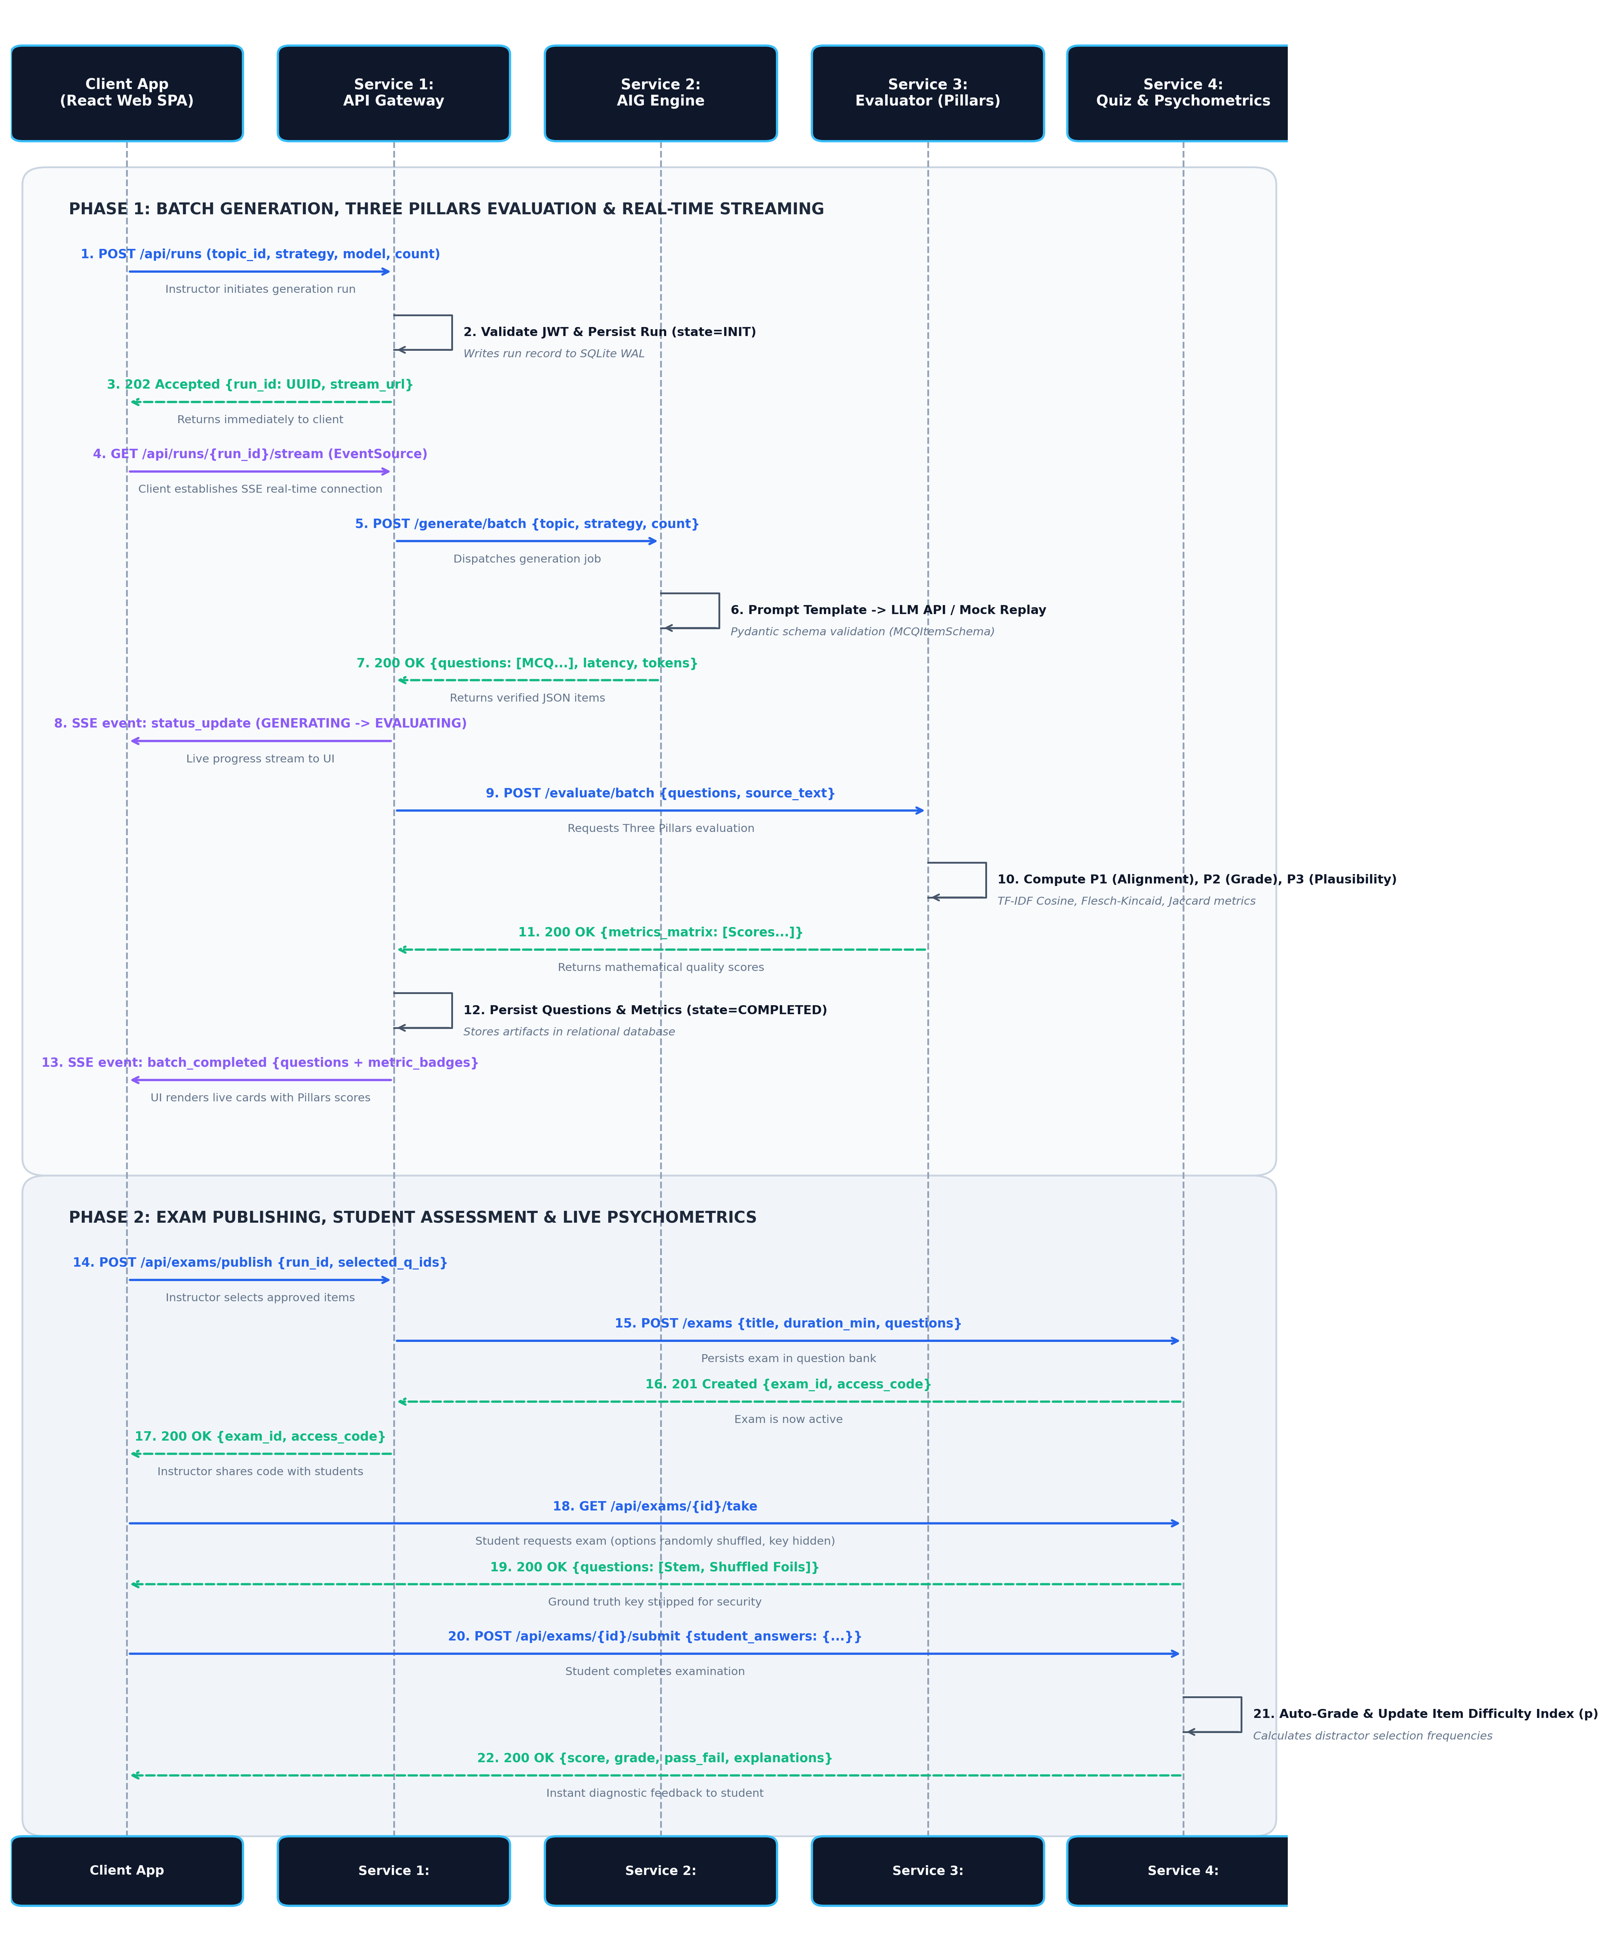
Figure 1: End-to-End Sequence Diagram illustrating Batch Generation, Three Pillars Evaluation, and Student Assessment Delivery.
- 1. Generation Trigger: Instructor clicks 'Generate' in Client UI. Client dispatches `POST /api/runs` to API Gateway.
- 2. Request Dispatch: Gateway creates a Run record (ID: UUID) and dispatches `POST /generate/batch` to Service 2 (AIG Engine).
- 3. Item Synthesis: Service 2 loads syllabus context, formats the prompt template, queries the LLM (or Mock Provider), validates Pydantic schema, and returns JSON MCQs to Gateway.
- 4. Metric Evaluation: Gateway dispatches `POST /evaluate/batch` with generated questions and source text to Service 3 (Evaluation Engine).
- 5. Score Computation: Service 3 calculates TF-IDF alignment, Flesch-Kincaid readability, and Jaccard foil plausibility, returning complete metric matrices to Gateway.
- 6. Real-Time Streaming: Gateway broadcasts evaluated questions and status updates to Client UI over the open SSE connection.
- 7. Exam Publishing: Instructor reviews questions and clicks 'Publish Exam'. Gateway forwards approved items to Service 4 (Quiz Service).
- 8. Student Interaction: Student takes quiz via Client UI; Service 4 records answer choices and updates live psychometric item difficulty indices.

5. DevOps, Containerization & Deployment (Docker Compose)
To ensure effortless portability across development workstations, faculty evaluation labs, and grading environments, the entire platform is packaged into containerized services managed by a single root `docker-compose.yml` file:
Docker Container | Internal Port / Mapping | Key Responsibilities
edugen-client | Port 3000 -> 80 (Nginx) | Serves compiled React static assets and proxies `/api` calls to Gateway.
edugen-gateway | Port 8000 -> 8000 (FastAPI) | Exposes public API, manages JWT tokens, coordinates inter-service calls, SSE streaming.
edugen-generator | Port 8001 (Internal) | Processes LLM prompts, enforces Pydantic schemas, runs Mock/Live generator.
edugen-evaluator | Port 8002 (Internal) | Computes Three Pillars NLP metrics (Alignment, Grade Level, Plausibility).
edugen-quiz | Port 8003 (Internal) | Manages exam pools, handles student quiz attempts, grades submissions, computes psychometrics.

Verification & Reproducibility: One-Command Startup: The professor or evaluator can run the entire distributed infrastructure with zero manual configuration using:
`docker compose up --build`
All microservice health checks and inter-container DNS resolutions (`http://generator:8001`, `http://evaluator:8002`, etc.) are automated.
6. Project Milestones & Implementation Roadmap
Development is structured into four sequential, verifiable milestones designed to deliver incremental value:
- Milestone 1: Architecture & Service Scaffolding (Weeks 1–2): Initialize monorepo repository; configure Docker Compose network and shared configuration schemas. Implement Service 3 (Evaluator) with unit tests for The Three Pillars metrics.
- Milestone 2: Generative Engine & Mock Replay Layer (Weeks 3–4): Implement Service 2 (AIG Generator) with Pydantic output validation and offline Mock Provider using verified thesis benchmark datasets. Validate batch generation API.
- Milestone 3: Gateway Orchestration & Quiz Delivery (Weeks 5–6): Implement Service 1 (API Gateway) with JWT auth and SSE event streaming. Implement Service 4 (Quiz & Psychometrics) with database models and auto-grading algorithms.
- Milestone 4: Client Web Application & Integrated Testing (Weeks 7–8): Develop React/Tailwind frontend (Instructor Studio + Student Exam Portal). Execute end-to-end integration tests, package final Docker build, and prepare live demonstration.
7. Academic Alignment & Pedagogical Value
This project bridges the gap between academic research and modern software engineering. By adapting the research concepts from the candidate's BSc thesis into a decoupled microservices architecture, the project provides unique benefits:
- Complete Domain Justification: Rather than creating an artificial toy example, the microservices cleanly delineate real computational boundaries: high-latency generative AI inference is decoupled from mathematical NLP evaluation, and exam delivery is isolated from backend generation.
- Pedagogical Reinforcement: Implementing the Three Pillars and psychometric item evaluation in production clarifies the theoretical equations for the candidate's upcoming diploma thesis defense.
- Guaranteed Evaluation Stability: The built-in dual execution mode (Live API + Mock Replay) ensures that the project can be demonstrated seamlessly in any classroom or grading environment without external API dependencies or latency bottlenecks.

