**JENKINS NEXUS INTEGRATION**

Nexus software manager:

1. It runs on java
2. Used to store artifacts
3. Used as a package manager which is used to download the repos
4. It is both open source & enterprise type
5. Supports various tools like maven, docker, ruby etc.,

**Jenkins integration with nexus:**

1. Launch a new instance (centos 7) for Nexus in AWS
2. Nexus will run on port num 8081
3. Create a security group for Nexus (nexus security group)

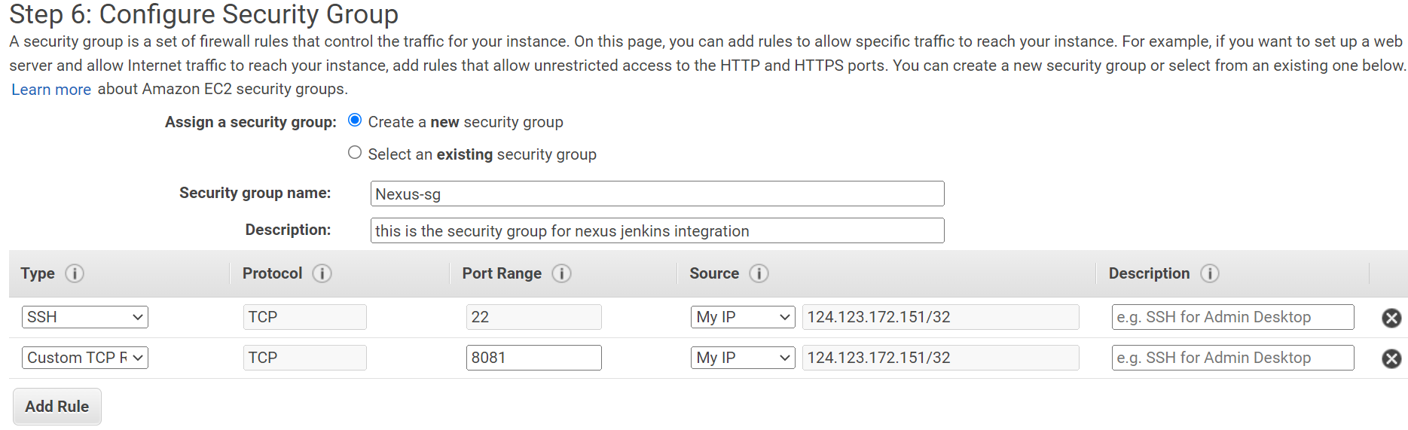

1. Then click on review & launch
2. Then create a new key pair of nexus & launch the instance
3. Login to the nexus server and be as a root user using sudo -i
4. Nexus needs java so install the java
5. Search for java (yum search jdk)
6. Then install java 1.8 atleast
7. Yum install java-1.8.0-openjdk.x86_64
8. Download the nexus 2 from its official website by using wget command with the below link

(https://download.sonatype.com/nexus/oss/nexus-2.14.21-02-bundle.tar.gz)

1. Then move the downloaded nexus to /usr/local dir

**mv nexus-2.14.21-02-bundle.tar.gz /usr/local/**

1. Change to the local dir and extract it

**tar -xvzf nexus-2.14.21-02-bundle.tar.gz**

1. Make a soft link of that nexus

**ln -s nexus-2.14.21-02 nexus**

1. cd nexus

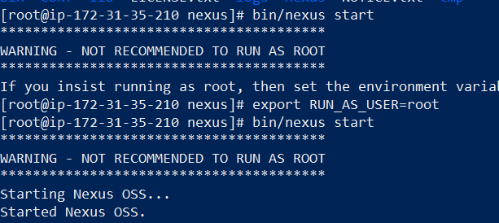

1. to check the logs

**tail -f logs/wrapper.log**

1. connect to the nexus using the public ip of the instance (**13.233.80.161:8081/nexus)**
2. At the top right we have a option called login

The default user name is “admin” & pass is “admin123”

1. To change the pass go to the admin profile here we have a option to change the password

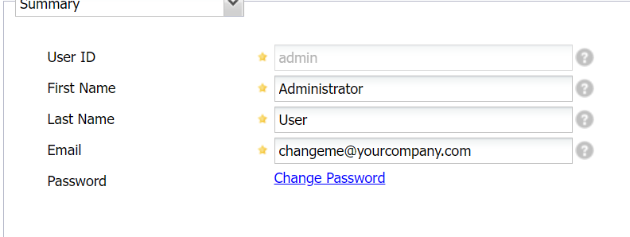

1. To add our repository click on repository 🡪 add 🡪 hosted repository
2. Specify the repository id & repository name then select the provider name and save
3. Then a repository is created with a url to access the repository
4. Open the Jenkins 🡪 manage Jenkins 🡪 plugins manager
5. Then install “nexus artifact uploader” plugin
6. Install the copy “artifact plugin” to copy the artifact from one Jenkins job to another job
7. Before copying artifacts from one job to another 1st we have to do this

Open job 🡪 configure 🡪 post build actions

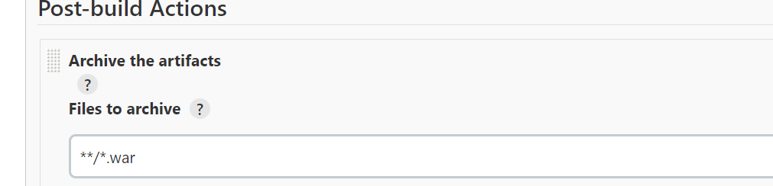

1. Clean the workspace before build
2. Go the new job 🡪 configure 🡪 build 🡪 select copy the artifacts from another plugin option

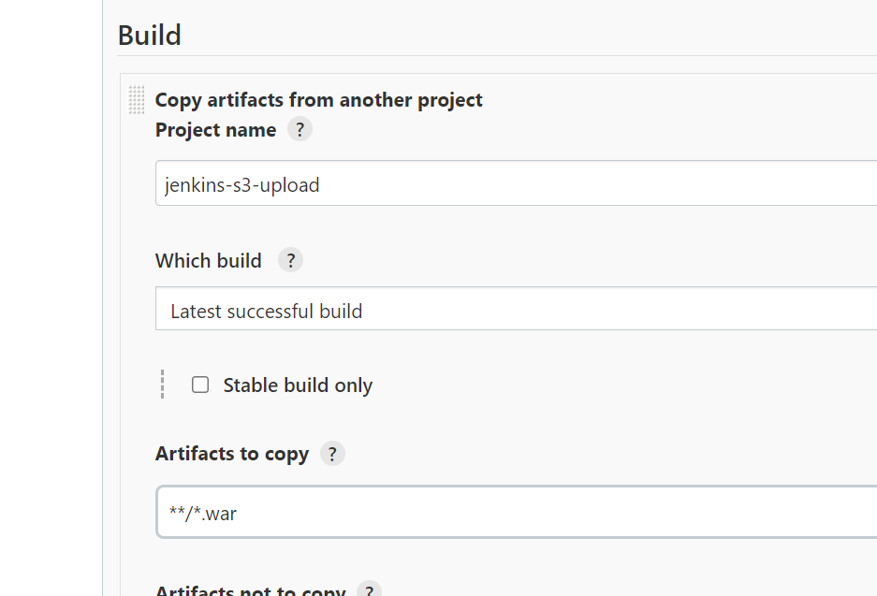

1. Then click on save & build
2. Click on configure for the same job to upload the artifact to the nexus

Configure🡪 build 🡪 select nexus artifact upload

1. Then it will shows like this

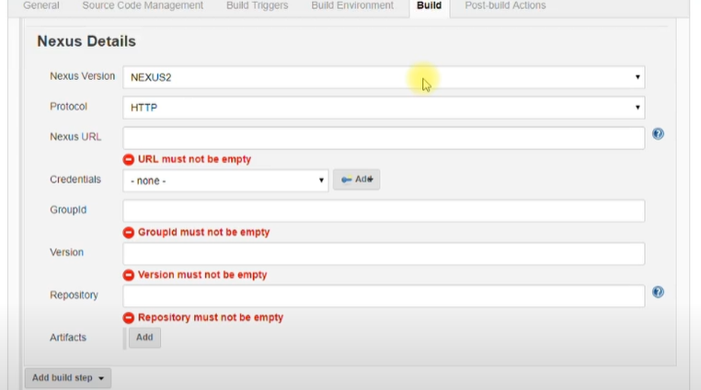

1. In the nexus url give the private ip of nexus server:port-number/nexus
2. Give the creds of nexus
3. Group id can be anything (i.e.,based on our requirement)
4. In version 🡪 $BUILD_ID
5. Repository name is as same as wt we created in the nexus
6. Click on add to add the artifact details

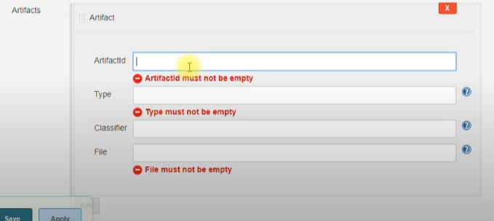

1. In artifact id give 🡪 artifactname-$BUILD_TIMESTAMP
2. In type give as war
3. In file 🡪 target/artifactname-version.war
4. The nexus server has to access the Jenkins for that we have to do
5. Open nexus instance 🡪 security groups 🡪 inbound rules 🡪 edit
6. Add rule 🡪 custom tcp 🡪 8081 port 🡪 give the security wt we created for Jenkins-nexus integration
7. Save and build
8. Go to the nexus page and click on refresh on repositories