**GIULA’S BOTIQUE INVENTORY SYSTEM**

**DATABASE**

**Tables**

-all the connected parts of the system. There are currently 7 tables in the current inventory system.

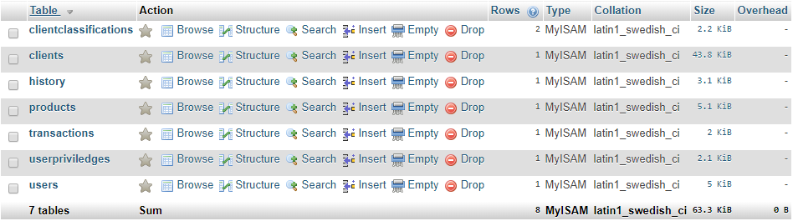

***Explanations for each of the tables are explained below:***

**ClientClassifications**

-the Client Classifications table lists the classification of the client. For example: renter, shareholder.

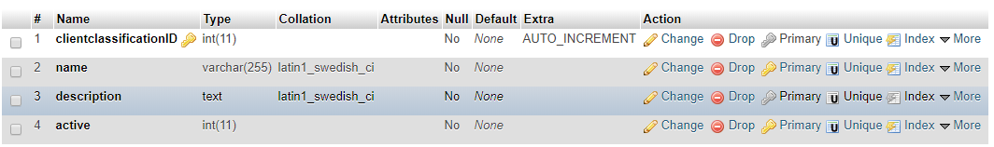

Sample input:

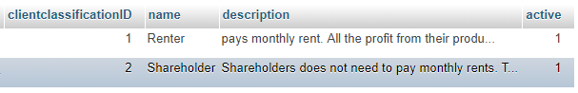

**Clients**

-the Clients table contains the list of all the clients (active or inactive) in the database. Active clients are the clients that are currently in partneship with Giulia’s while inactive are previous business partners.

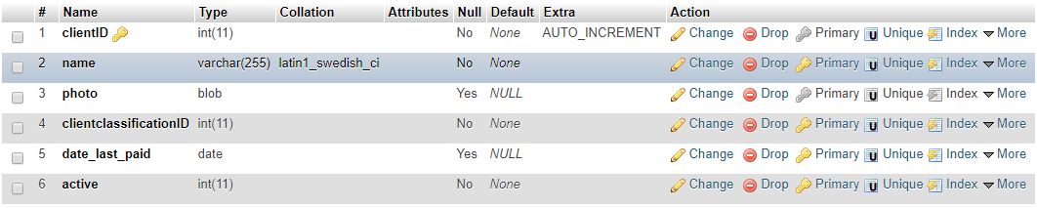

Sample input:

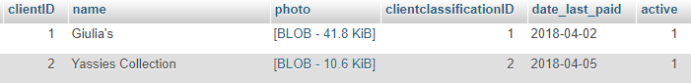

**History**

-the History table holds the list of all the activities related to handling the system; wether updating the stocks to adding a new client, all the actions done in the system is recorded in this table.

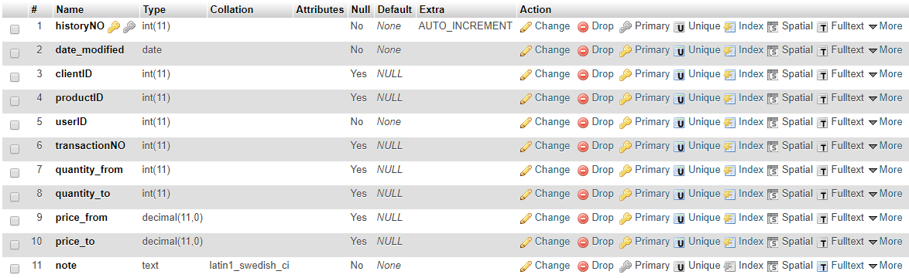

Sample input:



**Products**

-the Products table contains a list of all the products in the system. The Products table also contains all the necessary information of the product such as the current price, quantity, and description, etc. of the product.

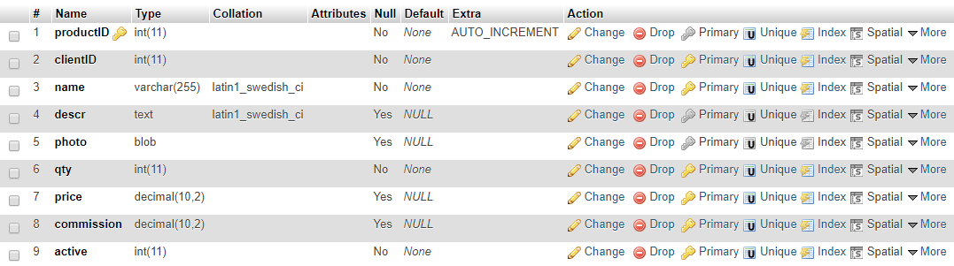

Sample input:



**Transactions**

-the Transactions table stores all the information about a specific transaction. A transaction is done when a customer purchases one or more items from the shop.

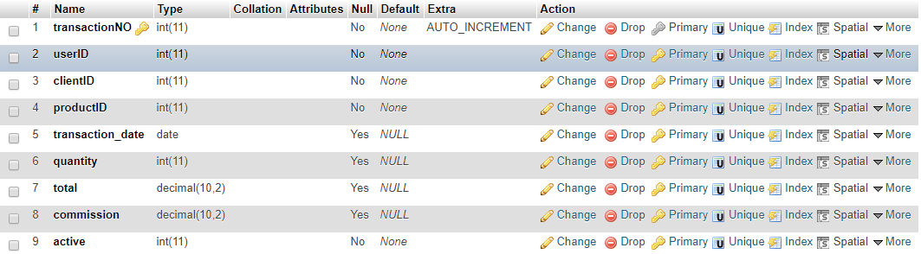

Sample input:



**UserPrivileges**

-the UserPrivileges table is able to determine the priviledges of a particular user. There are parts of the system that only a particular user can access.

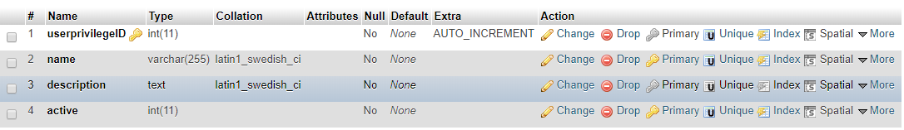

Sample input:

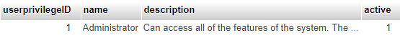

**Users**

-the Users table lists all the users of the system. This table also contains the user’s personal information such as name, birthday, etc.

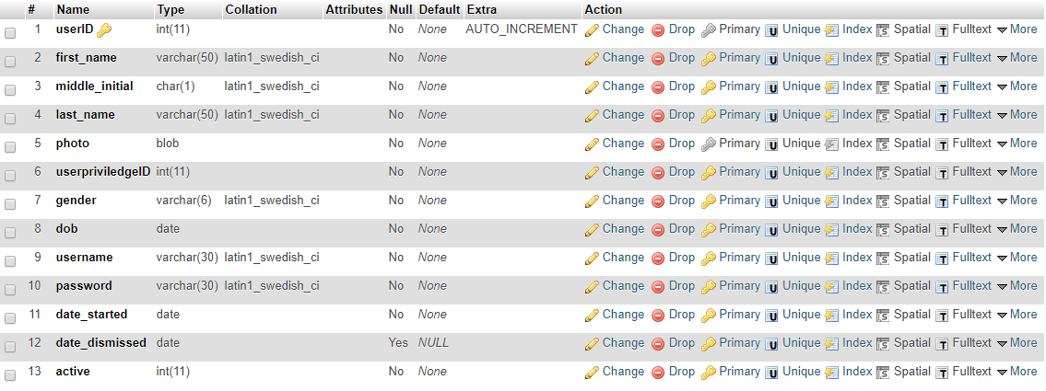

Sample input:



**USER PRIVILEGES**

On the user privilege table sample, one given privilege is the administrator. The owner of the shop is automatically the administrator of the system.



In the analyzation phase of the system development, the developers decided to have (3) three fixed user privileges to cater the needs of the shop.

1. Administrator / Owner
2. Manager
3. Sales Representative

**ADMINISTRATOR**

The administrator or the owner is the overseer of the system. The administrator has the access to all the system’s features. Some of the administrator’s given privileges are the following:

Adding/Updating a new client, printing reports, accessing transactions page, adding a new employee, viewing system history, etc.

**MANAGER**

The manager can access the important features of the system such as viewing client and product information.

The manager almost has the same amount of privileges as the administrator in cases where the owner is away.

**SALES REPRESENTATIVE**

The sales representative is the person in charge of updating the transactions form. The sales representative holds the least amount of privileges to limit the security of the system.

In case of updating and voiding of transactions, the owner or manager must be on duty to assist the sales representative.

**SYSTEM DESIGN**

The following section holds the GUI or the Graphical User Interface of the System. The designs may vary depending upon the user. A person has limitations on the priviledges that he/she can access.

**LOGIN FORM**

The login form is the first form that the user sees upon seeing the system. The user can input their credentials and once they click the login button, the system can determine who they are.

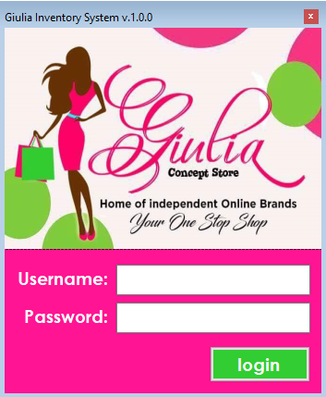

**HOME FORM**

The home form contains all the features of the of the system. Upon logging in, the “Name” label is replaced with the user’s username. The specific pictures may or may not be visible depending on the user’s given priviledges.

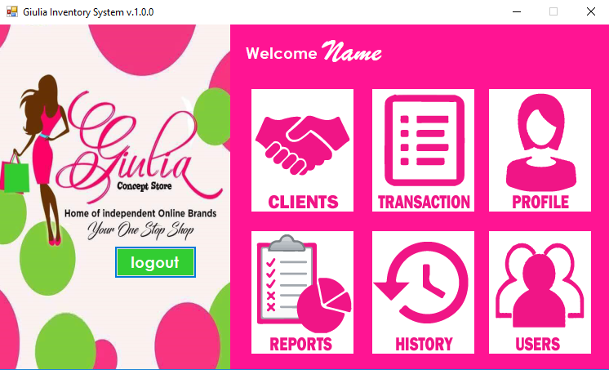

**HOME FORM WITH ALL FEATURES AVAILABLE.**

**HOMEPAGE LIMITATIONS**

Only the Owner/Administrator has the access to all the features of the system. A image above is the image seen if the user accessing the system is the administrator or the owner.

**MANAGER**

The manager can see the clients, transactions, profile, and the reports features.

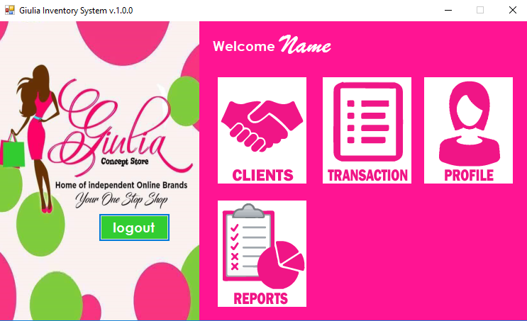

**SALES REPRESENTATIVE**

The sales representative can only access the clients, transactions, and profile features.

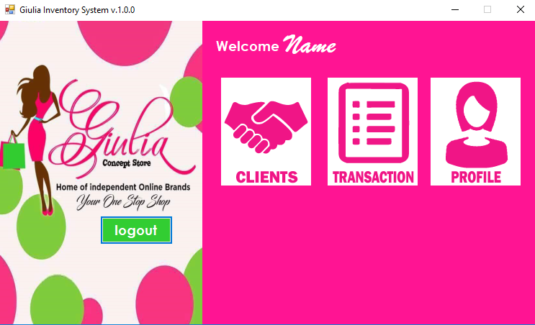

**CLIENTS FORM**

The clients form contains all the information about the clients and their products. The client form is capable of searching for a particular client or product of the client and once the user clicks it, the client information will show up on the upper right side of the screen.

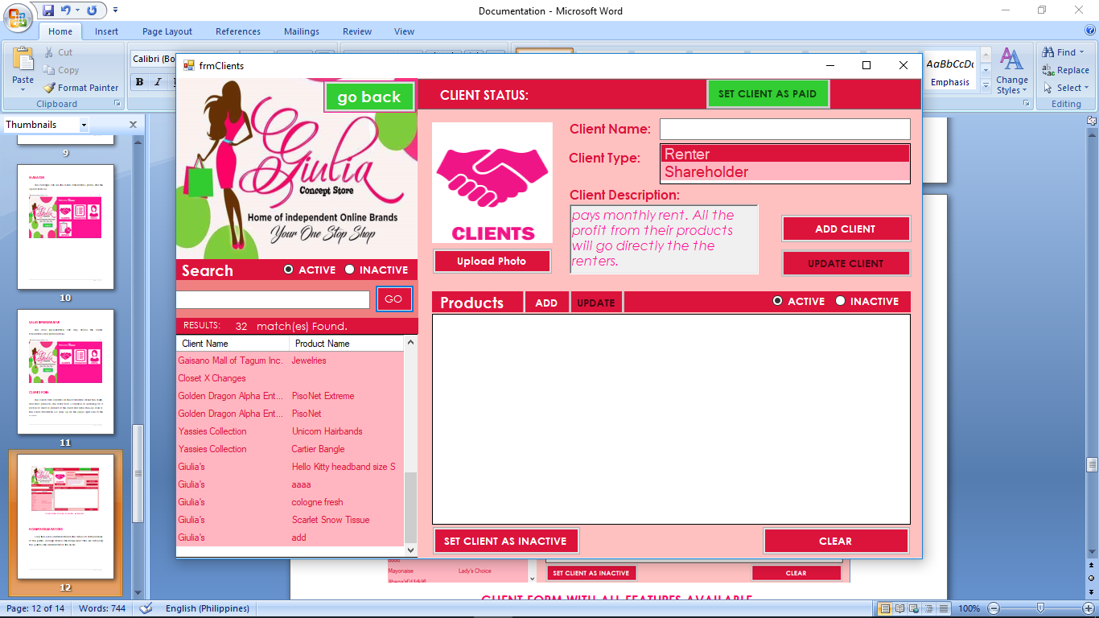

**CLIENT FORM WITH ALL FEATURES AVAILABLE.**

By default, a list of all the clients and their products are shown on the left side of the form. The user can sort the client name or the product in in alphabetical order by clicking the column header.

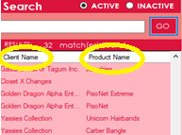

The user can also search of a specific client or product. In the text box below the search text. If the user is ready to search of the client or product, the user needs to click the GO button.

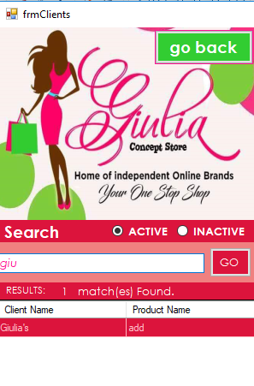 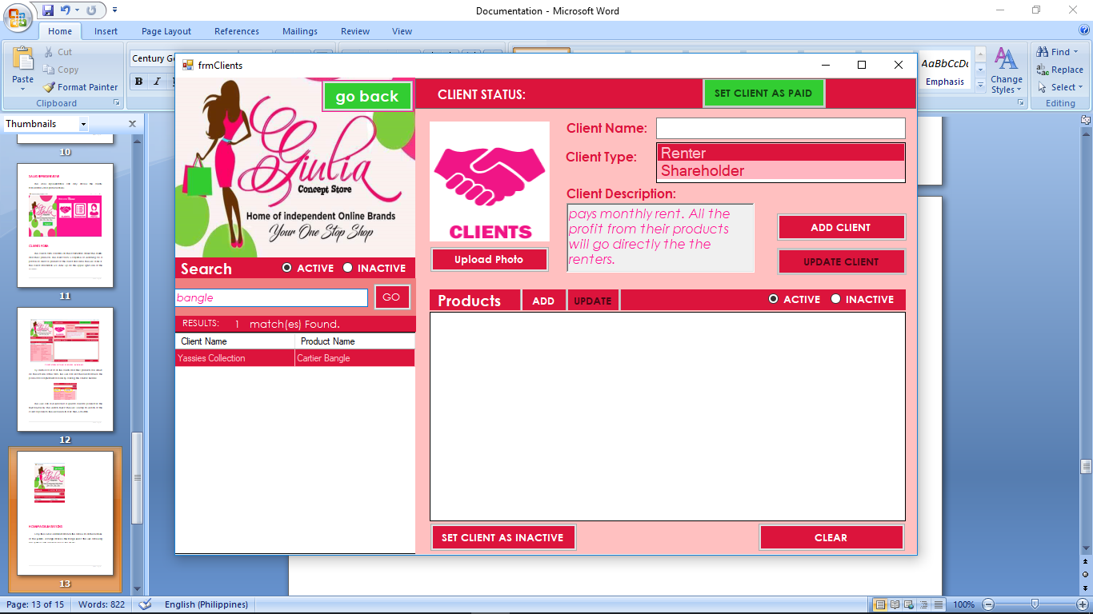

If the user clicks the chosen client name or product name, an information about the client and product is shown on the right side of the screen.

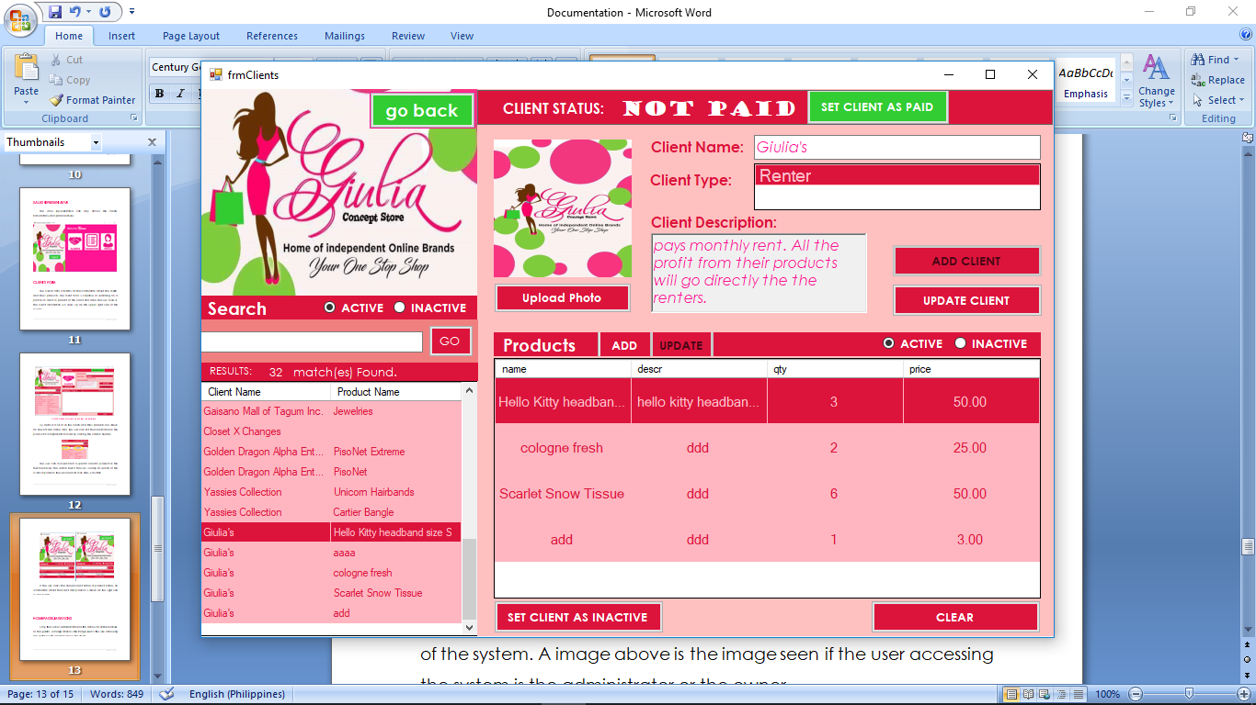

On the top right portion of the screen, the client status is shown. The client status checks if the user has already paid the rent for the current month. The client status is only applicable to renters and not to shareholders.