Name: Abdul Rehman
Roll no: 067
Section: BSAI-3B
Lab task 4

Introduction:
In this lab I applied informed search, namely the A* algorithm, to a campus routing graph. A* prioritises the frontier by f(n) = g(n) + h(n), where g is the actual cost so far and h is an estimate of the remaining cost. In the graph, S is the starting building and G is the destination. Edges are travel-time units, and the h values are abstract time estimates (not measured campus distances).

Graph and Heuristic
Node | Edges (cost) | h (given) | True remaining cost
S | A(1), B(4) | 5 | 6
A | C(2) | 4 | 5
B | G(5) | 4 | 5
C | G(3) | 2 | 3
G | - | 0 | 0
There are two complete routes: S-A-C-G = 1 + 2 + 3 = 6 and S-B-G = 4 + 5 = 9. The optimal cost is therefore 6.

Task 1: First three expansions (hand calculation)
Step | Selected | g, h, f | Calculation | Remaining frontier
1 | S | g=0, h=5, f=5 | f = 0 + 5 = 5 | A: g=1, h=4, f=1+4=5 | B: g=4, h=4, f=4+4=8
2 | A | g=1, h=4, f=5 | f = 1 + 4 = 5 | C: g=1+2=3, h=2, f=3+2=5 | B: f=8
3 | C | g=3, h=2, f=5 | f = 3 + 2 = 5 | G: g=3+3=6, h=0, f=6 | B: f=8
Why is the next node G? On the frontier G has f=6 and B has f=8, so the node with the smallest f, G, is selected.
After step 1, A (f=5) was preferred over B (f=8). After step 2, C (f=5) was preferred over B (f=8). A* never expanded B.

Heuristic Audit
Admissibility: h must never be greater than the true remaining cost.
Node | h | True cost | Check
S | 5 | 6 | 5 <= 6 OK
A | 4 | 5 | 4 <= 5 OK
B | 4 | 5 | 4 <= 5 OK
C | 2 | 3 | 2 <= 3 OK
G | 0 | 0 | 0 <= 0 OK

Consistency: for every edge u -> v, h(u) <= cost(u,v) + h(v).
Edge | Check | Result
S -> A | 5 <= 1 + 4 = 5 | OK
S -> B | 5 <= 4 + 4 = 8 | OK
A -> C | 4 <= 2 + 2 = 4 | OK
B -> G | 4 <= 5 + 0 = 5 | OK
C -> G | 2 <= 3 + 0 = 3 | OK
On this small instance the heuristic is admissible and consistent, verified explicitly.

Task 2: A* and UCS Comparison
Counting convention: a node is counted as expanded when its successors are examined. Processing the goal is logged but not counted. Stale queue entries were ignored (no stale entries occurred in this graph).

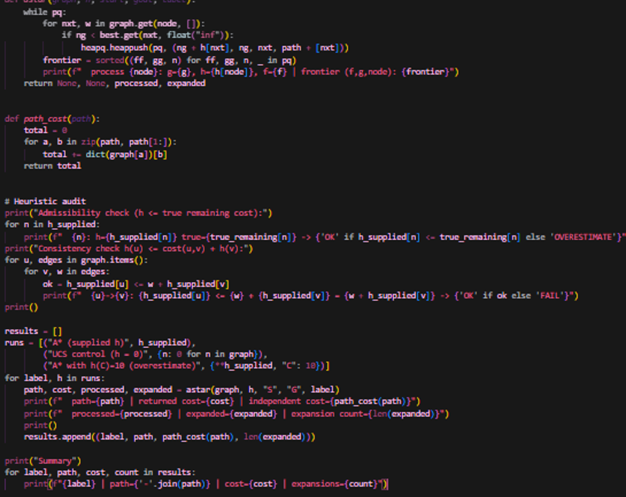

Output:
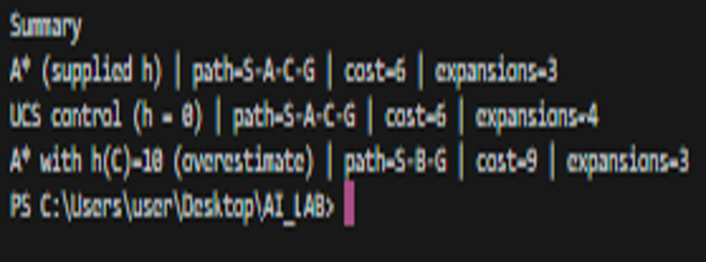

Run | Path | Cost | Expansions | Processed order
A* (given h) | S-A-C-G | 6 | 3 | S, A, C, G
UCS baseline (h = 0) | S-A-C-G | 6 | 4 | S, A, C, B, G
Independent cost check: 1 + 2 + 3 = 6 (both runs give the same path). Both returned the optimal path, but A* expanded 3 nodes while UCS expanded 4 (UCS also expanded B). This difference comes only from the measured counts on this small graph and is not a general claim.

Task 3: Overestimate Experiment
Only one value was changed: h(C) from 2 to 10. The true remaining cost of C is 3, so 10 > 3 and admissibility is broken. Everything else was kept the same (h(G) = 0, the other h values, the graph, the start and the goal).
Run | Path | Cost | Expansions | Processed order
A* original h | S-A-C-G | 6 | 3 | S, A, C, G
A* with h(C)=10 | S-B-G | 9 | 3 | S, A, B, G
Observed behavior: the cost went from 6 to 9. After expanding A, A* gave C f = 3 + 10 = 13, which is higher than B's f = 8, so B was expanded first and G was reached at cost 9.
Why does overestimating break the optimality guarantee? When h is larger than the true cost, a good continuation (C) is wrongly made to look expensive and A* never examines it. Note also that for some overestimates the result does not change, so getting the same result in a single run is not proof that a heuristic is safe.

Edge Case / Failure Analysis
Input: h(C) = 10, everything else original.
Observed behavior: A* returned the non-optimal path S-B-G (cost 9), while the optimal cost is 6.
Likely cause: h(C) = 10 is larger than the true remaining cost of 3, which means the heuristic is inadmissible.
Proposed improvement: check admissibility and consistency first (as in the audit code), and always keep h below the true remaining cost.

Limitations
The graph has only 5 nodes and the heuristic values are abstract, so the efficiency results apply only to this instance. Admissibility was shown only by explicit checking on this small graph; larger graphs need a separate proof.

Reflection
What did you learn today? A* combines the actual cost and an estimate to expand fewer nodes, but it is optimal only when the heuristic is admissible.
How will you apply this? For navigation-style problems I will use a straight-line type heuristic, but I will check its admissibility first.
What failed or surprised you? Changing just one heuristic value made the optimal path wrong.
What would you do differently? I would compare A* and UCS counts on a larger graph.

Responsible Practice
The efficiency claims are based only on measured expansion counts. The heuristic values are synthetic and abstract, and this is stated clearly in the report.

