Name: Abdul Rehman
Roll no: 067
Section: BSAI-3B
University: Superior University, Lahore
Lab 1: Introduction to AI & Paradigms

Introduction
In this lab I looked at the difference between symbolic (rule-based) AI and probabilistic (data-driven) AI. I built a small scholarship-screening prototype in which 'Review' means the application is flagged for a human reviewer, not that an award has been decided. All thresholds are synthetic lab assumptions and the probability values are invented demo inputs; no model was trained, so this is a comparison of behaviour and not an accuracy experiment.

Task 1: AI Timeline
Year | Event | Significance | Source
1950 | Turing's paper 'Computing Machinery and Intelligence' | Proposed the imitation game, the first well-known way to judge machine intelligence by its behaviour. | A. M. Turing, Mind, vol. 59, 1950
1956 | Dartmouth Summer Research Project on AI | This is where 'Artificial Intelligence' began as a research field. | McCarthy, Minsky, Rochester, Shannon, 1955 proposal
1974-1980 (AI winter) | First AI winter: funding cuts after the Lighthill Report (1973) | Because results had been over-promised, funding and expectations fell, exposing the gap between hype and evidence. | Lighthill, 'Artificial Intelligence: A General Survey', 1973; Russell & Norvig, AIMA
1997 | IBM Deep Blue defeated Garry Kasparov in a chess match | Showed that very large amounts of compute and search can beat a world champion at one narrow task. | IBM Research / Campbell et al., Artificial Intelligence, 2002
2012 | AlexNet won the ImageNet competition (a modern compute/data milestone) | GPUs and a large labelled dataset (ImageNet) made deep learning practical. | Krizhevsky, Sutskever, Hinton, NeurIPS 2012
Note: please re-check the sources against your own reference style before submitting.

Task 2: Rule-based Scholarship Checker
The original conditions (score >= 70 and documents complete) were kept, and two new named conditions were added: attendance_ok (attendance >= 75) and community_ok (community_hours >= 10). These thresholds are synthetic lab assumptions.
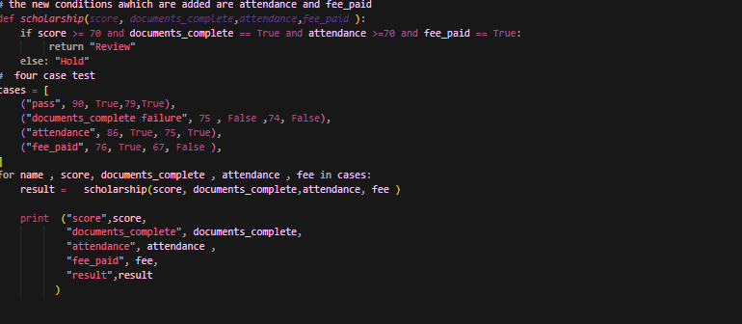

How the test cases were chosen: one passing case, one failing case for each new condition (attendance and community hours), and one boundary case that checks the >= behaviour at the exact thresholds (70, 75, 10).
Expected output:
Case | Input | Expected | Reason
pass | 85, True, 90, 15 | Review | all conditions met
attendance_fail | 85, True, 60, 15 | Hold | attendance below 75
community_fail | 85, True, 90, 5 | Hold | community hours below 10
boundary | 70, True, 75, 10 | Review | all conditions met (>= boundary)

Actual output:

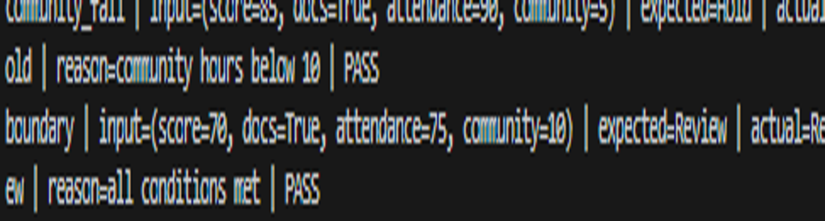

In all four cases the expected and actual results match (PASS).

Rule vs Threshold Comparison

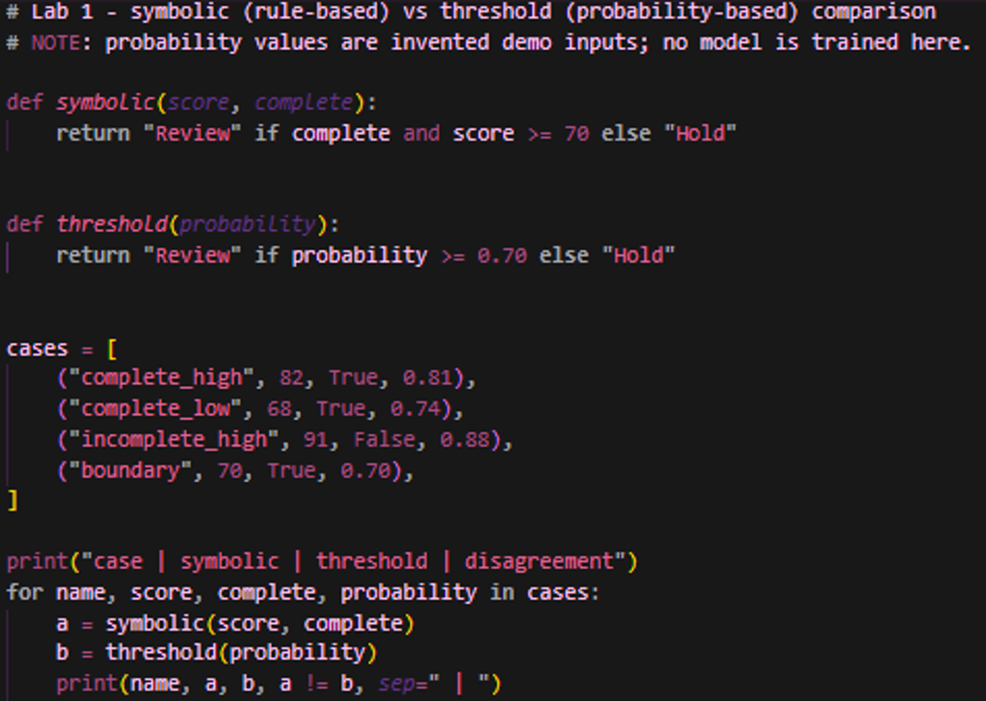

Output:
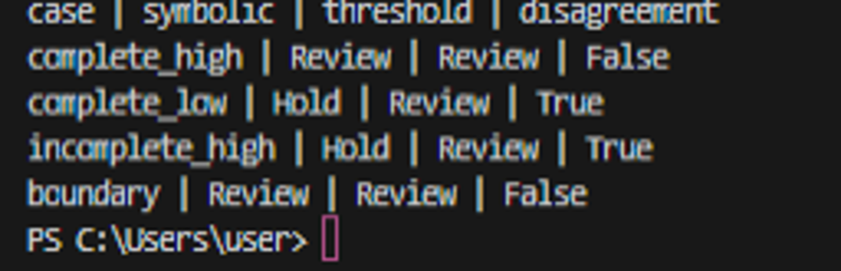

Case | Symbolic | Threshold | Disagree? | Which condition explains it
complete_high | Review | Review | False | Both conditions met
complete_low | Hold | Review | True | Score 68 < 70, so the rule blocked it; probability 0.74 >= 0.70
incomplete_high | Hold | Review | True | Documents incomplete; the threshold does not know about it
boundary | Review | Review | False | Passes at both 70 and 0.70 (>= boundary)

Edge Case / Failure Analysis
Input: incomplete_high (score 91, documents incomplete, probability 0.88).
Observed behavior: symbolic = Hold, threshold = Review.
Likely cause: the threshold rule looks only at the probability; document completeness is not one of its inputs. Despite the high score, an incomplete application was flagged for review.
Improvement: add an explicit documents_complete check alongside the probability rule (a hybrid), and keep human review as the final authority.
Boundary test: with score 69 and probability 0.69 both approaches return Hold, so just below the threshold the two rules behave the same. Testing them in isolation showed that the real difference comes from the extra condition (documents), not from the threshold itself.

Task 3: Conversational Test vs General Intelligence
A conversational test (the Turing Test) only observes whether a machine's answers seem human-like and convincing. It does not prove that the machine follows a documented rule, reasons correctly or has general intelligence. A fluent answer and a correct answer are two different things.
Fluent but incorrect example: a scholarship assistant says 'Your application is strong (score 91), so it has been sent for Review', although the documents are incomplete and the rule says it should be Hold. The answer is convincing but goes against the rule.
An additional test of reliable task performance: take a held-out set of labelled applications (with ground-truth outcomes), check whether the assistant flags every case according to the documented rule (complete + score >= 70), and record the accuracy and the types of mistakes. The sources for the historical claims (Turing 1950) are given in the timeline above.

Reflection
What did you learn today? Symbolic rules are traceable, while a data-driven threshold can pick up complex patterns but its logic stays hidden.
How will you apply this? In a real system I will combine rules and probability (a hybrid) and keep a human reviewer in the loop.
What failed or surprised you? It was surprising that an incomplete application with a high probability still got a Review.
What would you do differently? I would predict the test cases first and choose the threshold using validated data.

Responsible Practice
All values are synthetic. A real scholarship decision needs validated data, clear policy ownership and human review. Marketing claims should be kept separate from demonstrated capability.

