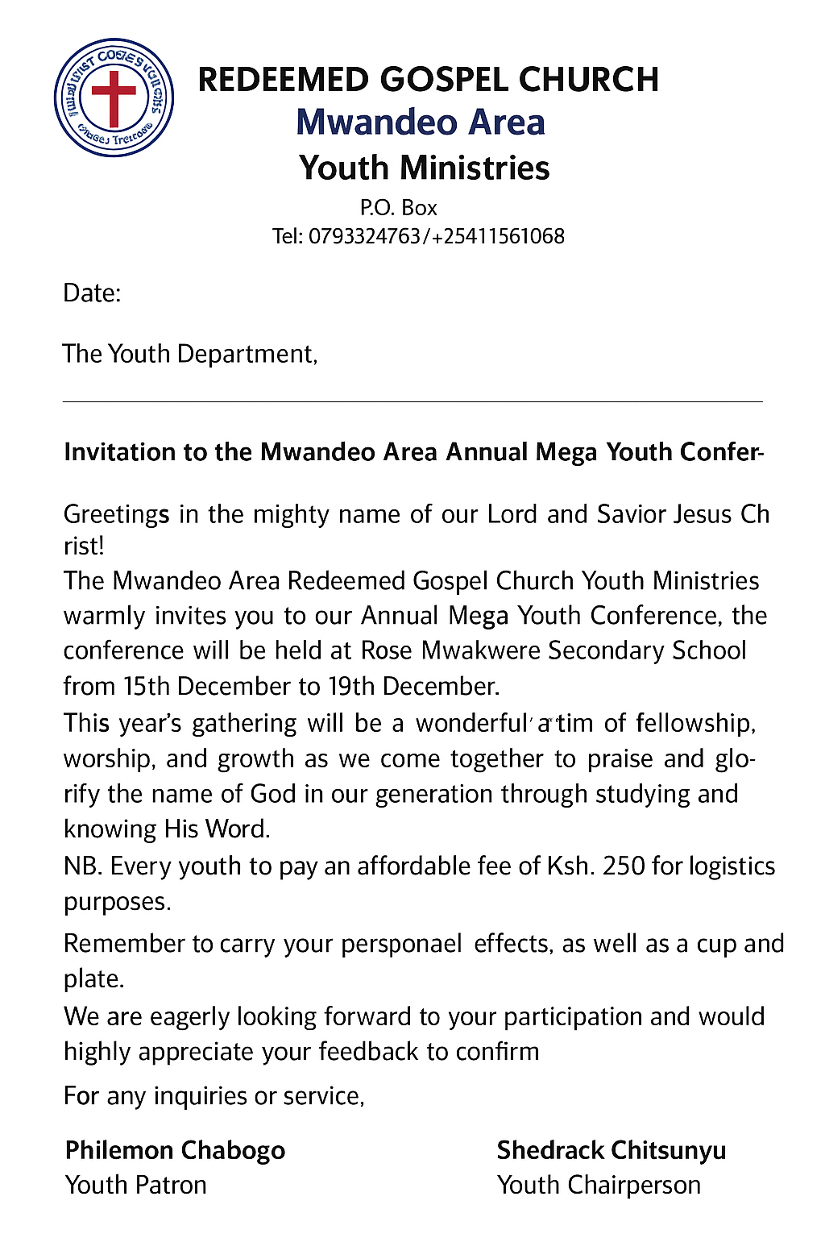

REDEEMED GOSPEL CHURCH
Mwandeo Area
Youth Ministries
P.O. Box [Insert Box Number]
Tel: 0793524783 / +254115651068
Date: [Insert Date Here]
The Youth Department,
__________________________ Church.
Subject: Invitation to the Mwandeo Area Annual Mega Youth Conference
Greetings in the mighty name of our Lord and Savior Jesus Christ!
The Mwandeo Area Redeemed Gospel Church Youth Ministries warmly invites the youth from ________________ Church to our Annual Mega Youth Conference. The conference will be held at Rose Mwakwere Secondary School from 15th December to 19th December.
This year’s gathering will be a wonderful time of fellowship, worship, and growth as we come together to praise and glorify the name of God in our generation through studying and knowing His Word.
We kindly request every youth to contribute a small participation fee of Ksh. 250 to cater for logistics purposes. Please remember to carry your personal effects, as well as a cup and plate for use during the conference.
We are eagerly looking forward to your participation and would highly appreciate your feedback to confirm attendance.
For any inquiries or confirmations, please reach out to:
- Philemon Chabogo – Youth Patron: 0793524783
- Shedrack Chitsunyu – Youth Chairperson: +254115651068
May the grace of our Lord Jesus Christ be with you as you prepare to join us.
Philemon Chabogo
Youth Patron
Shedrack Chitsunyu
Youth Chairperson

