 | 
Step 2: Bloom’s Taxonomy
and SLO Statement Design

September 30, 2022
10am – 12noon PDT

REGISTRATION
 | Panelists:
 |   Bethany Tasaka  Associate professor of mathematics at San Bernardino Valley College (SBVC). She is also the Outcomes Faculty Lead and Curriculum Faculty Co-Chair at SBVC. She is the President of the Asian and Pacific Islander Association at SBVC and the Asian Pacific Islander Caucus Chair for the statewide Academic Senate for California Community Colleges.  Bethany is passionate about advocating for API voices, lifting the stories of women, and breaking down silos in institutions.    Melinda Manlowe  Professor of Communication Studies, Departmental Student Learning Outcome Facilitator, and ASLO committee member. In addition to teaching courses such as Intercultural and Interpersonal Communication, Melinda serves on the ASLO committee contributing to the design, assessment, and alignment of Course SLOs and Institutional SLOs. She is honored to be part of a team that supports faculty and helps foster student success. | 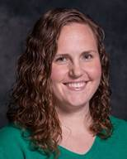  Trisha Wilging  Trisha Wilging teaches in the Reading and Teacher Preparation Department at Long Beach City College. She is the Student Learning Outcomes Coordinator and has served in this role since March 2020. Trisha enjoys assessment work and is thrilled by the potential to impact student learning in ways that extend beyond her own classroom. She works to foster a culture of inquiry around SLOs and is committed to meaningful change.  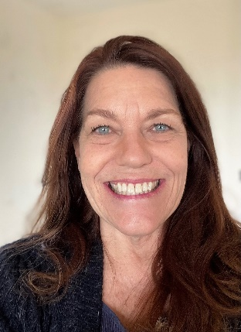  Darla Anderson  Lecturer, Communication Studies, CSUN,  and Adjunct Instructor, Communication Studies, Oxnard College. Darla’s first assessment work was assessing the general education program at a private arts college. Later, she assisted with the annual assessment of program student learning outcomes for Communication Studies Department, CSUN. As a result of this work and accompanying trainings, she integrates Bloom’s Taxonomy into course curriculum.
Discussion Moderators:
Jarek Janio, Ph.D. Santa Ana College
Enrique Jauregui, Fresno City College

Friday Student Learning Outcomes (SLO) Talk
Fall 2022 Schedule

All Talks are scheduled on Fridays between 10am and 12noon PST

Zoom Meeting Registration Link

October 7: Step 3: SLO Alignment to Program and Institution SLOs

October 14: Step 4: Direct Assessment/Rubric Design

October 21: Step 5: SLO Assessment Data Analysis

October 28: Step 6: Closing of the Assessment Loop

November 4: Canvas and record keeping

December 2: Equity, course design and pedagogy

December 9: Grand Finale

