5

**Bangladesh University of Engineering and Technology**

**Course Number**  **:** EEE 304

**Course Title** **:** Digital Electronics Laboratory

**Project: Adaptive Traffic Control, ‘Smartlights’**

**SUBMITTED BY**

**Group 06**

**Department:** EEE

**Section:** A2

Group Members: 1706054, 1706047, 1706057

Date of Submission: 27/02/2022

**Introduction:**

Our project aims to demonstrate the design of a digital algorithm that allows adaptive control over the duration of green and red signals in road intersections. The algorithm can be extended for more roads added into an intersection, but for the sake of simplicity and in order to concisely demonstrare, we are dealing with 2 lanes of traffic. A North to South lane and an East to West Lane.

***North - South Lane***

***East - West Lane***

**Working Principle:**

We allow the movement of traffic for one lane, while the other lane is kept off. Thus, when one lane has green signal, the other lane is off. After a certain period of time, the green signal is turned on in the other lane and red signal is turned on in the previously active lane.

Then after a fixed period of time, the first lane once again gets green signal and the process is repeated. We will call this total time of one lane being green and then red until it becomes green again, as one total cycle of the traffic system.

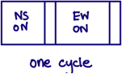

Our objective is to put more time spent on keeping one lane on when that specific lane has higher traffic. Our control signal should be such that when it detects high traffic on one lane at the end of one cycle, it will automatically make it so that the next cycle will have higher time spent on keeping that side of the lane on.

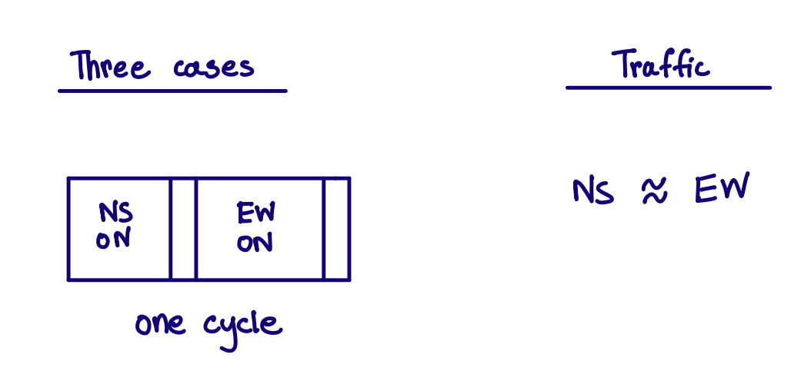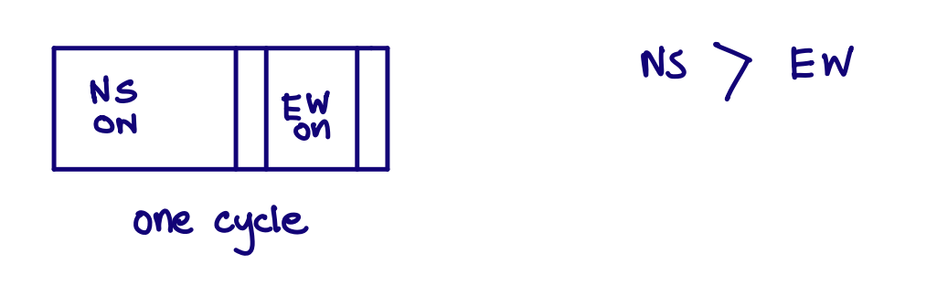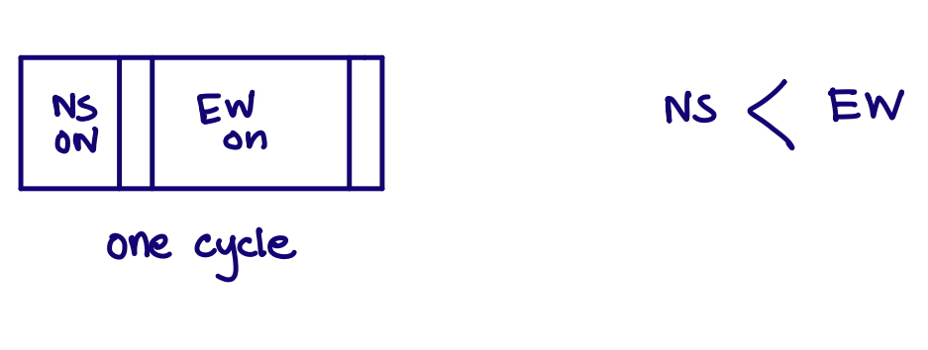

In the figure below, we now give a pictoral representation of how our algorithm should be working after each cycle.

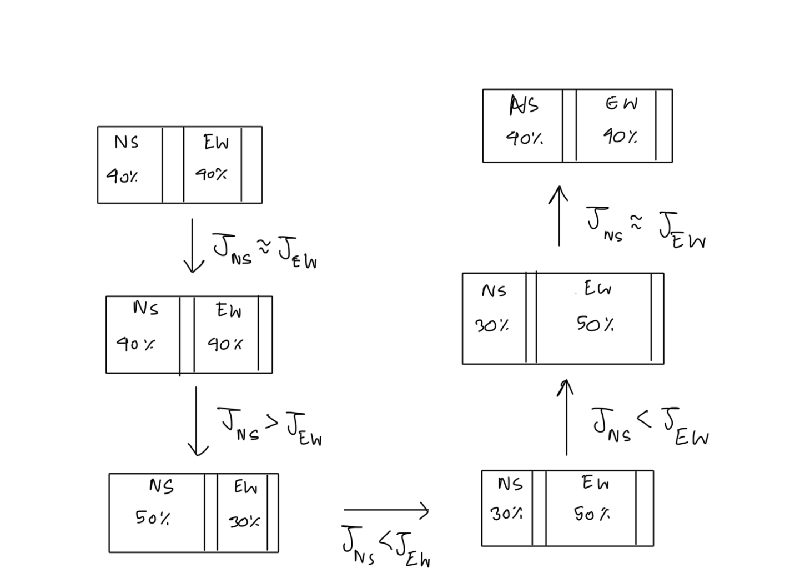

We use JNS and JEW to denote traffic densities of the North South and East West lanes respectively. These traffic densities will be obtained from our sensors in each lane. They are calculated by collecting entering traffic in the lane and leaving traffic and then finding their difference in order to see the amount of traffic left in the lane.

**The Entire Circuit:**

1) The main circuit:

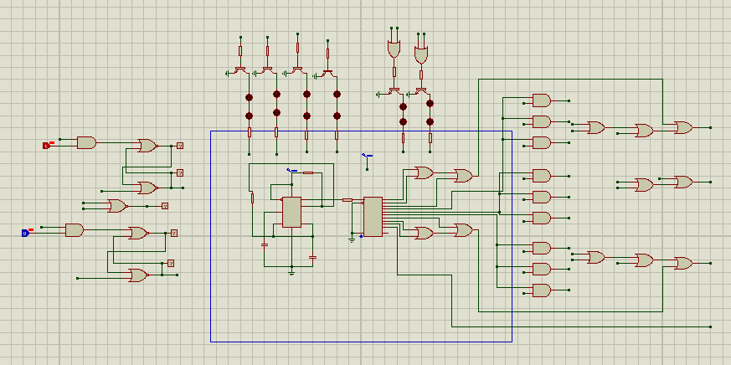

2) The sensory circuit:

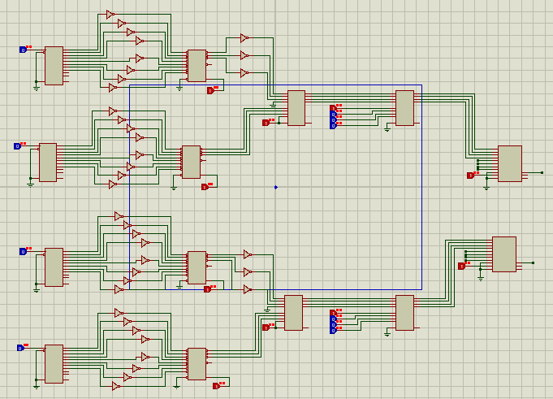

We now try to subdivide the circuits into smaller sections and explain them carefully.

**1) The main circuit:**

The main circuit has 4 parts:

a) The counter circuit, b) The Logic circuit, c) The control circuit, d) The output circuit.

a) The counter circuit:

The counter circuit consists of a 555 timer operating in astable multivibrator, generating a train of pulses at a desired frequency. The frequency is controlled by changing the desired resistance and capacitance values.

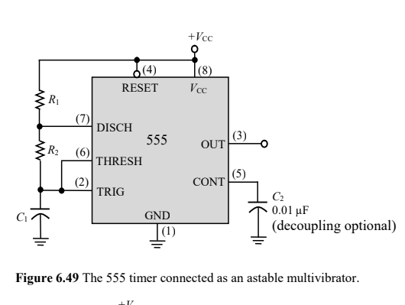

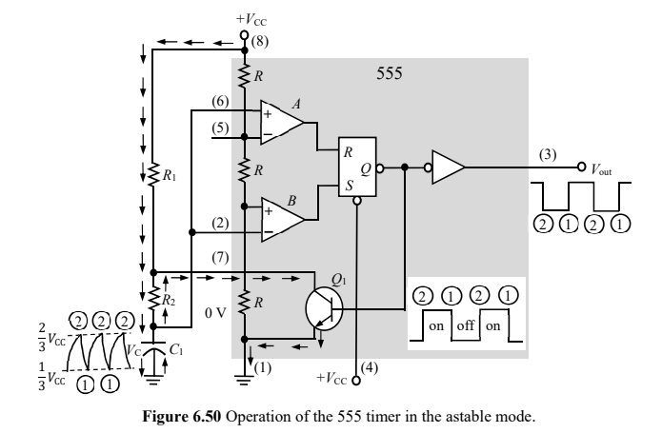





Any one of the two equations can be used to find either the time period or the frequency of the train of pulses and the other term can be found by inversing the obtained value.

This clock pulse is fed into the decade counter in order to generate high outputs for the duration of the pulses in the decade counter. The decade counter outputs are one hot encoded, so the outputs will be something as given below in the figure:

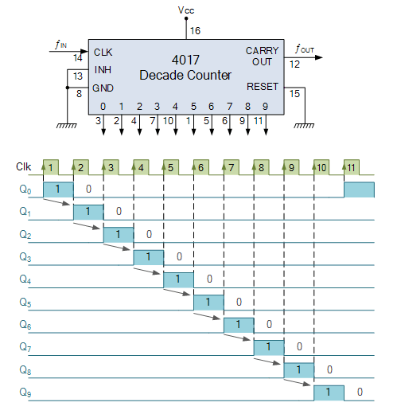

Our objective is to use these active HIGH pulses in a way so that they control the duration of on and off for each lane.

Normal Operation:

When traffic densities are fairly close, we want to allocate equal time to both the lanes so they stay on and off for an equal amount of time. This Is done by keeping the counter outputs connected to the traffic lights as shown in the figure above.

Q0, Q1, Q2, Q3 -> connected to North South Green light and East West Red Light

Q4 -> Transition period. Connected to North South Yellow light and East west Red Light

Q5, Q6, Q7, Q8 -> connected to East West Green Light and North South Red Light.

Q9 -> Transition period. Connected to East West Yellow Light and North South Red Light.

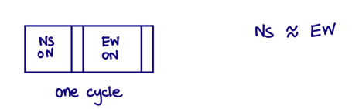

When Traffic is higher on North South Lane:

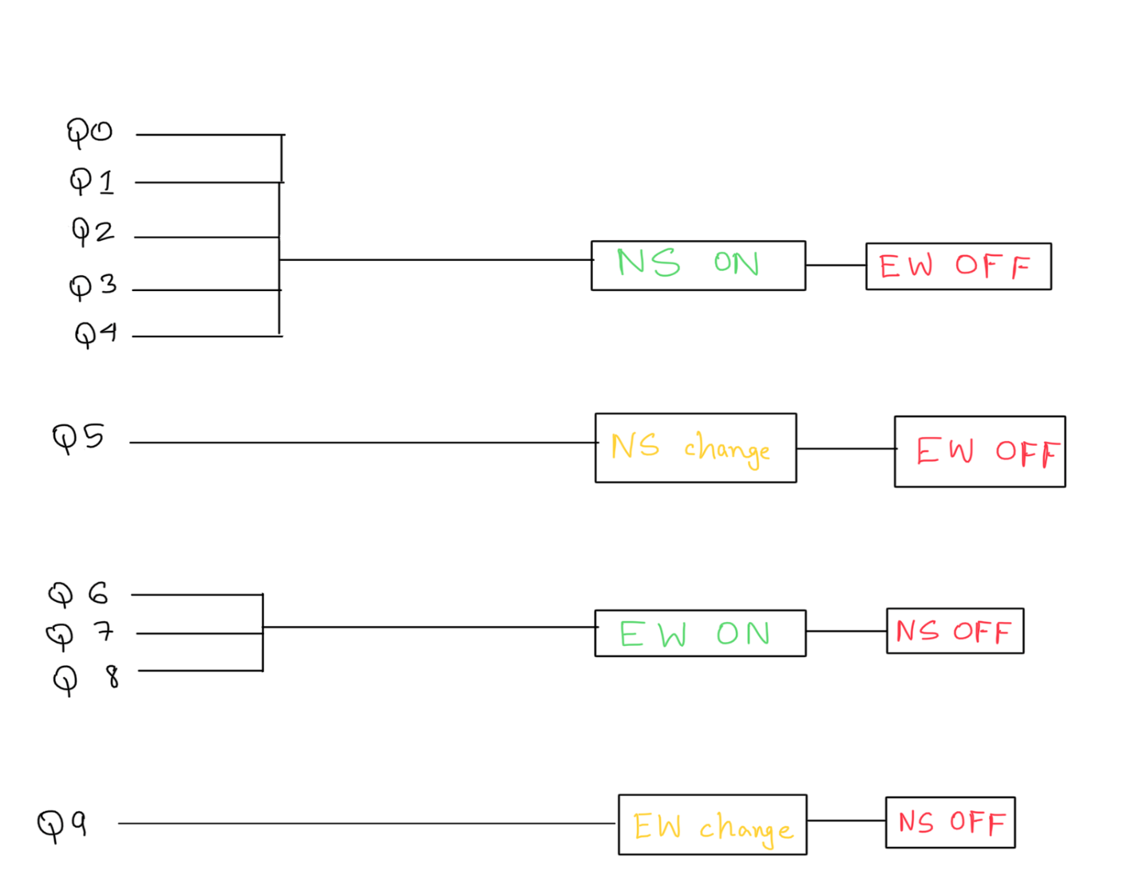

When north south traffic is higher, we want to allocate more on time and less off time for the North South Lane. This Is done by keeping the counter outputs connected to the traffic lights as shown in the figure above.

Q0, Q1, Q2, Q3, Q4 -> connected to North South Green light and East West Red Light

Q5 -> Transition period. Connected to North South Yellow light and East west Red Light

Q6, Q7, Q8 -> connected to East West Green Light and North South Red Light.

Q9 -> Transition period. Connected to East West Yellow Light and North South Red Light.



When Traffic is higher on East West Lane:

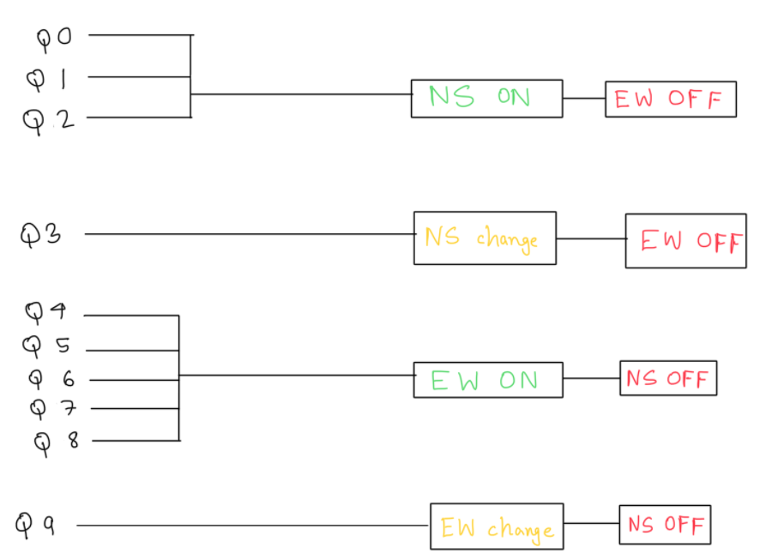

When east west traffic is higher, we want to allocate more on time and less off time for the east west Lane. This Is done by keeping the counter outputs connected to the traffic lights as shown in the figure above.

Q0, Q1, Q2 -> connected to North South Green light and East West Red Light

Q3 -> Transition period. Connected to North South Yellow light and East west Red Light

Q4, Q5, Q6, Q7, Q8 -> connected to East West Green Light and North South Red Light.

Q9 -> Transition period. Connected to East West Yellow Light and North South Red Light.



b) The Logic circuit:

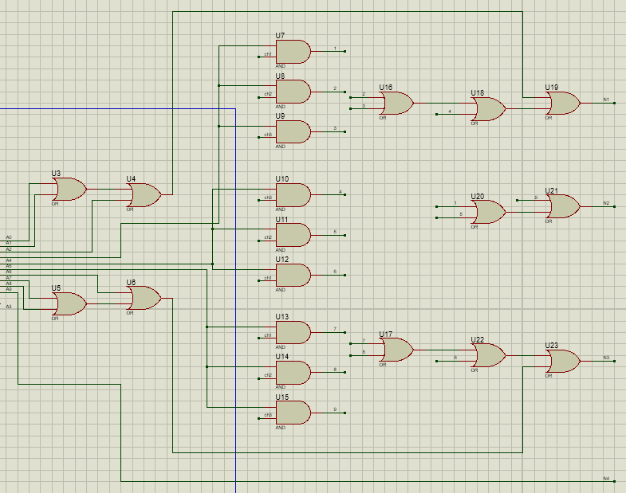

We mainly switch the connections of the Q3, Q4, Q5 pins in order to connect to the N1, N2, N3 and N4 pins of the output circuit which we will see a bit later. This is done as shown below:

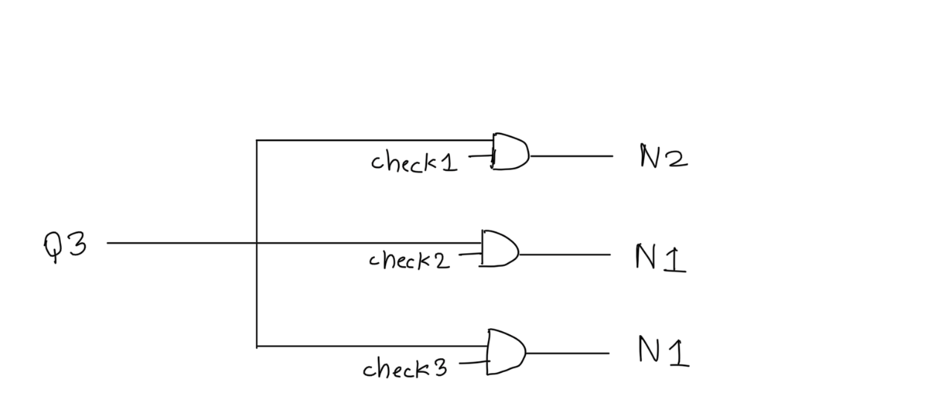

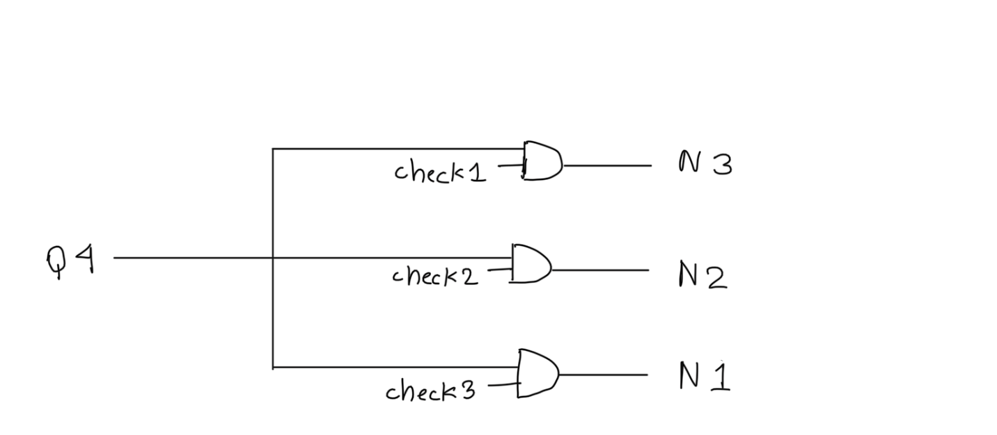

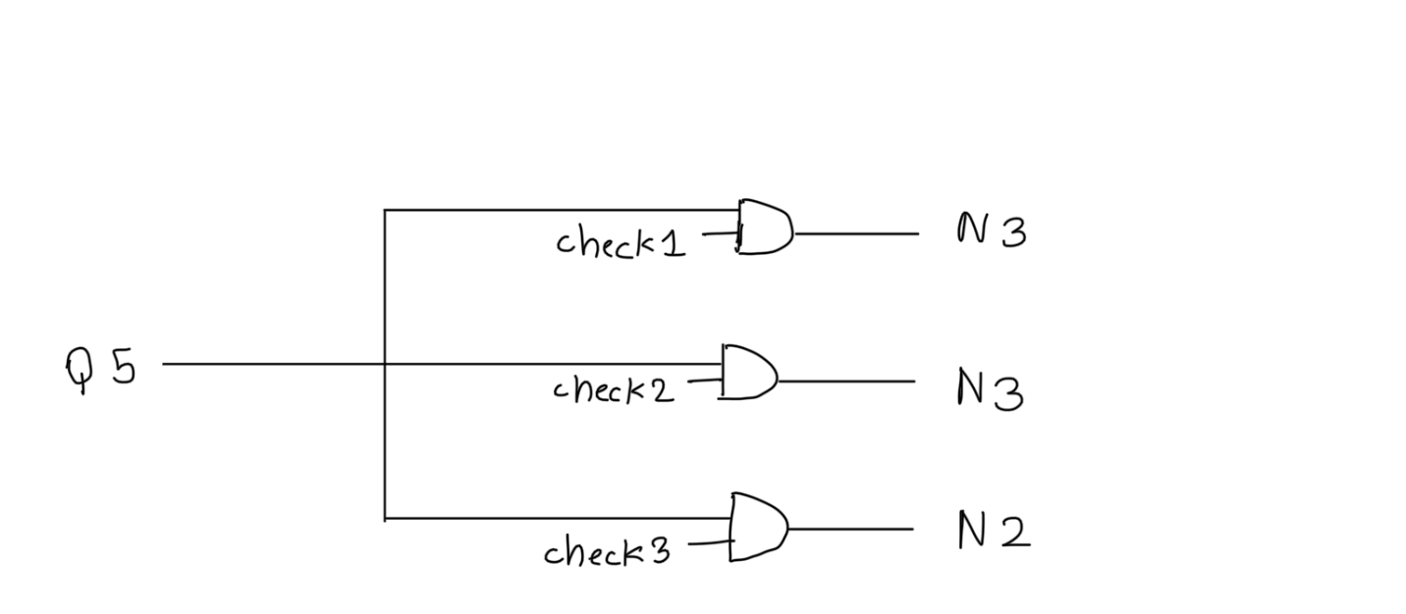

The check nodes are generated from the control circuit.

c) Control Circuit:

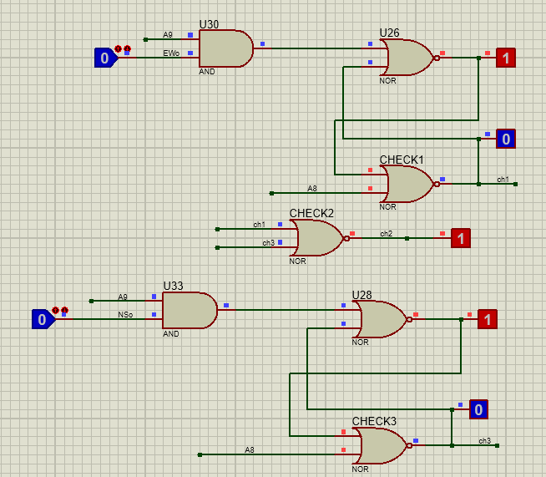

The circuit schematic is fairly understandable. The latches are used to set check 1, check 2 or check 3 high depending on NSo and EWo signals. The A8 signals which are basically the Q8 signals from the counter are used to reset the latches.

When NSo is high, check 3 is made to be high until the Q8 signal of the next cycle is generated.

When EWo is high, check 1 is made to be high until the Q8 signal of the next cycle is generated.

When none of the Now or EWo are high, check 2 is high.

The NSo and EWo signals are generated from the sensory circuit which will be explained later in the report.

d) Output Circuit:

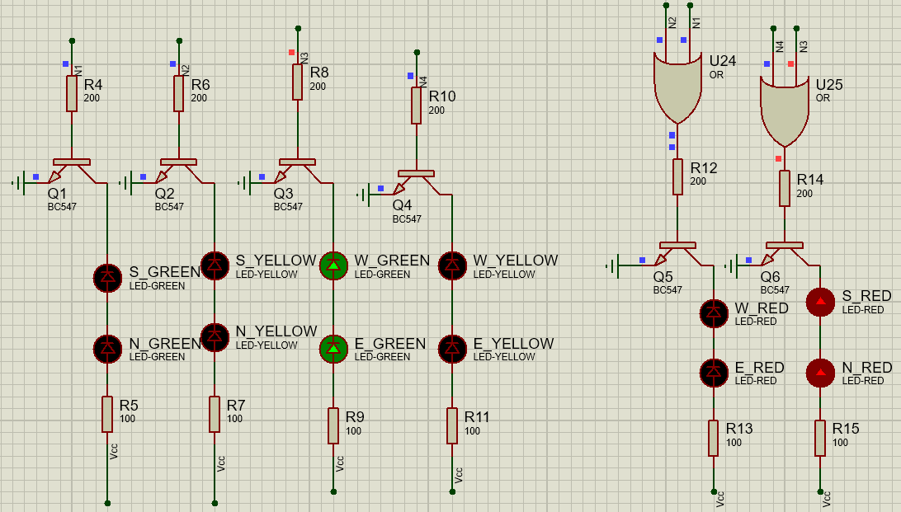

A more intuitively pleasing schematic is given below:

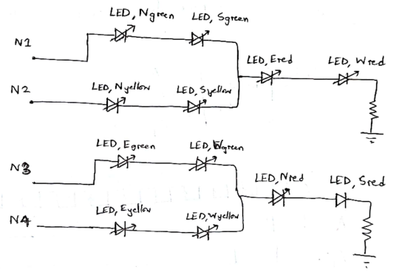

The N1 node controls whether North South green lights and East West red lights stay on or not.

The N2 node controls whether North South yellow lights and East West red lights stay on or not.

The N3 node controls whether East West green lights and North South red lights stay on or not.

The N4 node controls whether East West yellow lights and North South red lights stay on or not.

In our circuit, the output looks slightly different, because we used a separate source to power the traffic lights. The N1 to N4 pins were connected in a way so that they were used to close the circuits of the green and red lights so that the above conditions were met.

2) Sensory Circuit:

The basic idea of the sensory circuit was:

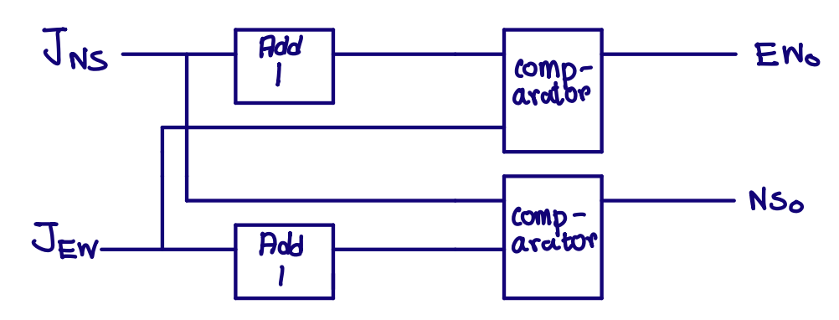

The traffic densities would be generated by adding entering traffic and subtracting leaving traffic. This would be done by counting entering traffic and leaving traffic by counter and then using encoder to convert to binary and then using adder IC to subtract and obtain the densities.

We then add a threshold to our densities and use a comparator to determine whether any lane has higher traffic.

If, north south traffic + threshold is less than east west traffic, then east west traffic will be considered heavy.

If, east west traffic + threshold is less than north south traffic, then north south traffic will be considered heavy.

If none of them are true, then both NSo and EWo are active LOW.

For simplicity, our threshold is set to 1. This means that whenever one traffic density is 2 or more higher than the other one, it is considered ‘heavy’ traffic.

**The output simulation:**

Now that we have explained our circuitry, we wish to show the simulation outputs and demonstrate it. But since it is something that needs to be run in realtime, we are unable to incorporate it In a doc file. Hence, we leave a drive link to the video presentation:

https://drive.google.com/file/d/1xETfDXZNv5-Uio_B7A0QQkLhtiqQht7f/view?usp=sharing