**ChaChing Integration - SFRA**

***Version 24.1.0***



**Table of Contents**

1. Summary 3

1.1 Company Overview 3

1.2 Integration Overview 3

2. Component Overview 3

2.1 Functional Overview 3

2.2 Use Cases 4

2.3 Limitation, Constraints 4

2.4 Compatibility 4

2.5 Privacy, Payment 4

2.6 Supported Locales 4

3. Implementation Guide 4

3.1 Adding the cartridge in SFCC UX Studio 4

3.2 Business Manager Configurations 5

3.2.1 Activating the cartridge in Business Manager 5

3.2.2 Enable Cartridge Module 5

3.2.3 Importing Metadata 6

3.2.4 Custom Site Preferences 6

3.2.5 HTTP Services 9

3.2.6 Jobs 9

3.3 Custom Code 10

3.4 External Interfaces 11

3.5 Testing 11

4. Operation, Maintenance 11

4.1 Data Storage 11

4.2 Logs 11

4.3 Availability 12

4.4 Support 12

5. User Guide 12

5.1 Roles, Responsibilities 12

5.2 Business Manager 13

5.2.1 Jobs run 18

5.3 Storefront Functionality 19

6. Known Issues 23

7. Release History 23

**Intended Audience**

This document is for technical personnel assigned to integrate Chaching into a Commerce Cloud shop (SFRA 6.3.0) solution.

# Summary

## Company Overview

Every day, our powerful product-discovery platform gets you in front of shoppers just as they’re looking to buy things like “toys”, “shoes”, or anything else you sell. Whether you’re a brand or retailer, we then pay shoppers to buy directly from you instead of other stores or competitors. When we do that, your margins and sales volumes explode as you take and defend market share from competitor products. Hard-working families across the country are better off too, with more in their pockets.

## Integration Overview

Easily set up with minimal technical support, the ChaChing Link Cartridge allows you to advertise your products in ChaChing – Advertiser Portal.

Once installed, you can instantly connect to your ChaChing account and upload the products you want to advertise on the ChaChing – Advertiser Portal. After Uploading the products to ChaChing – Advertiser Portal, customers can see the products through the ChaChing mobile app.

When customers shop on the ChaChing app, customers will get a certain percentage of cash payback on their purchases.

# Component Overview

## Functional Overview

The ChaChing cartridge exports catalog and gets all product details and creates the product at ChaChing - Advertiser Portal. ChaChing will list all the products in the ChaChing app.

The cartridge has the following parts:

1. A Business Manager extension that provides a custom UI to create an account at ChaChing - Advertiser portal or connect with an existing account.
2. Jobs that are responsible for full or delta sync Salesforce Commerce Cloud Products with ChaChing - Advertiser portal.
3. Storefront based controllers are there to identify the products that are purchased through the ChaChing app.
4. Job that is to identify the returned items.

## Use Cases

1. Connect sites with the ChaChing account and disconnect sites from the ChaChing account.
2. Sync Salesforce Commerce Cloud products with ChaChing – Advertiser Portal.
3. Purchase items through the ChaChing app and customers will get payback.
4. Identify the return items and deduct the payback from the customer’s ChaChing account.

## Limitation, Constraints

None

## Compatibility

The ChaChing link cartridge is compatible with the latest Storefront Reference Architecture version, currently 6.3.0 and 21.2 compatibility mode.

## Privacy, Payment

This cartridge does not access any credit card information. It exports catalog and sync Salesforce Commerce Cloud products of that catalog to ChaChing – Advertiser Portal.

## Supported Locales

This Cartridge supports the following Locales.

* English (United States)
* English (United Kingdom)

# Implementation Guide

## Adding the cartridge in SFCC UX Studio

To upload the cartridges into the SFCC server, you first need to add the cartridges in SFCC UX Studio. In order to do this, follow these instructions.

1. In UX Studio, select in the menu File > Import.
2. In the import dialog, select General > Existing Projects in the workspace and click on 'Next'.
3. Ensure 'Select archive file' is selected and select the compressed cartridge file by clicking on the 'Browse' button.
4. Click on the ‘Finish' button to import the cartridges.
5. Studio will now ask you if you want to link the cartridge to your active DigitalServer connection. Click on yes or manually link the cartridge to your server by checking the project under project references in the server connection properties.

## Business Manager Configurations

For the ChaChing integration to work, the following need to be configured in the Business manager.

### Activating the cartridge in Business Manager

Before the Chaching functionality can become available to Site, the cartridges have to be added to the cartridge path of the Site. To do this, follow the following instructions:

1. Log into Business Manager.
2. Navigate to Administration > Sites > Manage Sites.
3. Click on the site name and on the next page go to the 'Settings' tab.
4. In the 'Cartridges' input field add 'int_chaching_sfra:int_chaching_core' in front of the base cartridge path.
5. Click on the ‘Apply' button.
6. To activate the cartridge for the Sandbox/Development/Production instances repeat steps 4 and 5 after selecting the appropriate instance from the 'Instance Type' dropdown menu.
7. Repeat steps 3 to 6 for each site that is to use Chaching.
8. Go to 'Manage the Business Manager site'.
9. In the ‘Cartridges’ input field add 'bm_chaching:int_chaching_core'.
10. Click on ‘Apply’ button.

### Enable Cartridge Module

To enable Cartridge module,

1. Go to Administration > Organization > Roles & Permissions.
2. Click on ‘Administrator’ and click on ‘Business Manager Modules’ tab.
3. In Select Context dialog, check your site ID checkbox and click on ‘Apply’ button.
4. Find ‘ChaChing’ and check the checkbox to enable it.
5. Click on ‘Update’ button.

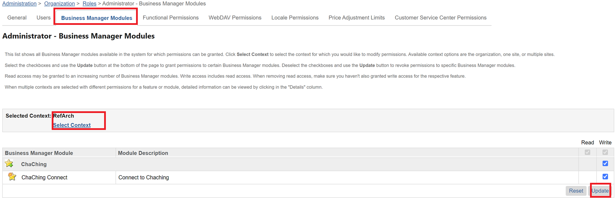

### Importing Metadata

For the Chaching integration to work, the following object structures (metadata) need to be imported and configured in the Business manager. Follow the below steps:

1. In the cartridge bundle find ‘metadata/chaching-meta-import’ folder.
2. Find the ‘sites’ folder and inside it, find the ‘RefArch’ folder.
3. If folders mentioned in step 2 are not found then jump to step 5.
4. Rename this ‘RefArch’ folder to the ID of your site. If you have multiple sites to which this meta has to be imported, then copy and paste this ‘RefArch’ folder to replicate for other sites. Rename those folders with the ID of corresponding sites.
5. In the cartridge bundle, inside ‘metadata’ folder, compress chaching-meta-import folder to generate ‘chaching-meta-import.zip’ file.
6. Go to Business Manager Menu > Administration > Site Development > Site Import & Export
7. Under Import: Upload Archive: Ensure that the radio button with label ‘Local’ is enabled (Else click on the radio button to enable it)
8. Click on Choose File input field, select the ‘chaching-meta-import.zip’ file from the open dialog box and click on the upload button.
9. After finishing the upload, from the Archives list click the radio button corresponding to ‘chaching-meta-import.zip’ and click on the ‘Import’ button.
10. Click on the ‘OK’ button of the confirmation box asking, ‘Are you sure that you want to import the selected archive?’

### Custom Site Preferences

After the successful metadata import following attributes should have been created:

In Business Manager, navigate to the Merchant Tools > Site Preferences > Custom Preferences. Custom site preference groups with the ID ‘Chaching’ will be available.

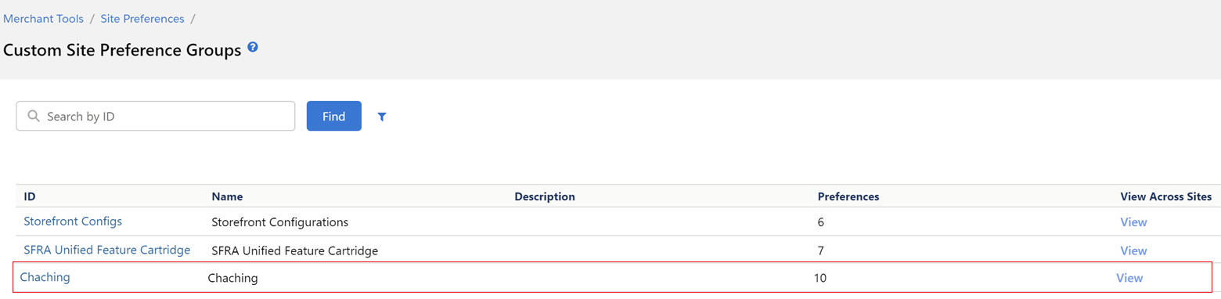

Please select it and edit the attributes as needed.

For each site, set the values for your site preferences.

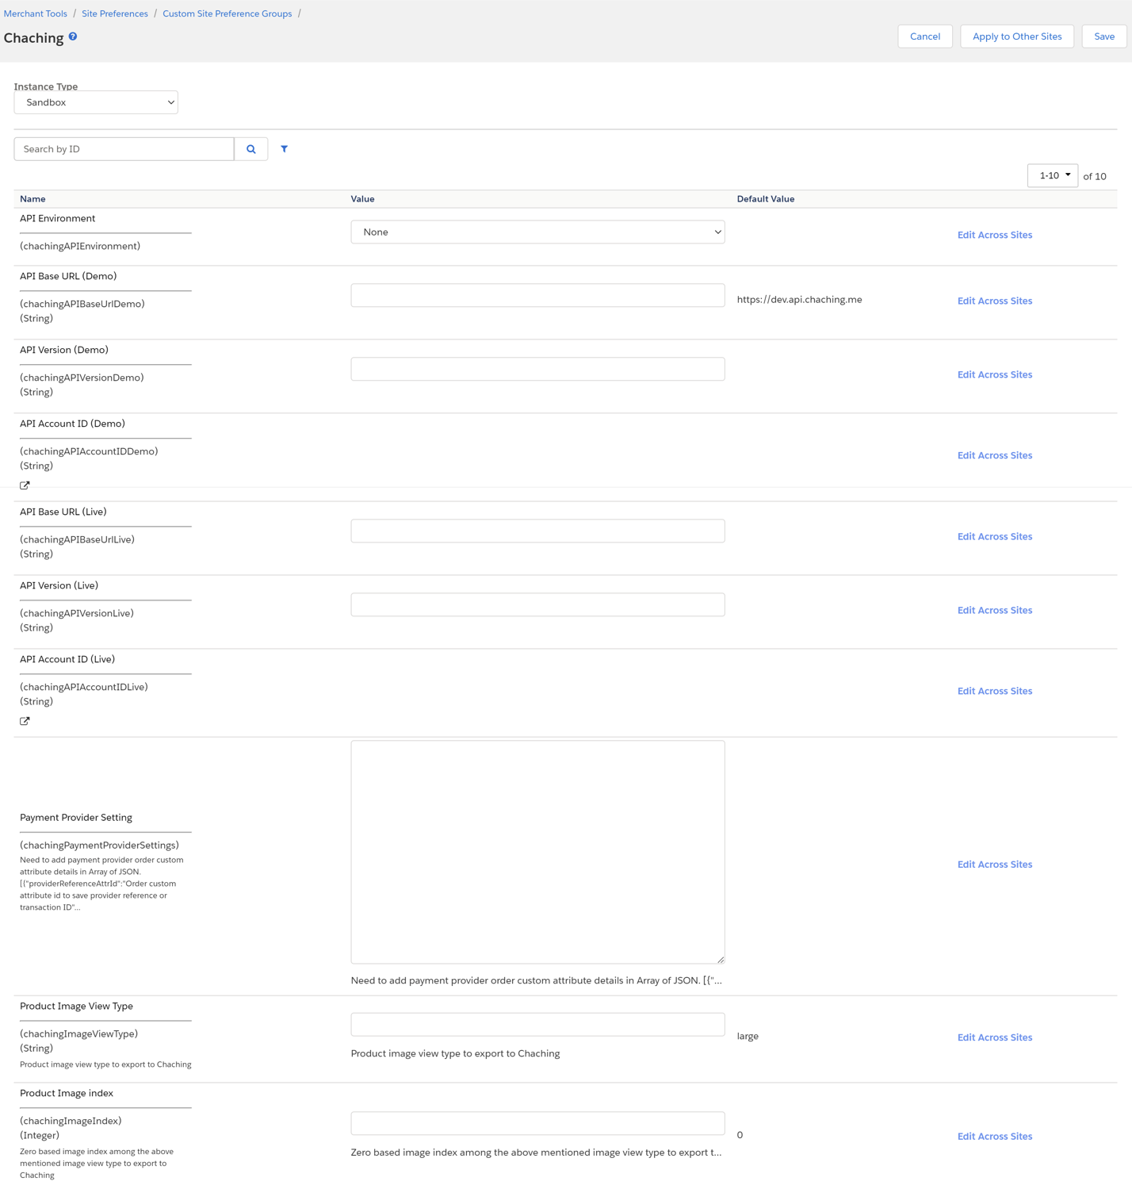

1. **API Environment** (ID – chachingAPIEnvironment, Type - enum-of-string) – Select the instance environment, live or demo.
2. **API Base URL (Demo)** (ID – chachingAPIBaseUrlDemo, Type - string) – ChaChing staging API Base url.
3. **API Version (Demo)** (ID – chachingAPIVersionDemo, Type - string) – ChaChing staging API version.
4. **API Account ID (Demo)** (ID – chachingAPIAccountIDDemo, Type - string) – ChaChing staging account ID. It will be set externally.
5. **API Base URL (Live)** (ID – chachingAPIBaseUrlLive, Type - string) – ChaChing production API Base url.
6. **API Version (Live)** (ID – chachingAPIVersionLive, Type - string) – ChaChing production API version.
7. **API Account ID (Live)** (ID – chachingAPIAccountIDLive, Type - string) – ChaChing production account ID. It will be set externally.
8. **Payment Provider Setting** (ID – chachingPaymentProviderSettings, Type - text) – Add order custom attributes id which store transaction id and order status and custom order status value for returned and canceled order for all available payment providers in below format.

Example value: *[{"providerReferenceAttrId":"opttyProviderReference","providerOrderStatusAttrId":"opttyOrderStatus","providerCustomOrderStatus":"Refunded"}]*

1. **Product Image View Type** (ID – chachingImageViewType, Type - string) – Salesforce Commerce Cloud product image type which merchant wants to display in ChaChing app. Default value is ‘large’.
2. **Product Image index** (ID – chachingImageIndex, Type - integer) – If there are multiple images available for a product, then needs to specify the index of image. Default value is 0.

### HTTP Services

Under Administration > Operations > Services, check that services with ID ‘chaching.http’ are created.

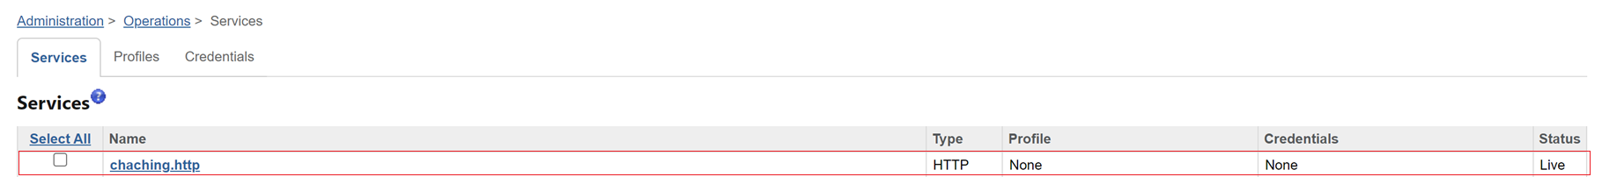

### Jobs

Under Administration > Operations > Jobs, check that job with ID ‘Chaching-Order-Export’, ‘Chaching-Product-Export-Delta-RefArch’ and ‘Chaching-Product-Export-Full-RefArch’ are created.

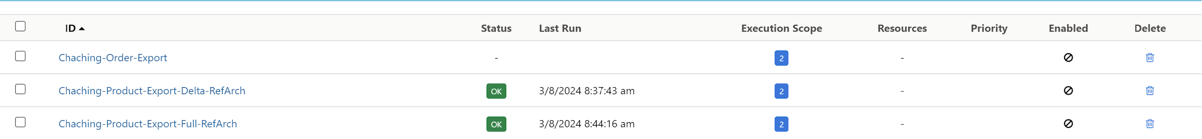

1. ‘Chaching-Product-Export-Full-RefArch’ and ‘Chaching-Product-Export-Delta-RefArch’ jobs need to be replicated for all sites.

For example, if the site ID is ‘XYZ’, the new job ID will be ‘Chaching-Product-Export-Full-XYZ’ and ‘Chaching-Product-Export-Delta-XYZ’. Under the ‘Job Steps’ for the jobs, the scope must be your site ID. Some of the job steps’ input fields also have the site ID mentioned in it, which also needs to be replaced with relevant site IDs. List of these occurrences are mentioned under each Job below.

1. **Chaching-Product-Export-Full-<SiteID> Job setting**
   1. Click on the job step id ‘chaching-catalog-export-full-xml’ and add the master catalog id of your site in the ‘CatalogID’ field and click on the ‘Assign’ button. If you have multiple master catalogs, you have to set master catalog ID one by one and have to run the job for each master catalog.
   2. Click on the job step id ‘chaching-export-pricebook’ and add your site’s sale pricebook ID in the ‘PriceBookID’ field and click on the ‘Assign’ button.
   3. Click on the job step id ‘chaching-export-inventory’ and add the inventory id of your site in the ‘InventoryListIDs’ field and click on the ‘Assign’ button.
   4. Following are the Job steps and corresponding fields having the site ID mentioned as RefArch which are to be replaced by the actual site ID

| **Job Step** | **Field** |
| --- | --- |
| chaching-catalog-export-full-xml | ExportFile |
| chaching-export-listpricebook | ExportFile |
| chaching-export-salepricebook | ExportFile |
| chaching-export-inventory | ExportFile |

* 1. This job has to be run once when the integration of the cartridge is finished and the ChaChing account is connected to the integration using the custom page which is available on menu Merchant Tools > ChaChing > ChaChing Connect

1. **Chaching-Product-Export-Delta-<SiteID> Job setting**
2. Click on the job step id ‘chaching-pricebook-export-xml-delta’ and add your site’s sale pricebook ID in ‘PriceBookID’ field and click on the ‘Assign’ button.
3. Click on the job step id ‘chaching-catalog-export-delta-xml’ and add the master catalog id of your site in the ‘CatalogIDs’ field and click on the ‘Assign’ button. If you have multiple master catalogs, you have to set master catalog ID one by one and have to run the job for each master catalog.
4. Click on the job step id ‘chaching-export-inventory-delta’ and add the inventory id of your site in the ‘InventoryListIDs’ field and click on the ‘Assign’ button.
5. Following are the Job steps and corresponding fields having the site ID mentioned as RefArch which are to be replaced by the actual site ID

| **Job step** | **Field** |
| --- | --- |
| chaching-listpricebook-export-xml-delta | ExportFile |
| chaching-salepricebook-export-xml-delta | ExportFile |
| chaching-catalog-export-delta-xml | ExportFile |
| chaching-export-inventory-delta | ExportFile |

1. This job is expected to be running in each regular interval of time after once executing the full export job
2. Set the recurring interval run time as per your business requirement.
3. For Chaching-Order-Export, under the ‘Job Steps’ add the site IDs as scope.

## Custom Code

No customization required to existing storefront code.

Merchant needs to modify code to store the return lineitems details in ‘chachingReturnLineItems’ order custom attribute in below format when customer raises request for return or cancel.

[{"id":"productId","quantity": item quantity(number)}, {"id":"productId","quantity": item quantity(number)}]

## External Interfaces

To test storefront functionality, it is required to install the ChaChing app on mobile. Contact the ChaChing team to get test mobile app access.

## Testing

1. In Business Manager, navigate to the Merchant Tools > Site Preferences > Custom Preferences. A custom site preference group with the ID ‘Chaching’ is available. Please click on the group ID and set the respective data obtained from the Chaching.
2. In Business Manager, navigate to the Administration > Operations > Jobs. ‘Chaching-Order-Export’, ‘Chaching-Product-Export-Delta-RefArch’ and ‘Chaching-Product-Export-Full-RefArch’ jobs are available.
3. In Business Manager, navigate to the Administration > Operations > Services. ‘chaching.http’ service is available.
4. In Business Manager, navigate to the Merchant Tools and check ChaChing > ChaChing Connect module is available.
5. When the service is unavailable, Chaching API will provide the industry wide and expected HTTP 500 response error and user cannot connect to chaching account.

# Operation, Maintenance

## Data Storage

This integration requires System Object Extension to store payment related information.

**Order Custom attributes:**

1. Chaching Click Id (ID – chachingClickId, Type – string)
2. Return Lineitems (ID – chachingReturnLineItems, Type – text)
3. Is Chaching Order (ID – isChachingOrder, Type – Boolean)
4. Is Chaching Purchase Return API Error (ID – isChachingPurchaseReturnAPIError, Type – Boolean)
5. Is Chaching Return Success (ID – isChachingReturnSuccess, Type – Boolean)
6. Is Send To Chaching (ID – isSendToChaching, Type – Boolean)

## Logs

This integration introduces a few new custom logs.

1. **Chaching custom log**

This log file contains all errors related information of the int_chaching _sfra, int_chaching _core and bm_chaching cartridges. Example log file:

custom-chaching-ecom-sandbox-<SANDBOX>-appserver-<DATETIME>.log

1. **Chaching service log**

This log contains every request and response to the Chaching API endpoint.

To enable these logs, go to Administration > Operations > Services > chaching.http and check the Communication Log Enabled preference. Examples of service communication log –

service-chaching-ecom-sandbox-<SANDBOX>-appserver-<DATETIME>.log

## Availability

If the Chaching service is unavailable, the user cannot connect to the ChaChing account, cannot create products at ChaChing – Advertiser Portal, purchase verification, purchase return will not happen at ChaChing side.  
  
The service availability can be tracked in Business Manager (Administration > Operations > Service Status).

There will be errors detailing the exact issue in custom-chaching-ecom-…log and service-chaching-ecom…log log files.

## Support

For any issues or support related enquiries for merchants, please contact us at

Email: support@chaching.me

# User Guide

## Roles, Responsibilities

Integration of this cartridge will typically be done by a SFCC (B2C commerce) developer.

ChaChing will provide ChaChing-Advertiser portal credentials.

ChaChing introduces no new roles with this integration. You will need to update existing roles and update new ones if you want to use the Business Manager extension ChaChing Connect.

## Business Manager

1. Once the cartridge is installed and integrated based on instructions. You can see ‘ChaChing’ module, under the Merchant Tools tab.

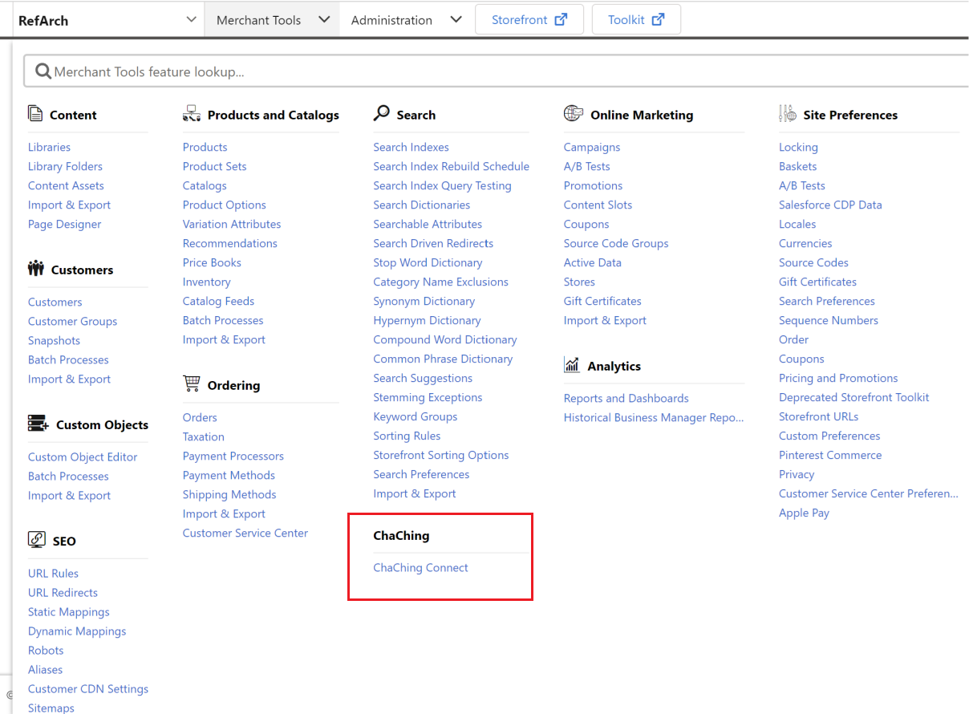

1. On click of ‘ChaChing Connect’, you will be redirected to the ChaChing landing page.

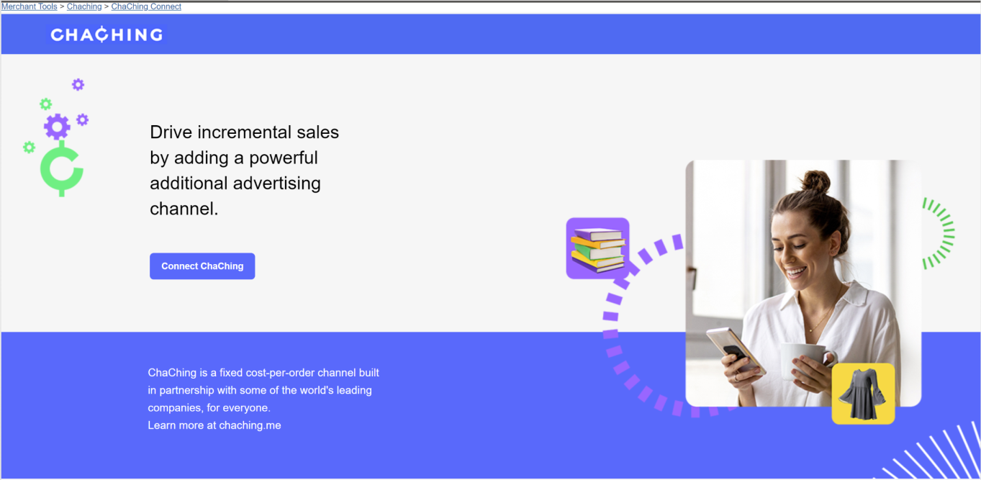

1. On click of ‘Connect ChaChing’ it will land on the signup page. There are two options.

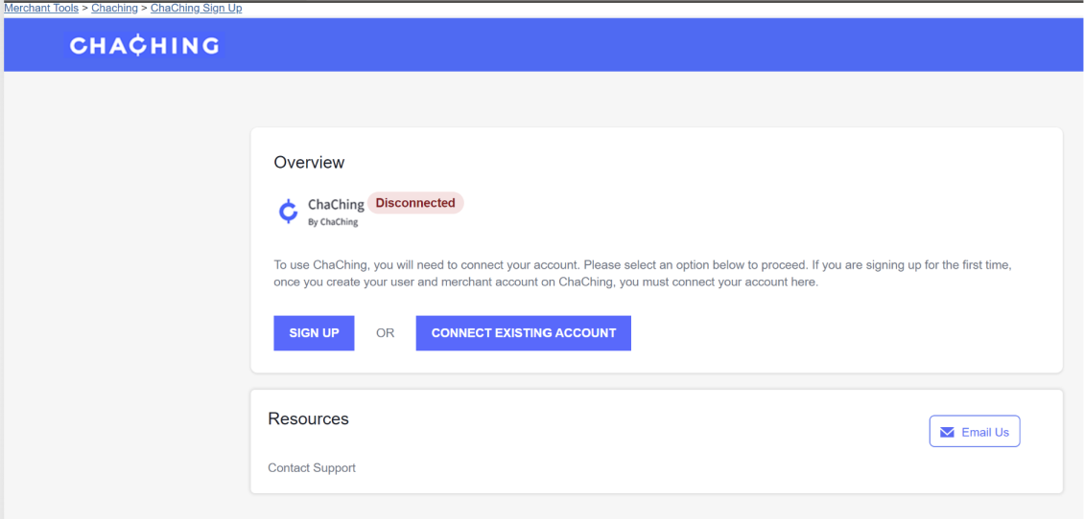

1. If a merchant has not signed up at ChaChing – Advertiser Portal already then click on ‘SIGN UP’ button. On click of ‘SIGN UP’ button, ChaChing – Advertiser Portal signup page will open in a new window. Merchant needs to fill in the signup form and need to create an account for each site. After completing sign up, the merchant will return to Business sign up page and click on ‘CONNECT EXISTING ACCOUNT’ button.

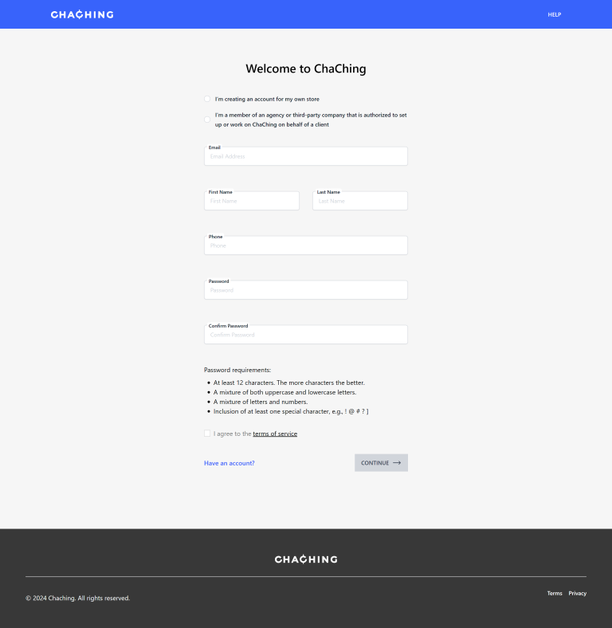

1. If the merchant signed up at ChaChing – Advertiser Portal, click on the ‘CONNECT EXISTING ACCOUNT’ button. On clicking the ‘CONNECT EXISTING ACCOUNT’ button, merchant will land on login page.

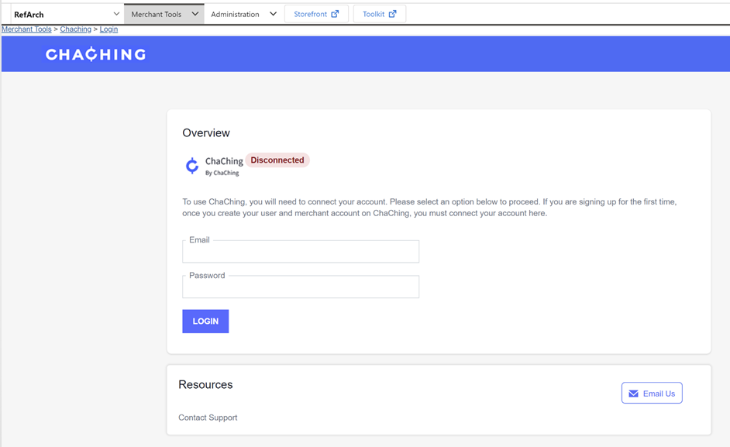

1. In the Login page, it is required to fill ChaChing – Advertiser Portal Login email id and password and click on the ‘LOGIN’ button. After login, it will land on the account selection page.

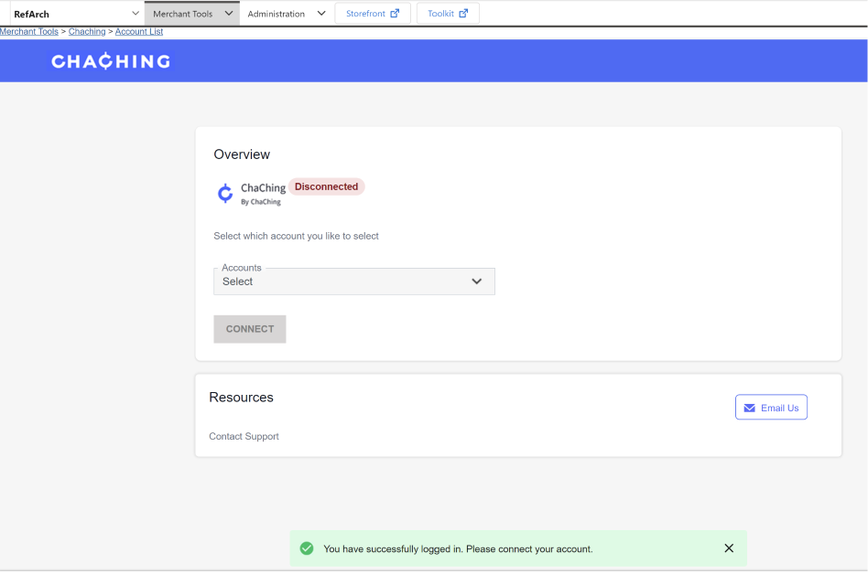

1. Select the account for the site and click on ‘CONNECT’. It will land on the account dashboard page.

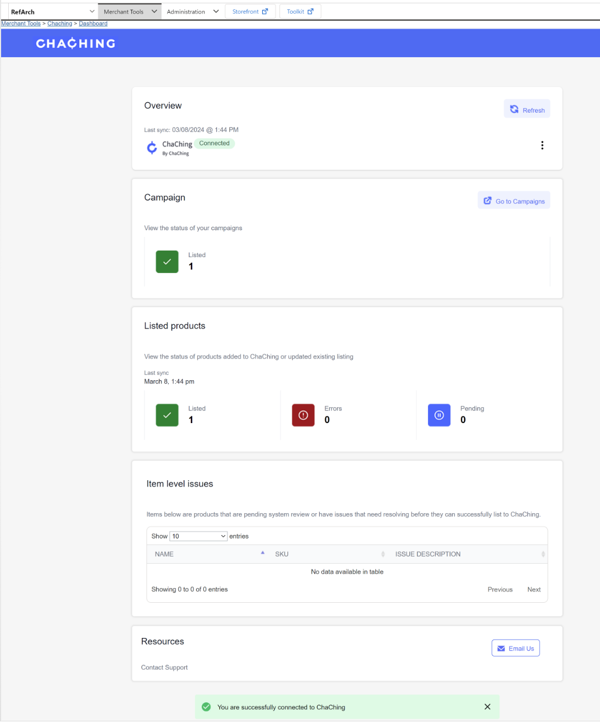

1. In the dashboard page, on clicking the vertical ellipsis button, ‘Disconnect’ button will be visible. On click of ‘Disconnect’ button, disconnect confirmation modal will open. On clicking the ‘YES, DISCONNECT’ button, all products will be deleted from ChaChing – Advertiser portal and it will land on signup page.

### Jobs run

1. After connecting the ChaChing – Advertiser portal account with the site, merchants can run the ‘Chaching-Product-Export-Full-<SiteID>’ job manually. After running the job, products will be created in the ChaChing – Advertiser portal.
2. If there are any changes in product related data, ‘Chaching-Product-Export-Delta-<SiteID>’ needs to be run.

## Storefront Functionality

To test storefront functionality, it is required to use the ChaChing mobile app.

1. Install ChaChing app on mobile.
2. Click on the ‘Login’ button. If you don’t have an account, click on the ‘Sign up’ link. If you have an account login with credentials.
3. After login search with keywords, product name, category.

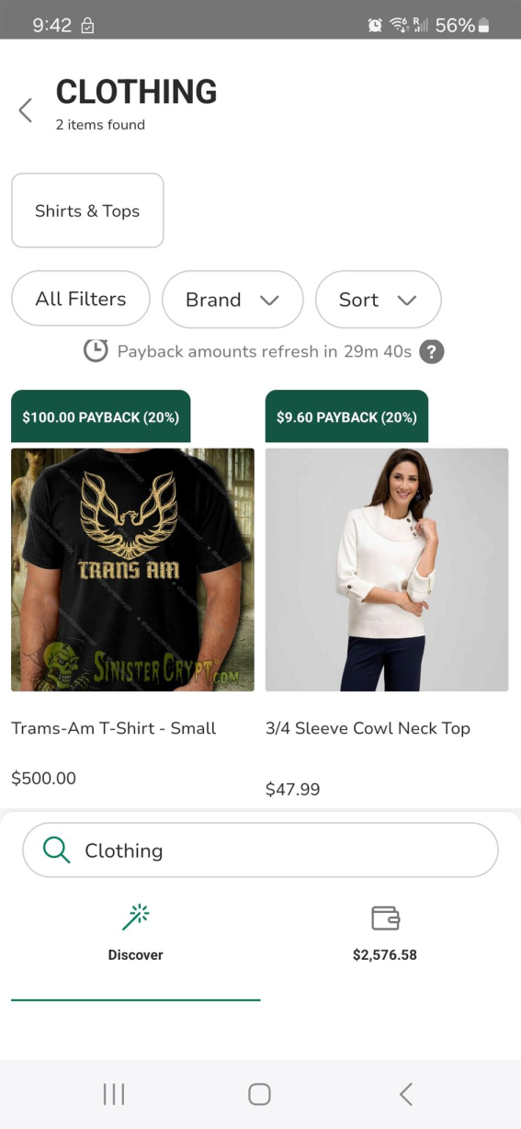

1. Click on Product to select variation.

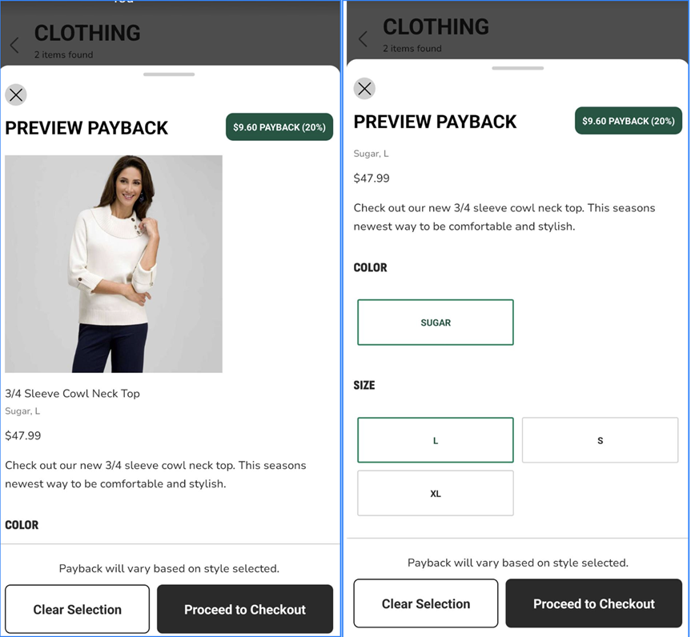

1. After selecting the variation click on the ‘Proceed to Checkout’ button. It will redirect to your site’s product detail page (PDP).

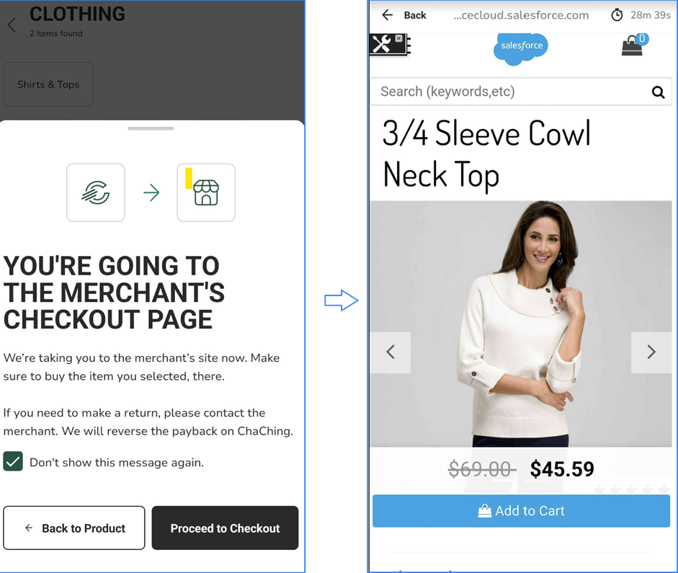

1. Add product to cart and complete checkout, after successful order place, payback modal will open, and payback point will add in customer’s account.

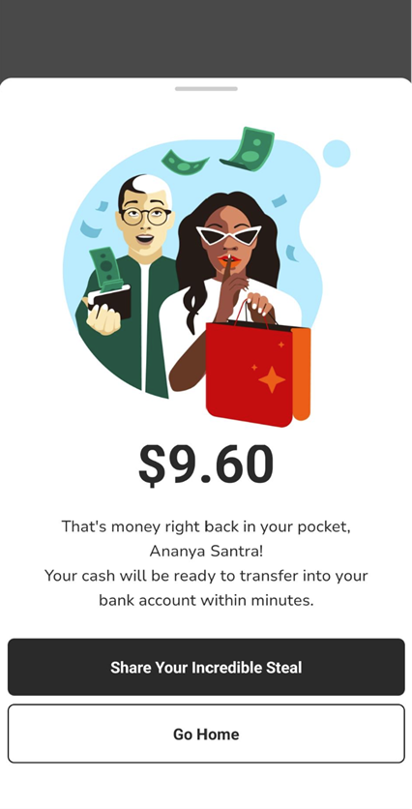

1. If you don’t place an order for the same product which is selected in the app then No payback modal will open.

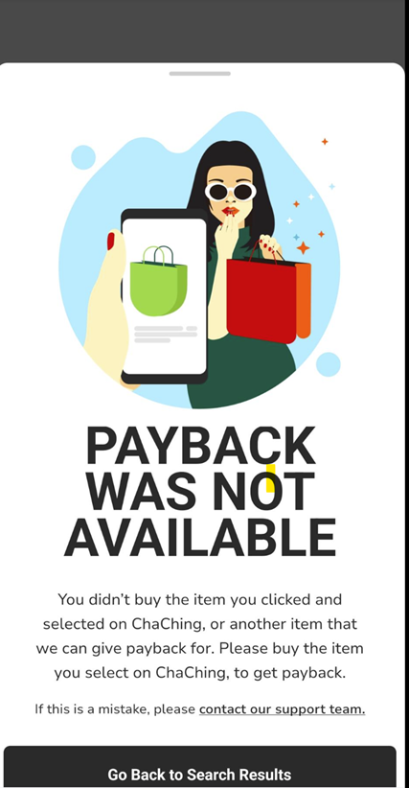

1. To check payback, click on the wallet icon in the app home page.

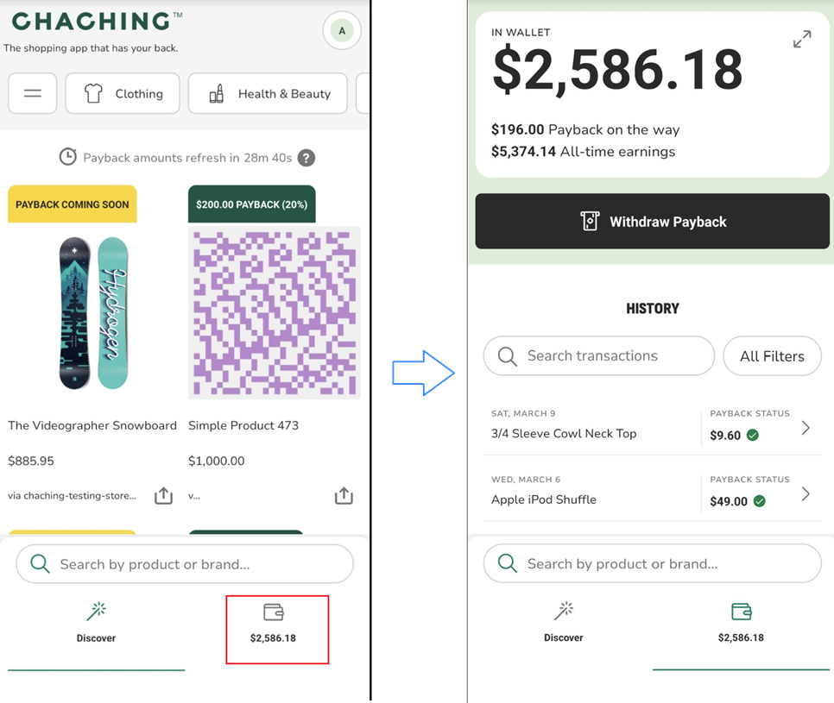

# Known Issues

No Known issue at the time.

# Release History

| **Version** | **Date** | **Changes** |
| --- | --- | --- |
|
| 24.1.0 | 28/03/2024 | Initial release |
|