**Loan App**

**TECHNICAL DESIGN DOCUMENT**

|  |  |
| --- | --- |
| **Author** | Chad ONeal |
| **Last Updated** | 2/19/2023 3:37 PM |
| **Version Number** | 1.0.0 |

**Version History**

|  |  |  |  |
| --- | --- | --- | --- |
| Name | Date | Reason for Change | Version |
| Chad ONeal | 02/19/2023 | Initial Version | 1.0.0 |
|  |  |  |  |
|  |  |  |  |
|  |  |  |  |
|  |  |  |  |
|  |  |  |  |
|  |  |  |  |
|  |  |  |  |
|  |  |  |  |
|  |  |  |  |

Table of Contents

SECTION 1: INTRODUCTION 3

1.1. Purpose 3

1.2. Terminology 3

1.3. User Personas 3

1.4. User Stories 3

1.5. Time Estimations 3

SECTION 2: PROCESS DESIGN 4

2.1. Prototypes 4

2.2. ORD (Object Relational Diagram(s) 4

# SECTION 1: INTRODUCTION

## Purpose

The purpose of this loan application is to provide a simple and easy way for users to be able to figure out how much their monthly loan payment would be and what the total amount of interest paid would be. Users will be able to do this by inputting the loan amount, interest rate, and the number of years they wish to finance the loan on the left-hand side of the page, push the calculate button, and the results will then be displayed on the right-hand side of the page. Users will also be able to clear the displayed calculation results and be able to re-enter their inputs to configure different loan amounts, interest rates, and numbers of years to best suit their financing needs. The application will be free of charge.

## Terminology

These are the technical terms that will be used in this document.

|  |  |
| --- | --- |
| **Name** | **Comments** |
| MEAN Stack | MongoDB, Express, Angular, and Node.js |
| VS Code | Development IDE |
| Slytherin | Color Palette - https://www.qualitylogoproducts.com/blog/harry-potter-color-schemes/ |
| MongoDB Compass | Database development IDE |
| Angular Material | <https://material.angular.io/> |
| Flex-layout | <https://github.com/angular/flex-layout> |

## User Personas

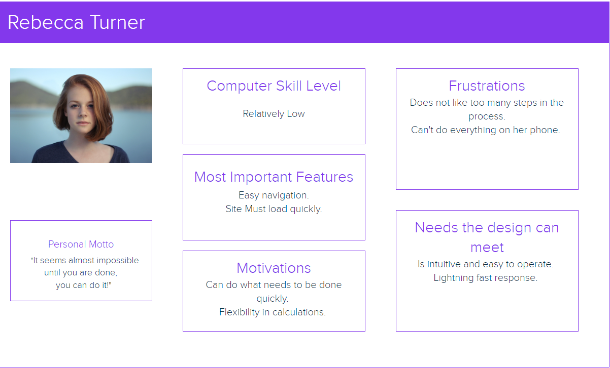

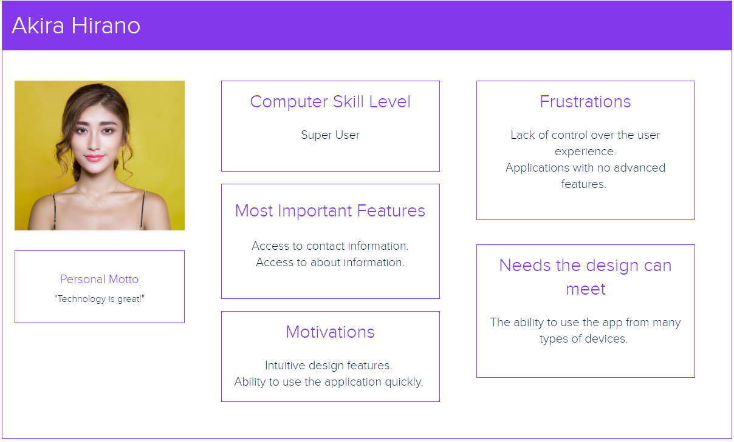

## User Stories

Rebecca Turner

1. As an app user, I need to be able to easily navigate the site, so that I can find what I need without frustration.
2. As an app user, I need to be able to be able to use my phone, so that I use the loan-app on the go.
3. As an app user, I need to be able to access the site quickly, so that I can save time running calculations.

Brad Grey

1. As an app user, I need to be able to have correct calculations, so that I will not waste time with a site that does not perform like it should.
2. As an app user, I need to be able to see easily readable information, so that I understand exactly what I am looking at.
3. As an app user, I need to be able to be able to use the site without very little effort to not get confused.

Akira Hirano

1. As a super user, I need to be able to fully understand the features, so that I can use the system to its fullest.
2. As a super user, I need to be able to see contact info, so that I can ask questions from the maker of the app if I need to.
3. As a super user, I need to be able to use the application from many devices, so that I can make use of the service in all situations.

## Time Estimations

|  |  |  |  |  |  |  |
| --- | --- | --- | --- | --- | --- | --- |
| **Story**    Rebecca Turner – Loan App User | | | | | | |
| **Task** | | **Work Hours** | | | **Points** | |
| 1. Add a navigation feature that is very easy to see and use. | | 8 | | | 3 | |
| 1. Make sure to make the site is responsive according to different demographics (especially smartphones). | | 16 | | | 7 | |
| 1. Make sure that the website is set up properly on the server and is routed correctly so that it runs very quickly. | | 10 | | | 5 | |
| **Total Required:** | | **34 hours** | | | **15 points** | |
| Hours to Points Conversion | | | | | | |
| **(1-4** Hours**) = 1** Point | **(4-8** Hours**) = 3** Points | | **(8-16** Hours**) = 5** Points | **(16-24** Hours**) = 7** Points | | **(24+** Hours**) = 9** Points |

|  |  |  |  |  |  |  |
| --- | --- | --- | --- | --- | --- | --- |
| **Story**    Brad Grey – Loan App User | | | | | | |
| **Task** | | **Work Hours** | | | **Points** | |
| 1. Ensure that the loan-app calculations are routed correctly and return the correct values quickly. | | 10 | | | 5 | |
| 1. Make sure that the app is easily readable to see all necessary information. | | 5 | | | 3 | |
| 1. Make sure that the site is simplistic in nature, avoiding any unnecessary buttons or features that will confuse the user. | | 12 | | | 5 | |
| **Total Required:** | | **27 hours** | | | **13 points** | |
| Hours to Points Conversion | | | | | | |
| **(1-4** Hours**) = 1** Point | **(4-8** Hours**) = 3** Points | | **(8-16** Hours**) = 5** Points | **(16-24** Hours**) = 7** Points | | **(24+** Hours**) = 9** Points |

|  |  |  |  |  |  |  |
| --- | --- | --- | --- | --- | --- | --- |
| **Story**    Akira Hirano – Loan App Super User | | | | | | |
| **Task** | | **Work Hours** | | | **Points** | |
| 1. Use the least number of steps possible, eliminate clutter**.** Ensure usability is at its fullest. | | 2 | | | 1 | |
| 1. Ensure there is a section for contact information. | | 5 | | | 3 | |
| 1. Ensure the app is responsive on many different devices. | | 8 | | | 3 | |
| **Total Required:** | | **15 hours** | | | **7 points** | |
| Hours to Points Conversion | | | | | | |
| **(1-4** Hours**) = 1** Point | **(4-8** Hours**) = 3** Points | | **(8-16** Hours**) = 5** Points | **(16-24** Hours**) = 7** Points | | **(24+** Hours**) = 9** Points |

# SECTION 2: PROCESS DESIGN

## 2.1. Prototypes

<https://marvelapp.com/prototype/69bhi4h/screen/90727254>

## 2.2. ORD (Object Relational Diagram(s)

